Overview of the DPO inclusive education capacity building process

The DPO inclusive education capacity building component of the TOFI programme supports DPOs and their members to boost their capacity around inclusive education.

Needs assessment
The 3 training modules are not set in stone. A needs assessment is carried out with the DPOs first, so that the training content can be adapted to the specific needs of the DPO membership in each context.

Selecting and preparing training facilitators
Individuals are identified from within the DPOs to be training facilitators. They will deliver the training at district/regional levels.

They receive training on the content of the modules, but also receive extra help with learning new facilitation skills, so they can facilitate lively, participatory workshops. A ‘Skills for inclusive facilitation’ module and video have been created for this purpose.

Training process
An overview of this process is shown in the diagram below:
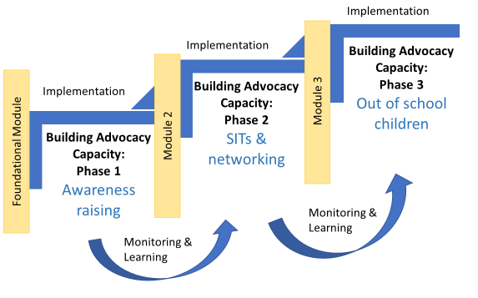

The capacity building process includes three training modules:
- Foundational module: this looks at ‘what is inclusive education?’ and basic skills for inclusive education advocacy.
- Module 2: this looks at school inclusion teams (SITs) and networking for inclusive education.
- Module 3: this focuses on identifying and supporting out-of-school children.

Each module builds on learning from the previous module. At each stage there are opportunities for participants to put their learning into practice and build their capacity to advocate. This is done through carrying out small action research activities within their communities in between modules.

The DPO inclusive education component of the TOFI programme also involves building the DPO’s capacity to monitor and learn throughout the process.

