Call for Articles
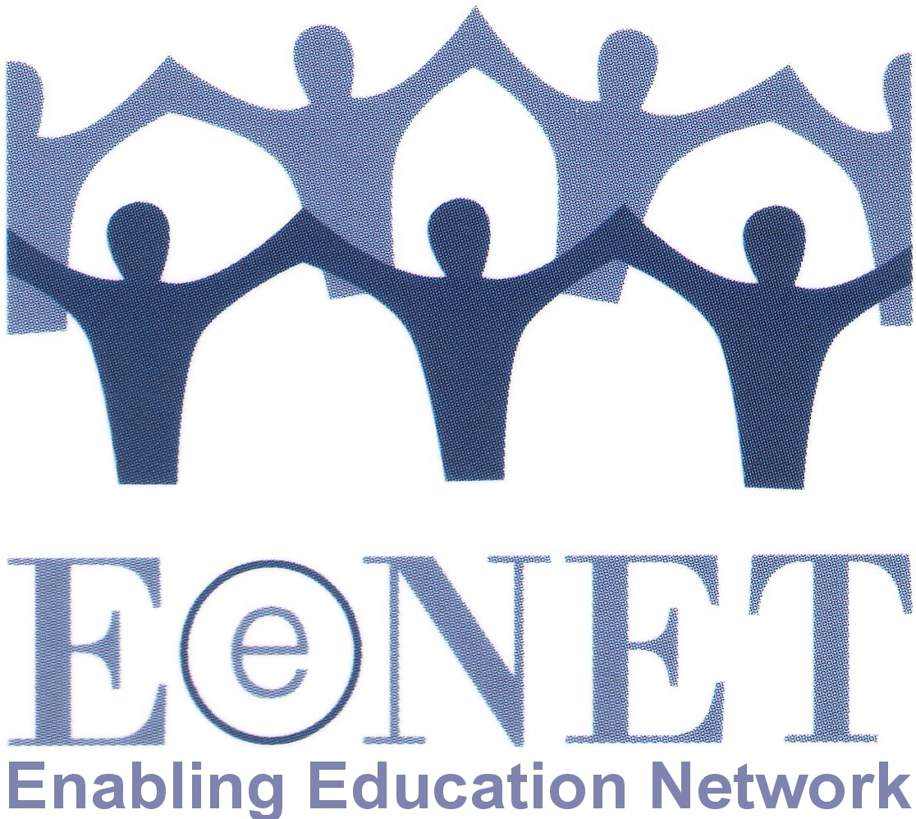
Enabling Education Review
Issue 10, 2021

Over the last year we have all found ourselves in an unusual situation. Our theme for the next edition therefore draws on the work being done to support children’s learning as we have adapted to the COVID-19 pandemic and school closures. It will also look at the broader context of what it means to learn at home.

The theme for the 2021 edition of Enabling Education Review will be:

“Home learning”

The deadline for submitting first drafts of articles is 31 March 2021. Details of suggested topics and how to submit articles are provided below.
Contact info@eenet.org.uk with any questions.

1. Why have we chosen this topic?

Many children learned at home before the COVID-19 pandemic for various reasons. For example, they may have been denied access to school, or their parents may have chosen home schooling as their preferred approach. Plus of course most children experience a great deal of informal learning at home, even if they also go to school.

Learning at home has often been seen as separate from mainstream education and not part of the movement towards inclusive education. EENET has always argued that, with the right strategies, approaches and support in place, learning at home can be considered an integral contribution to an inclusive education system.

Over the last year, COVID-19 school closures meant millions of children suddenly had to learn at home, and their teachers and education ministries had to work out how to facilitate that. One of the biggest challenges has been ensuring that learning at home is inclusive of every learner.

In early 2020 EENET, through our partnership with Norwegian Association of Disabled, launched a project to explore home learning and the education experiences of stakeholders during the widespread lockdowns. Using evidence from a survey, we developed a home learning guidance poster and booklet for families. These resources recognise that home education can be extremely stressful for learners and families, especially in the context of the COVID-19 pandemic. They also show that home learning is always relevant, whether or not schools are open, and we can do more to weave effective learning at home into high quality inclusive education systems.

What has been your experience as a teacher, parent, family member, learner, or other stakeholder involved in education? Was home learning a new experience for you during the pandemic, or is it something you have been involved with for a long time? How do you cope with or support learning at home? What works well and what is challenging? What support did or do you receive, or would you like to receive?

2. What could you write about?

There are many aspects of home learning that you could write about, including but not limited to:

- What has been done to ensure emergency-response or long-term home learning initiatives promote inclusion and are inclusive for all learners?
- How are inclusive home learning initiatives financed and managed?
- As a parent/caregiver/learner – how have you advocated at the local or national level for home learning provision to be more inclusive.
- As a teacher – what did you do to reach and support all your learners when schools were closed? What problems did you solve to help you reach and support more/all learners? Who helped you?
- For learners who were already learning at home before the pandemic, how has their home learning been affected (positively or negatively) by the changes in the education system resulting from the COVID-19 pandemic?
- How have approaches to learning changed as a result of responsibility for learning shifting heavily onto parents and families for prolonged periods?
- How does home learning affect the mental and physical well-being of learners, parents, families, and teachers?
- What lessons have we learned from the COVID-19 home learning experiences that we could use to improve the design and inclusivity of education systems long term?

Enabling Education Review helps people share and learn from each other’s experiences. We therefore welcome articles that offer practical insights, to help others who are looking for ideas that they can adapt and try. We like articles that provide a little background to the context, project or programme, and then explain in more detail the activities that happened (what, where, when, with or by whom, and why). We also like to read about the results, if possible.

3. How can you submit an article?

Please email your article to info@eenet.org.uk or send a hard copy to the address at the end of this document.

Authors can write in English or in their preferred language.

Length – either 550 words (for a single-page article) or 1,100 words (for a double-page article). We may edit longer articles down to a single page, depending on the quantity and quality of articles received.

Style

Write an article: please keep the article easy-to-read and non-academic. We encourage the use of sub-headings, bullet lists, simple diagrams, etc. Have a look at previous editions of the publication if you are not sure what style to use: www.eenet.org.uk/enabling-education-review/

Write a poem: we encourage you to be creative with your submissions, so if you prefer to write a poem rather than an article, that’s great.

Present a drawing: if you feel that the story you wish to tell is better told visually, please feel free to submit a drawing rather than an article. Please give your drawing a title. You could also write and submit a shorter piece of writing that explains the drawing.

Editing – we are happy to help edit the article, so don’t worry if you are not an experienced writer. We can work with you to improve the structure and content of your article, make it shorter/longer, etc.

Working in audio – if you would like to send us a voice recording of your article, or be interviewed as the basis for an article, please contact Su Corcoran on info@eenet.org.uk to discuss options.

Photos – it is great if you can add photos, drawings or diagrams to your article. When selecting photos, please look for the following:
- Active images – e.g., children learning in groups, children playing, teachers/ parents working with learners, and so on;
- Images that are not too dark, blurred, or pixelated.

Please send us high-resolution images by email (these should be at least 1mb in size), or post us an original print/drawing. For every image you want to add to your article, you will probably need to remove about 75-100 words of text – but we can help with this editing.

Permission
Please ensure that the people in any photos have given their permission for the photos to be published, or that parents/guardians have given permission for photos of children or vulnerable adults to be used.

Please fill in and send us the permission form (below) attached to your photo(s).

Deadline – the first deadline for draft submissions is 31 March 2021. We will then review all articles and work with the authors to edit them.

Selection – please note that we might not publish all of the articles we receive. In addition to ensuring that we publish articles that are easy-to-read and of practical use to a range of education stakeholders, we will also ensure that the final selection includes:
- articles from a variety of countries/regions
- articles about a range of different issues
- articles by authors from different backgrounds.

Articles that are not selected for publication in EER may instead be published on EENET’s website (www.eenet.org.uk).

Queries – if you have any questions, please email info@eenet.org.uk.

Postal address – if you want to send an article in hard copy or as an audio recording (e.g. on CD or flashdrive), please send to:

EENET
PO Box 422
Hyde
Cheshire, SK14 9DT
UK

Permission form – Enabling Education Review

Please fill in a form for each photo you want us to publish. Please also fill in a form if you are naming people in a case story and have chosen not to change their names.

Name of person submitting the article to EENET:

Title, file name or description of photo:

Name of person in photo / story (delete as applicable):

Parent / guardian’s name (if person in photo/story is under 16):

I understand that my / my child’s photo / story may be published in EENET’s Enabling Education Review, in printed copy and online.

I also understand my / my child’s photo / story may be shared through other media, such as social media.

I understand that once the photo / story is published and shared online, it will not be possible to remove it in future.

I give my permission for my / my child’s photo / story to be used in these ways.

Signature:

Date:

Contact details (e.g. tel no, email, address):

