Call for Articles
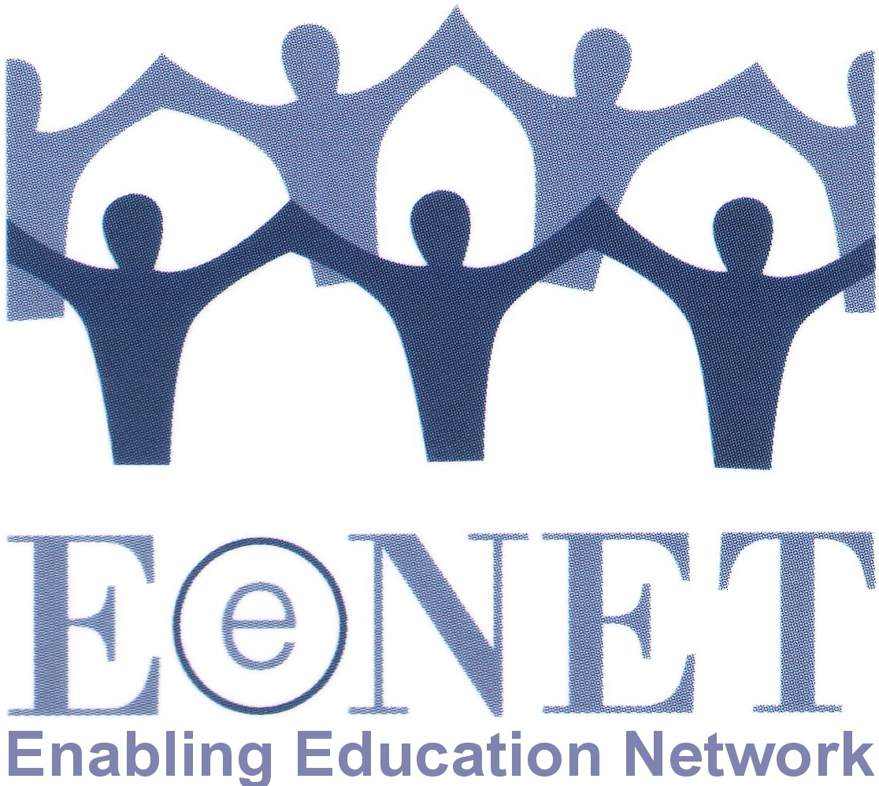
for Enabling Education Review
Issue 9, 2020

To coincide with the launch of our new training videos on inclusive early childhood development and education, the 2020 Enabling Education Review is seeking articles on:

“Inclusive early child development and education (ECDE)”

The deadline for submitting first drafts of articles is 31 August 2020. Details of suggested topics and how to submit articles are provided below. Contact info@eenet.org.uk with any questions.

1. Why have we chosen this topic?

Early childhood development and education (ECDE) sets the foundation for lifelong learning, behaviour and health. Early childhood experiences are fundamental to shaping the brain and building a child’s capacity for learning and social interactions. It is vital that all young children are included in efforts to support early development and learning. This is why Sustainable Development Goal 4.2 focuses on quality early childhood development, care and pre-primary education.

In July 2020, EENET is launching two new training videos which look at:
- Inclusive teaching and learning in ECDE settings;
- Inclusive transition to, from and within ECDE settings.

To coincide with the video release, this year’s main edition of Enabling Education Review aims to capture and share good ideas and promising practices in inclusive ECDE around the world.

2. What could you write about?

The following are ideas for questions you could focus on when writing your article, but feel free to add your own ideas:

- How have you supported ECDE initiatives to become inclusive for all learners?
- What practical innovations have you developed and used to make ECDE more inclusive?
- How have you financed and managed inclusive ECDE initiatives?
- How can we plan and budget effectively for embedding ECDE into government and non-government education improvement initiatives?
- What ECDE policy changes have you advocated for or implemented?
- What advocacy have you done (as parents/caregivers, parents groups, non-government organisations (NGOs), disabled persons organisations (DPOs), etc) at local or national level to call for ECDE to become more inclusive?
- What practical actions have you taken in the community (as parents/caregivers, parents groups, NGOs, DPOs, etc) to overcome barriers to inclusion for young learners and/or to support parents/caregivers experiencing challenges with their child’s early development and education?

Enabling Education Review helps people share and learn from each other’s experiences. We therefore welcome articles that offer practical insights, to help others who are looking for ideas that they can adapt and try. We like articles that provide a little background to the context, project or programme, and then explain in more detail the activities that happened (what, where, when, with or by whom, and why). We also like to read about the results, if possible.

3. How can you submit an article?

Please email your article to info@eenet.org.uk or send a hard copy to the address at the end of this document.

Authors can write in English or in their preferred language.

Length
Please write either 550 words (for a single-page article) or 1,100 words (for a double-page article). We may edit longer articles down to a single page, depending on the quantity and quality of articles received.

Style
Write an article: please keep the article easy-to-read and non-academic. We encourage the use of sub-headings, bullet lists, simple diagrams, etc. Have a look at previous editions of the publication if you are not sure what style to use: www.eenet.org.uk/enabling-education-review/

Write a poem: we encourage you to be creative with your submissions.

Present a drawing or diagram: if you feel that the story you wish to tell is better told through a visual, please submit a drawing or diagram. Please give your drawing/ diagram a title. You could also write and submit a short piece of writing that explains the drawing/diagram.

Editing
We are happy to help with editing the article, so don’t worry if you are not an experienced writer. We can work with you to improve the structure and content of your article, make it shorter/longer, etc.

Working in audio
You can use a voice recording to submit an article. Please contact Su Corcoran on info@eenet.org.uk to find out more.

Photos
It is great if you can add photos, drawings or diagrams to your article. When selecting photos, please look for the following:
- Active images – e.g. children learning in groups, children playing, teachers working with pupils, parents taking actions to support the school, and so on;
- Images that are not too dark, blurred or pixelated.

Please send us high-resolution images by email (these should be at least 1mb in size), or post us an original print/drawing. For every image you want to add to your article, you will probably need to remove about 75-100 words of text – but we can help with this editing.

Please ensure that the people in any photos have given their permission for the photos to be published, or that parents/guardians have given permission for photos of children or vulnerable adults to be used. Please use the permission form below for this. With each photo, please include the name of the photographer/organisation and a brief caption (activity, location, date, etc.).

Deadlines
The first deadline for draft submissions of articles is 31 August 2020. We will then review all articles and work with the authors to edit them.

Selection
Please note that we might not publish all of the articles we receive. In addition to ensuring that we publish articles that are easy-to-read and of practical use to a range of education stakeholders, we will also ensure that the final selection includes:
- articles from a variety of countries/regions
- articles about a range of different issues
- articles by authors from different backgrounds.

Articles that are not selected for publication in EER may instead be published on EENET’s website (www.eenet.org.uk).

Queries
If you have any questions, please email info@eenet.org.uk.

Postal address
If you want to send an article in hard copy or as an audio recording (e.g. on CD or flashdrive), please send to:

EENET
PO Box 422
Hyde
Cheshire, SK14 6NG
UK
Permission form – Enabling Education Review

Please fill in a form for each photo you want us to publish. Please also fill in a form if you are naming people in a case story and have chosen not to change their names.

Name of person submitting the article to EENET:

Title, file name or description of photo:

Name of person in photo / story (delete as applicable):

Parent / guardian’s name (if person in photo/story is under 16):

I understand that my / my child’s photo / story may be published in EENET’s Enabling Education Review, in printed copy and online.

I also understand my / my child’s photo / story may be shared through other media, such as social media.

I understand that once the photo / story is published and shared online, it will not be possible to remove it in future.

I give my permission for my / my child’s photo / story to be used in these ways.

Signature:

Date:

Contact details (e.g. tel no, email, address):

