Call for Articles for
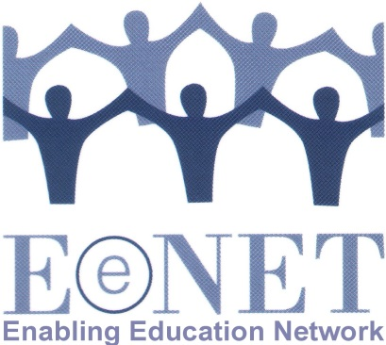
“Enabling Education Review” 2014

Deadline for submission extended until 30 JUNE 2014

The theme for the 2014 newsletter will be:

“Inclusive education – beyond schools”

1. Why have we chosen this topic?

EENET is committed to the principle that education is about more than just attending a formal school. Education happens in many different ways, throughout our lives. Making education inclusive therefore means more than simply ensuring that existing kindergartens, schools, colleges and universities are welcoming and adaptive to the needs of everyone.

We need to look at what happens to learners outside school, to respond to anything that may be affecting their presence, participation and achievement in school. We also need to ensure that other forms of education (e.g. adult literacy classes or accelerated learning programmes for former child-soldiers, street children, child mothers, etc) are inclusive. Further, we need to look more innovatively at how those most at risk of exclusion from education (e.g. children with severe disabilities; or young mothers) can be included in a quality education relevant to their lives and aspirations, even if attending their local school is currently not an option for whatever reason. How can we ensure that any such alternative education solutions really do promote inclusion and tackle discrimination, rather than enhancing segregation?

For the purpose of this edition of Enabling Education review, we will borrow the following definitions from WHO’s (2010) Community-based Rehabilitation Guidelines. Education Component (p.4):

“In general: ‘formal education’ refers to education that takes place in recognized institutions, e.g. schools, colleges and universities, often leading to recognized qualifications and certifications; ‘non-formal education’ refers to organized educational activity outside the formal system; ‘informal education’ refers to all the learning that happens throughout life as a whole – from family, friends and communities – which is often not organized, unlike both formal and non-formal education.”

2. What could you write about?

- Your experiences of developing alternative, informal or non-formal education that is inclusive / non-discriminatory.
- Your experiences of initiatives outside the school that seek to enhance the success of inclusive education in school.
- Your experiences of creating ways to link up formal and non-formal or informal, or school and non-school-based, education initiatives.
- Your experiences of developing education policies that address inclusion in education settings beyond the formal school setting.
- Your experiences as a student (or teacher or parent) within an inclusive alternative/non-formal/informal education initiative.
- Your experiences of supporting/training teachers/educators to work inclusively in alternative/non-formal/informal education settings.

3. How do you submit an article?

Please email your article to ingridlewis@eenet.org.uk or send a hard copy to the address at the end of this document.

Length – either 550 words (for a single page article) or 1,100 words (for a double-page article). We may edit longer articles down to a single page, depending on the quantity and quality of articles received.

Style – please keep the article easy-to-read and non-academic. We encourage the use of sub-headings, bullet lists, etc. Have a look at previous editions of the publication if you are not sure what style to use: www.eenet.org.uk/resources/eenet_newsletter/index.php

Editing – we are very happy to help with editing the article, so don’t worry if you are not an experienced writer, we can work with you to improve the structure and content of your article, make it shorter/longer, etc.

Photos – it is great if you can add photos, drawings or diagrams to your article. Please send us high resolution images by email, or post us an original print/drawing. For every image you want to add to your article, you will probably need to remove about 75-100 words of text – but we can help with this editing. Please ensure that the people in any photos have given their permission for the photos to be published.

Deadlines – the first deadline for draft submissions of articles is 1 June 2014.
***EXTENDED UNTIL 30 JUNE 2014***
But we welcome submissions as soon as possible so we can spread the editing workload. We will then review all articles and work with the authors to edit them. This process will happen June–July. We then aim to finalise articles and design the publication in August/September, so that it can be printed in October 2014.

Selection – please note that we might not publish all of the articles we receive. In addition to ensuring that we publish articles that are easy to read and of practical use to a range of education stakeholders, we will also ensure that the final selection includes:
- articles from a variety of countries/regions
- articles about a range of different issues
- articles by authors from different backgrounds (e.g. teachers, NGOs, parents, academics, etc).

Articles that are not selected for publication in the newsletter may instead be published on EENET’s website (www.eenet.org.uk).

Queries – if you have any questions, please email ingridlewis@eenet.org.uk.

Postal address – if you want to send an article in hard copy or as an audio recording (e.g. on CD), please send to:

EENET CIC
37 Market Street
Hollingworth
Cheshire, SK14 8LS
UK

