Universal Design for Learning in the Classroom: A Way Forward?

All of Rohan’s classmates were chirping about, sharing with each other their new discoveries of stories with vivid illustrations that they were receiving in the form of a set of books – an early reading series. Rohan felt left out, as he could not share this excitement. He knew that when the teacher comes round to him, there might not be any books for him. His Braille and audio books may take a while to arrive. And illustrations, what are those? They never carried any meaning for him.

“Don’t worry Rohan, I’ll read all the stories to you!” his friend Priya tried to assure him as she spotted the drooped shoulders and disappointment on Rohan’s face. When the teacher arrived at their desk she handed the books to both Priya and Rohan. They were surprised. Was this a mistake?

“Rohan look!” Priya exclaimed, “This book is for you. Wait, but I can read it too. Rohan, both of us can read this book!” At first Rohan didn’t understand. He flipped through this new book. It had text in Braille. Priya pointed out that the book also had printed text right above the Braille. Rohan flipped ahead and discovered that he could also feel some textures and outlines on the pages. Priya told him that these were part of the illustrations. Gradually Rohan realised that objects and other characters had a distinct feel. One of the main characters in the story was wearing a turban and Rohan recognised this character on each consecutive page as it had the same texture on all the pages of the story book. Nadira who had partial vision came running to Rohan and Priya. “I can see all the pictures in these new books! The colours are so vivid and clear!” Nadira exclaimed with joy.

“Priya, how about we all read together today?” Rohan suggested. “Yes” said Priya, “And now that we all have the same book, you can teach me how to read Braille.” Rohan nodded and his drooped shoulders straightened with pride. Charged with excitement, Rohan, Priya and Nadira got into a huddle and started reading the books. They were now a part of the class. Just then the teacher called everyone’s attention and said “all those who want to select and read the stories on the computer in the library can do so too.”

India’s National Council for Educational Research and Training (NCERT) annually conducts a National Achievement Survey to assess the grade level achievement of students in school. Its latest survey reveals that on an average, only 59 percent of children in grade III are able to read with comprehension. The above scenario has much to reveal for all those concerned with augmenting this achievement level especially from the perspective of building inclusive environments for inclusive learning? And while we are at it:

- How can we use specific design features to make learning material accessible to all?
- How can we use learning material to build the right attitudes of respect and regard for differences in the early years?
- How can we avoid singling out a few because of their needs and diluting the essence of inclusion?
- How can we promote inclusive practices of teaching and learning in the true sense?

While reflecting on these concerns it is important to understand that when one addresses learning to read in inclusive settings with children of varying abilities, phases of achievement cannot be compartmentalized into a concrete timeline. One has to allow for learning to take place according to a pace that the child is comfortable with. Children with special needs often face neglect and delay in reaching the pivotal milestone of learning to read. A child with visual difficulties for example may not be exposed to reading early enough. When she is, she may be given audio books as a way of providing learning material. But does any child learn to read through an audio book?

Learning to Read with Accessible Learning Material

For adequate grasp of the skill of reading, all children, despite their diverse abilities should be exposed to the concept and practice of reading. This should happen as early as possible. The use of reading material, or any learning material for that matter, which is inclusive and accessible, consolidates the foundation upon which children develop as learners. Barkhaa: A Reading Series for ‘All’ recently released at NCERT, New Delhi, is an attempt at exactly this. Adapted from the original Barkhaa Reading Series, it is an innovative exemplar that aims to promote early reading among children with varying abilities in inclusive settings. It is a supplementary reading series that breaks away from the disenchantment of prescriptive textbook reading in order to promote reading for meaning and pleasure.

Barkhaa: A Reading Series for ‘All’ consists of 40 story booklets based on every day, humorous, ‘slice of life’ accounts from the lives of children in the Indian context. In order to make it inclusive and accessible this reading series has been designed with a focus on the principles of Universal Design for Learning (UDL). UDL finds its roots in the architectural concept of Universal Design wherein structural designs allow for greater accessibility for numerous individuals across a diverse range of needs.

True Inclusion through Universal Design for Learning

In inclusive classrooms, Universal Design for Learning is a systematic and flexible approach to designing learning activities and materials by customising and making adjustments for individual needs while keeping the material meaningfully functional for all.
Embracing the UDL principles Barkhaa: A Reading Series for ‘All’ has retained all the features of the original Barkhaa Series. This was necessary in order to prove that any learning material regardless of whether or not it is prepared with the aim of inclusion can, nevertheless, be adapted for inclusion. By retaining all original features of the Barkhaa Series, the intension is to emphasize, that children with special needs can and should be provided with the same book that the rest of the class uses. In the pretext of an otherwise inclusive setting, they should not be alienated with an exclusive range of learning material.

The Process

The approach to developing Barkhaa: A Reading Series for ‘All’ has been structured and scientific. It was conceptualised over a series of workshops and consultations with a multidisciplinary team of experts and practitioners at the national level. Sample copies of Barkhaa: A Reading Series for ‘All’ in print and digital formats with UDL based inclusive features were field tested with children with special needs from various inclusive and special schools in the northern states of the country. The rich feedback availed from the tryouts was incorporated to develop the final version of Barkhaa: A Reading Series for 'All' in both print and digital forms.

Inclusive Features that Respect Each Learner

The inclusive features in Barkhaa: A Reading Series for ‘All’ aim to provide a multi-sensory experience to young readers in order to cater to different learning styles. The challenges encountered while incorporating these inclusive features during the development of the reading series were overcome through a range of innovative solutions that were agreed upon by a team of experts.

To promote collective reading in an undifferentiated, non-discriminate fashion, every child in a classroom should be given a book that looks, feels and is the same in all aspects. The print version of Barkhaa: A Reading Series for ‘All’ tries to meet this goal with text in print form and in braille on the same page. Realising the limitations of conventional braille, embossed invisible Braille with a longer shelf life is used in the story booklets. As the books are also intended to be a part of school libraries, embossed Braille that lasts longer will allow the books to maintain their quality even when they are not replaced.

Illustrations are considered impractical for some children with special needs. In order to dispel this myth and to make illustrations increasingly accessible the salient features of illustrations are made tactile and high resolution.

Some children, when they are learning new vocabulary, may hesitate in expressing that they do not know the meaning of certain words. To aid vocabulary development and reinforce difficult words, in-text picture flashcards in printed text and Braille have been placed on the same page that refers to the difficult word. A child can refer to the real image and text in a flashcard at her own pace and as many times as she prefers. This can help her grasp the meaning of words in an immediate and unintimidating fashion.

Each page in Barkhaa: A Reading Series for ‘All’ has a surrounding black border to draw the eye in to the page. To help children follow the text, green and red dots indicate beginning and end of sentences. There are arrows at the bottom corner of each page to indicate turning of page. Turning of pages is made easier through page gradation. These features assist in retaining the attention of all children and aid their navigation from one sentence to the next and from one page to the next.

When designing any sort of learning material, a child’s safety is of utmost significance and it must never be compromised on. This was kept in mind while developing the story booklets in Barkhaa: A Reading Series for ‘All’. The 40 booklets are put together through durable and safe ‘wiro’ binding. This bypasses the use of staples which may harm children especially while reading Braille. It also allows the booklets to open flat on the desk for more convenient Braille reading.

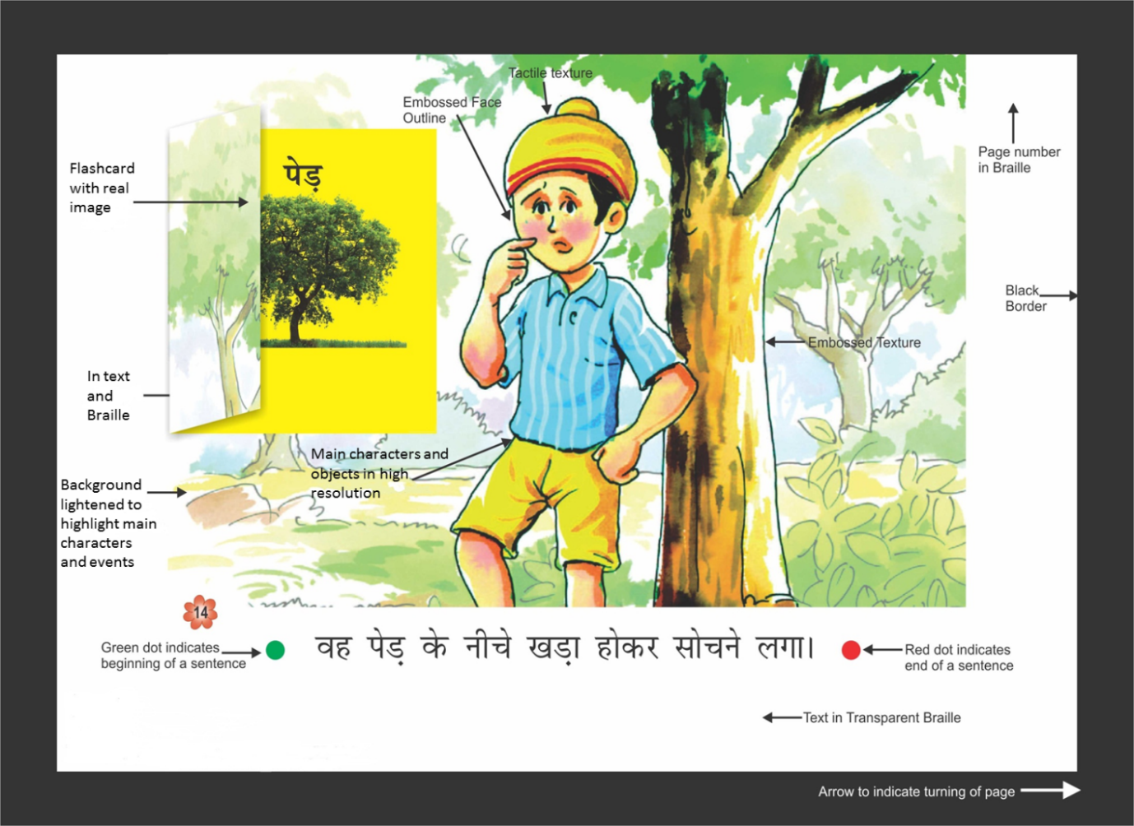
A page from one of the books depicting additional inclusive features.

To enhance access, a digital version of Barkhaa: A Reading Series for 'All' is available free of cost on NCERT's website and its e-pathshala portal. It can be accessed on computers, mobile phones, laptops and tablets. It can be accessed for free with an internet connection and at a cost of only 30 Rupees for a DVD if there is no internet connection. This also complies with the Digital India Campaign’s vision of providing “universally accessible digital resources”.

The digital version retains all adapted features of the print version. This version is accompanied by a 'How to Use' section that guides the user through simple pointers and visual clues. In addition, to raise curiosity and build interest an introductory note for each booklet is incorporated in audio-video format. Care has been taken not to reveal the story in this introduction. This audio-video note is available in sign and regular language forms. This also introduces all children to sign language as a regular form of communication. For enhanced visual accessibility, the digital version has been made available in 3 different choices of colour schemes along with the option increase the font size.

This digital version is unique in its functionality because it allows for greater flexibility and has greater scope of appealing to all. Children can access all 40 story booklets through a single device. This also gives them space to revisit any book whenever and wherever they like. The privacy that is afforded by being able to read on one’s own computer or tablet allows one to read comfortably and at one’s own pace. For example, a child who may be a slow reader can feel assured in the knowledge that others are not judging him for being on or wanting to go back to a certain page.

Implications for the Future

Barkhaa: A Reading Series for ‘All’ is a sensitively designed reading series for the early years. It can pave the way for truly inclusive and need-sensitive learning material. It is an exemplar that illustrates how the principles of UDL can be applied to adapt existing learning material and design new learning material with inclusiveness and accessibility as the focus.

India’s Accessible India Campaign calls for making accessible the built environment (buildings, public spaces), transportation system and the system of information and communication. As mandated by the country’s Right to Education Act 2009, one would argue that there is also a need to make accessible the process of learning along with the tools involved. The concept of universal design should therefore be more widely applied to learning.

Barkhaa is among the initial steps towards mainstreaming the concept of universal design to promote inclusion at all levels of learning. With this, it is hoped that children’s early experiences with inclusive learning material will lead to demands for better and more inclusive learning and reading material in the later stages of their school life.

And then again, why should inclusive, UDL based learning and reading material be limited in its scope to only children in school? Indeed the adult world would also benefit from such advances. This was realised by our team during the tryout phase of Barkhaa: A Reading Series for ‘All’ when a blind father of a young child spoke to us about being able to read a story book to his child for the first time ever. This was an achievement for him as well as for the NCERT team developing this reading series for all.
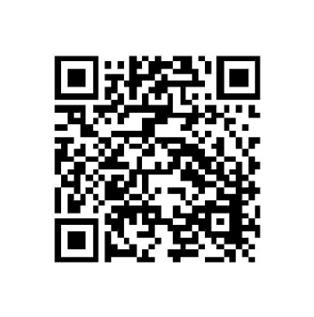
Scan to view the digital version of Barkhaa: A Reading Series for ‘All’.

Authors:
Anupam Ahuja works in the area of inclusive education and is currently heading the Department of Education of Groups with Special Needs at NCERT. She can be reached at ahujaa56@gmail.com

Richa Shrivastava is a Senior Research Associate at NCERT. She has a keen interest in studying patterns of inclusion in multicultural settings. She can be reached at richaomshrivastava@gmail.com

National achievement survey (cycle 3) class III: Achievement highlights. (2014). New Delhi: National Council for Educational Research and Training.
Supported by Government of India’s Ministry of Human Resource Development.
The original Barkhaa: A Reading Series is a culmination of the efforts of the Department of Elementary Education (DEE), NCERT.
http://www.ncert.nic.in/departments/nie/degsn/NCERTBarkhaseries/Start.html
Vision and Vision Areas of Digital India, (n.d.). Retrieved May 01, 2017, from http://www.digitalindia.gov.in/content/vision-and-vision-areas
Accessible India Campaign. (n.d.). Retrieved May 01, 2017, from http://accessibleindia.gov.in

