Module
9
Including Learners in Transition

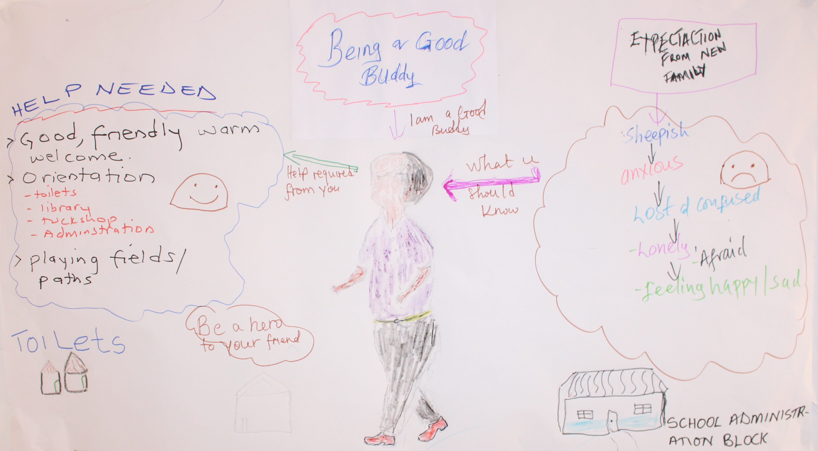

A manual for teacher trainers
Prepared for:
Ministry of General Education, Zambia
The Norwegian Association of Disabled
Developed by:
Enabling Education Network, December 2019

This work is licensed under the Creative Commons Attribution-NonCommercial-ShareAlike 4.0 International License. To view a copy of this license, visit http://creativecommons.org/licenses/by-nc-sa/4.0/
Contents
Introduction 4

Session 9.1: Understanding education transition and its impacts 6
Session 9.2: Meeting the challenges 10
Session 9.3: Developing inclusive transition in our schools 26
Session 9.4: Using action research to promote inclusive transition 29

Warm-up/ice-breaking activities 34

Resource 9.1: Research findings – sample A 38
Resource 9.2: Research findings – sample B 39
Resource 9.3: Research findings – sample C 40
Resource 9.4: Research findings – sample D 41
Resource 9.5: EENET’s ‘Arriving in school’ film, programme 3 42
Resource 9.6: ‘Arriving at school’ film transcript 43
Resource 9.7: Nokuthula, aged 7 45
Resource 9.8: Thandi, aged 7 46
Resource 9.9: Daniel, aged 10 47
Resource 9.10: Mwene, aged 11 48
Resource 9.11: Gamba, aged 11 49
Resource 9.12: Emmanuel, aged 14 50
Resource 9.13: Tamara, aged 15 51
Resource 9.14: Key principles for a smooth transition 52
Resource 9.15: Challenge cards 53
Resource 9.16: Strategy cards 56
Resource 9.17: Transition planning guidance – home/pre-school to primary school 61
Resource 9.18: Buddy training 62
Resource 9.19: Buddy guidance 65
Resource 9.20: Agree/disagree 67
Resource 9.21: Language support for new arrivals – some tips for teachers 68
Resource 9.22: Review cards 70
Resource 9.23: Continuum base board 72
Resource 9.24: Review questions and notes to support school self-evaluation 73
Resource 9.25: Supporting inclusive transition – checklist for teachers 75
Resource 9.26: Example of an observation sheet 76
Resource 9.27: Interview guidelines 77

Notes 79

Introduction
The aim of this module is to provide teacher trainers with ways to further promote the achievement of learners who are in transition. The module enables teachers to ensure all learners receive the support they need for a smooth and effective transition so that they can access their full educational entitlements enshrined in the Education Act No. 23 of 2011

Education transition usually refers to learners who are leaving, arriving or newly arrived in education. Most learners move school at planned times, for example from the family home to Early Childhood Education (ECE), from ECE setting to primary school, from primary school to secondary school, or from secondary school to a tertiary institution or employment. However, significant numbers of learners also move to or from education settings outside these planned times. These include those who experience:

- a delayed start to schooling (e.g. for financial reasons).
- difficulty finding or sustaining a school place, including those learners with disabilities, who have difficulty finding a school that meets their needs.
- migration (e.g. moving countries or from a rural to an urban area to find work or to join family).
- being forced to move (e.g. being displaced by ‘development’ or fleeing organised violence and becoming internally displaced or a refugee).
- being excluded from their school.

Learners may also face difficulties transitioning within an educational setting, for example, from one year to the next year, e.g. from grade to grade, or even during the day, e.g. from one subject/lesson to a different subject/lesson or from classroom to break-time and vice versa.

Planning the delivery of the sessions in this module should be done with close reference to the other training modules in this series, with particular reference to ‘Identifying Out-of-School Children’ (Module 3) ‘Creating Individual Education Plans’ (Module 5) and ‘Developing learner participation’ (Module 8). Further information is also contained in the module on Including Learners with Additional Needs. This includes advice and guidance on identifying additional needs, how additional needs can exclude learners, and practical tips and ideas for teachers on supporting learners with additional needs in the school and classroom environment. This information is highly relevant to supporting transitions.

As with the other modules, the training outlined here focuses on using participatory methods and active learning techniques. It follows this basic principle:

We must use inclusive training methods if we are to successfully train others how to teach inclusively.

Duration of training
Trainers should adapt this training to suit the local context and the time available to them for training. Trainers may decide not to use all of the activities, or to shorten some activities if time is limited, or to expand activities if teachers need more support with understanding a particular topic. If all activities are used, without significant adaptation, shortening or lengthening, this module requires approximately 10 hours of training over 2 days, depending on the preferred length of training days, number and length of breaks, and so on.

Session 9.1: Understanding education transition and its impacts

This first session helps teachers understand what is meant by education transition and how it can affect learners’ participation and achievement.

The trainer should have the following definition of education transition displayed at the start of the session:

Education transition is when learners arrive in school or leave school, it is when they go to school for the first time, or move from one grade, class or school to another.

“Transition is a process that happens over time (for example) from when children are beginning to get ready to start school until the time when they have adjusted to school, as opposed to a single point in time such as the day or week they commence.”

Education transition can be a challenging time for the learners, their families and their teachers. Many learners drop out during or soon after transition, especially if they have specific needs that are not addressed during the transition process.

Activity 9.1a: Our own experiences of education transition
Main
40 minutes

The trainer should ask teachers to reflect on their own experiences of education transition. They should talk to their neighbour and try and recall what happened and how they felt as a learner when they started a new school or had to change class/schools mid-year.

After about 10-15 minutes, the trainer should ask for volunteers to feedback to the whole group one positive and one negative experience that was shared by their neighbour. The trainer can open up any pertinent issues arising for wider discussion and recollection.

Then the trainer should ask teachers to continue to work in pairs and discuss the following:
- What kind of transitions do their learners experience, e.g. home to ECD setting/pre-school/primary school, primary school to secondary school, secondary school to higher education, special educational needs (SEN) withdrawal to mainstream or vice versa, one learning group to another within a class/year, and/or arriving in school mid-year?
- If some of their learners arrive or leave outside planned times, why do they do so?
- Are their learners in transition effectively supported? How?

Finally, the trainer should ask teachers to feedback their thoughts to the whole group, and she/he should note the ideas on the board or flipchart.

Activity 9.1b: Understanding the impact of education transition
Main
40 minutes

The purpose for this activity is to enable teachers to consider how education transitions may impact on learning.

The trainer should first mention that learners’ experience of transitions and their impact can be varied. Research suggests a range of impacts, including:
- that the first experience learners have of school can have a significant impact on their progress and future schooling.
- that for many learners the change of setting and the feeling that they are ‘moving forward’ can act as a stimulus for development, but if they find this change too abrupt, there is a risk that the learner will regress, feeling uncomfortable and unsettled.

Resource 9.1
Research findings – sample A

Resource 9.2
Research findings – sample B

Resource 9.3
Research findings – sample C

Resource 9.4
Research findings – sample D

The trainer should give one of the Resources 9.1 - 9.4, to each of the groups, including additional copies to ensure that every teacher has a copy to read. Try to ensure that each group looks at a different resource, unless there are more than four groups in which case some groups may be looking at the same one. The trainer should explain that these are just brief extracts from some research literature over several years, chosen from a range of sources.

These samples are not attempting to represent all significant research done in this area; they are only given to help stimulate useful discussion and the sharing of further experiences and practice issues by teachers.

The trainer should point out that though these samples mainly relate to findings from studies of the impact of primary school to secondary school transition, the findings are also relevant to other school stages. There is very little research available on internal transitions from year to year, from class to class, when children join different working / subject groups.

The trainer should ask each group to:
- Together read through the sample text they have been given and understand it.
- Share with each other how the findings relate to any learners that they work with.
- Circle or highlight with a colour pen/pencil anything that is new to them or surprises them.

Time permitting, the trainer can give a different resource to any group that finishes the task early.

The trainer should ask each group to share what it has learned and discuss with the whole group and make notes on any key points arising.

The trainer should emphasise that:

‘Our learners’ experiences of transition differ and are diverse. Many experiences are positive though some learners suffer anxieties and difficulties that may be protracted’.

Finally, the trainer should ask the groups to each create a statement about transition, beginning with: ‘Transition is ____’

The group statements should emphasise the challenges learners face, but remember that these are part of life, and can help to build resilience, confidence, flexibility and self-esteem.

The statements can be read out and displayed on a wall.

Session 9.2: Meeting the challenges

This session encourages teachers to consider effective support strategies for learners experiencing different kinds of transition challenges.

Activity 9.2a: Arriving in school
Main

90 minutes

The purpose of this activity is to encourage teachers to empathise with learners, especially those who are new to the school, who may experience difficulties at the start of the school day.

The trainer should begin by explaining that the move from home to pre-school/primary school, from pre-school to primary school, or primary school to secondary school may involve some of the following changes that learners need to try to adapt to:
- If just starting pre-school/school, leaving the home environment for the first time.
- Moving to a different and probably bigger environment.
- Higher ratios of learners to adults than in their previous school.
- Making new friends and establishing new relationships.
- Learning in a different/additional language.
- Encountering different approaches to teaching, and to the curriculum.
- Different expectations of parents/guardians/care-givers, teachers and school management.
- The new environment not meeting their expectations and aspirations.
- Different toilets, mealtime facilities, layout of classrooms, corridors and outdoor environment.

The trainer should explain that teachers will be watching a five-minute film that focuses on the experiences learners have arriving at school each day. She/he should make the following points:
- Arrival at school is very important. It can determine whether new arrivals have a good start to their new school and whether learners already attending school have a good start to their day. It can determine whether they feel welcome or unwelcome – which can influence their participation throughout the day. It can even influence whether they keep coming to school.
- Some learners may find the arrival at school very stressful, confusing or upsetting.
- There are lots of simple, free or low-cost things we can do to make the school more welcoming and to help learners find their way around the school more easily.
- We can make changes to attitudes, the environment, our practices and behaviour, and the resources we use. We can even make changes to school policies, to ensure that our school is more welcoming and inclusive.

The trainer should ask teachers, as they watch the film, Resource 9.5, EENET’s ‘Arriving in school’ video programme 3, to think about what it may be like for newly enrolled learners (new arrivals) to arrive at the school, what their first day might be like.

Resource 9.5
EENET’s ‘Arriving in school’ film, programme 3

Resource 9.6
EENET’s ‘Arriving in school’ film transcript

If the trainer cannot access the film online, he/she should give a copy of the video transcript to each group. After watching, the trainer should encourage some brief reflection on the key messages of the film.

The trainer should divide teachers into an even number of groups. She/he should aim to have about five people in each group. Then give teachers the following instructions:
- Create a short role-play that lasts a maximum four minutes. Half of the groups will create a role-play that shows a negative arrival at school. The other groups will create a role-play showing an ideal positive arrival at school.
- Before you start planning your role-play, do some brainstorming of ideas in your groups. The role-play should be about the experience a learner has arriving in the school for the first time in the middle of the school year.
- Those who will role-play a negative arrival at school, think of all the unwelcoming things that might happen. These could be things you experienced when you were a child at school, or things you have seen happening at the school where you teach, or ideas inspired by the video.
- Those who will role-play a positive arrival at school, think about all the things that could be done to make children feel as welcome, confident and comfortable as possible when they arrive. Think of solutions that are possible with the resources available in a school like yours.
- Make sure everyone in your group has a part in the role-play. You might be a child, a teacher, a parent, or another person. Your characters should include male and female people. You may decide particular characteristics for the new child, for example, she/he may not be able to speak the main language, or she/he may have a disability. Think about what your characters will say and do.

The trainer should give teachers at least 20 minutes to brainstorm and then prepare their role-plays. Then invite the groups to perform them. Invite the ‘negative arrival’ group(s) to perform first and then the ‘positive arrival’ groups.

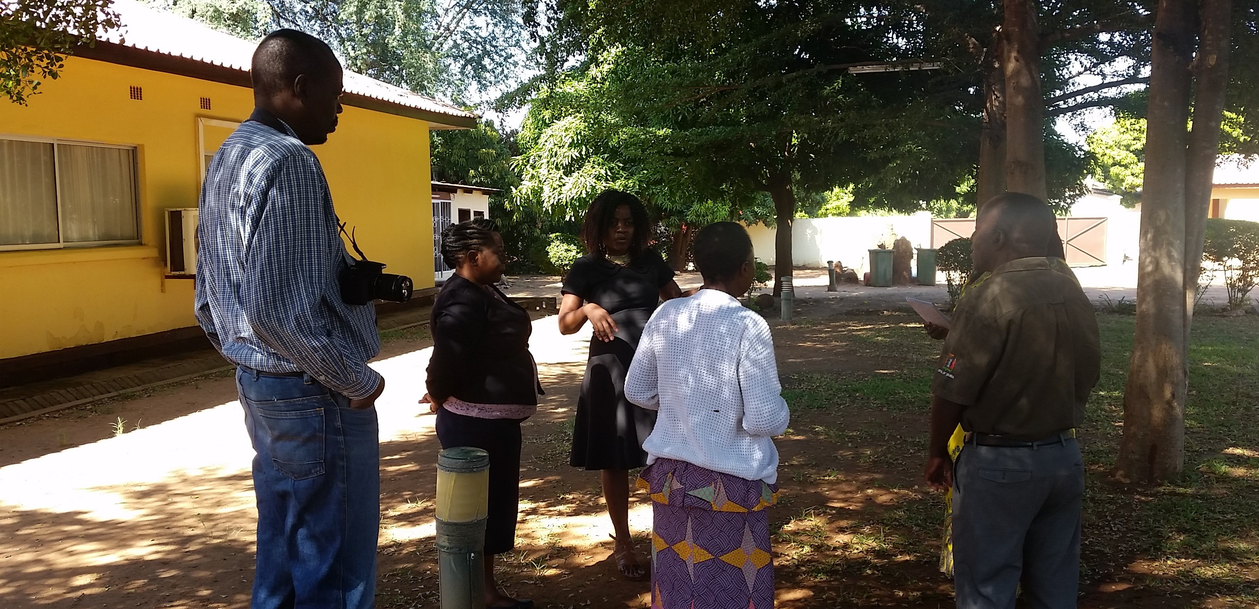Group preparation for role-play
[Image description: A group of Principal Trainers, four women and one man, stand outside a building, under some trees. They are having a discussion. A male photographer stands behind them.]
After everyone has performed, the trainer should invite a whole group discussion guided by these questions:
- Which of the negative things happen at your school? Who do you think is affected by these, and how are they affected?
- Which of the positive things happen at your school? Who helps them to happen?

Finally, the trainer should ask teachers to list two things they could change or introduce to make sure their school is more welcoming and inclusive. Make sure these are ideas they can act on with the resources available.

Note for trainers:
For the trainer’s reference, here are some possible answers to expect from teachers.

The role-plays for a ‘negative arrival at school’ might involve:
- Seeing a stern or angry teacher as soon as you walk through the gate.
- Feeling overwhelmed, being stuck in the middle of a big group of children.
- Being bullied.
- Feeling lonely or not knowing how to make friends or talk to other children.
- Trying to find somewhere quiet to wait.
- Not understanding what the other children and teachers are saying.
- Not being able to read the signs around the school.
- Feeling confused.
- Being unable to get up the steps into the classroom.

The role-plays for a ‘positive arrival at school’ could draw on what teachers saw in the film and might involve:
  - Being greeted by a happy, smiling teacher.
  - Being met by friends.
  - Pairing up with your buddy who helps you to move around or find where to go.
  - Seeing signs that welcome you and/or that guide you as to what to do or where to go.
  - Going to a designated quiet area while you wait for lessons to start.
  - A well-organised routine for entering the classroom (e.g. everyone lines up and waits for the teacher to say come in, or children know they enter in pairs, etc).

Activity 9.2b: Case studies - what would you do?
Main
60 minutes

The trainer should remind teachers what a welcoming and inclusive school looks like. One that would provide new arrivals with:
- A welcoming, safe and stress-free environment.
- Opportunities to work with peers and make friends.
- A place where they are valued and belong.
- Recognition of their skills and talents.
- The chance to quickly feel part of the community.
- A normal learning environment.
- Accessible learning opportunities.
- Support for wider needs.

Such a positive school experience is vital for every learner’s development and particularly for those who are vulnerable. New arrivals joining a school mid-year may come from difficult circumstances. For example, their family may have been on the move and they have consequently experienced long periods of interrupted schooling or no previous schooling; they may have additional needs that have delayed their admission; they may have been expelled from another school; their family may have lacked the resources to send them to school at the usual admission time. Refer to the module on Including Learners with Additional Needs if required, as a reminder of some of the barriers faced in accessing education by learners with specific impairments.

The trainer should explain that the following case studies are of vulnerable learners, some of whom are about to arrive in school or arrived mid-year. She/he should ask the teachers to study them carefully and together in groups consider ways they can support each learner.

Resource 9.7
Case study – Nokuthula, aged 7 programme 3

Resource 9.8
Case study – Thandi, aged 7
Resource 9.9
Case study – Daniel, aged 10

Resource 9.10
Case study – Mwene, aged 11

Resource 9.11
Case study – Gamba, aged 11

Resource 9.12
Case study – Emmanuel, aged 14

Resource 9.13
Case study – Tamara, aged 15

If there are sufficient numbers, the trainer should ask teachers to sit in groups of 4-5 with colleagues from the same school level/phase (e.g. pre-school, primary school, secondary school). The trainer should give out Resources 9.7 - 9.13, one of the relevant school stages/phases to each group (a copy to each teacher). Resources 9.7 and 9.8 are pre-school/early primary, Resources 9.9. 9.10 and 9.11 are primary, and Resources 9.12 and 9.13 are junior secondary/secondary.

However, there is no problem if some groups have teachers looking at a case study from a different school level/phase to the phase/level they work in. Indeed, it is often of benefit to the whole group to have different perspectives engaged in case study practice discussion.

Each group should read the case study together and discuss the questions given beneath each case study (and also below). If there is time, and a group feel they have discussed their case study to the full, the trainer should give the group another case study (either from the same school level/phase or from a different level/phase).

Discussion questions
- What are your concerns?
- What are the learner’s needs and the strategies you would use to support these needs?
- How can you and other services/professionals support the child’s successful transition?
During their discussion, the trainer should encourage teachers to consider effective welcoming, induction and assessment practice in the classroom, including through peer-support, and, if it is within their remit, pastoral management and the administration of admissions. It is important to emphasise that an inclusive school does not expect learners to be ‘school-ready’ (ready for school) when they arrive, though they should where possible provide information and support to help each learner prepare; it is however essential that the school is ‘learner-ready’ (ready for the learner) and able to effectively support the learner’s transition.

After about 30 minutes, the trainer should ask for feedback and encourage discussion, whilst noting key points on the board/flipchart under each case study.

Resource 9.14
Key principles for a smooth transition

The trainer should give each teacher Resource 9.14. These are key principles informed by a project and report from Bridge of Hope, entitled ‘Strategy to maximise the inclusive learning environment for children. Transition guidance to support smooth transition from pre-school institutions to primary school’ (2017). Bridge of Hope’s guidance can help ensure that what is familiar to each learner supports their move as they enter a new environment. It can also help ensure that this change proves to be a smooth and supportive experience, rather than a shock.

Finally, the trainer can share the following quote from the report:

‘Children approach change differently … Some may feel excited and proud to be moving on, some may easily adapt to new surrounding and conditions, some may feel nervous and uncertain – or children may feel some or all of these of emotions. Some children face serious stress even when small changes happen in their usual routine, which may result in anxiety, which can have an impact on their behaviour and understanding. Recognising this has been referred to as needing to provide a transition process which ensures 'compatibility without sameness and stimulation without shock' (Joyce and Watt 1993).’
Main

Activity 9.2c: Strategies for inclusive transition
40 minutes

Resource 9.15
Challenge cards

Resource 9.16
Strategy cards

The trainer should give out the cards from Resource 9.15 and Resource 9.16 to each group. The cards from Resource 9.15 and Resource 9.16 should be a different colour.

The trainer should ask teachers to connect the strategies to the challenges that they can respond to. She/he should point out that there is not one strategy per challenge card; several strategy cards respond to several challenge cards, so groups should put them in clusters to show those strategies that connect with a range of challenges.

On the blank cards, teachers can write additional challenges and strategies, if they identify any during discussion.

After about 20-25 minutes the trainer should ask the groups to feedback to the whole group the decisions they made about appropriate strategies and discuss:
- Are they effective strategies?
- At learner/school/family/community level, whose role/responsibility is it to deliver each strategy?

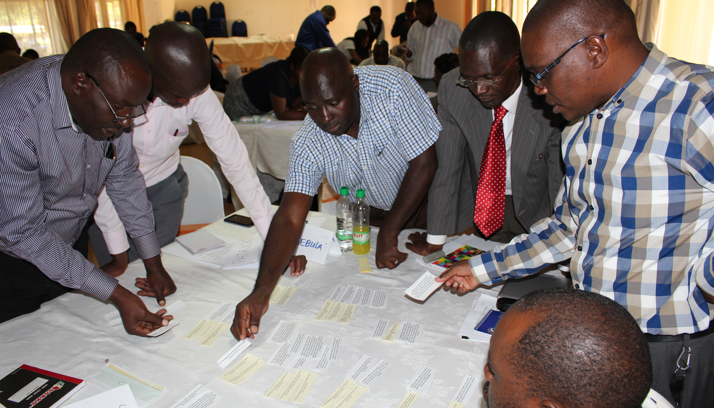
Matching strategies to challenges
[Image description: Six male Principal Trainers are leaning around a table. On the table are white ‘strategies’ cards and yellow ‘challenges’ cards, which they are pointing to and picking up.]

For the trainer’s reference, the table below suggests which challenges and strategies are linked:

Challenges | Strategies
I can’t find my way around or find accessible routes in my new school. | Give new learners a tour, maps and organise peer-support (e.g. a ‘class friend’) to help him/her find their way around.
I’m confused by the new timetable. Where am I supposed to go and when? I get told off for being late. | Make sure there is peer-support for all new arrivals for several weeks, and that all learners know they are expected to help each other and rewarded for helping.
My parents are less involved in the school now I’m in a higher class, but I still want them to talk with my teachers when I have problems. | Warmly welcome all parents/ guardians/care-giver and provide an admission meeting where information can be shared before their child’s arrival in class. Invite parents/ guardians/care-givers of new arrivals in again after a few weeks to share early progress and to clarify the school’s expectations.
As a girl, now I am older, I have to do more chores at home. This makes me late to school and I get into trouble. | Enable teachers to make home visits to some learners to find out about their needs and family and community support systems.
My parents don’t understand that I have to do homework when I get home. They expect me to always look after my brother and do other chores around the house. | Consult parents/guardians/care-givers early on when developing individual development plans (IEPs) and transition plans. Give parents/guardians/care-givers leaflets on what to expect and what activities they and the school can do to make transition easier.
My new school is in a different part of town and I have to go to school on my own, but it is not safe. | Help new arrivals manage their own learning and together reflect on their experience of transition. Some schools have held very successful discussions focusing on how learners feel and what it will be like moving to a new school.
I’m not used to being away from my parents all day. | Welcome parents/guardians/care-givers into the classroom (especially pre-school and reception classes) to help their children settle.  Involve parents/guardians/care-givers in developing transition plans and activities.
The teachers do things differently at this school. They have different ways of teaching. I can’t get used to their expectations. | Have staff who co-ordinate grade/school transition.
 | Communicate to support learners before, during and after transition.
The lessons are boring. I am learning the same things as I did in my previous school. | Adjust the curriculum and teaching methods to acknowledge new arrivals’ prior learning experiences in their last school.
 | Ensure IEPs are recorded and shared with the learner’s new teacher/school.
 | Develop effective initial assessment and set a few short-term settling-in social and academic targets for each new arrival, reviewing progress after a few weeks.
The teachers in my old school planned how to help me in lessons. My new school doesn’t know about this. All the support plans have to be started again. I wish my old teacher could still be involved. | Organise teacher exchanges between schools. For example, the teacher of the new school who is in charge of the transition year, together with the inclusive education coordinator (IECo), can make visits to the leavers’ class (which they are about to leave) to get to know the learners and answer their questions.
I want to go to vocational college. I don’t know which colleges are inclusive for students with disabilities. No one at my school knows either. | Ensure secondary schools have information about accessible/inclusive higher and vocational education options.
 | Ensure secondary, higher and vocational institutions offer career guidance giving appropriate and motivational advice to learners with disabilities.
I get in trouble for being rude to my new teacher because I can’t understand what she wants me to do.  Everyone thinks I’m ‘big’ and should be able to cope with my new school. I’m still scared and confused! | Ensure teachers are fully aware of the prior learning of each learner, supported by effective initial assessment of new arrivals.  Support a learner when she/he does not understand; expect some new arrivals to be chatty or noisy if they are nervous or excited in their new environment.
I did not see inside my new school until the first day of term. I was scared. | Help learners visit their next class/school and become familiar with the surroundings, people and procedures before they move.
 | Organise ‘induction days’ during the term before transfer. On these days the new arrivals can meet the teachers they will have next year and experience some lessons, have the opportunity to meet future classmates from other schools and question learners who had moved from their school in the previous year.
I am worried I won’t find new friends or actively participate in the school events | Train all staff how to support learners’ emotional, physical and academic needs when they leave or join a school and provide guidance materials.
 | Plan friendship-building activities into the first few weeks of lessons.
 | Support-staff need to make sure they do not make their learner feel isolated or different from the rest of the class.
 | Quickly reward new arrivals for trying hard, for anything they do well and for settling-in well.
 | Make sure new arrivals are given responsibilities early on and that they get involved in activities with older learners, including extra-curricular activities such as sports, clubs and school play productions.
 | Sustain transition support throughout the year to learners who need it.
I don’t feel part of this school. | Ensure all new arrivals are involved in creative and recreational activities within the curriculum and outside hours so that they quickly engage with a new community, feel enthusiasm and are given a sense of purpose and achievement.
 | Listen to new arrivals and their peer mentors. Organise review meetings with them after the first few weeks. They are the ones who have first-hand knowledge of what it is like to make the transition between schools and are therefore in the best position to offer useful suggestions about what support they and others need
I get bullied and I am especially scared during break-times and lunchtimes. | Develop an effective anti-bullying policy and make sure those adults who staff break-times and lunch-times are told if there are any new arrivals.
 | Provide organised games/activities at break-times/lunchtimes.
 | Make sure everyone knows where to go (especially during break-times) if they do not feel safe.
I got laughed at on the first day because I didn’t have a coat. | Make sure spare clothing is available.

Transition planning guidance – home/pre-school to primary school
Resource 9.17

The trainer should give out a copy of Resource 9.17 to each teacher and ask them to read it and say whether this guidance is useful. Ask teachers if the guidance is also relevant to supporting transition between primary school and secondary school.

Activity 9.2d: Developing peer support - buddying
Main
60 minutes

The trainer should explain that they are now going to look at the role of ‘buddies’. Remind teachers that ‘buddies’ were referred to in the film they saw in Activity 9.2a. ‘Buddy’ is a term used to describe peer support, and this assistance is often offered to new arrivals in the school.

The trainer should explain that all learners who are new to the school can benefit from the support of their peers. At the beginning of the school year, older learners can be assigned to visit new classes and offer support such as giving them information, answering questions, and providing a guided tour of the school.

For learners who arrive mid-year, or for new arrivals who are vulnerable, an individual buddy can be assigned to offer support and guidance. A buddy can help in a variety of ways, including:
- showing the new arrival around the school
- helping with timetable information
- introducing the new arrival to school staff
- introducing other learners who speak the new arrival’s first language
- helping to explain work set
- helping with learning the main language of instruction (e.g. local language/English)
- accompanying the new arrival during play/break-time
- being a potential friend or access to friendships
- supporting a review of how a new arrival is settling in.

It is important that a buddy is someone who is responsible and who has good social and communication skills. Teachers should also remember that other learners, who may not be buddies, can also support new arrivals in many ways.
Buddies can also be more effective if they receive training and ongoing support. Providing rewards and accreditation can give the role of buddy status.

Resource 9.18
Buddy training

Resource 9.19
Buddy guidance

The trainer should ask teachers to work in pairs and give a copy of Resource 9.18 and Resource 9.19 to each pair. These provide an example lesson plan for teachers to train ‘buddies’ and guidance text that could inform a ‘buddy booklet’ or other form of guidance.

The trainer should ask each pair to read through both resources, discuss them and then join their larger group to discuss the training, whether it could be adapted for their own schools, and if so, what changes need to be made for it to be used effectively.

The trainer should ask for each group to briefly feedback from this discussion.

Finally, the trainer should give each group flipchart paper and coloured pens and ask them to complete Activity 4 from Resource 9.18 and themselves design and draw their own poster to train buddies; the poster should communicate the main messages from Activities 1-3 in the lesson plan. These should be displayed for teachers to look at during break-time.

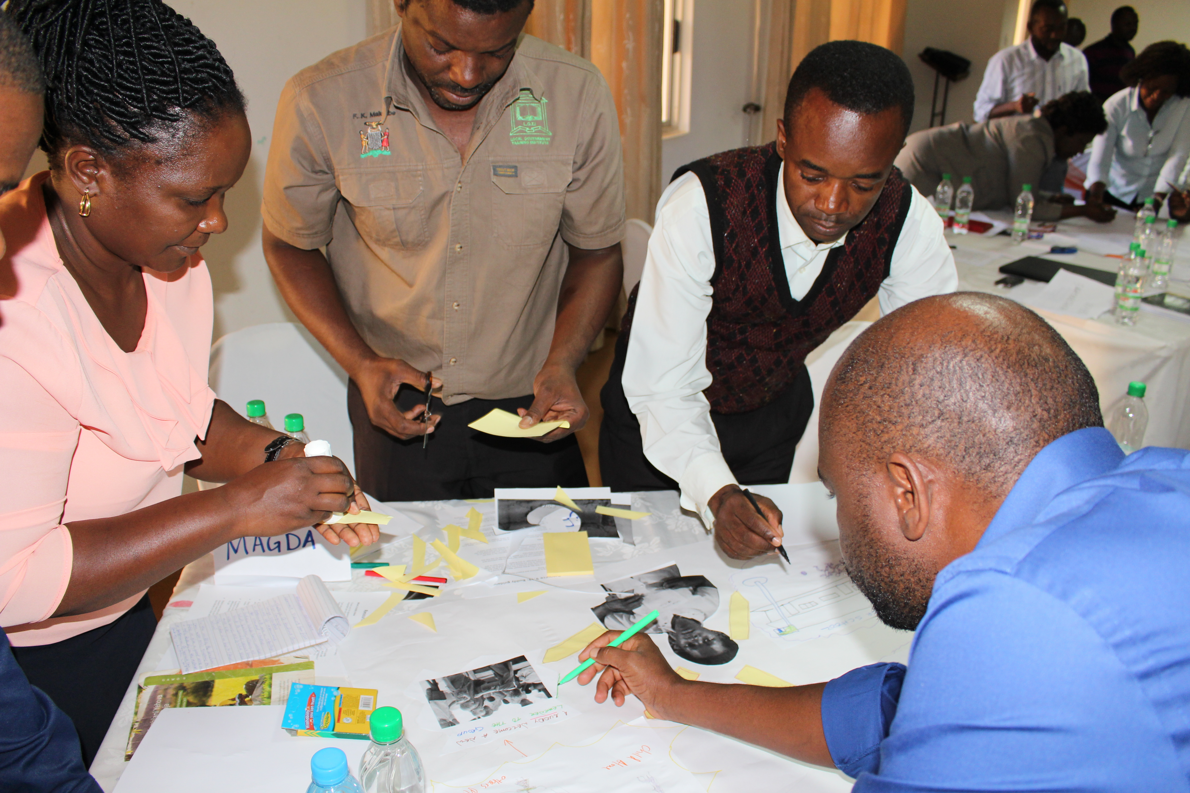
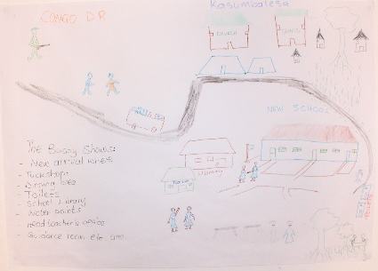
Designing a poster to train buddies Peer support poster
[Image description: (left) A hand-drawn poster. Details include: ‘Congo D R’ written in the top left corner; sketches of people are running away from there; a river is drawn running from top left to bottom right. Above the river are some village buildings and below the river there is a school. In the bottom left hand corner are some instructions about what a buddy can do to help the children coming from Congo D R]
[Image description (right): Four Principal Trainers, three men and one woman, are standing around a table on which there is a poster which they are making. They are cutting pieces of card, gluing the card and colouring in the poster.]

Activity 9.2e: Supporting additional language acquisition
Main
30 minutes

Some new arrivals, for example, those who join their school outside normal admission times, may have experienced interrupted or little previous schooling. As a result, they may not be able to understand the main language used in lessons as well as their peers. Some may be new to the main language altogether when their peers are not.

Resource 9.20
Agree/disagree

Teachers should work in groups. Give out Resource 9.20 to each group and ask them to decide which of the 8 statements about additional language learning they agree with, and which they disagree with.

After 5–10 minutes collect feedback, perhaps through asking for hands to be raised to show agreement or disagreement with each statement.

For the trainer’s information, the following four statements are correct:
- When learners are learning a language it’s normal for them to be silent for a while.
- Learners learn a language more easily if they are not afraid of making a mistake.
- It’s very important to have opportunities to talk and work with others when learning a new language.
- Learners learn languages more easily when they have a real need to communicate with other people speaking that language.

And the following four statements are incorrect:
- Learners learn languages more easily if they work through grammar exercises.
- It’s very important to correct learners’ mistakes when they are learning a language.
- Once learners can communicate in the main language, they don’t need further language support.
- Learners shouldn’t use their first language in class. It gets in the way of them learning the language they need to study.

To further explain, the trainer should introduce some key principles to guide teachers supporting additional language acquisition:
- There should be a secure environment where learners are valued, anxiety levels are low, and expectations are high.
- Learners acquire an additional language best through interaction with others when they are using that language.
- The learner’s first language has an important role in the acquisition of additional language: knowledge, concepts and cognitive skills developed in one language readily transfer to another.
- The learning experiences planned for additional language learners should be as cognitively challenging as for their peers who are more fluent in that language.

Language support for new arrivals – some tips for teachers
Resource 9.21

Finally, the trainer should give out Resource 9.21 to each teacher for them to read through.

After enough time is given, encourage discussion to ensure teachers are clear about what the guidance is saying.

Session 9.3: Developing inclusive transition in our schools

Activity 9.3a: Where are we now and where do we want to be?
Main
100 minutes

Resource 9.22
School practice and provision review cards

Resource 9.23
Continuum base board cards

Teachers should sit, if possible, in their pilot school groups. The trainer should give out Resource 9.22, a set of the ‘School practice and provision review’ cards to each group, and Resource 9.23, a development continuum diagram on flipchart paper.

The trainer should give teachers the following instructions:

- Each pilot school group should decide where to stick each card on the development continuum, somewhere on or between ‘Things we are doing well’ and ‘Things we need to develop’.

Your decisions should be based on your knowledge of the pilot school and what evidence you believe can be offered to back up that decision. For example, if you decide to place the card ‘Teachers are fully aware of vulnerable learners and their specific needs from early on’, near ‘Things we are doing well’, then you need to know that it can be shown that the school has those information-gathering and information-sharing systems in operation (e.g. admissions forms given to teachers with that information on).

- Once all the cards are placed, look at the cards you have placed on or near ‘Things we need to develop’. Discuss how you may go about developing that particular practice/provision and identify the tools/resources you may need to do so (e.g. effective active learning strategies that promote social integration, assessment tools, training packages, transition plans, IEPs, highly developed peer support systems, etc). Remember, tools also at the disposal of your school partners that can be deployed to bring about change in your work to support education transition (e.g. community and faith group activities that can welcome new families to the area, social services or health workers who can reach new parents/guardians/care-givers, etc).
- Finally, consider what gaps there are in your ‘toolkit’ and write down three obtainable resources you would like to add to your toolkit that you believe could substantially improve your support to learners in transition. Explain how these resources will make a difference.

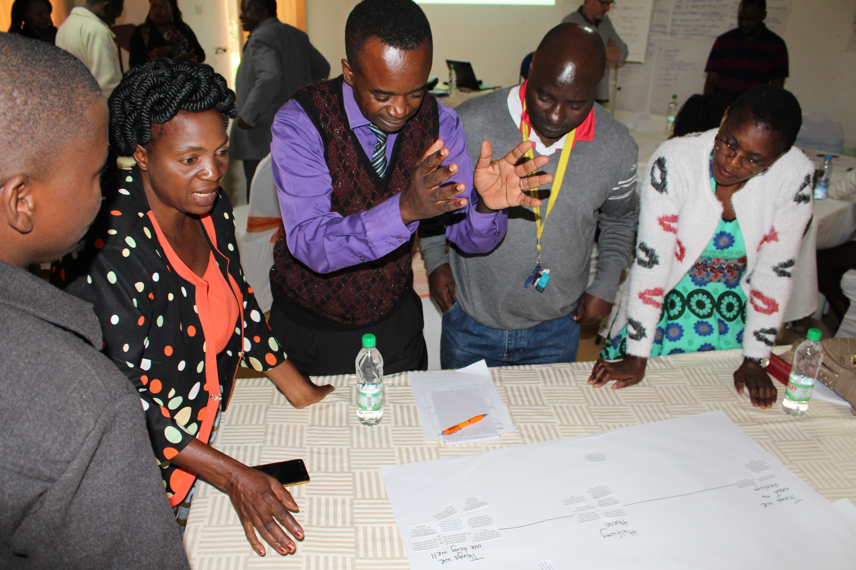
A group discussing where to put their cards on the continuum line.

[Image description: Five Principal Trainers, three men and two women, are standing around a table on which there is a flipchart paper. On the paper is drawn a continuum line, from one side of the paper to the other. Some cards have been stuck below the line. The trainers are discussing, and one man is gesturing with his hands.]

The trainer should ask each group to present, during a gallery walk, some of the things they identified that they are doing well, and some of the things they need to develop. Groups should also provide details of the toolkit they feel they already have available, and the additional tools they would like to have and why, should school development priorities allow.

The trainer should emphasise the importance of coordinated support, where schools work alongside other agencies and services to ensure the access to schooling of children and families in transition.

Review questions and notes to support school self-evaluation
Resource 9.24

Supporting inclusive transition - checklist for teachers
Resource 9.25

Finally, the trainer should give out Resource 9.24 and Resource 9.25 explaining that the first is a review checklist to support whole school self-evaluation of their pilot school’s education transition support provision and practice, and the second provides guidance for classroom teachers when welcoming and supporting the inclusion of new arrivals.

After teachers have read through and commented on these resources, the trainer should finish by displaying the following:

‘Inclusive transition support aims to help every child settle into a new school and become an effective learner in as short a space of time as possible and to make the first crucial weeks in a new school a happy experience. An inclusive transition establishes the beginnings of a successful home-school partnership between the parents/guardians/care-givers and the school.’

Session 9.4: Using action research to promote inclusive transition

Remembering previous action research undertaken, it is important to re-emphasise how every school has a unique set of challenges and strengths in education, requiring a unique set of responses. Teachers, therefore, cannot simply rely on ‘experts’ from elsewhere to tell them how to make their school inclusive.

Teachers – along with the learners, parents/guardians/care-givers and other members of the school community – need to be experts in their own situation. They need to be able to investigate what is happening in their school and community, and identify barriers to inclusion that need tackling, or inclusion solutions that need expanding. And then (with the help of others) start taking relevant action. Action research is very useful for this. It helps stakeholders to look at their situation, analyse the problems, suggest solutions and then act.

In this session teachers will conduct a ‘supervised’ action research activity that could support an action research initiative in their own school, or schools they work with, and in communities.

Activity 9.4a: Deciding the focus
Main
45 minutes

This activity will provide teachers with the opportunity to decide what their research focus will be.

The trainer should tell teachers that they will be visiting their pilot school to conduct observations and interviews. During this activity teachers will decide what they want their action research to focus on.

The trainer should give teachers the following instructions:

- Individually look back over the work you have done throughout this module and make a (mental) note of what each session was about.
- Thinking about all the sessions, decide what you might like your action research to focus on. Think of reasons why and think about whether it is a focus that you will be able to observe in the pilot school. You may wish to consider what support for learners in transition there is at your school and where there are significant gaps. This may help you decide what you want to explore further.
- You may also wish to consider ways to involve learners, including those who are experiencing transitions, or have recently transitioned, in the action-research and in responding to the findings.
- Pair up with another teacher and discuss your decisions with each other to make sure they seem practicable. Try and think of creative ways to involve learners in conducting the research.

The trainer should write each teacher’s chosen research topic on the board or flipchart. The whole group can discuss whether the chosen topics seem practicable. Finally, the trainer should ask teachers to present their research focus in the form of an enquiry or question.

For the trainer’s reference, the following enquiries could arise from the main session topics covered in this module:
- What additional resources are available to support learners in transition?
- Can a buddy system for new arrivals be realistically developed in my school? If yes, why? If no, why not?
- Is initial assessment that informs teachers’ planning for the inclusion and early progress of new arrivals evident?
- Are new learners and their parents/guardians/care-givers properly welcomed and informed about the school and the curriculum?
- Do teachers and the school consult learners about how to make the school a more welcoming and inclusive environment? If yes, give examples and evidence of how it affects learning. If no, what steps can be taken to consult them?
- Are new learners given roles of responsibility early on? If not, why not? Can it be redressed?
- Are teachers aware of strategies to promote additional language acquisition for those new to the language of instruction?

- Are teachers and the school community aware of why some learners have had interrupted schooling? Do they understand their responsibility to help them catch up?

Activity 9.4b: Preparing for the school visit
Main
60 minutes

One aim of this activity is to help teachers remember some of the action research methodology, which they can then use in their setting. The trainer must explain clearly, however, that action research ‘for real’, e.g. performing the tasks over a longer period with school and community members, will involve more than simply replicating what they do in this short visit to the pilot school. This activity also helps teachers to compile questions/observation sheets to support their action research visit.

The trainer should explain to teachers that during this activity they will decide how they will record what they see and consider what questions they might ask.

The trainer should remind teachers what they have already learned about asking interview questions and preparing observation sheets (especially in Session 3.4: (‘Strategies and solutions in identifying out-of-school children’) in Module 3: ‘Identifying Out-of-School Children’.

They should be especially reminded of the following:

Observations
- Record what we see as objectively as possible.
- Pay attention to what happens, interactions between people, body language, what is said, and also the silences.
- Record what you see or hear on an observation sheet.
- Remember observers often need to be as unobtrusive as possible – for instance if you are observing a classroom, you should not ask the learners or teachers questions or interfere with the running of the lesson.

Interview questioning
- There are two basic types of questions:
- Closed questions – these elicit short, fixed answers. ‘Yes’ and ‘no’ answers are examples of closed questions.
- Open questions – these elicit longer answers which are not fixed or limited to predetermined categories. ‘Why?’ questions are open questions because they require explanatory answers.

Focus group discussions
- These are discussion groups with perhaps one particular stakeholder group, for example, parents/guardians/care-givers, or a range of stakeholders who focus on a particular topic.
- Teachers will need to prepare for a focus group discussion in a similar way to preparing for an interview. Prepare guiding questions to help you get the discussions started, and to ensure that you stay ‘on topic’.

The trainer should highlight that focus group teachers are not always used to speaking openly, which can make it difficult to get a discussion started. In their groups, teachers should think of methods they could use to stimulate a lively discussion, even if their focus group teachers are shy or not used to expressing their views. Module 8’s activities about learner participation may offer inspiration. The trainer should then facilitate a plenary feedback and makes notes on a flipchart.

Mapping
- Mapping is a way of making sense of (and sharing) the school and community environment.
- It includes the natural and built environment, and the social and cultural environments.
- In an action research activity, you can use a map to highlight barriers (and solutions).

The trainer should then give out Resource 9.26 and Resource 9.27 and ask teachers to read both and remind themselves of these tools.

Resource 9.26
Example of an observation sheet

Resource 9.27
Interview guidelines

The trainer should ask teachers to work in pairs, helping each other to:
- decide who they might interview at the pilot school to investigate their chosen topic, or whether they want to meet a focus group,
- prepare some questions that they could use,
- decide what they will be looking for if they visit a class in session,
- decide how they may go about using mapping to support their research.

Teachers should then feedback in plenary, so the trainer can check the interview/focus group discussion questions, and both the trainer and other teachers can further discuss the observation/questioning planned, including use of open and closed questions.

Warm-up/ice-breaking activities

An icebreaker is an optional activity, game, or exercise that is used to welcome teachers and warm up the conversation and interactions amongst the group in a workshop, training, meeting, or another event.

Ice-breaker 1: ‘On the Bus!’
20 minutes

This is an ice-breaking activity that is active and fun, promotes collaboration, and models a useful way of supporting additional language acquisition. It can be undertaken outside the classroom if there is not enough space within; it involves each teacher taking their chair with them outside.

The trainer should ask the teachers to get into pairs and line up their chairs in one line, two chairs to a row. The long line of pairs of chairs represents passenger seats in a bus. The teachers should sit alongside their partner on their chairs. The pair at the front of the line are at the front of the bus and the pair at the back are at the back of the bus.

The trainer should give each row a number, starting as ‘number 1’ at the front. Therefore, if there are 20 rows (40 teachers) then the back row will be given number ‘20’.

When everyone is settled and ready, the trainer explains that her/his word is final, even if she/he makes a mistake. The trainer should then state how long the game will last (perhaps 10 minutes) and sets the timer (or appoints a timekeeper who can also be a judge, for example, if there is an odd number of teachers).

The trainer then shouts out a number (between the numbers given the front and back rows, e.g. between 1 and 20 if there are 20 rows) and the people in the row of that number have to immediately put their hands up – together. If one is slower than the other, they must go to the back of the bus. If anyone makes an error (e.g. someone puts their hand up by mistake or does not put their hand up when they should) then that person and his/her partner go to the back of the bus.
When a pair go to the back of the bus, this means everyone else moves forward a row. Their number now becomes that of their new row (e.g. the numbers of the rows stay the same when the occupants change). It is important that the trainer tries to make sure the pair who occupy the front row are caught out and must go to the back. This makes the game seem fairer and means everyone experiences moving forward.

When time is up, the game finishes and the winners are the ones at the front.

The trainer can deploy various strategies to catch people out: e.g. adding rules mid-way through the game such as ‘only follow my instructions IF my hand is up when I give them’. Other strategies to catch people out can include shouting out a different number to the row the trainer looks at.

The trainer should also mention that this activity can be used successfully with learners. As a game that promotes pair work, listening and number recognition it is particularly useful for learners who are new to the class, and/or who are at the early stages of learning the medium of instruction (e.g. local language/English).

Ice-breaker 2: ‘A group of…’
15 minutes

This is a warm-up activity that allows the trainer to re-organise the groups so that teachers are working with different people, e.g. on Day 2 of a workshop. It is also a good activity to use in school to have fun, to promote collaboration between learners, and to create positive relationships.

The game should take place in area free from obstacles, with enough space for teachers to walk around and quickly get into different size groups (e.g. in an out-of-doors space).

The trainer should ask teachers to walk around the space until told to get into groups.

At various intervals the trainer asks them to get into “a group of…”, which is whatever the trainer chooses, e.g. people of the same age, same height, same length of hair, support the same football team, same shoe size, same number of brothers and sisters, travelled the same number of kilometres/miles to the training, etc.

Once they have done this, the trainer asks the teachers to again individually walk around the room/area until the next command.

It is important to start with simple groupings, but the trainer can move onto more complex ones that require the teachers to question each other in greater depth.

After several different grouping commands, change the command, and instead ask teachers to get into groups of a certain number (e.g. 4 or 5 or 10 or 3, etc). Tell teachers that when told to get into groups of a certain number, they should walk (not run) as quickly as they can and try not to get left out (as not everyone may be able to join a group if numbers do not permit (e.g. if there are 32 teachers and they have to get into groups of 10, then 2 teachers will be left out.)

Finally, the trainer should ask the teachers to get into the number she/he wants to work with, and these groups will be those the teachers will now work in.

The trainer should acknowledge those who put their heart and soul into the activity.

Module
9
Resources

Resource 9.1: Research findings – sample A

One finding is that there is often a dip in academic progress during a learner’s first weeks in a new school.

Research suggests though that the problems learners have adjusting to a different school culture and routines may be very short-term. Other factors can mean a dip in academic performance, such as a long holiday break or loss of purpose after sitting exams or work initially repeating what they did before in their previous school or learning group.

However, some learners face much bigger problems than others. For example:

- Some learners from disadvantaged circumstances may need extra support dealing with further disruption and social challenges.
- Some learners are vulnerable to bullying.
- The needs of learners with SEN require careful planning for; without this planning they may lack the support and understanding they enjoyed in their previous school.
- Some adjustment problems may need to be understood over the longer term. For example, even where girls are academically succeeding, including in relation to boys, some girls in their second year at secondary school report feeling less able to succeed and flourish in life.
- Learners who arrive during the school year/term (e.g., children who have moved home, those excluded from another school, refugees) often experience inadequate induction support.

Resource 9.2: Research findings – sample B

Transition can confront the learner with a different culture and have the effect of a ‘culture shock’. This has different phases over the first few months:

- Honeymoon, e.g. someone may embrace their new school culture with enthusiasm and high expectations.
- Negotiation, e.g. having to negotiate their new environment after finding their hopes and expectations are not met, therefore they feel discouraged, and perhaps irritated or frustrated.
- Adjustment, e.g. they have to adjust to their circumstances, learn what to expect, developing routines to manage the instability and dislocation they feel, and make sense of their new environment.
- Adaptation, e.g. they become fully part of their new school community, identifying with it and learning to resolve their problems through constructing a perspective from within it.

It is normal, as an aspect of culture shock, for a stage of uncertainty and conflict. However, learners can find transition very challenging, including those at the adolescent developmental stage, and those learners who find it most difficult to identify with the culture of the school. They may feel a loss of status at their new school, perhaps made worse by stereotyping in ways that exclude learners from identifying with the school. Teachers can contribute to this stereotyping through ignorance of their previous schooling and achievements.

If the learner quickly falls behind, she/he can become despondent and alienated, especially if they do not experience friendship, responsibilities and belonging in their new community. Social differences can be further entrenched through less involvement of parents/guardians/care-givers in school life.

Resource 9.3: Research findings – sample C

Learners with SEN can find education transitions especially challenging.
- Sometimes the learner’s teacher is not aware of the support plans in place for the learner at their previous school.
- Significant numbers experience bullying in their first term.
- Some find that they no longer have the support in place for them to achieve.
- Some learners with disabilities have difficulty finding accessible routes to school.
- Some learners, particularly when poor performance is linked to some form of learning disability, are much more likely to be excluded on the grounds of bad behaviour.

Resource 9.4: Research findings – sample D

When learners were interviewed prior to transition from primary school to secondary school, they tended to support the view that while a degree of continuity was important, so too was an element of discontinuity.

- They worried about coping with the work, but nevertheless were excited to have a wider range of subjects to study, particularly those involving doing and making, such as science, art, and design and technology.
- They regretted the loss of their primary school teacher but looked forward to being taught by a range of subject specialists.
- They worried about losing their old friends from primary school but were excited about making new relationships.

This may be particularly relevant when transition takes place at a crucial development time during adolescence. Whilst learners at that stage of development may be vulnerable to certain stresses, they may also crave change, greater independence, and new experiences.

Learners tended to display positive well-being through transition periods in schools where the emphasis was on greater learner autonomy, a less controlling environment, and where more opportunities for risk-taking were provided during lessons in contrast to schools which made learners feel safe and cared for by strictly imposing rules for behaviour (e.g., good walking down corridors), using older learners as playground monitors and offering rewards to increase effort.

This suggests a need for schools to modify the process of formulating rules and evaluating progress so that it increases children’s participation and a sense of a degree of ownership (e.g., processes involved in supporting transition need to be seen as informational rather than controlling).

Resource 9.5: EENET’s ‘Arriving in school’ film, programme 3

Go directly to the video on YouTube. It is 4 minutes and 40 seconds long:

www.youtube.com/watch?v=d3Lon8YdsL0

Or visit EENET’s website to find out more about the video and access viewing and download links:

www.eenet.org.uk/the-10-videos-and-manuals/

Resource 9.6: ‘Arriving at school’ film transcript

Imagine having to go somewhere every day, knowing you will feel unwelcome or uncomfortable when you get there.

Unfortunately, this happens to many children every day.

School can be an overwhelming place for children, especially if it is a big, noisy, overcrowded school.

A stressful arrival at school can affect a child’s concentration all day and may even discourage them from coming to school at all.

Children often wait in a playground before going to class. This can be a busy, noisy place.

For many children, this is fun – a great opportunity to meet friends and play before lessons start.

But for others, it can be intimidating and frightening.

The start of the day can be confusing for some children, such as those who are very young, who have just joined the school, who have difficulty seeing or hearing, or who have learning difficulties.

They may struggle to work out or remember where they should go and when.

What can you do?

You can help to make the first few minutes at school a positive experience each day.

A friendly, smiling teacher who welcomes everyone in the morning can make a big difference.

Children can also be encouraged to welcome each other.

“All the people know Ana and say ‘hello Ana’. They say, ‘give five Ana, give five’, and she’s happy about that. She sees the attitudes are very positive. There’s no negative attitude. From the first day, she was happy to come to school. Why? Because the environment is very friendly.”
You can encourage children to pair up so that they help each other move around the school. This is sometimes known as buddying.

“The good thing about our inclusive class is the attitude of children towards Varia. It’s wonderful to see how they welcome her, how they play with her in a circle. She does not speak but they understand and accept her. Varia has revealed her personality. She can communicate with her peers and this has been a huge advantage for her. The development of inclusive education makes society kinder and maybe even a little bit purer.”

You can put up signs....

... or use different colours on walls, floors and doors to help children remember where to go.

You can use a clear routine in the morning. This helps children to learn when, where, and how to move from the playground into the classroom.

You can create a quiet area in the school for children who find it difficult to spend time in the big, noisy playground.

Resource 9.7: Nokuthula, aged 7

Nokuthula arrived in the area six months ago. She came with her mother and two older siblings. Her family used to live in Matabeleland, in Zimbabwe. Nokuthula’s father was arrested in Zimbabwe and has since disappeared. Her mother and siblings are staying with a member of their family who works on a farm near the border in Zambia.

Nokuthula was admitted into grade one. She is a small, frail girl and looks very young for her age.

Three months after admission Nokuthula has not settled very well or made any real friends with the other children. She is behaving like a much younger child, and finds it difficult to concentrate. She often falls asleep on the floor during the day. The teacher has attempted to communicate with Nokuthula using another girl in the school who speaks Ndebele (the main spoken language in Matabeleland), but this has not been successful. The other girl says that Nokuthula doesn’t understand what she says. The teacher has noticed that Nokuthula does seem to enjoy playing in sand and with water.

Recently, Nokuthula’s mother has started attending the local church.

Discuss

- What are your concerns?
- What are Nokuthula’s needs and the strategies you would use to support these needs?
- How can you and other services/professionals support Nokuthula’s successful transition?

Resource 9.8: Thandi, aged 7

Thandi’s mother says that she was a difficult baby always crying and difficult to settle: ‘She was my first baby and I didn’t always know if I was doing everything right. By 18 months old I felt there was something wrong but I didn’t know what. She had a few words – that seemed OK. But she didn’t seem to play well, tended to break things and never spent any time on any one thing. I thought I might be doing something wrong.’

When Thandi started pre-school, her mother noticed that her interaction with other children was poor, but pre-school staff insisted everything was fine and that Thandi would ‘develop at her own rate’.

Now Thandi has started primary school. The teacher is not happy with Thandi’s behaviour and has upset her mother by suggesting poor parenting. Thandi’s mother has noticed that her daughter mixes up words and misunderstands some things, but she does not know what to do.

Discuss

- What are your concerns?
- What are Thandi’s needs and the strategies you would use to support these needs?
- How can you and other services/professionals support the child’s successful transition?

Resource 9.9: Daniel, aged 10

Daniel arrived one month ago at a Lusaka primary school. He is 10 years old. He used to think Lusaka was a separate country. When he arrived, he thought he would be able to walk home to his village whenever he liked.

Daniel had been living in a rural village with his grandmother since he was six years old; now he has come to Lusaka to join his mother and his new stepfather, whom he has not met before. Daniel says he prayed: ‘Please let me go to Lusaka to be with my Mum’.

In school Daniel seems interested in learning, but he is easily distracted. When given work to be done at his desk, he starts the page, but soon he is jumping up to sharpen his pencil, leaning over to talk with his neighbour, pulling objects from his bag to play with, or simply rummaging through his bag searching for things. When the teacher stops to check on him, he looks up, but often has forgotten what he is searching for. He starts his assignments but doesn’t finish them. When this has been mentioned to his stepfather, he has asked the school to tell him when Daniel is given homework so that he can make sure Daniel does it.

Daniel enjoys games and sport, though he can get into arguments with other children.

Discuss

- What are your concerns?
- What are Daniel’s needs and the strategies you would use to support these needs?
- How can you and other services/professionals support Daniel’s successful transition?

Resource 9.10: Mwene, aged 11

Mwene comes from Kayombo and is a member of the Vaka Chiyama Cha Mukwamayi community. He has already attended two other schools and joined your school 6 months ago.

Mwene has difficulty reading and writing and his English, the medium of instruction, is underdeveloped.

He sits on his own and his attendance is patchy. He rarely does homework and hates to talk in class. If the teacher tries to involve him, he tends to start to miss lessons. Other teachers have said not to worry about it as he will be absent for several weeks soon and maybe not come back as he will attend the Mukanda, an initiation school connected to the Makishi Masquerade ritual of his community.

Nobody in the class talks to him except to call him names. One day in class he lashes out at a boy who is teasing him – the school excludes him for the day.

Discuss

- What are your concerns?
- What are Mwene’s needs and the strategies you would use to support these needs?
- How can you and other services/professionals support Mwene’s successful transition?

Resource 9.11: Gamba, aged 11

Gamba is an able, independent and enthusiastic learner. His parents want him to succeed academically and he has never missed a day’s school.

In recent weeks Gamba’s teacher has noticed that he is falling behind in his work. He seems distracted and anxious and unable to concentrate.

His teacher arranges to see him at lunchtime to ask him what is wrong. He says his family have been told to leave their home to make way for a commercial farm. The family have been told they will be relocated to an area much further away where the soil is much poorer quality, where there will be little access to amenities and where there is no school. He says he is very worried about how his mother and father and siblings will cope, and he doesn’t know if he will be able to keep up his attendance since he will have to travel so far.

Discuss

- What are your concerns?
- What are Gamba’s needs and the strategies you would use to support these needs?
- How can you and other services/professionals support Gamba’s ability to manage this transition?

Resource 9.12: Emmanuel, aged 14

When at primary school in Livingstone, Emmanuel was reluctant to attend school. When he did attend, he often got into confrontations with teachers. He was nearly excluded several times for his behaviour and had help from a guidance and counselling teacher. She realised Emmanuel was deeply anxious about his mother (who has critical health needs) and this explained his apparent school phobia. The guidance and counselling teacher’s interventions included a home visit to help Emmanuel’s mother learn to support him more effectively.

Emmanuel’s family has now moved, and he is attending a new secondary school. When preparing for his transition, the guidance and counselling teacher discussed Emmanuel’s anxieties about his mother with his new school. It was agreed that Emmanuel could ask to go to the school office at any time if he felt anxious about his mother. He would not have to pretend to have stomach-ache or make trouble in order to be allowed home and check on her well-being. Emmanuel is too embarrassed to accept support in class even in his weak subjects, but he did agree to meet with a guidance and counselling teacher/support adult after school once a week.

Then, unexpectedly, an attendance problem arose. Emmanuel’s mother told the guidance and counselling teacher that he would not go to school again. A group of older boys had followed him after school, and he believed they were going to assault him.

Discuss

- What are your concerns?
- What are Emmanuel’s needs and the strategies you would use to support these needs?
- How can you and other services/professionals support Emmanuel’s successful transition?

Resource 9.13: Tamara, aged 15

Tamara is looking forward to going to secondary school next year. She has cerebral palsy. She has to use a wheelchair and her speech can be unclear. Tamara’s parents, classmates and teachers are all able to communicate with her and understand her.

Tamara is intellectually able and is ambitious. In her current school adjustments have been made for her to access most learning.

After liaison with the secondary school to discuss Tamara’s needs, the school’s admissions teacher interviews Tamara and he assumes that she also has learning difficulties. He refuses to admit her as he thinks she will be unable to cope academically. He also says that although most school facilities are accessible to wheelchairs, she will not be able to access some core subjects as these classrooms are not accessible.

Discuss

- What are your concerns?
- What are Tamara’s needs and the strategies you would use to support these needs?
- How can you and other services/professionals support Tamara’s successful transition?

Resource 9.14: Key principles for a smooth transition

- All children deserve and are entitled to a smooth transition
- Good relationships are vital: effective transitions are based on mutual trust and respect between the child, the parent and all the professionals involved
- Each learner is an individual: transition support should be flexible and tailored to the learner’s needs
- Coordinated support and good communication between teachers and agencies is essential
- The school environment should support open, trusting and honest communication and encourage cooperation
- Enough time and resources need to be allocated to ensure admission, initial assessment and induction support is effective
- Learners are listened to, however young they are, so that their needs are understood and their views are taken into account
- Families are involved in planning: parents/guardians/care-givers are a crucial source of information and support for the school.

Resource 9.15: Challenge cards

Copy and cut out a set of these cards for each small group. Please note on the blank cards, teachers can write additional challenges, if they identify any during discussion.

I can’t find my way around or find accessible routes in my new school. | As a girl, now I am older, I have to do more chores at home. This makes me late to school and I get into trouble.
I’m confused by the new timetable. Where am I supposed to go and when? I get told off for being late. | My new school is in a different part of town and I have to go to school on my own, but it is not safe.
My parents don’t understand that I have to do homework when I get home. They expect me to always look after my brother and do other chores around the house. | The teachers in my old school planned how to help me in lessons. My new school doesn’t know about this. All the support plans have to be started again. I wish my old teacher could still be involved.
My parents are less involved in the school now I’m in a higher class, but I still want them to talk with my teachers when I have problems. | The teachers do things differently at this school. They have different ways of teaching. I can’t get used to their expectations.
I got laughed at on the first day because I didn’t have a coat. | I’m not used to being away from my parents all day.
The lessons are boring. I am learning the same things as I did in my previous school. | Everyone thinks I’m ‘big’ and should be able to cope with my new school. I’m still scared and confused!
I want to go to vocational college. I don’t know which colleges are inclusive for students with disabilities. No one at my school knows either. | I did not see inside my new school until the first day of term. I was scared.
I get in trouble for being rude to my new teacher because of the way I ask when I can’t understand what she wants me to do. | I am worried I won’t find new friends or actively participate in the school events.
I don’t feel part of this school. | I get bullied and I am especially scared during break-times and lunch-times.
 | Blank cards for teachers to write additional challenges

Resource 9.16: Strategy cards

Copy and cut out a set of these cards for each small group. Please note on the blank cards, teachers can write additional strategies, if they identify any during discussion.

Give new learners a tour, maps and organise peer-support (e.g., a ‘class friend’) to help her/him find their way around. | Consult parents/guardians/care-givers early on when developing IEPs, individual development plans and transition plans. Give parents/guardians/care-givers leaflets on what to expect and what activities they and the school can do to make transition easier.
Make sure there is peer-support for all new arrivals for several weeks, and that all learners know they are expected to help each other and rewarded for helping. | Enable teachers to make home visits to some learners to find out about their needs and family and community support systems.
Warmly welcome all parents/guardians/care-givers and provide an admission meeting where information can be shared before their child’s arrival in class.  Invite parents/guardians/care-givers of new learners in again after a few weeks to share early progress and to clarify the school’s expectations. | Quickly reward new arrivals for trying hard or for anything they do well and for settling-in well.  Sustain transition support throughout the year to learners who need it.
Welcome parents/guardians/care-givers into the classroom (especially pre-school and reception classes) to help their children settle. | Involve parents/guardians/care-givers when developing transition plans and activities.
Have staff who co-ordinate grade/school transition. | Communicate to support learners before, during and after transition.
Adjust the curriculum and teaching methods to acknowledge new arrivals’ prior learning experiences in their last school. | Organise teacher exchanges between schools. For example, the teacher of the new school who is in charge of the transition year, together with the IECo, can make visits to the leavers’ class (which they are about to leave) to get to know the learners and answer their questions.
Ensure IEPs are recorded and shared with the learner’s new teacher/school. | Develop effective initial assessment and set a few short-term settling-in social and academic targets for each new arrival, reviewing progress after a few weeks.
Ensure secondary schools have information about accessible/inclusive higher and vocational education options. | Ensure secondary, higher and vocational institutions offer career guidance giving appropriate and motivational advice to learners with disabilities.
Support a learner when she/he does not understand; expect some new arrivals to be chatty or noisy if they are nervous or excited in their new environment. | Ensure all new learners are involved in creative and recreational activities within the curriculum and outside hours so that they quickly engage with a new community, feel enthusiasm and are given a sense of purpose and achievement.
Help learners visit their next class/school and become familiar with the surroundings, people and procedures before they move. | Ensure teachers are fully aware of the prior learning of each learner, supported by effective initial assessment of new arrivals.
Support-staff need to make sure they do not make their learner feel isolated or different from the rest of the class. | Plan friendship-building activities into the first few weeks of lessons.
Organise ‘induction days’ during the term before transfer. On these days the new arrivals can meet the teachers they will have next year and experience some lessons, have the opportunity to meet future classmates from other schools and question learners who had moved from their school in the previous year. | Help new arrivals manage their own learning and together reflect on their experience of transition. Some schools have held very successful discussions focusing on how learners feel and what it will be like moving to a new school.
Develop an effective anti-bullying policy and make sure those adults who staff break-times and lunchtimes are told if there are any new arrivals. | Train all staff how to support learners’ emotional, physical and academic needs when they leave or join a school and provide guidance materials.
Make sure spare clothing is available. | Provide organised games/activities at break-times/lunchtimes.
Make sure new arrivals are given responsibilities early on and that they get involved in activities with older learners, including extra-curricular activities such as sports, clubs and school play productions. | Listen to new arrivals and to their peer mentors. Organise review meetings with them after the first few weeks. They are the ones who have first-hand knowledge about what it is like to make the transition between schools and are therefore best able to tell us what support they and others need.
Make sure everyone knows where to go (especially during break-times) if they do not feel safe. | Blank cards for teachers to write additional strategies

Resource 9.17: Transition planning guidance – home/pre-school to primary school

Planning can help to ensure that children, families, and teachers feel well supported with a smooth transition, with clearly allocated responsibilities and steps for all to carefully follow.
- Transition planning should begin well before the child starts primary school. For children who do not attend pre-school, the primary school should give information to parents/guardians/care-givers via ‘prospective parent visits/open days’ or through other venues, e.g. health-clinics.
- The school should receive relevant information about new admissions in time before the start date so they can plan.
- Staff of the pre-school should initiate a planning meeting with the school in order to discuss the special needs of the child and any required adaptations or support required.
- The primary school should assign a key person responsible for all communication with the pre-school.
- Primary school staff should receive any appropriate training required before the child starts school.
- An activity plan should be designed by the primary school to support smooth transition including a schedule of activities which will enable all children to participate.
- An ‘individual transition plan’ should be developed for each child where possible, especially learners with disabilities or with SEN.
- The primary school should assign a peer mentor from the older learners and these mentors should undergo training to know how to support new arrivals.
- A post-placement review should take place within 2 months following starting school, and involve the learner, her/his parent(s)/care-givers and the teacher. This may take the form of regular, less-formal talks between the parent(s) and the teacher when the child is collected at the end of the school day.

Resource 9.18: Buddy training

Resources needed

A2 sized paper/flipchart paper or similar; pencils, coloured pencils/pens, marker pens, copies of a ‘Buddy Guide’ and/or poster; the classroom organised for group work.

How the teacher should introduce the ‘buddy’ initiative to learners

Explain the following:

- This session is to train everyone in the class to be a ‘buddy’ to new learners in the class or school, should they be asked to be one. Mention that the school often has several learners who need additional help when they first arrive.
- When a new learner arrives, the class teacher will nominate one or two members of the class to welcome and help the new arrival and be his/her ‘buddy’.
- They will remain buddies to the new learner for about three weeks after which they will be debriefed by the class teacher.
- If the new learner settles in quickly, it may be less than three weeks. If the new learner needs support after three weeks then other kinds of support may be arranged.

The class teacher must emphasise that welcoming a new learner is everyone’s responsibility. Everyone is expected to be helpful and supportive both to the new learner and to her/his buddies.

In this training they are going to think about:
- Belonging
- What moving home, school and class can be like
- What it’s like to be new.

They are also going to plan ways to make a new learner’s first few weeks a happy experience where they are welcomed, able to make friends and get on with work and school life quickly.
Activity 1: Imagining being new

Ask learners to talk in pairs and find out if their partner has ever been involved in officially helping new learners, either at this school or a previous school. Ask them to also find out if it was something they enjoyed/found difficult, etc. Get some feedback to share with the whole class. Acknowledge learners’ skills at welcoming and helping.

The class should then close their eyes and visualise their home, people who live there, their belongings. Imagine everything is quiet and peacefull. People seem to getting on with their lives in their usual way.

After a pause, state the following urgently:

“Suddenly people and vehicles arrive and everything is taken out of your home; all your belongings and those of your family. Everyone seems to be in a rush and it is very noisy and chaotic. You may not even be able to say any goodbyes as you, your family and your belongings are all taken away to a different place to live.

“Now Imagine arriving at a new home in a new area; sleeping in an unfamiliar room, getting up next morning, getting ready for a new school. Your journey to school is through unfamiliar streets and pathways. You feel very confused.

“Now you’re at your new school. Everyone is shouting or laughing; everyone else seems to know where to go and what is happening.”

Finally, the class can open their eyes but they must try and keep hold of their ‘feelings’ on arriving at the new school.

Brainstorm these feelings and write them down on the board/flipchart.

Activity 2: What help is needed?

Divide the class into groups of about 4 or 5.

The groups brainstorm on flipchart paper, for example, using a mind-map or spidergram: ‘what help a new learner needs’. The diagrams could be collected and displayed around the room.

During this activity the teacher can add scenarios, e.g. what if the new learner is unable to speak the main language, or feeling homesick, or has a disability, or hasn’t been to school for nearly a year, or has never been to school before, or is a brilliant sports player, or particularly loves reading, or is very shy, etc.

Activity 3: Buddy Guidance Booklet

Ask the class to work in groups and read through the ‘buddy guidance booklet’ together. Then discuss, answering any questions, seeing if the points they made in Activity 2 are similar or different, and making sure the guidance is understood.

Activity 4: Designing a poster

Finally, ask the groups to each design a poster, incorporating the main messages from activities 1, 2 and 3, so that the poster can be used as a training resource and displayed around the school.

Resource 9.19: Buddy guidance

What a buddy does

Thank you for agreeing to welcome and support new arrivals. It’s a very important job you are doing.

Can you remember your first day at this school? Many have found it quite frightening. Some of you may have arrived in the middle of a term and will know it can be even harder to find out where to go and what to do. Imagine if you can’t speak the local language, or any English, or come from a very different school!

You can see how important it is to make new learners feel welcome and happy. This is everybody’s job, but it’s yours in particular for the first two weeks of a new learner’s time here.

Because your job is so important you will get recognition for it. We will mention your work in your progress file, so that when you are moving on to your next school or college, or looking for a job, people can see that you can be given important responsibilities. We will also reward your good work in other ways.

On the first day

- If you are allocated a new learner, go to the office and collect her/him. Make sure you introduce yourself and learn her/his name. Explain you will be looking after her/him.
- Introduce the new learner to the class and teachers. Make sure the teachers can say his/her name correctly. If he/she is new to the local language or to English, introduce him/her to others who speak their language (if any are present).
- Show the new learner where the guidance and counselling room is, the toilets are, the school library, the dining area, play areas and the school assembly area.
- Help her/him fill in her/his personal timetable. Explain the most important school rules.
- If he/she is in your class, show him/her where to go for each lesson. Introduce her/him to the teachers. Sit with her/him at first in lessons, or if you are in a different learning group ask someone who is to make sure he/she knows where to go.
- Make sure she’s/he’s not lonely during break-time and lunchtime. If she/he doesn’t want to join you, make sure she/he knows about places to go, including the library or club activities.

Some questions and answers

Must I do all the things you list in this booklet?
These have been some suggestions, but you will find out what your new learner needs most. The most important thing is that you do what you think is best, as you become experienced in welcoming new learners.

What if the new learner and I don’t get on?
As long as you have tried to assist the learner, and made sure she/he understands school routines and where to go for help, then there is no reason why you should be together if you don’t get on.

What if the new learner doesn’t need much help?
Sometimes the new learner will not need help and will make friends quickly. Then you will be leaving them to get on with school life quite early on.

When do I finish being the learner’s buddy?
Within three weeks. Sometimes your teacher will debrief you afterwards to find out how it went and learn from your experience. Don’t forget to ask other buddies in your class or your teachers for help whenever you need it.

Resource 9.20: Agree/disagree

Copy and cut out a set of these cards for each small group.

When learners are learning a language it’s normal for them to be silent for a while. | Learners learn a language more easily if they are not afraid of making a mistake.
It’s very important to have opportunities to talk and work with others when learning a new language. | It’s very important to correct learners’ mistakes when they are learning a language.
Learners learn languages more easily if they work through grammar exercises. | Learners learn languages more easily when they have a real need to communicate with other people speaking that language.
Once learners can communicate in the main language, they don’t need further language support. | Learners shouldn’t use their first language in class. It gets in the way of them learning the language they need to study.

Resource 9.21: Language support for new arrivals – some tips for teachers

Before a new learner arrives
- Try to learn to spell and pronounce the new learner’s name correctly.
- Find out about their first language and their previous educational experience.
- Think about what groupings will be supportive. Don’t automatically place new arrivals in lower groups.
- Organise class ‘buddies’ who can help the new learner with routines and making friends.
- Inform any additional adults who are working with the class.

Remember
- Some learners who are new to the main language used to study (e.g. the local language or English) are shy, quiet or even silent when they first arrive. They will be adjusting to their new situation and tuning their listening to the new language. In the early stages of additional language acquisition, a ‘silent’ period is common and quite normal.

Tips for when the new learner arrives
- Provide a warm welcome.
- Ensure there are lots of opportunities for them to listen and talk in every lesson.
- Encourage new arrivals to speak, read and (if literate in it) write in their first language as they will utilise conceptual knowledge and it values their culture. Learn how to say a few phrases in the learner’s first language if you are not a speaker of it yourself. Let them see you are making an effort as well.
- Relate content to their previous experiences to allow them to utilise their knowledge of the world.
- Sit the new learner with others who are sympathetic and helpful. If one of their group can speak their language that will also be helpful.
- Provide plentiful visual support, such as real objects, pictures, maps and diagrams.
- Provide plentiful opportunities for paired and group work to develop oral skills.
- Vary the activities in lessons – a full lesson of listening or writing can be very tiring and frustrating.
- Plan opportunities for peer support or with additional adults to help the new learner contribute and participate as much as possible.
- Ensure the new learner’s family understand ways they can support learning.

Resource 9.22: Review cards

Copy and cut out a set of these cards for each school pilot group.

Teachers have high expectations of all new learners and place them in learning groups that will challenge them. | We arrange for our leavers to visit their next school/college and become familiar with the surroundings, people, and procedures before they move. | All new learners see their cultures, histories and experiences reflected in the curriculum, and know that the school values their heritage. | New arrivals’ arriving mid-year are initially assessed and their progress is tracked, monitored, and reviewed at an early stage.
All new learners and their families are welcomed, and information is shared, with interpretation if necessary. | The school has effective links with other agencies and services working with learners in the area. | There are clear admission and induction procedures for all new learners, and staff are familiar with them. | New parents/guardians/care-givers are linked to other parents/ guardians/care-givers and to the parent-teachers association and other activities.
Teachers meet the parents/guardians/care-givers of new learners and discuss early progress with them. | Staff are well-informed about the background, prior learning and culture of new learners. | Learners and their parents/guardians/care-givers are consulted about their experiences of transition and their needs. | We make sure new learners quickly access extra-curricular and creative activities.
Learners are given time for the settling in process, to watch and listen until ready to join in. | Staff are familiar with strategies for supporting the inclusion of new arrivals | Teachers use a range of strategies to engage, motivate and accelerate progress for newly arrived learners. | Translated information about the school is available in the main languages that are read by the community.
Staff are confident about tackling bullying. | A member of staff co-ordinates provision for new learners. | Teachers have time to plan for all new arrivals and liaise with other staff. | We provide exit support to learners who have to leave suddenly, before their cohort leaves.
The impact of school initiatives for all new arrivals is monitored. | The inclusion of all new arrivals is planned for in the school development plan. | Teachers are aware of vulnerable learners and their specific needs from early on. | There is peer support for all new learners.

Resource 9.23: Continuum base board

Copy this onto flipchart paper (landscape) for each school pilot group.

Evaluating our school’s progress towards the welcome and inclusion of all new arrivals

Things we need Halfway there Things we are
to develop doing well

Resource 9.24: Review questions and notes to support school self-evaluation

1. Are we aware of the level of learner transition/movement in and out of the school and the profile of newly arriving learners?
- Monitoring and maintaining data on the intake of new arrivals.
- Identifying vulnerable groups.
- Regular review of trends and patterns of arrival.
- Good background information on the linguistic, educational and cultural needs of new arrivals.
- School leadership and management team reinforce school commitment to inclusion.

2. Do we have clear and effective admission and induction arrangements for new arrivals?
- Welcome from head teacher or senior manager to new parent/care-giver and child.
- Development of the role of staff coordinator for admission and induction.
- Use of interpreters where appropriate.
- Set days for admission interviews and start day.
- Systems for dissemination of information to class and/or subject teachers.
- Support with immediate needs including access needs, meals and school uniform.

3. Do we monitor and track how new learners settle into school and provide appropriate support for individual needs?
- Effective initial assessment, understanding of prior learning and level of fluency in language of instruction (e.g. local language/English).
- Class and group placements carefully considered and reviewed.
- Peer mentoring and buddying.
- Careful monitoring of settling-in informs targeted support.
- Multi-agency links that facilitate co-ordinated support for vulnerable new arrivals, including learners with disabilities.

4. Do we have effective strategies for teaching and learning that enable new arrivals to fully participate in the educational opportunities provided and make the best possible academic and social progress?
- Adapting schemes of work to meet the needs of individual learners and groups of learners.
- Flexible approaches to modifying and adapting the curriculum.
- Identifying gifted and talented new arrivals.
- Strategies to address gaps in learning resulting from interrupted schooling, or little or no previous school experience.
- The diverse cultures and languages of the school are considered in curriculum planning.
- Use of assemblies and festivals to enhance awareness of diversity and promote equality.
- Use of a range of teaching methods, supported by varied and differentiated learning materials and resources that are appropriate for different learning styles.
- Effective assessment for learning that helps learners build on what they already know and assists teachers in setting clear and appropriate learning goals.
- Opportunities for informal, after school hours learning.

5. Do we have effective links with parents/guardians/care-givers of new arrivals, including those who may be hard to reach?
- Monitoring of involvement of parents/guardians/care-givers of new arrivals.
- Provision of (translated) information about the school.
- Range of strategies for communication and consultation.
- Home-school liaison initiatives.
- Family learning opportunities that assist parents/guardians/care-givers in supporting their children’s inclusion and achievement in school.
- Liaison and development of partnerships with community and faith groups.

Resource 9.25: Supporting inclusive transition – checklist for teachers

- I have prepared equipment and learning groups to ensure my new arrival’s welcome and inclusion in learning activities.
- Other key staff have been/will be involved in my planning.
- The class have been informed and ‘buddies’ identified.
- Buddies will be prepared, supported and accredited.
- I have read/discussed the information gained at admission meetings and initial assessment, and I have planned to adapt and modify the curriculum to meet my learner’s needs.
- I know how to pronounce the learner’s name, I know his/her first language and cultural background and I have identified other learners in the class who share this.
- I have gathered resources to support access and welcome.
- I have met the parent/care-giver and will keep them informed about early progress when I see them.
- I will make sure my new learner has access to different social groupings, feels safe, and that there are clear and enforced procedures against bullying.
- I will carefully monitor the early progress of my new learner.
- I will be checking on her/his wellbeing after break-times and lunchtimes.
- I will be monitoring attendance and promptly referring any concerns.
- I will be reviewing progress with the learner and key staff after the first few weeks.

Resource 9.26: Example of an observation sheet

Things I will look at | I see or I hear…. | I think…. | Possible action…

Resource 9.27: Interview guidelines

The following are guidelines to help you in conducting good interviews:

Preparation
- Make sure your interview has a clear purpose.
- Make a short list of topics or questions to guide your interview (4 or 5 are enough).

Introduction
- Introduce yourself first at the start of an interview.
- State clearly the purpose of your interview.
- Ask the interviewee(s) if they have enough time for the interview now, or if not, ask if they can suggest another convenient time.
- Ask if the interviewee(s) if they want the interview to be confidential.

Conducting the interview
- Begin with some friendly, general conversation to help make the interviewee(s) feel comfortable.
- Make the first questions easy ones for the interviewee(s) to answer – beginning an interview with a very personal, or difficult, question may cause offence and stop the flow of information.
- Try to express only one idea per question to avoid confusion.
- Avoid too many ‘yes’ or ‘no’ closed questions because that can stop the flow of information.
- Be careful about how often you ask ‘why'?’. Although ‘why?’ is an important question, asking this too often or pushing too hard for an answer can make the interviewee(s) feel uncomfortable.
- Be careful about asking ‘leading questions’ - that is questions that try to influence the interviewee(s) answers. An example of a ‘leading question’ is ‘Don’t you think that….?’
- Ask the interviewee(s) to repeat an answer if you didn’t understand it or weren’t able to record what they said. Also, ask them to explain, or clarify their answers if you did not fully understand them.
- Avoid passing judgement, giving advice, or your own opinions.
- Tell the interviewee(s) when you are changing the topic, so they can be prepared.
- Be aware of your body language, because this may tell the interviewee(s) what you are feeling about their answers and may disturb the interview. It can also make the interviewee(s) feel uncomfortable or like you are not really interested in what they are saying if, for example, you look bored, or fidgety, or avoid eye contact.

Closing the interview
- Keep your interviews relatively short (less than an hour if possible).
- Try to summarise the main points that you have learned during the interview to check with the interviewee(s) if you’ve correctly reflected what was said.
- Ask the interviewee(s) if there are any questions they’d like to ask you.
- Thank the interviewee(s) for their time and trouble.

Guidelines for recording an interview
- Use a notebook.
- Record details of what was said.
- Record details of body language and feelings that were expressed.
- Record your observations about how the interview went.
- If it was a group interview, who said what and did the others agree?
- Make any follow up notes as soon as possible after the interview.
- Record your personal impressions.

Adapted from: S.B. Rifkin and P. Pridmore, (2001) ‘Partners in Planning – Information; participation and empowerment’, Macmillan Education.

Notes

Hirst, M., Jervis, N., Visagie, K., Sojo, V. and Cavanagh, S. (2011) Transition to primary school: a review of the literature, Commonwealth of Australia, Canberra. https://minerva-access.unimelb.edu.au/bitstream/handle/11343/123771/Transition-to-Primary-School-A-literature-review.pdf?sequence=1&isAllowed=y
Please see Resources section 9.1 for a list of publications which informed the research for this activity.
These activities are found in EENET’s support materials accompanying the video programme: https://www.eenet.org.uk/the-10-videos-and-manuals/
Bridge of Hope (2017) ‘Strategy to maximise the inclusive learning environment for children. Transition guidance to support smooth transition from pre-school institutions to primary school’ https://bridgeofhope.am/wp-content/uploads/2018/02/Final-Transition-Guide_English-3.pdf
The following publications inform research findings given in Resource 9.1 – 9.4: Evangelou, M., Taggart, B., Sylva, K., Melhuish, E., Sammons, P., and Siraj-Blatchford, I. (2008). What makes a successful transition from primary to secondary school? Department for Children, Schools and Families Research Report No. DCSF-RR019. London: DCSF; Hirst, M., Jervis, N., Visagie, K., Sojo, V. and Cavanagh, S. (2011). Transition to primary school: a review of the literature. Canberra: Commonwealth of Australia; Margetts, K. (2007) Understanding and supporting children: shaping transition practices. In Dunlop, A. and Fabian, H. (Eds) Informing transitions in the Early Years. Berkshire: Open University Press; Bennett, J. (2007) Towards strong and equal partnerships. In Moss, P. and Woodhead, M. (2007) (Eds) Early Childhood in focus 2 Transitions in the lives of young children. Milton Keynes: The Open University; Galton, M., Gray, J., Ruddock, J. (1999). The Impact of School Transitions and Transfers on Pupil Progress and Attainment. London DfEE; Rice, F., Frederickson, N., Shelton, K., McManus, C., Riglin, L. and Ng-Knight, T. (2015) Identifying factors that predict findings successful and difficult transitions to secondary school. London UCL; Symonds, J. (2015), Understanding School Transition: what happens to children and how to help them. Routledge Education; Dobson, J. M., Henthorne, K., and Lynas, Z. (2000) Pupil Mobility in Schools Final Report. London UCL.
Bridge of Hope (2017) ‘Strategy to maximise the inclusive learning environment for children. Transition Guidance to Support Smooth Transition from Pre-school Institutions to Primary School’ https://bridgeofhope.am/wp-content/uploads/2018/02/Final-Transition-Guide_English-3.pdf

