Promoting Active Learning in the Classroom

Module
7

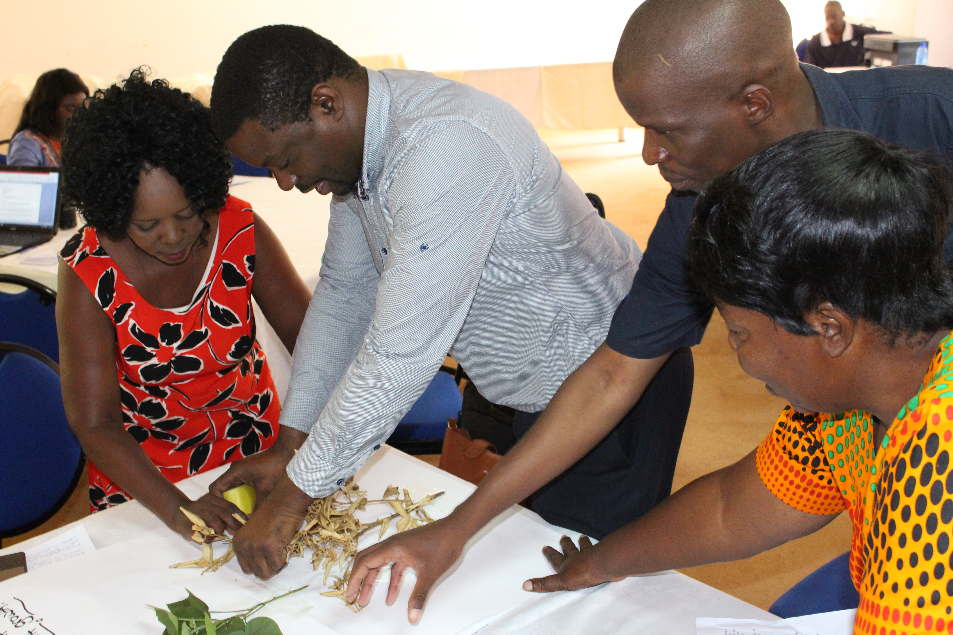

A manual for teacher trainers
Prepared for:
Ministry of General Education, Zambia
The Norwegian Association of Disabled
Developed by:
Enabling Education Network, December 2019





This work is licensed under the Creative Commons Attribution-NonCommercial-ShareAlike 4.0 International License. To view a copy of this license, visit http://creativecommons.org/licenses/by-nc-sa/4.0/

Contents
Introduction 5

Session 7.1: Our commitment to inclusion 7
Session 7.2: Creating an active learning environment 12
Session 7.3: Developing activities to promote active learning 19
Session 7.4: Planning and running group work 25
Session 7.5: Using differentiation in mixed-ability classes 34
Session 7.6: Using assessment in support of learning 44
Session 7.7: Using action research to promote active learning 53

Resource 7.1: Reactive and proactive responses 60
Resource 7.2: Reactive and proactive statements 61
Resource 7.3: ‘Our vision’ cards 62
Resource 7.4: Realising ‘our vision’ 63
Resource 7.5: Classroom photos 64
Resource 7.6: Responding to the classroom photos 67
Resource 7.7: Recommended changes 68
Resource 7.8: Organising the classroom’s physical environment 69
Resource 7.9: Organising the classroom’s psycho-social environment 71
Resource 7.10: EENET’s ‘An Inclusive Day’ video, programme 7 on teaching and learning 74
Resource 7.11: Key extracts from the video transcript 75
Resource 7.12: Active-learning approaches 77
Resource 7.13: Learning objectives 78
Resource 7.14: Strategies for active learning 80
Resource 7.15: Benefits and challenges of group work 81
Resource 7.16: Planning the composition of each group 82
Resource 7.17: Checklist for planning successful group work 83
Resource 7.18: Roles and responsibilities 84
Resource 7.19: Classroom rules for group work 85
Resource 7.20: Checklist for running successful group work 86
Resource 7.21: Grouping strategies for different purposes 87
Resource 7.22: Scaffolding v differentiation 90
Resource 7.23: Differentiation to include all abilities 91
Resource 7.24: Differentiation planning 92
Resource 7.25: Benefits and challenges of group work 93
Resource 7.26: Video transcript 94
Resource 7.27: Support for learners with disabilities 96
Resource 7.28: Adapting activities for learners with disabilities 97
Resource 7.29: Interventions to support learning 98
Resource 7.30: Useful feedback 99
Resource 7.31: Dos and don’ts 100
Resource 7.32: Feedback role-play cards 101
Resource 7.33: Better questions 102
Resource 7.34: Some questioning strategies 103
Resource 7.35: Example of an observation sheet 105
Resource 7.36: Interview guidelines 106

Notes 108

Introduction
This module provides teacher trainers with ways to share inclusive teaching strategies that promote active learning and that are effective in a range of settings, including under-resourced schools with large classes. These strategies are designed to support differentiation and the effectiveness of mixed-ability groupings in promoting achievement. Differentiation is the manner in which a teacher plans for and responds to different learners’ needs. To meet learners’ different learning needs, teachers change the content that is taught, how they teach and the methods learners use to learn. This is called differentiation.

Active learning involves learners thinking about what they are doing. In this type of learning, learners are not passive. Active learning is not so much about transmitting information from the teacher to the learner, but rather it is about developing learners’ independent learning skills. Active learning requires teachers to skilfully use a wide range of strategies to engage learners in the learning process. This includes planning lessons and collaborative activities to allow learners of all abilities to learn the same content, using assessment in support of learning, and adjusting tasks to meet each learner’s individual needs and learning styles.

Teachers often experience a lack of resources in their schools, including having to teach large class sizes. As a result they often resort to using lecture methods during teaching, which leaves learners as passive listeners. The training sessions provided in this module help teachers promote active learning in large, under-resourced, mixed-ability classes, enabling all learners to participate and improve their learning.

Planning the delivery of the sessions in this module should be done with close reference to the other training modules in this series, especially ‘An Introduction to Inclusive Education’ (Module 1). The module on Including Learners with Additional Needs is also a useful reference. It includes advice and guidance on identifying additional needs and practical tips and ideas for teachers which will help them with differentiation and supporting learners with additional needs in the school and classroom environment.

As with the other modules, the training outlined here focuses on using participatory methods and active learning techniques. It follows this basic principle:

We must use inclusive training methods if we are to successfully train others how to teach inclusively.

Duration of training
Trainers should adapt this training to suit the local context and the time available to them for training. Trainers may decide not to use all of the activities, or to shorten some activities if time is limited, or to expand activities if teachers need more support with understanding a particular topic.

If all activities are used, without significant adaptation, shortening or lengthening, this module requires approximately 16 hours of training, split over 3 days, depending on the preferred length of training days, number and length of breaks, and so on.

Session 7.1: Our commitment to inclusion
Enabling learners to be active in the learning process is a vital strategy for inclusion. This first session is intended to help teachers reflect on what they already know or think they know about inclusive education, and will give the trainer an indication of existing knowledge or misunderstandings. The session will give each teacher an opportunity to develop more effective teaching strategies through consideration of what inclusive teaching looks like.

Activity 7.1a: A positive attitude for change
Main
30 minutes

This activity gives teachers the opportunity to consider the importance of adopting a proactive attitude so as to work effectively to improve learners’ learning.

The trainer should explain to teachers that, while accepting the limitations imposed by school policy and resources, to improve learning we need to achieve more inclusive classrooms, and to do that teachers need to be proactive. They need to think and act in an inclusive, learner-friendly way, and they need to be committed to continual improvement.

The trainer should ask teachers to work in small groups. Where possible, these groups should be a mixture of people from school, government education ministries and other relevant education stakeholders. The trainer should give each group a copy of Resource 7.1 and Resource 7.2.

Resource 7.1
Reactive and proactive responses

Resource 7.2
Reactive and proactive statements

The trainer should ask each group to read both resources. After reading Resource 7.1, each group needs to decide which of the statements in Resource 7.2 are reactive and which are proactive. They could make notes on the sheet or, if the trainer prefers, they could make notes separately on a piece of blank paper with two column headings – ‘Reactive’ and ‘Proactive’.
The trainer should ask one group to feedback what they have decided and then give teachers the chance to explain and discuss their decisions.

For the trainer’s reference, the following language is likely to show a reactive response:
- “There’s nothing I can do”;
- “That’s just the way I am”;
- “She makes me so mad”;
- “They won’t allow that”;
- “I have to...”;
- “I can’t...”;
- “I must...”;
- “If only...”.

The following language is likely to show a proactive response:
- Let’s look at what we can do”;
- “I can change”;
- “I choose...”;
- “I will...”;
- “I commit myself to...”;
- “I prefer...”;
- “I can...”.

The trainer should state that those who are proactive tend to focus their energies on their ‘circle of influence’, finding that their ‘circle of influence’ grows. Those who are reactive tend to focus their energies on their ‘circle of concern’ and therefore find their ‘circle of influence’ shrink. The trainer can then emphasise the importance of teachers being proactive and embracing positive attitudes for change when planning to improve inclusion. The trainer can explain that the next two activities are about them translating this positive attitude into a vision of what they want their classrooms to look like.

Activity 7.1b: Our vision
Main
40 minutes

This activity helps teachers recall their learning about inclusive education and its benefits. Teachers use that understanding to identify an inclusive vision they have for their learners that they can work towards achieving.

The trainer should ask teachers to recap and explain what inclusive education is. Key points could be collected on the flipchart or board.

The trainer should provide a recap of the main points, drawing from Module 1, ‘An Introduction to Inclusive Education’. These could be:
- Inclusive education is about increasing the presence, participation and achievement of all learners in schools. It involves restructuring the cultures, policies and practices in schools so that they respond to the diversity of all learners in the community.
- Inclusive education is built on the understanding that educational exclusion happens because of fundamental problems in the education system or school. It does not place the ‘blame’ for exclusion on a learner’s personal characteristics or abilities.
- An inclusive education approach brings about changes so that schools can effectively welcome and educate any learner.
- Inclusive education encourages flexible teaching, which supports differentiated learning, using different methods to suit various learning styles.
- Inclusive education is something we always keep working towards, because we can always keep improving.

Teachers should work in small groups. The trainer should give out Resource 7.3, a set of the ‘Our vision’ cards to each group.

Resource 7.3
‘Our Vision’ cards

The trainer invites teachers to identify any statements that are particularly relevant to what is needed in schools they work in or with. Then he/she asks them to choose one statement which they must adapt or rework to reflect a vision for their own classrooms or the whole school.

For example, a teacher may want to redevelop this statement from Resource 7.3:

‘All learners enjoy their lessons and look forward to them.’

The teacher may want to set up an extra-curricular club during lunchtime or after school, e.g., drama, sewing, looking after the school garden or helping one another with exam revision, and therefore composes the following adapted vision statement as relevant for her/him to realise at her/his school:

‘Every learner in the exam year will want to attend our lunchtime study club at least once a month.’

Another example of a Resource 7.3 statement is:

‘We plan activities to promote positive relationships among the learners.’

A teacher who wants to give learners more responsibility, and wants to develop group-work, decides on the following adapted vision statements as more relevant in her/his school/class:

‘Every learner will be assigned responsibilities in the classroom or across the whole school community’. And ‘Paired or group-work will take place in every lesson’.

Teachers should write up and share their vision statement with their neighbour and then their group. The trainer should then ask for volunteers to discuss their vision with the whole group. The vision statements can then be displayed on the wall and looked at during break-time.

It is important that the trainer provides positive feedback and especially endorses contributions that effectively promote inclusion.

Activity 7.1c: Working towards an inclusive classroom
Main
30 minutes

This activity helps teachers identify what barriers may need to be overcome in order for them to realise their inclusive vision for their classroom or school.

The trainer gives out Resource 7.4 to each teacher.

Resource 7.4
Realising ‘our vision’

Teachers should work individually and choose one vision statement from those displayed on the wall at the end of Activity 7.1b. They should choose a vision that is both relevant to their own classroom or school setting, and which provides them with a challenge.

The trainer should ask each teacher to consider the changes she/he may need to make to her/his practice for this vision to be achieved.

After teachers have completed Resource 7.4 the trainer should ask them to share their answers in pairs, considering any further thoughts they want to add to the hand-out after their discussion. The trainer can then select some teachers, or ask for volunteers, to present their ideas to the whole group for further discussion and feedback.

Notes

Session 7.2: Creating an active learning environment
The focus of this module is on promoting active learning and thereby achieving a more inclusive classroom and school setting. The way the classroom is organised can have a big impact on whether active learning can be realised and whether learners are able to join in or concentrate in lessons.

In this session, teachers will see that there is always something that can be done to make the environment more welcoming, inclusive and ready for active learning, even where classrooms may be overcrowded or have little or poor-quality furniture.

Activity 7.2a: Preparing the learning environment
Main
1.5 hours

This activity supports teachers to consider ways of preparing the learning environment to promote active learning.

The trainer should emphasise the importance of creating a learning environment that is a comfortable place in which to teach and learn, even when classes are large. Preparing a positive learning environment can make the difference between a calm and functioning classroom and a classroom in chaos.

Resource 7.5
Classroom photos

Resource 7.6
Responding to the photos

The trainer should give out copies of Resource 7.5 and 7.6 to each group and then give the following instructions:
- Work in small groups.
- Look at and discuss the photos of classrooms in Resource 7.5.
- Each group should start by looking at a different photo. Group 1, look at photo 1 first. Group 2 look at photo 2 first, and so on.
- If there is time, groups can of course look at and discuss more photos once they have finished discussing their first photo.
- Groups need to think about and make some notes on the following questions (see Resource 7.6):
- What are the good things about these classrooms?
- What challenges or barriers to learning can you see in each photo?
- Which learners might struggle in this learning environment and why?

After about 20 minutes, the trainer should invite each small group to share their first photo with the whole group and explain what they have discussed. Other groups can ask questions and add their own opinions about the photo.

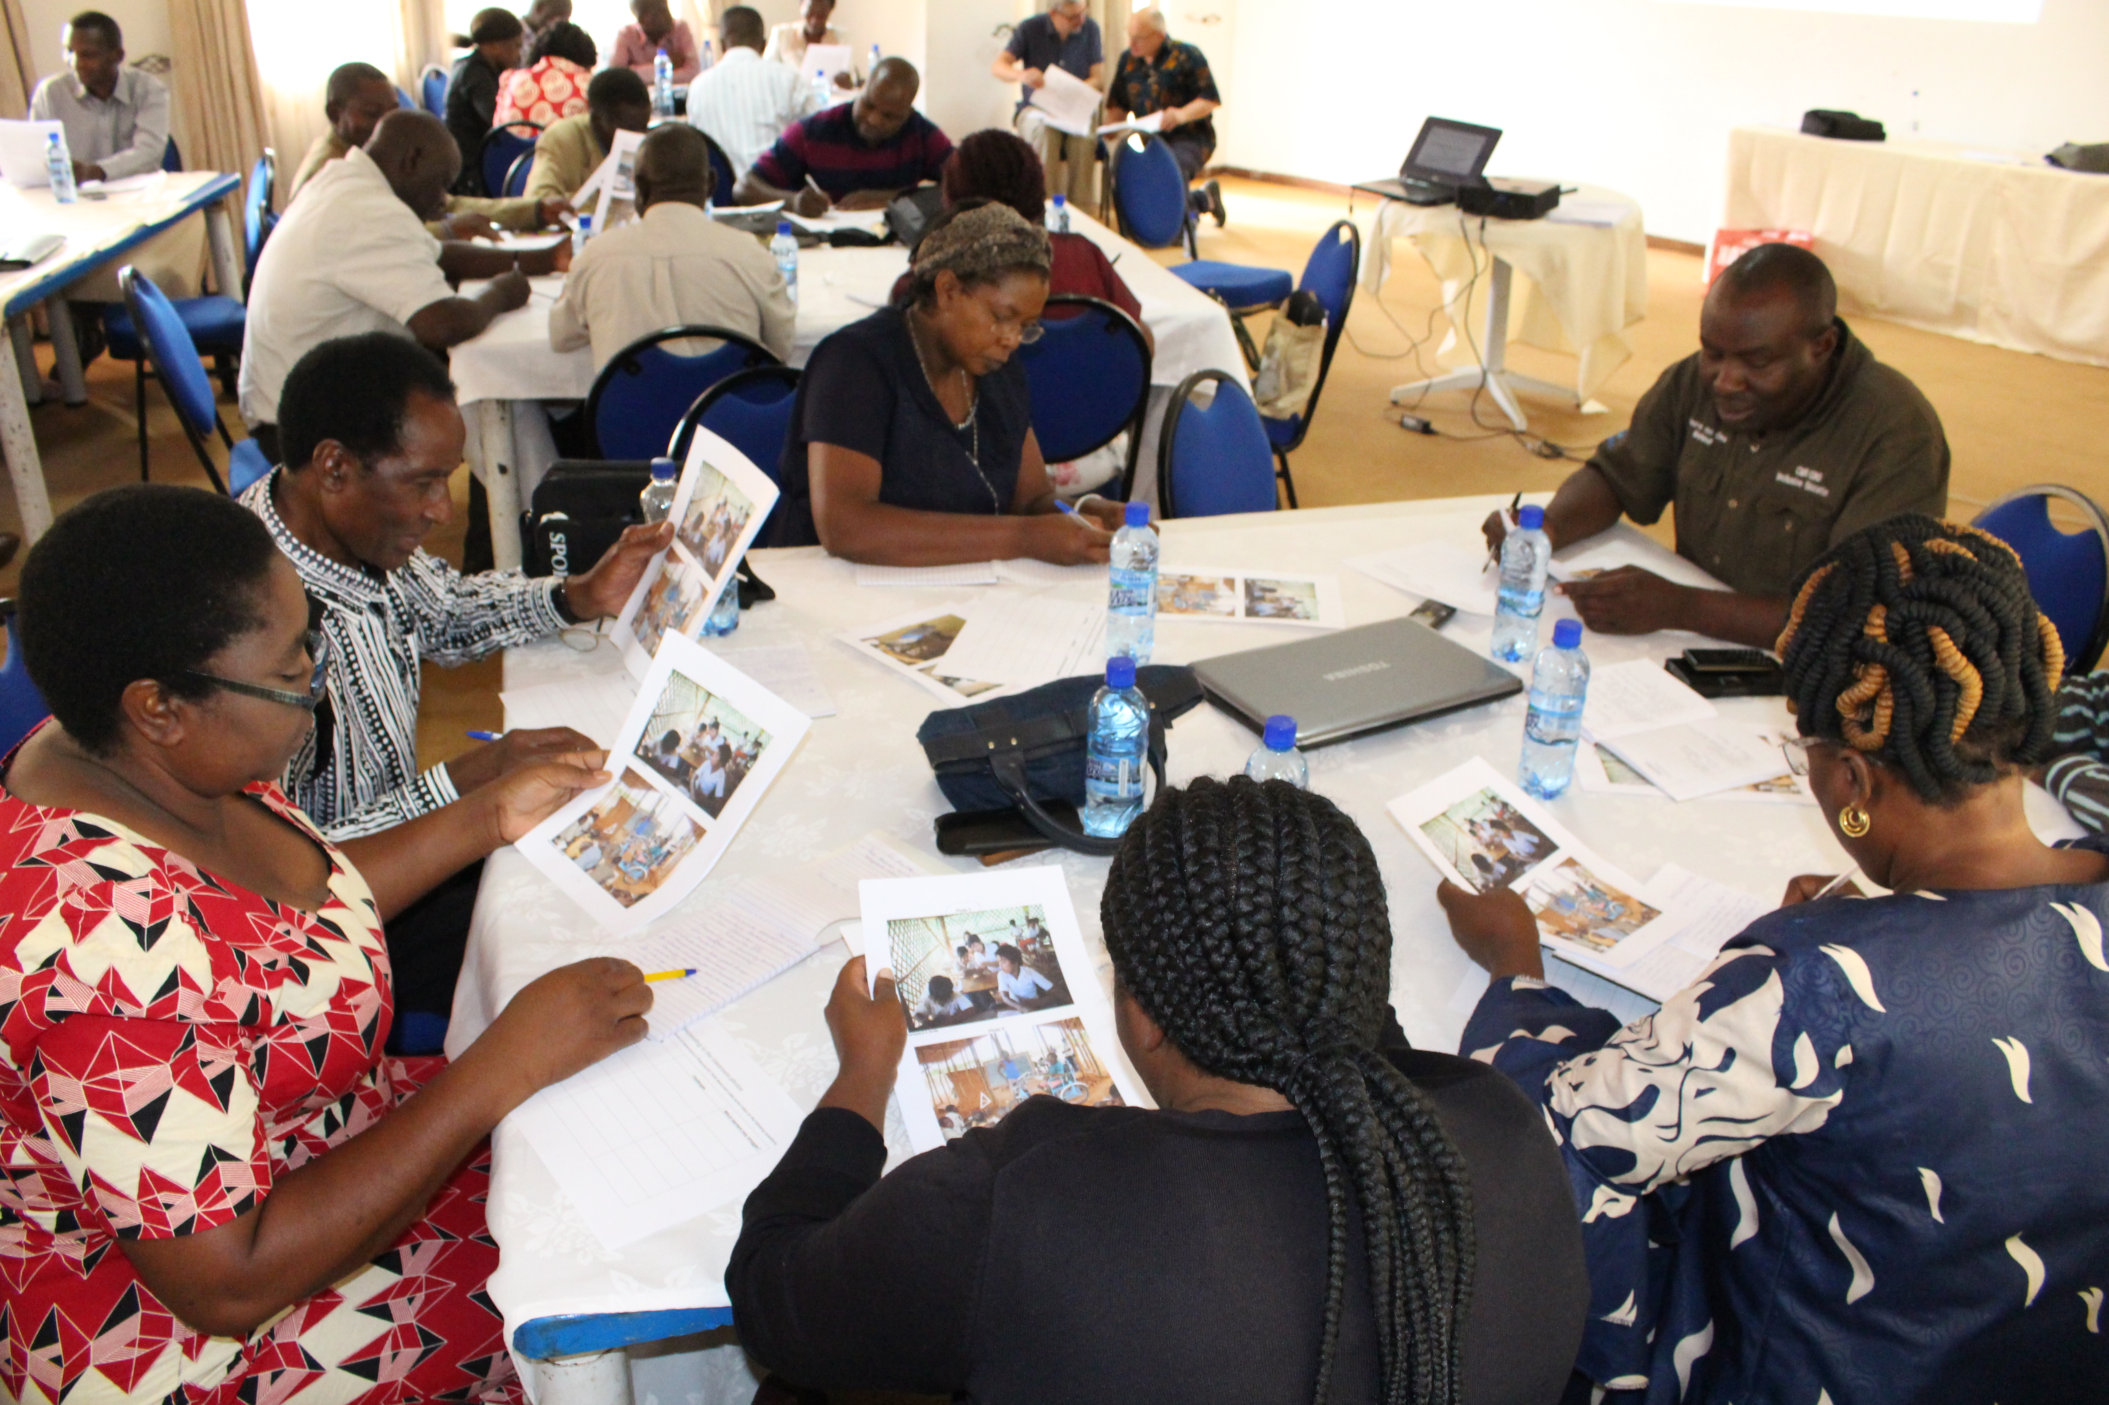
A group in Zambia looking at and discussing photos of classrooms

Resource 7.7
Recommended changes

After about 20 minutes of discussion, the trainer should give teachers the following instructions:
- Look again at the same photos (your group should start with the same photo as last time).
- Answer the questions in Resource 7.7. Write your answers in the spaces provided below these questions. If you need more paper, please ask:
- What simple changes could you make in these classrooms to ensure that:
- learners feel more comfortable;
- learners can see or hear better;
- learners and the teacher can move around more easily?
- What changes might be needed that you could not make by yourself as a teacher?
- Describe the changes.
- Explain who else needs to be involved and why.

The trainer should allow about 20-30 minutes for the group work. During that time the trainer should display the classroom photos from Resource 7.5 around the room.

When they are ready the trainer should give these instructions:
- On the wall around the room, there are 6 photos.
- Cut up your notes for solutions and stick them under the relevant photos.
- Then walk around and look at each photo and read each other’s suggestions for changes to the learning environment. You can add your own suggestions and comments to the displays using post-its (sticky notes).

After about 10 minutes of the gallery walk the trainer can ask the teachers to sit down and then invites people to share their reactions to the suggested changes they have read about.

In the box below are possible answers for just one of the photos. In your role as the trainer, you should think through possible answers for all the other photos before you run this session. You are also free to use photos from your own schools. The photos provided here are just examples. Please remember that your interpretations of the photos and those of the teachers need to be explained. Given that you will not know exactly what is happening in the photo, you need to allow a variety of viewpoints as long as they are justified/ explained.

Photo 1
Challenges / barriers
- Not enough desks/chairs for everyone
  - This could be a barrier for learners who have mobility difficulties who may find it difficult to sit on the floor.
  - It is also a barrier for any learner because it is hard to concentrate if you are uncomfortable.
- Dusty floor
  - Learners get dirty and their books get dirty.
  - Dirty clothes could be a barrier if their parents/guardians/care-givers get annoyed and say they do not want them going to school if they get so dirty. Or learners themselves may decide they do not want to be in class if they have to sit on a dirty floor all day. Sitting on concrete can also be cold.
  - Dirty books – it can be hard to read from or write on pages that are dusty, which could be particularly difficult for learners who cannot see well.
- The learners sitting at desks on the left of the picture look like they are having to twist their bodies to see the board at the front of the class (the board at the back is probably a notice board).
  - This could be a barrier for any learner, as it is difficult to learn and concentrate if you are uncomfortable.
  - Learners who have problems remembering or understanding may find it harder to focus if they constantly have to keep moving their body and head to look between their book/desk and the board.

Good things
- Bright, good light
- Seems to be a big room, enough space
- The learners are working in groups

Changes the teacher could make him/herself to overcome these barriers
- Carefully plan who sits at the desks or on the floor. For instance, learners who find it difficult or painful to move should always sit at a desk. For other learners, there would be a rota, so that they take it in turns to sit at a desk or on the floor.
- You could plan activities so that the groups of learners who are sitting at desks do activities using books and writing, and those on the floor do other activities that involve thinking, talking, touching or making things. The groups can then swap.
- You could rearrange the desks so that learners need to move as little as possible to see the board. You could even turn this into a lesson, for instance, ask learners to design different layouts for the class that they think will be most comfortable. They could design layouts that will work best for group activities, for listening activities, for taking tests, and so on. You can then try out their designs and ask the learners to evaluate which work best. Such an activity could help them learn more about measuring, maths, drawing and design, as well as learning analytical thinking and even report writing skills, if you ask them to document the process and their findings.

Changes that may need help from others
- You could encourage learners to bring pieces of cloth or mats to sit on, if they are sitting on the floor. The cloth and mats can easily be brushed, shaken or washed and dried regularly. This may require help from parents/guardians/ care-givers, or others in the community who could donate mats/cloths.
- You could provide a bucket of water and soap so that learners can wash their hands after they have been sitting on the floor. This may help them keep their books cleaner. You may need help from someone to donate the bucket and soap if the school has no money to buy them.
- You could contact local businesses or NGOs to advocate for donations of more furniture for your school. The learners in your class could also get involved.

Activity 7.2b: ‘What a classroom ready for active learning looks like
Main
30 minutes

This activity gives practical ideas for preparing and organising the learning space.

There are two important aspects to the classroom environment: the physical, which includes physical space, furniture and classroom resources, and the psycho-social, which includes the prevailing ethos, classroom behaviour and how it is dealt with, and how safe and supported learners and teachers feel.

Resource 7.8
Organising the classroom’s physical environment
Resource 7.9
Organising the classroom’s psycho-social environment

The trainer should prepare this activity before the session. Copy and cut out the cards and mix them up well. Then give one set of cards from either Resource 7.8 or Resource 7.9 to each group. Make sure there is approximately the same number of groups working on each resource, e.g., three groups working on Resource 7.8 and three groups working on Resource 7.9).

The cards consist of ‘main organising tasks’ (in large bold type), and ‘supporting actions’ that can help to realise those main physical or psycho-social organising tasks. The cards help to show what a classroom ready for active-learning looks like.

In groups the teachers should think about which ‘supporting actions’ go with which ‘main organising tasks’ and put the relevant cards together.

In Resource 7.8 and Resource 7.9 the cards have been arranged to show the trainer the correct answers to make it easier to check the groups’ work.

After 10 minutes ask groups to pair up; i.e., one group working on Resource 7.8 should join with one group working on Resource 7.9 (one of the groups can carry their cards to the other group’s table). They can then share their thoughts and ideas about the physical and psycho-social ‘organising tasks’ and ‘supporting actions’.

As a whole group, the trainer can ask for feedback on which ‘supporting actions’ have been attached to each ‘main organising task’. Teachers can discuss what they have decided and the implications for their teaching practice.

Notes

Session 7.3: Developing activities to promote active learning
Active learning strategies enable learners to engage with and be active in the learning process. Activities are learner-centred, often collaborative, enquiry - or problem-based and involve learning through direct experience.

The aim of this session is for teachers to recognise the importance of using a range of teaching strategies in each lesson, and to collaboratively plan active learning opportunities that are engaging and inclusive.

Activity 7.3a: Recognising active learning approaches
Main
60 minutes

This activity will help make teachers aware of active learning strategies they (can) use in their classrooms.

The trainer should ask teachers what they understand by ‘active learning’. After writing teachers’ key points on a flipchart or board, the trainer should explain that active learning provides opportunities for everyone to contribute and learn.

If the following 5 key elements have not been covered in teachers’ responses, the trainer should emphasise that active learning:
- provides opportunities for speaking and listening: talking is fundamental to the process of explaining, learning and understanding,
- is collaborative: learners work and progress together,
- motivates: learners have the opportunity for active participation,
- is thought-provoking: the emphasis is on enquiry, problem-solving and extending knowledge, and
- is varied: appealing to and teaching a range of different learning styles.
Resource 7.10
EENET’s ‘An Inclusive Day’ video, programme 7 on teaching and learning

Resource 7.11
Key extracts from the video transcript

Resource 7.12
Active learning approaches

Following the feedback, teachers should watch programme 7 from EENET’s ‘An Inclusive Day’ video training package which focuses on teaching and learning (Resource 7.10). If the trainer cannot access the video online, he/she should give a copy of the video transcript (Resource 7.11) to each group.

The trainer should give each teacher Resource 7.12 and give the following instructions:
- Watch the video (Resource 7.10) or look through the transcript extracts (Resource 7.11). This video gives ideas for how to make lessons more learner-centred and interactive.
- Using Resource 7.12, make a list of all the active learning approaches for helping learners to participate and achieve which you see in the video or read about in the transcript. Look for the activities, resources and strategies used.
- Discuss in you groups:
- Which approaches are we not familiar with and would like to include in our own lesson planning?
- Are there any other inclusive active learning strategies we could use in those situations that are not shown in the video?

After 5-10 minutes of group discussion the trainer should write on the board or flipchart key points the teachers make. Link their discussion to the 5 key elements of active learning that are mentioned above: speaking and listening, collaborative, motivating, thought-provoking and varied. See the box below for a list of active learning approaches shown or mentioned in the video.

List of approaches seen or mentioned in the video:
- activities that involve looking/watching,
- activities that involve listening and comprehension,
- activities that involve talking,
- activities that involve touching things,
- activities that involve moving,
- using games,
- using toys,
- making lessons relevant to real life experiences,
- using real life and recycled objects,
- using project-based learning,
- using role-play, drama and performance,
- using outside spaces,
- using group work,
- using pair work,
- use peer learning and buddy or peer support systems, and
- use text books in a creative way.

Notes

Activity 7.3b: Planning activities that promote active learning
Main
1.5 hours

This activity is designed to help teachers develop their confidence with planning activities that are engaging and inclusive and that promote active learning. The activity will do this by giving teachers the opportunity to creatively plan some engaging and inclusive lesson activities together.

First the trainer should emphasise the need for careful lesson planning. While acknowledging that teachers may often rely solely on textbooks, it is important that the lesson is planned from learning outcomes that build on knowledge of what each learner needs to learn next. Even if teachers still use a textbook, they need to carefully prepare how they communicate the learning so that the learners understand what is written.

The trainer can emphasise how a good lesson plan will support each teacher’s confidence in the classroom. They will know in advance what to do and will have given themselves time to prepare learning materials that increase the engagement of the learners. With clear objectives for the lesson, teachers can plan and adapt activities to ensure every learner progresses towards those outcomes.

The trainer should emphasise that lesson planning is more effective if teachers work together. They can help each other solve problems and plan more interesting and inclusive lessons if they share ideas and experiences.

Resource 7.13
Learning outcomes

The trainer should organise teachers into small groups of 4 or 5 and remind them of the teaching approaches and strategies that they identified in Activity 7.3a. The trainer should give each group a different card cut out from Resource 7.13.

Each group should look at their learning outcome card. Working as a group they should design one learning activity that promotes active learning and can help learners towards the learning outcomes. It will be helpful for the trainer to give an example of how to do this. The trainer could use the Maths learning outcome and ask teachers to place themselves in a row in order of height. The trainer can explain that this activity can be used to illustrate the terms ‘ascending’ and ‘descending’. This is an example of one activity that promotes active learning and enables learners to progress towards the Maths learning outcome on the card. (It is important to tell the group with this card not to use the same activity!).

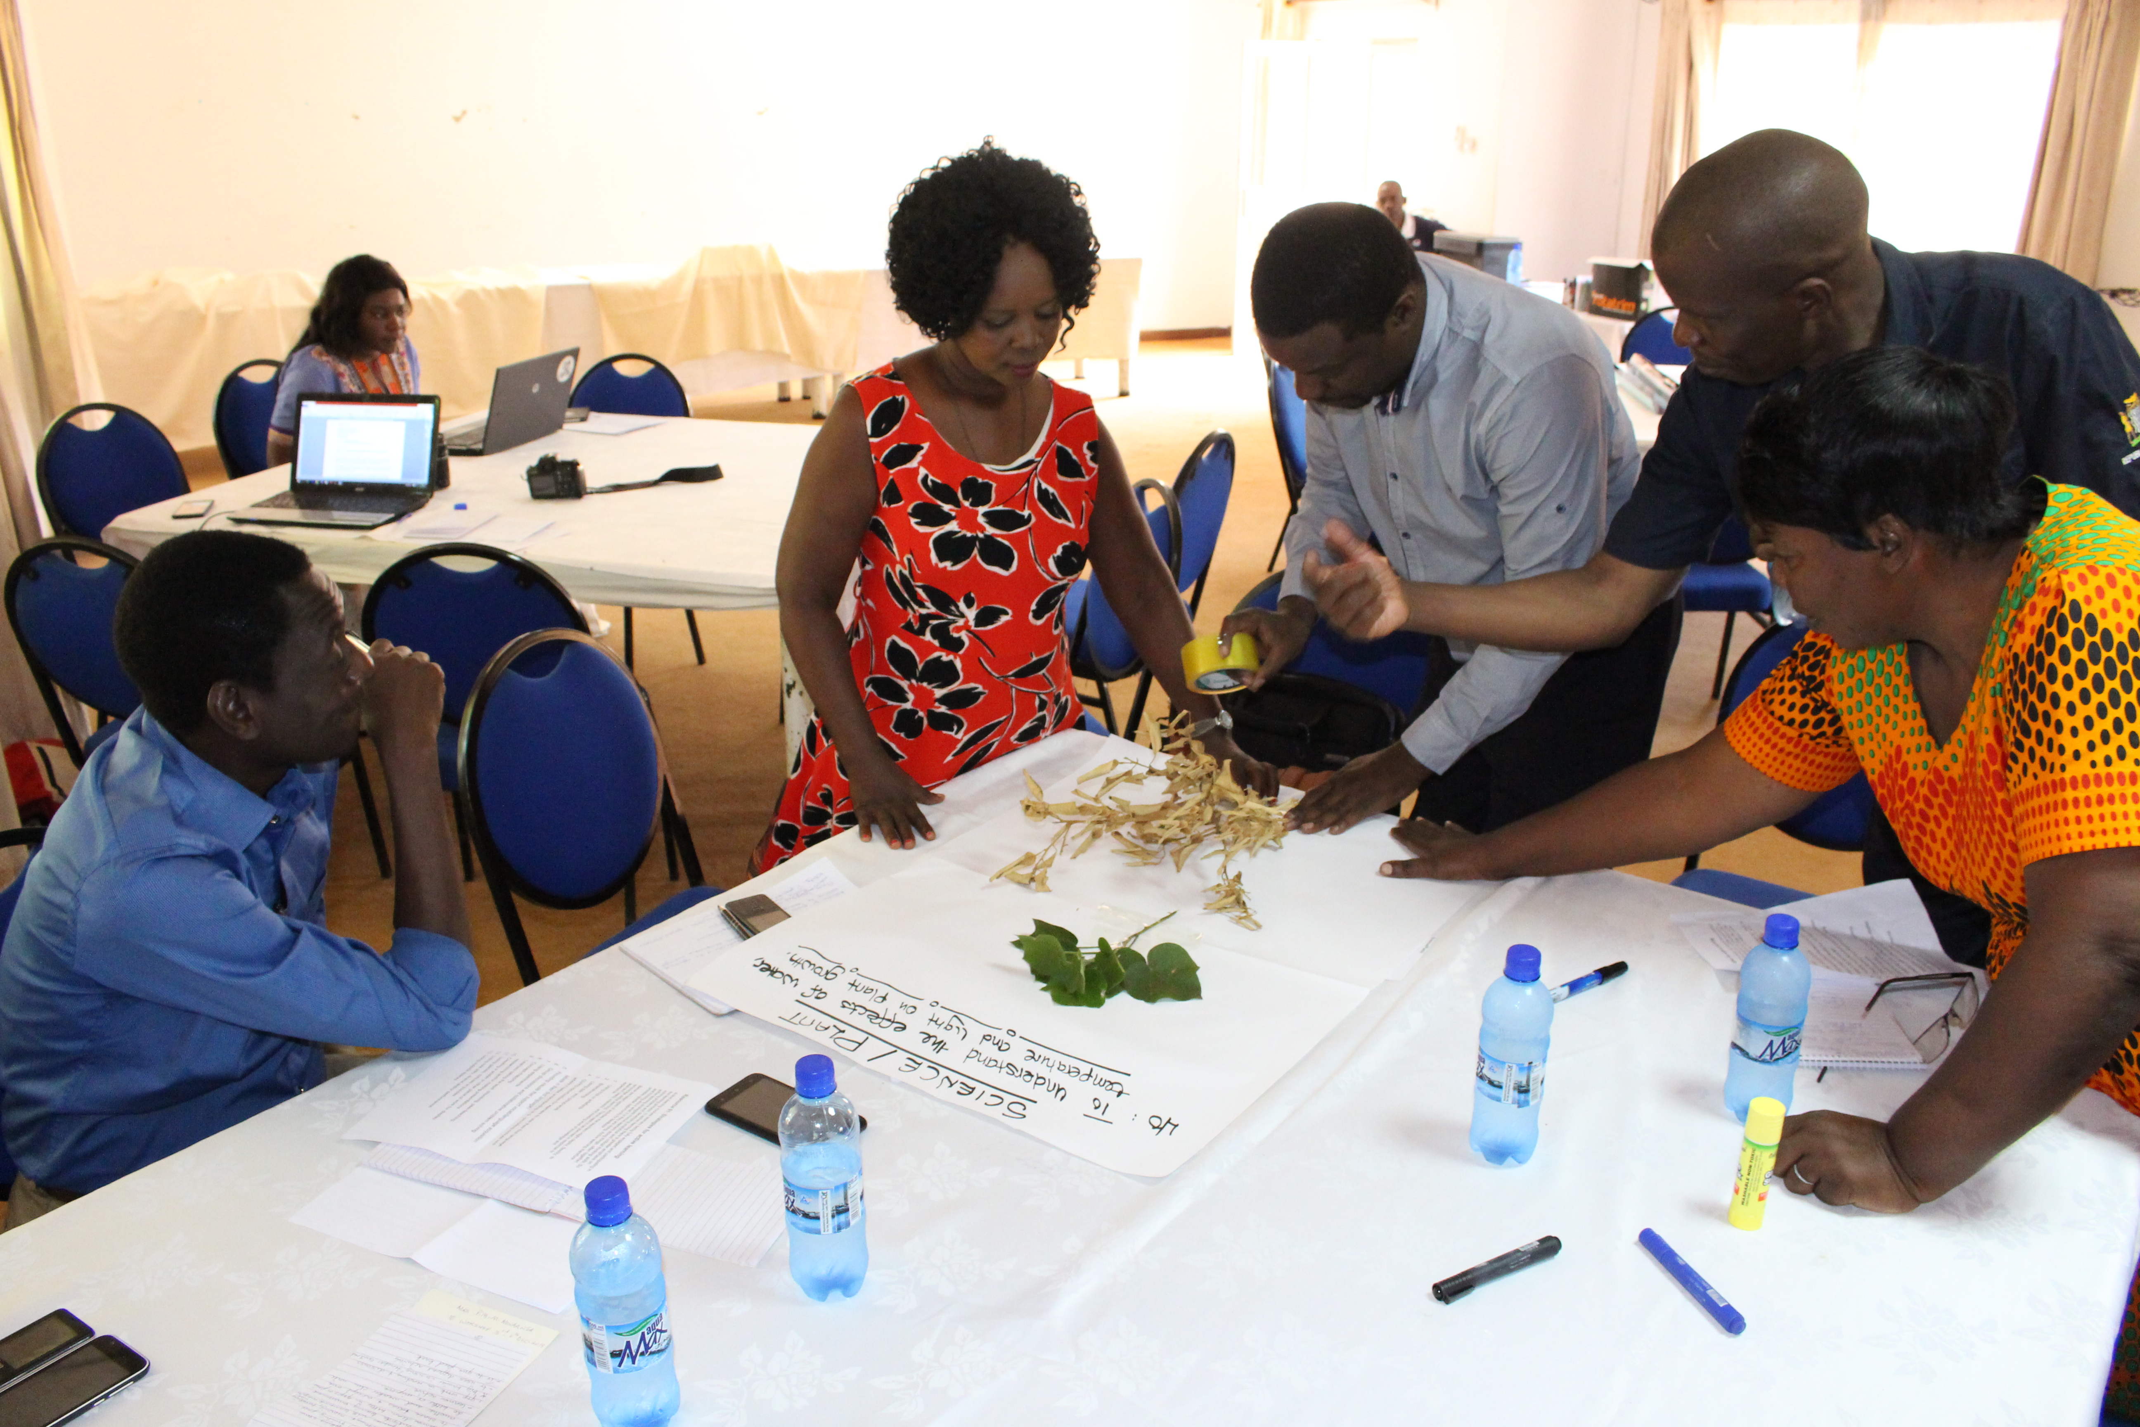
A group of principal trainers in Zambia designing a learning activity

[Image description: 2 women and 2 men are standing by a table and another man is sitting watching them. The people who are standing are sticking leaves and twigs on to a large sheet of paper.]

After 30 minutes (or sooner, if everyone has finished), each group should feed back on the activity they have designed. The whole group can discuss whether the activity promotes active learning and helps learners towards the learning objective.

Resource 7.14
Strategies for active learning

The trainer should give out Resource 7.14 and ask each group to find a strategy in the list that describes their activity. Then each group should design two further activities that promote active learning and help learners toward their learning outcome. They should consult the list for ideas.

The activities they design should be written onto flipchart paper and displayed with their learning outcome card from Resource 7.13. The display needs to be stored carefully and re-exhibited during Activity 7.5b.

Notes

Session 7.4: Planning and running group work
Learners learn a great deal by explaining their ideas to others and by participating in activities in which they can learn from their peers. They develop skills in organising and planning learning activities, working collaboratively, giving and receiving feedback and evaluating their own learning.

The aim of this session is to build teachers’ confidence through practising planning and running group work and pair work.

Activity 7.4a: Why is group work important?
Main
40 minutes

Teachers will see both the benefits of group work and pair work and how it improves learning, and also consider ways to meet the challenges of running group work in large classrooms.

The trainer should explain that group work is a vital strategy for inclusion. If it was shown, the trainer should ask teachers to recall the EENET video (Resource 7.10 used in Activity 7.3a above). The trainer can re-play a section of the video (between 8:49 minutes and 9:53 minutes) or write the shortened version of the transcript (provided below) on the flipchart or board:

“Group-work means the children work together to share their ideas to create something good….it also allows the children to accept one another….and for the weaker children to do better. Group work provides pleasure for the children and I, to be honest, find pleasure in watching the children develop and achieve something… the children need to be active and to be their own teacher. Our role is to guide them in their work. They are the main actor in their education.” Honorine Boussini, teacher

The trainer should remind teachers that much of the work they have done so far in this training has been carried out in pairs or groups.

The trainer should ask each small group to divide into two sub-groups or two pairs. One of the sub-groups/pairs should discuss the benefits of group work and pair work in the classroom, including in large classes, as opposed to learners working on their own. They can be encouraged to reflect on their own experiences of doing group work and also how group work has helped them during the training.

Teachers should list the main points from their discussions. The trainer may wish to give some examples, such as ‘two brains are better than one’, ‘more ideas were generated’, etc.

The other sub-group/pair should consider some of the challenges of doing group work, especially in large classes. Examples may include ‘no room to move chairs and desks’, ‘the noise interfering with other classrooms’, etc. Again, they should list these challenges.

After about 5 minutes each sub-group/pair should join the other sub-group/ pair to share, discuss and compare the benefits and challenges they have identified.

After about 10 minutes, the trainer should briefly take feedback from some of the groups, identifying any particular issues or differences arising and providing a snapshot of the kind of benefits and challenges identified across the room. These should be listed on a flipchart or board.

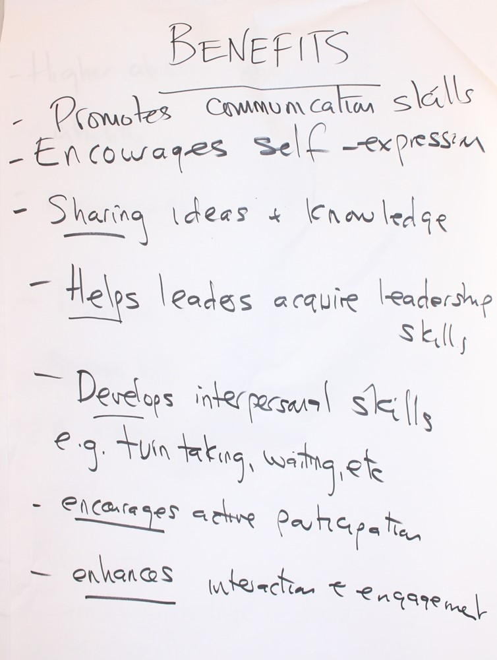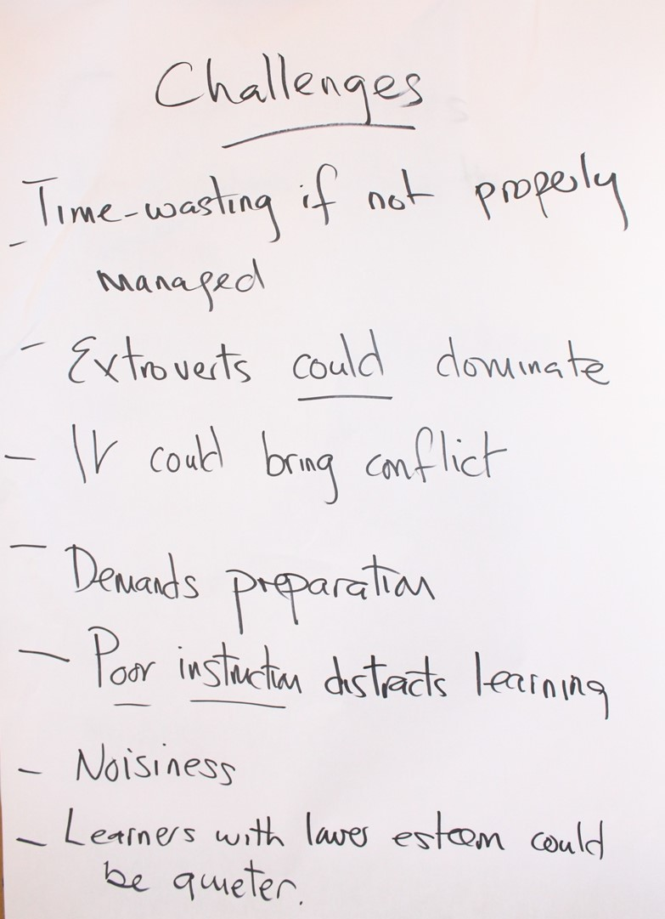
Flipcharts from Zambia listing benefits and challenges of group work

Resource 7.15
Benefits and challenges of group work

The trainer should give Resource 7.15 to each group. Ask teachers to read through the list of benefits and challenges together, discussing any that are new to them.

Finally, the trainer should encourage the groups to come up with ideas for how to meet the challenges identified so that group work can be conducted successfully. Each group could be assigned two or three of the challenges and given a few minutes to come up with solutions. These are then fed back to the whole group for further discussion.

Notes

Activity 7.4b: Planning group work
Main
40 minutes

This activity will support teachers to plan and organise successful group work, including in large classes.

The trainer needs to emphasise to teachers that effective teaching mixes whole-class teaching, individual, pair and group work during each lesson to increase engagement, participation and learning. It is therefore important that teachers know when to use group work, and that they plan it carefully to ensure the best effect.

The trainer should explain that, on most occasions while consulting learners about who they like to work with, teachers will decide the composition of each group rather than letting learners decide for themselves. This is important because it allows for a more diverse learning environment and will encourage all learners to take an active part.

On a flipchart or board the trainer can show how a range of different grouping techniques and strategies can serve different purposes in the classroom.

These include:
- mixed-ability groups where learners with different skills, knowledge and abilities can come together to problem-solve,
- targeted groups where learners with particular or additional needs can receive focused intensive teaching responding to their needs,
- same-ability groups where the teacher can pitch work at their level or leave groups of faster learners to get on with work so that extra help can be given to other learners.

The trainer can add that grouping learners in pairs has many of the advantages of group work but may sometimes be used to maintain the pace of a lesson, by avoiding time spent ‘getting in groups’. Working in pairs can also ensure everyone is involved, as it is very hard for learners in pairs to avoid participating. Further, pair work may be used when there is no space for groups to work or for the teacher to supervise.

In this activity teachers should consider how they may best organise learning to teach particular tasks.

Resource 7.16
Planning the composition of each group

Teachers should work in small groups. The trainer should give each group a set of cards cut up from Resource 7.16. They must decide whether the task card should be conducted in mixed-ability groups, targeted groups or same-ability groups. They must also decide which rationale (‘Why?’) card (in italics) supports their decision.

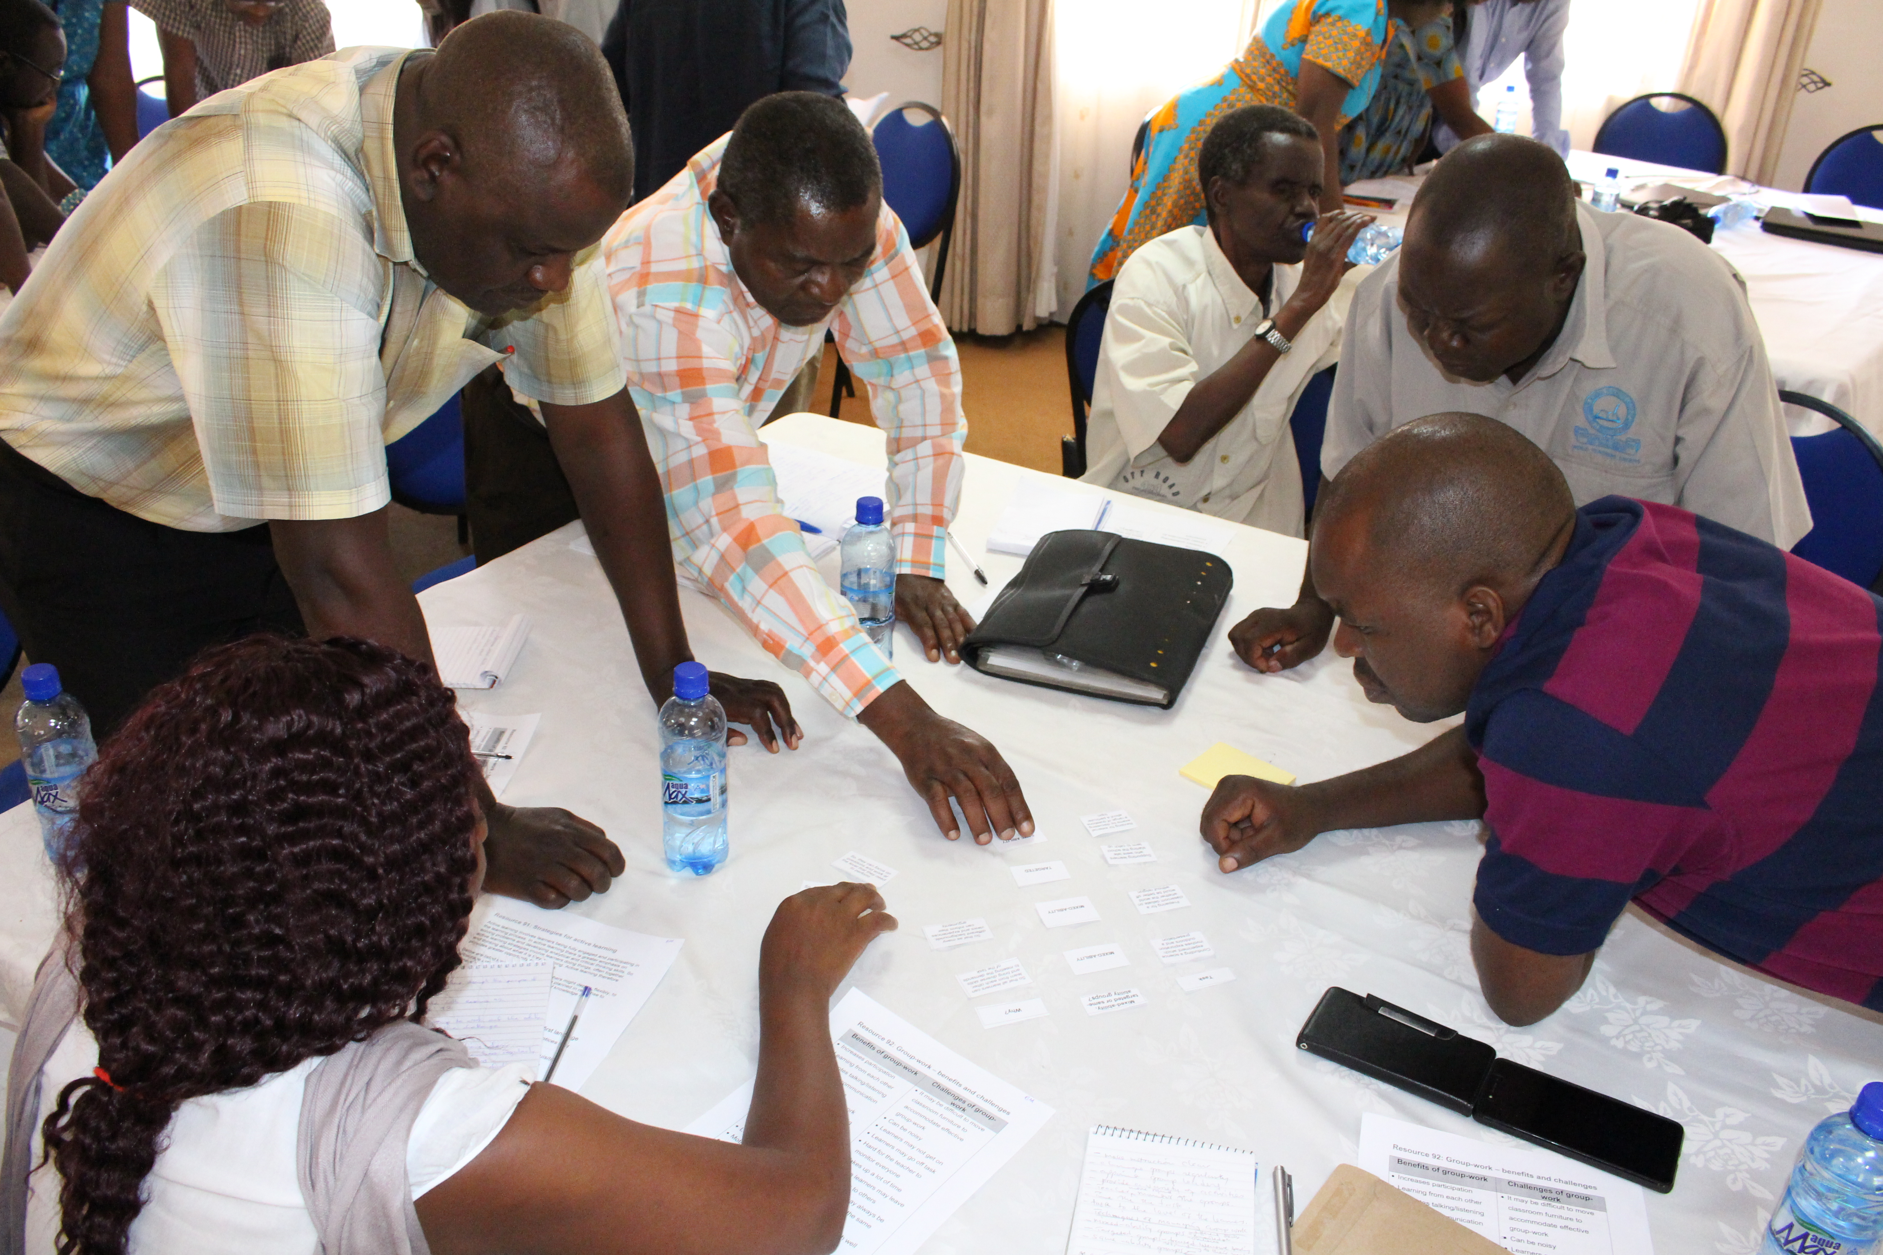
A group in Zambia carrying out the ‘group composition’ card activity

[Image description: 4 men and one woman around a table are looking at and placing small pieces of paper into a grid format on the table.]

Finally, they should be asked to use the three blank cards to design their own task, identify what kind of grouping would be most appropriate, and explain why by writing in the blank rationale card. These ideas can be shared with the whole group.

The cards in Resource 7.16 are arranged to show the correct answers, to help the trainer check the groups’ work.

The trainer can point out that research evidence on the impact of learner grouping practices suggests that no one form of grouping benefits all learners all of the time. What is important is that teachers organise learning groups fairly so that particular learners, including girls and learners with disabilities, are not over-represented in under-performing groups. Using mixed-ability groups in the classroom means that the more able learners can improve their learning by helping the others, and the less able learners can benefit from working alongside more engaged and motivated learners.

Resource 7.17
Checklist for planning successful group work

The trainer should give Resource 7.17 to each teacher and ask them to discuss the checklist in pairs. They should identify any gaps and decide if it is a useful tool for helping teachers plan for group work. It is useful for the trainer to ask teachers to consider if any further requirements need to be identified for planning group work in large classes.

Notes

Activity 7.4c: Running group work
Main
50 minutes

This activity will help teachers to run successful group work in the classroom.

The trainer should emphasise how important it is to establish group working rules in the classroom. For group working to be successful, all learners need to be involved in making sure they perform their roles responsibly and the teacher needs to work out ways to ensure these become routine.

Teachers should work in small groups.

Resource 7.18
Roles and responsibilities

The trainer should cut up and give a set of cards made from Resource 7.18 to each group. Each set of cards consists of:
- four ‘role cards’ – the chair, the note-taker, the reporter and the organiser/timekeeper,
- four cards which describe the roles, and
- cards which give examples of what people in those roles might say (in italics).

The trainer should ask each group to decide which role description card goes with which role cards. Then they need to decide which of the ‘what people might say’ cards goes with which role. Teachers can be encouraged to write on the additional blank cards to give further examples of what learners in those roles might say.

The cards in Resource 7.18 are arranged to show the correct answers to help the trainer check the groups’ work.

Next, the trainer should ask teachers to brainstorm and come up with a list of rules that learners need to follow if group work is to run successfully. These could be written on a flipchart or board.

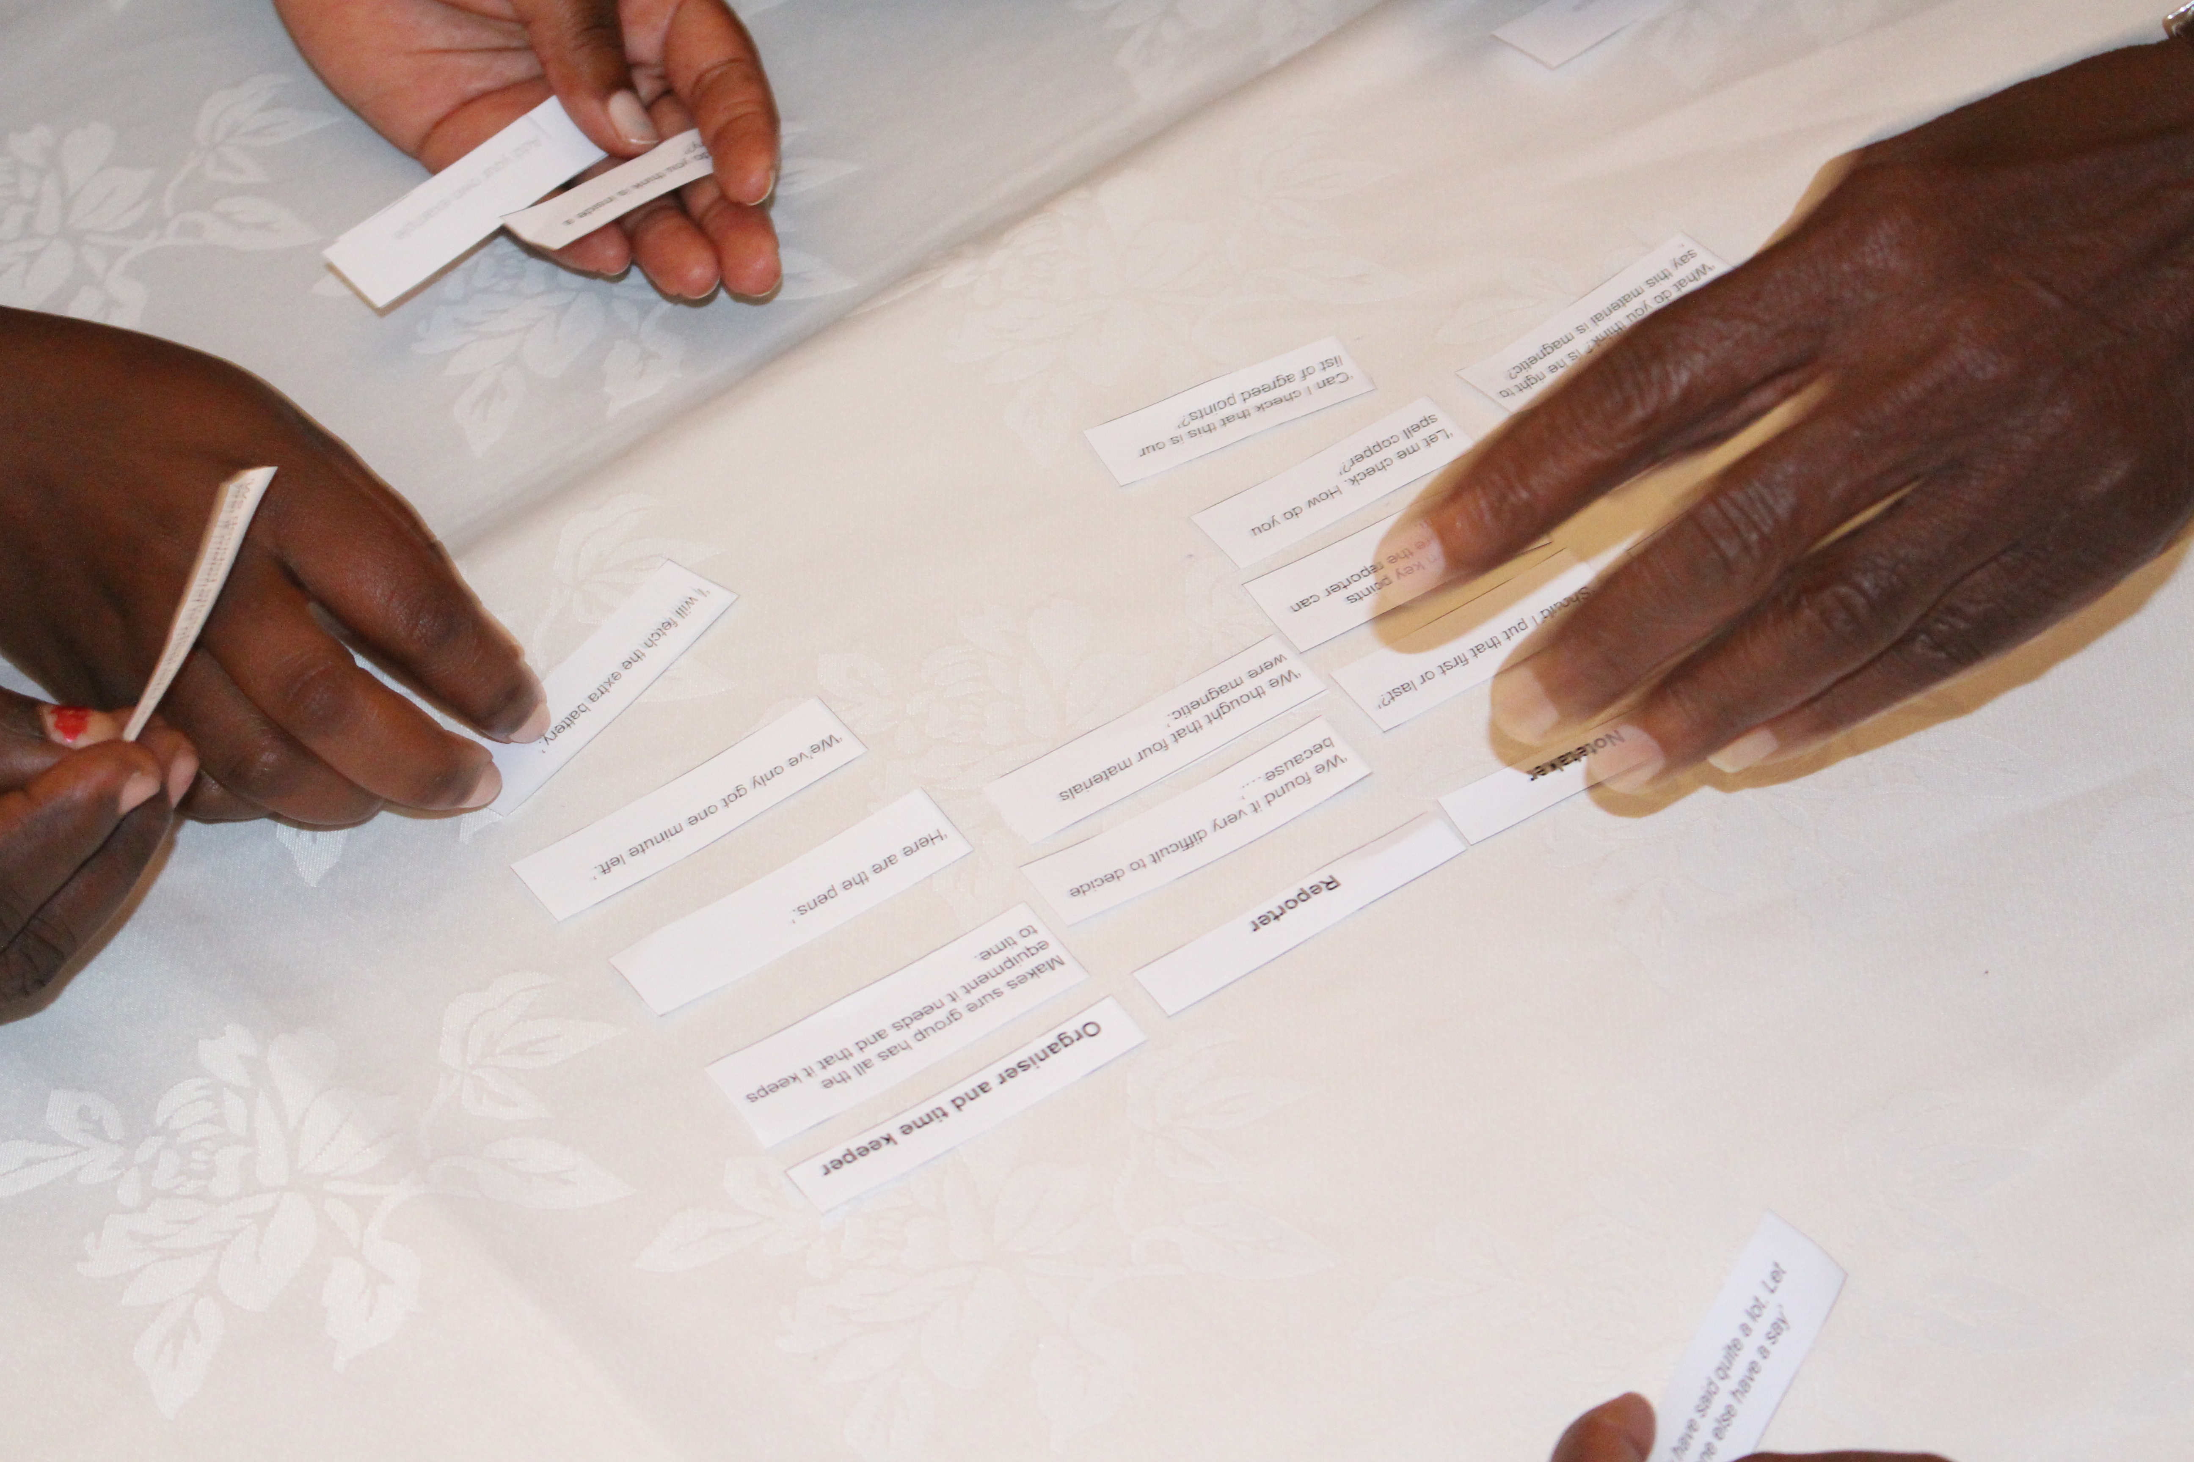
Teachers in Zambia organising the group work role cards

[Image description: Small pieces of paper with writing on are arranged on the table in a grid format, and 5 hands are holding/placing the pieces of paper.]

Resource 7.19
Classroom rules for group work

The trainer should then give each group Resource 7.19 for them to compare with their own brainstorm. They can write on the additional blank cards to give further examples of useful rules.

The whole group can then discuss how they could use either of these two resources (Resource 7.18 and Resource 7.19) to train learners in their schools. They could also suggest further ways to support learners to learn about how to work well in groups. This may include learners being involved in drawing up the rules themselves, or making posters and publicising good group work practice.

Resource 7.20
Checklist for running successful group work

The trainer should then give each teacher Resource 7.20 and ask them to discuss the checklist in pairs. They should identify any gaps and decide if it is a useful tool for helping teachers run group work.

Finally, the trainer should ask teachers to recall the kind of group activities they have undertaken during the training so far.

Resource 7.21
Grouping strategies for different purposes

Then the trainer should give Resource 7.21 as a hand-out for teachers to read and keep for future reference as an example of some grouping strategies. This resource provides examples of grouping strategies used for particular purposes.

The trainer and teachers can discuss this resource to understand each strategy. If there is time, they can think of classroom examples for how to use each grouping strategy (e.g., think of a problem/question that could be tackled by using ‘Think, Pair and Share’).

Notes

Session 7.5: Using differentiation in mixed-ability classes
Active learning requires teachers to engage learners of all abilities in the learning process. By using differentiation, a teacher adjusts or modifies teaching methodologies, teaching and assessment strategies, and curriculum content to motivate and enable each individual learner so she/he can access the learning and experience success (see the module on Including Learners with Additional Needs for more hints and tips for motivating and enabling learners with different needs). A range of differentiation methods have already been referred to in the earlier sessions of this module, including a focus on strategies for active learning (Session 7.3) and a focus on organising access to learning through group or pair work (Session 7.4).

Good teachers ensure that all learners in their classes participate and achieve. They know that all learners learn differently and may need different types of support. Here is a powerful quote that the trainer could write on the board or flipchart for teachers to read as they enter the room:

“My calling in life is to make sure that every single child reaches their full potential that I unlock that potential, that whatever it is that they need to achieve I make that happen.”
Andria Zafirakou, 2018 Global Teacher Prize winner
(see www.youtube.com/watch?v=BrMaive-xiU)

Activity 7.5a: Introducing differentiation
Main
30 minutes

This activity will enable teachers to understand what is meant by ‘differentiation’.

The trainer asks teachers what they understand by ‘differentiation’. The trainer can encourage teachers to think about what they already do in the classroom and what has been covered in earlier sessions. The trainer should write suggestions from teachers on the board or flipchart.

Following this the trainer can make the following points:
- Differentiation means teaching the same content but in different ways so that all learners can be helped to reach the learning goal.
- There are common differentiation strategies that can be used. These strategies can be effective in large classes of learners of different ages and abilities.
- Collaborative and peer learning (which were referred to in Session 7.4) are a means of differentiation, as are other active learning strategies already covered in this module (e.g., in Session 7.3).
- Knowing your learners is an important first step for differentiation. Teachers need to know the level of each learner, their learning preferences and interests, backgrounds, abilities and needs (the next session in this module, Session 7.6, looks at assessment in more detail).

The suggestions from teachers may apply differentiation to three aspects of teaching:
- Content,
- how the content is taught, and
- how content is assessed.

The trainer should highlight any suggestions from teachers that link differentiation to the inclusion of learners of all abilities by adapting teaching to meet individual needs. The trainer can emphasise this as the main focus of this session: how content is taught. The session supports teachers to adapt activities and materials to ensure the inclusion of learners with a range of abilities and needs.

If teachers are familiar with the term ‘scaffolding’ as a strategy to support learning, trainers may want to explain what is usually meant by ‘scaffolding’ and how it differs from ‘differentiation’:
- Generally, ‘scaffolding’ is a term used to describe the personal guidance, assistance, and support that a teacher or peer provides to a learner, and how a teacher shapes lesson content so that the learning goal can be reached step-by-step by the whole class – such as breaking up the learning into manageable pieces and then providing a tool or structure with each piece. For example, when reading a text, the teacher might preview the text and discuss key vocabulary, or read the text in ‘pieces’ and discuss as the class reads it.
- With differentiation, however, a teacher might give a learner a different text – a shortened or modified one – and/or adjust the assignment that follows for different learners.

Activity 7.5b: A further look at scaffolding and differentiation
Extra
10 minutes

If the trainer feels there is a need to explain further the difference between ‘scaffolding’ and ‘differentiation’, then teachers can do the following short activity.

Resource 7.22
Scaffolding v differentiation

The trainer should print, cut up and give out the card sets from Resource 7.22. The cards are arranged to show the trainer the correct answers when checking the groups’ work.

Groups must read each card and decide whether the type of support is an example of differentiation or scaffolding strategy. They should make two piles of cards.

Notes

Activity 7.5c: Including differentiation in our planning
Main
60 minutes

This activity will help teachers to understanding how they can adjust/ modify activities to meet the needs of learners with different abilities.

The activity is in two parts. In the first part, for about 15 minutes, teachers will read some guidance on ways of differentiating for different abilities and then discuss it. This activity supports them to complete the next part of the activity, which is to plan ways of differentiating specific learning tasks.

Resource 7.23
Differentiation to include all abilities

The trainer should give Resource 7.23 to each teacher and explain that one way to plan effectively for differentiation is to plan three levels for each task in the lesson plan. Ask them to read the information individually and then discuss in pairs. They should identify any areas that could be further explained and decide if it is a useful tool for helping teachers.

The trainer should then ask teachers to work in small groups of 4 or 5 (if possible, the same groups that worked together in Activity 7.3b).

The trainer should ensure that the lesson activities devised by teachers in Activity 7.3b are still on display and give one copy of Resource 7.24 to each group.

Resource 7.24
Differentiation planning

The trainer should give the following instructions:
- Remember the subject topic/learning outcome cards from Resource 7.13 (Activity 7.3b). Choose one activity you developed. [Note, the activities should be on display in the training room.]
- Each group should complete Resource 7.24. Describe how you could adjust the chosen activity so that learning is improved for learners who are less or more able.
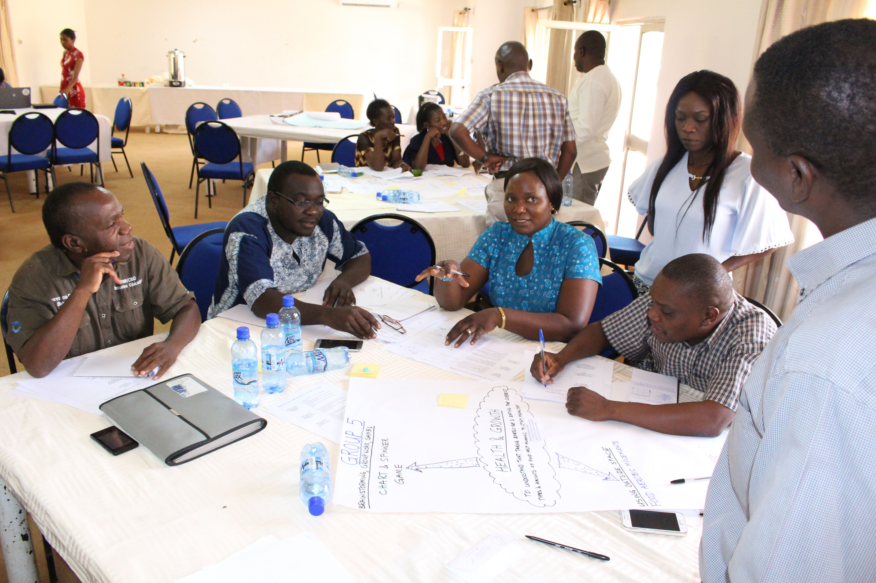
A group in Zambia working on adapting a learning activity

[Image description: 2 women and 3 men are around a table. On the table is a diagram drawn on a large sheet of paper. The people are talking and writing.]

Here is an example the trainer can give to help teachers:

Subject topic/learning objective: Maths – to order decimal numbers in ascending and descending order.
Active learning strategy from Session 7.3b: Quiz game – learners have to respond to teacher’s flashcards showing two decimal numbers at a time, and decide which is the higher or lower.
Adjustment for less able learners: Ensure every learner participates, for example, by giving each learner a decimal number on a card and they have to stand in a line showing ‘descending’ or ‘ascending’ order; or give out sets of cards of decimal numbers for each learner to arrange in ‘descending’ or ‘ascending’ order (the cards can be at different levels of difficulty).
Adjustment for more able learners: Invite a group of more able learners to teach the topic or prepare a quiz for the rest of the class; or give out sets of cards of decimal numbers for each learner to arrange in ‘descending’ or ‘ascending’ order at different levels of difficulty.

The trainer should collect feedback from each group so they share and discuss their ideas. They should discuss whether the suggestions for adjustments are practical for their classrooms. The suggestions can be displayed on flipcharts on the wall and looked at by teachers during break time.

The trainer should recap on how including learners from all ability levels means everyone stays engaged and learns new knowledge and skills. This includes high ability learners who need a challenge so that they do not become disengaged. Lower ability learners need extra help so they don’t fall behind and become discouraged.

Notes

Activity 7.5d: Differentiating for learners with disabilities
Main
45 minutes

This activity helps to develop teachers’ awareness and confidence with adapting lesson activities to include learners with disabilities such as visual, hearing or mobility impairments.

The activity is in two parts. In the first part, for about 20 minutes, teachers watch/read how teachers adapt learning activities so that they are accessible to learners with additional needs. This supports them to complete the next part of the activity, which is to think of ways to adapt their planned learning activities to meet the needs of learners who experience difficulties with seeing, hearing, moving, understanding, remembering, and communicating and so on.

Resource 7.25
EENET video programme 4 – preparing lessons

Resource 7.26
Video transcript

Teachers should watch EENET’s video programme 4 – Preparing Lessons (Resource 7.25). If the trainer cannot access the video online, then teachers can be given a copy of the video transcript (Resource 7.26) to read in pairs. Teachers will also need their copies of Resource 7.24, completed during Activity 7.5c.

In pairs, teachers should discuss and write down the main messages from the video and identify the key inclusive approaches to lesson planning.

For the trainer’s reference, here is the full list of approaches seen in the video:
- Adapt these activities for specific learners in your class, e.g., learners who cannot see, hear, or move very well.
- Create some simpler activities, or break tasks into smaller steps, for learners who have difficulty understanding or remembering.
- Before a lesson starts, organise any books, writing materials, and other objects that you will use.
- You can make teaching and learning aids yourself. Teaching and learning aids can be things collected or made for free, using items that are usually thrown away, like cardboard boxes, or bottle tops.
- If there are learners with disabilities and/or SEN in class, make sure to prepare materials for the lessons that they can use and manipulate.
- Get learners involved in making materials, e.g., older learners can help to make materials for learners in lower classes. Or sighted learners could help to make tactile materials for their friends who cannot see well.
- Improve your lesson planning, and make more creative teaching and learning aids, by working with other teachers.

Next the trainer should ask teachers to get into the same groups used for Activity 7.5c (their ‘home group’)

Three areas/tables in the room should be allocated for 3 ‘expert groups’. The idea is that each group will send delegate(s) to these tables to discuss how to further adapt their lesson activities to include learners with visual impairments, hearing impairments and mobility impairments.

The trainer should ask teachers to divide themselves up so they sit at the three ‘expert group’ tables. Each ‘expert group’ should have at least one teacher from each ‘home group’.

The trainer should place one card on each table, using the three cards cut out from Resource 7.27. There is a ‘See’ card, a ‘Hear’ card, and a ‘Movement’ card.

Note that the advice and guidance in the module on Including Learners with Additional Needs will be useful reference material for these activities.

Resource 7.27
Support for learners with disabilities

Each ‘expert group’ should look at the card on their table. It suggests ideas for ways to adapt activities to include learners with those needs. They should discuss these ideas and suggest further examples, including perhaps ways to adapt activities they have devised during this module.

After about 15 minutes the trainer should then ask teachers to re-join their ‘home group’.

Resource 7.28
Adapting activities for learners with disabilities

The trainer should give copies of Resource 7.28 to each group, with the following instructions:
- Look at Resource 7.28.
- Look again at your completed copies of Resource 7.24 (these may be on display). These show how you would differentiate an activity for less/more able learners to support the learning outcomes taken from Resource 7.13.
- In your groups, use the information you gathered while visiting the three ‘expert tables’ to help you complete Resource 7.28, Show how you would adapt your activity so that learners who have difficulty seeing, hearing, moving, understanding, remembering, communicating, etc., are included.

If a group thinks their activity is already accessible to learners who experience these difficulties, they should explain why.

Here is an example the trainer can give to help teachers:

Subject topic/learning objective: Maths – to order decimal numbers in ascending and descending order.
Activity: Quiz game – where learners have to respond to teacher’s flashcards showing two decimal numbers at a time, and decide which is the higher or lower.
Adapting for learners who have difficulty seeing: Use very large flash-cards: large pieces of paper/card with very large decimal numbers written on them. The best colours to use for visually impaired learners are black figures on a white or a yellow background. During the quiz these can be displayed two at a time and the learners are asked to put them in ascending/descending order. Alternatively, during the quiz the very large numbers are put on the table in front of the visually impaired learner so they are not looking longer-distance to see cards on a wall or held up by the teacher.
Adapting for learners who have difficulty hearing: When the quiz question is asked and displayed (see adaptation for visual learners above), make sure the question is read out and displayed on the board/wall or on a hand-out sheet. It is useful to include a drawing/photograph with each quiz question (if relevant and it does not give the answer away).
Adapting for learners who have difficulty moving: Make and use a document holder for the cards – a frame to display them on – if the teacher gives the cards to groups to sort into ascending/descending order. This frame ensures the cards can be moved closer to the learner.

The trainer should briefly list the ideas from each group on the board or flipchart. There could be 3 column headings – see, hear, movement.

Finally, the teachers can view the groups’ completed differentiated lessons during a gallery walk, where group members explain their ideas and take questions from their colleagues.

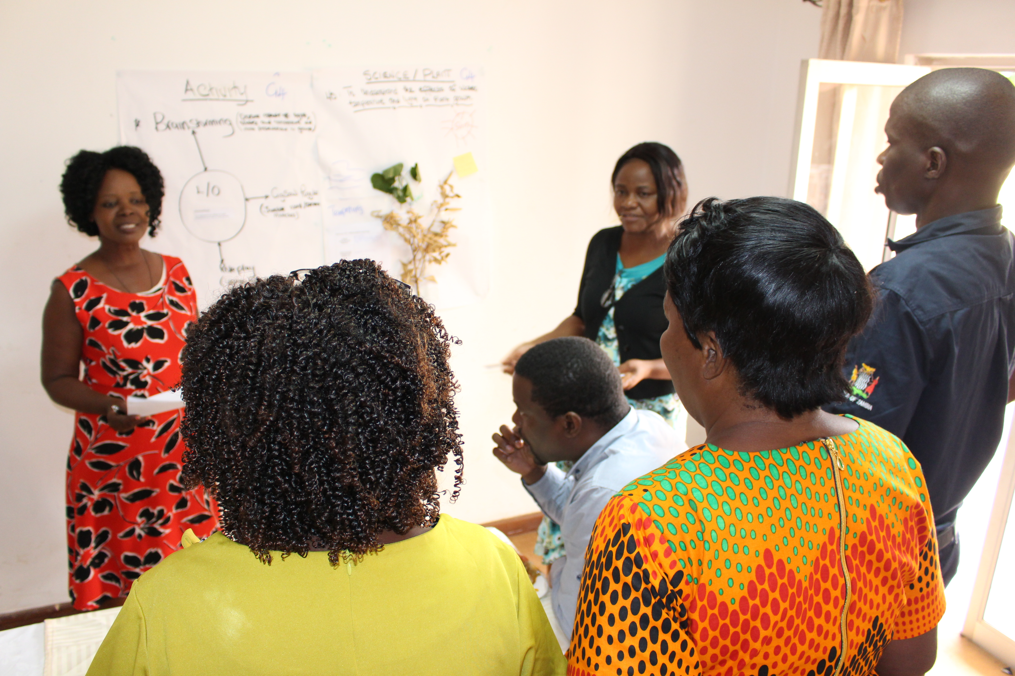
A gallery walk in Zambia

[Image description: two women are standing next to large sheets of paper on the wall containing diagrams and words, and with leaves/plants stuck on. Two men and two other women are looking at the presenters and sheets of paper.]

Session 7.6: Using assessment in support of learning
Using assessment in support of learning is a vital active learning strategy for effective inclusion. It means teachers can effectively plan what needs to be learned, communicate that to the learner, and design and modify tasks to ensure each learner can access the learning. This session focuses on ways of using assessment in support of learning, including providing effective feedback and asking better questions. Two important questions teachers need to continually bear in mind are:
- What do I want the learner to do?
- What do I want the learner to learn?

Teachers should be reminded of the work they did in Module 4 ‘Screening and identification of learning needs’.

It should be emphasised that peer-assessment and self-assessment are very powerful teaching tools and crucial to the assessment for learning process. This will be explored in a later module focusing on learners’ participation in their own learning.

Activity 7.6a: Using assessment for learning
Main
45 minutes

This activity will further develop teachers’ use of assessment information to advance learning.

Before setting the task, the trainer should explain the following assessment terminology:
- ‘Assessment of learning’, or ‘summative assessment’, tells a teacher if a learner got a question right and if they have met learning objectives. This assessment usually happens at the end of a lesson or unit of work.
- ‘Assessment for learning’, or ‘formative assessment’, helps identify why a learner performs as she/he does and how the learner can improve. Examples of formative assessment include observing and/or questioning learners as they conduct a task. It means that the teacher can adjust or adapt lesson delivery mid-way, or adjust their plan for the next lesson to ensure learning goals are achieved.

Teachers should work in groups and be introduced to the following scenario:

After looking as a whole class at some children’s stories and books, and discussing how they are constructed, the teacher has set the class the following task: ‘

Write a story that you can read to younger children.
The teacher is walking around the classroom and looking at the learners’ work over their shoulders while they do this. The teacher is checking if everyone is on-task.

The trainer must state that it is very difficult to provide every learner with individualised attention, especially in large classes. Therefore teachers should assume that the teacher in this scenario is using his/her knowledge about which learners need more attention or have not had individual attention for some time.

The trainer could suggest an example. For instance, the teacher is aware of a particular learner called Patience who has difficulty writing; her literacy skills are undeveloped. She does, however, enjoy drawing. The trainer should ask teachers how the teacher might intervene to support Patience with the story-writing task. Teachers must be reminded that the teacher’s intervention can only take a matter of seconds or a minute, as he/she has everyone else in the class to attend to. Answers could include:
- The teacher suggests Patience draws her story using very simple captions.
- The teacher has prepared some support materials to help Patience. For example, the teacher could give Patience a template with some simple questions to help her organise ideas such as: ‘Who is your main character?’ ‘What is she/he doing?’ Or the teacher could give Patience a list of words/vocabulary that she has learned recently and see if she can use these to build up a short story.

Resource 7.29
Interventions to support learning

The trainer should give Resource 7.29 to each group. She/he should explain that the following exercise considers ways the teacher could improve learning through their interactions with each learner. The trainer gives teachers the following instructions:
- Read aloud to each other what it says about how 5 particular learners are progressing with the task.
- Write in the second column ways you think the teacher could usefully respond to each learner.
- Each group should discuss each learner one at a time.

After about 30 minutes the trainer should go through each individual learner and ask groups to feed back some of their suggestions. These should be discussed. The trainer can refer to the following for further ideas if they are needed:

Ideas to guide trainer:

Thandi: Show some beginning sentences for stories for younger children (e.g., ‘once upon a time there was….’).
Joseph: Ask Joseph to read the story aloud and show him where the natural breaks are. Then ask him to punctuate where those breaks are, before continuing writing (with punctuation).
Trina: Suggest Trina writes a story about a girl who loses her bangle and searches the village for it, asking people in each house if they have seen it.
Francis: Check if there are any improvements he can work on and give him an extended activity such as designing a ‘book cover’ for his story, illustrating parts of the story with drawings, or writing a letter to a younger class or local nursery/primary school to ask if he and his class can visit to read stories to them.
Basia: Smile and indicate you have noticed her effort.

Finally, the trainer should ask teachers to think about the information the teacher gained from going around the class as they performed the story-writing task. How can these insights inform the teacher’s planning of the same task again in future – e.g., how could the teacher use this information to make changes and improvements?

The trainer should emphasise that, because it is difficult to observe every learner in a large class during the lesson, it is important that formative assessment that informs changes to lesson planning includes observation of learners across the ability range.

Notes

Activity 7.6b: Feedback to improve learning
Main
50 minutes

This activity will promote the effective use of feedback given to learners.

The trainer should explain that learners do best when they take responsibility for their own learning, knowing their progress and what they need to learn next. To do this they need accurate feedback, clearly and constructively communicated. They need to know their learning goals, what they are doing well, what the gaps in their learning are, and how they can improve. This means giving learners guidance, not just a score or mark.

This activity is in two parts. In the first part, for about 15 minutes, teachers read some ‘Dos’ and ‘Don’ts’ on ways to give feedback. This supports teachers to complete the next part of the activity, which involves role-playing classroom situations to better understand the impact of feedback, and practising making feedback constructive.

Resource 7.30
Useful feedback

Resource 7.31
Dos and don’ts

The trainer should ask teachers to work in pairs and give each pair a copy of Resource 7.30 and Resource 7.31.

The trainer should ask teachers to read both resources. After reading Resource 7.30, they need to decide which of the statements in Resource 7.31 are effective and which are ineffective. They could make notes on the sheet or, if the trainer prefers, they could make notes separately on a piece of blank paper with two column headings – ‘Effective’ (or ‘Dos’) and ‘Ineffective’ (or ‘Don’ts’). The trainer should ask teachers to share what they have decided and give them the chance to explain and discuss their decisions.

It is important, especially in settings where English is an additional language, which the trainer allows for interpretations of what is an ‘effective’ or ‘ineffective’ response to vary, though these terms need to be explained in terms of effective inclusive practice.
For the trainer’s reference, the following are likely to be effective responses:
- “That is a good idea, and it might work better if you...”.
- “I have marked where you have missed full stops or commas. Can you try to put in the correct punctuation?”
- “…finally, you were asked to summarise your findings but you didn’t. Thandi can show you hers as an example of how you can do this…”.
- “…yes, there is a lot of work still to do but I am really pleased with your effort.”
- “Last week you struggled with this but now you can…”.

The following are likely to be ineffective responses:
- “I don’t know. It seems silly to me…”.
- “The rest of the class understand so why don’t you?”
- “I don’t care if you don’t have a ruler, next time I want accurate measurements”.
- “Come on, activate your prior knowledge and tell me what it means”.
- “Read this to the class so they can see how lazy you are”.

The trainer should remind teachers of the two key questions for teachers to continually bear in mind:
- What do I want the learner to do?
- What do I want the learner to learn?

Resource 7.32
Feedback role-play cards

The trainer asks teachers to sit in groups of four where possible, choosing to sit with people they have not sat with before. If there are more than four people in a group, the additional teachers should be given the role of ‘observers’. The trainer gives Resource 7.32, a set of cards, to four members of each group, along with 2 pencils and 2 pieces of drawing paper per group. The cards must be handed to the group members, face-down.

The trainer should ask each teacher to take a card, read it without showing it to the rest of the group, and keep it without revealing it to the others. Two teachers in each group are ‘learners’ and two are ‘teachers’. Ask each teacher to take five minutes to get ready to be in role.

When everyone is ready, the trainer should announce a task that the ‘learners’ must start straight away. Using the pencil and paper provided they should draw a house and garden-plot in 5 minutes. The trainer can announce the task has started and, after 5 minutes, announce that the ‘learners’ must stop. During the 5 minutes, the trainer should make sure that the ‘teachers’ in each group stand up and closely observe each ‘learner’ in their group in turn, giving feedback as they watch each ‘learner’ draw.

If any teachers have been allocated ‘observer’ roles, they must watch the interactions carefully and be ready to give feedback at the end of the activity.

Once the ‘learners’ have stopped drawing, the trainer should ask the groups to come out of their roles and do the following:
- ‘Learners’ in each group should share with their group the impact of the feedback they received from the two ‘teachers’ – how it made them feel and what they learned from it.
- ‘Teachers’ in each group should share their experience of giving feedback.
- Any ‘observers’ should share what they observed during the role-playing.

Then the trainer can bring all teachers together to share some of the key points made in each group. The trainer should emphasise:
- Feedback is providing information to an individual which focuses on their performance or behaviour.
- The feedback provided should be delivered in a positive manner and lead to action to affirm or develop an individual’s performance or behaviour.
- Feedback provided should not be of a personal nature and should focus on data, facts or observed examples of evidence.
- Feedback should not be critical of learners for not doing something that was not a requirement stipulated in the instructions. This would be unfair and will only serve to promote mistrust.

Finally, the whole group can discuss any further issues arising about giving constructive feedback in the classroom. It may be useful for the trainer to mention how research shows that feedback plays a vital role in teaching and learning. For example, if feedback is given and sought, John Hattie’s findings published in ‘Visible Learning: A Synthesis of over 800 Meta-Analyses Relating to Achievement’ (2008), are that teaching and learning that is visible occurs when the following are present:
- teachers using each lesson to teach better,
- feedback is given and sought, and
- active, passionate and engaging people are the teachers in their learning.

Notes

Activity 7.6c: Asking better questions
Main
25 minutes

This activity will raise awareness of the importance of asking questions that improve learning, involving learners in the lesson through thinking and providing the teacher with an insight into the level of learning.

The trainer should ask teachers to work in pairs.

Resource 7.33
Better questions

Resource 7.34
Some questioning strategies

The trainer should give each pair a copy of Resource 7.33 and ask them to read it. The trainer should ask each pair to spend a few minutes thinking of an example question or beginning of a question to illustrate up to three of the points. For example:

- For number 2 (‘reinforce previous learning’), teachers could propose question beginning:
‘Explain why ….?’ ‘Say what ….?’ ‘When did……?’

- For number 6 (‘extend thinking from concrete to analytical’), teachers could propose a question like:
‘Tell me what the character did at the end of the story and suggest why?’

- For number 9 (‘Encourage creative thinking and problem solving’), teachers could propose a question beginning:
‘Work out why…?’

Then the trainer should give Resource 7.34 as a hand-out for teachers to read and keep for future reference as an example of some questioning strategies. The trainer and teachers can discuss this resource to understand each strategy.

Session 7.7: Using action research to promote active learning
Teachers should be reminded of Session 1.6 (‘Using action research’) in Module 1: ‘Introduction to Inclusive Education’, and of Session 3.4 (‘Strategies and solutions for identifying out-of-school children’) in Module 3: ‘Identifying Out-of-School Children’.

The trainer will re-emphasise how every school has a unique set of challenges and strengths in education, requiring a unique set of responses. Teachers, therefore, cannot simply rely on ‘experts’ from elsewhere to tell them how to make their school inclusive. Teachers – along with the learners, parents/guardians/care-givers and other members of the school community – need to be experts in their own situation. They need to be able to investigate what is happening in their school and community, and identify barriers to inclusion that need tackling, or inclusion solutions that need expanding. And then (with the help of others) start taking relevant action. Action research is very useful for this. It helps stakeholders to look at their situation, analyse the problems, suggest solutions and act.

In this session teachers will conduct a ‘supervised’ action research activity that could support an action research initiative in their own school, or schools they work with, and communities.

Activity 7.7a: Deciding the focus
Main
45 minutes

This activity will provide teachers with the opportunity to decide what their research focus will be.

The trainer should tell teachers that they will be visiting a pilot school to conduct observations and interviews. During this activity teachers will decide what they want their action research to focus on.

The trainer should give teachers the following instructions:
- Individually look back over the work you have done throughout this module and make a (mental) note of what each session was about.
- Thinking about all the sessions, decide what you might like your action research to focus on. Think of reasons why, and think about whether it is a focus that you will be able to observe in the pilot school. You may wish to recollect/revisit the ‘vision’ you decided on in Activity 7.1c and the changes you recorded in Resource 7.4 which you said would be needed for that vision to be realised. This may help you decide what you want to explore further.
- Pair up with another teacher and discuss your decisions with each other to make sure they seem practicable.

The trainer should write each teacher’s chosen research topic on the board or flipchart. The whole group can discuss whether the chosen topics seem practicable. Finally, the trainer should ask teachers together to present their research focus in the form of an enquiry or question.

For the trainer’s reference, the following enquiries could arise from the main session topics covered in this module:
- Is the classroom environment ready for active learning? If yes, why? If no, why not?
- Does the teacher use any active learning strategies? If yes, what are they? If no, what teaching strategies are most commonly used?
- Is there pair work or group work? How effective is it? How do we know?
- Do teachers differentiate for learners of different abilities or disabilities? If not, how does that affect learning? If yes, give examples and evidence of how it affects learning.
- What kind of feedback do the learners receive? Is it constructive or negative? What effect does this have on learning?
- What kind of questioning is there in the classroom? Is there evidence of teachers using questioning strategies? What effect does the questioning seem to have on learning?

Activity 7.7b: Preparing for the school visit
Main
60 minutes

One aim of this activity is to help teachers remember some of the methodologies which they can then use in their action research situation. The trainer must explain clearly, however, that action research in a real-life situation will involve more than simply replicating what they do in this short practice visit to the pilot school. This activity also helps teachers to compile questions/observation sheets to support their action research visit.

Explain to teachers that during this activity they will decide how they will record what they see, and consider what questions they might ask.

Resource 7.35
Example of an observation sheet

Resource 7.36
Interview guidelines

The trainer should remind teachers what they have already learned about asking interview questions and preparing observation sheets (especially in Session 3.4: (‘Strategies and solutions in identifying out-of-school children’) in Module 3: ‘Identifying Out-of-School Children’.

They should be especially reminded of the following:

Observations
- Record what we see as objectively as possible.
- Pay attention to what happens, interactions between people, body language, what is said, and also the silences.
- Record what you see or hear on an observation sheet.
- Remember observers often need to be as unobtrusive as possible – for instance if you are observing a classroom, you should not ask the learners or teachers questions or interfere with the running of the lesson.

Interview questioning
There are two basic types of questions:
- Closed questions – these elicit short, fixed answers. ‘Yes’ and ‘no’ answers are examples of closed questions.
- Open questions – these elicit longer answers which are not fixed or limited to predetermined categories. ‘Why?’ questions are open questions because they require explanatory answers.

Focus group discussions
- These are discussion groups with perhaps one particular stakeholder group, for example, parents/guardians/care-givers, or a range of stakeholders who focus on a particular topic.
- Teachers will need to prepare for a focus group discussion in a similar way to preparing for an interview. Prepare guiding questions to help you get the discussions started, and to ensure that you stay ‘on topic’.

The trainer should highlight that focus group teachers are not always used to speaking openly, which can make it difficult to get a discussion started. In their groups teachers should think of methods they could use to stimulate a lively discussion, even if their focus group teachers are shy or not used to expressing their views. The previous workshop activities may offer inspiration. The trainer then facilitates plenary feedback and makes notes on a flipchart.

Mapping
- Mapping is a way of making sense of (and sharing) the school environment.
- It includes the natural and built environment, and also the social and cultural environments.
- In an action research activity, you can use a map to highlight barriers (and solutions).

The trainer should then give out Resource 7.35 and Resource 7.36 and ask teachers to read both.

The trainer should ask teachers to work in pairs, helping each other to:
- decide who they might interview at the pilot school to investigate their chosen topic, or whether they want to meet a focus group,
- prepare some questions that they could use,
- decide what they will be looking for if they visit a class in session, and
- decide how they may go about using mapping to support their research (this will be particularly relevant if the enquiry is into whether the classroom environment is ready for active learning).

Teachers can be reminded to revisit the out-or-school mapping they created in Module 3: Identifying Out-of-School Children.

Teachers should then give feedback in plenary, so the trainer can check the interview/focus group discussion questions, and both the trainer and other teachers can further discuss the observation/questioning planned, including use of open and closed questions.

Notes

Activity 7.7c: Feedback on the action research session
Main
60 minutes

One of the benefits of using action research is that different people can be involved as researchers using techniques that best suit them and the stakeholders they want to find out information from. During the action research session, teachers may not have had time to try more than one of the techniques. A detailed feedback session can therefore help them to share what they learned when using other techniques. It also enables them to consider lessons learned when planning to conduct more extensive action research in future.

Before the next training, each pilot school group should create a presentation (visual and verbal) which pulls together all of the information they gathered using the various techniques – classroom and around-the-school observations, mapping, interviews and focus group discussions, and so on.

During the workshop, the trainer should facilitate one of the fun feedback/sharing methods already suggested in previous modules (carousel, press conference, etc.). The trainer can also ask teachers to reflect on the techniques they used during the action research practice session – the pros and cons, what went well, what wasn’t so successful, what they would do to improve the action research, etc.

Notes
Module
7
Resources

Resource 7.1: Reactive and proactive responses
People’s reactive responses | People’s proactive responses
…are predominantly influenced by:  - their physical environment – their attitude and feelings fluctuate with the conditions around them  - their social environment – their attitudes and feelings fluctuate with how others treat them or others feelings  - a belief that they are what they are today because of their genes, their past and their present environments, and that there is little they can do to effect change | …are predominantly influenced by:  - consciously held values  - a belief that they can choose their response to what happens to them  - a belief that they are what they are today largely because of the choices they made yesterday

Resource 7.2: Reactive and proactive statements
“There’s nothing I can do”

“She makes me so mad”

“I have to”

“Let’s look at what we can do”

“They won’t allow that”

“I can change”

“If only”

“That’s just the way I am”

“I choose”

“I will”

“I commit myself to”

“I must”

“I prefer”

“I can’t”

“I can”

Resource 7.3: ‘Our vision’ cards
Copy and cut out a set of these cards for each small group.

“The needs of each learner inform lesson-planning.” | “Our teaching is flexible and we use a range of teaching strategies to ensure the achievement of all learners.”
“All learners feel their cultural heritage is respected and that they are safe when they are at school.” | “We use assessment to strengthen learning rather than exclude learners from learning, recognising evidence of learning to help learners progress.”
“All learners enjoy their lessons and look forward to them.” | “We plan activities to promote positive relationships between the learners.”
“We have high expectations of all the learners, including those with additional needs.” | “We design our curriculum around the needs, capabilities and aspirations of our learners.”
“Our lessons are learner-centred and learning is active; we are creative in our use of limited resources.” | “Our learners understand the learning objectives of each lesson and our activities promote independent learning.”

Resource 7.4: Realising ‘our vision’
My vision is…
If the vision is to be realised for all my learners, changes and developments needed in my classroom may include…

Resource 7.5: Classroom photos
(Source: EENET (2017) ‘An Inclusive Day’, video training manual, programme 5, Hand-out 5a)
Photo 1
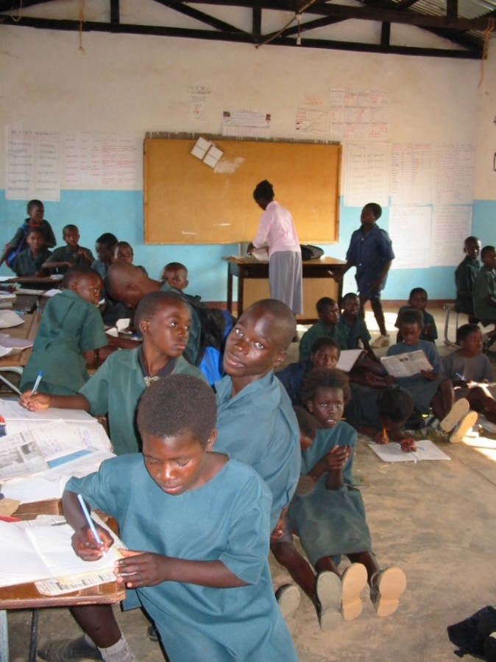
Zambia, EENET

Photo 2
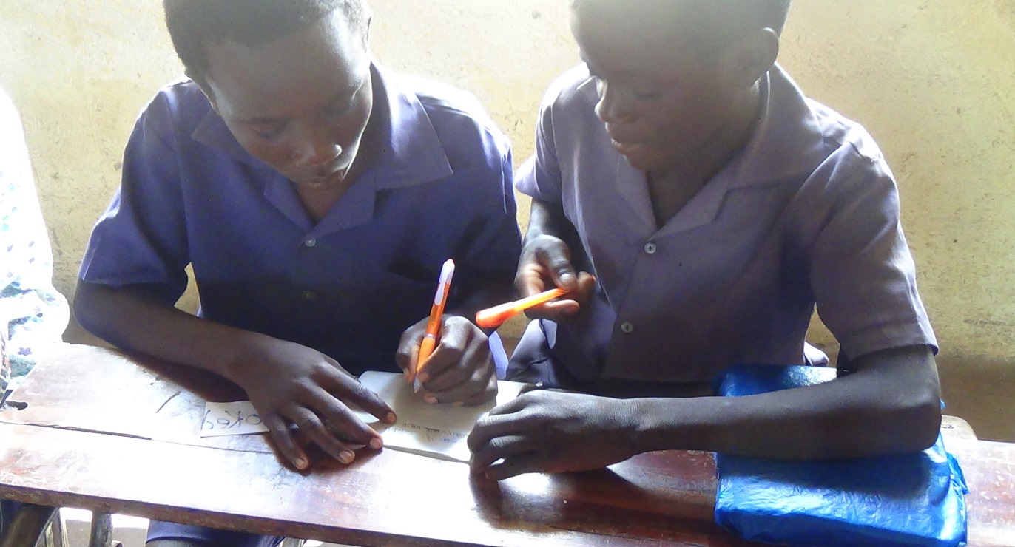
Zambia, EENET

Photo 3
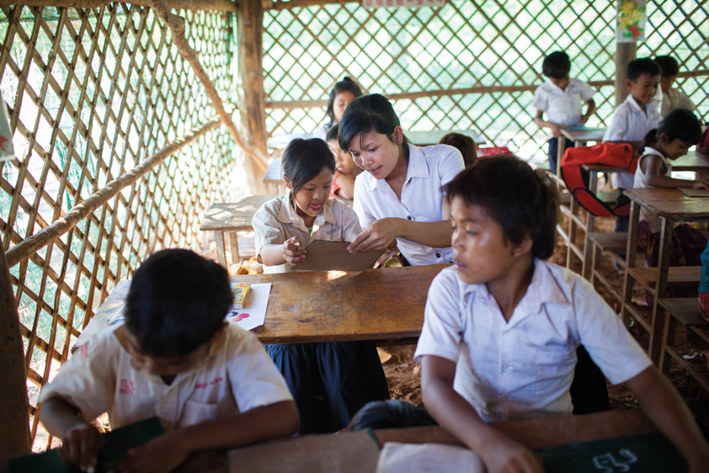
Cambodia Nicolas Axelrode / HI

Photo 4
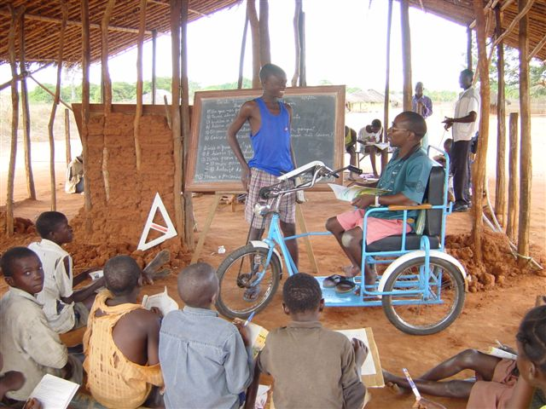
Mozambique, E. Schurman

Photo 5
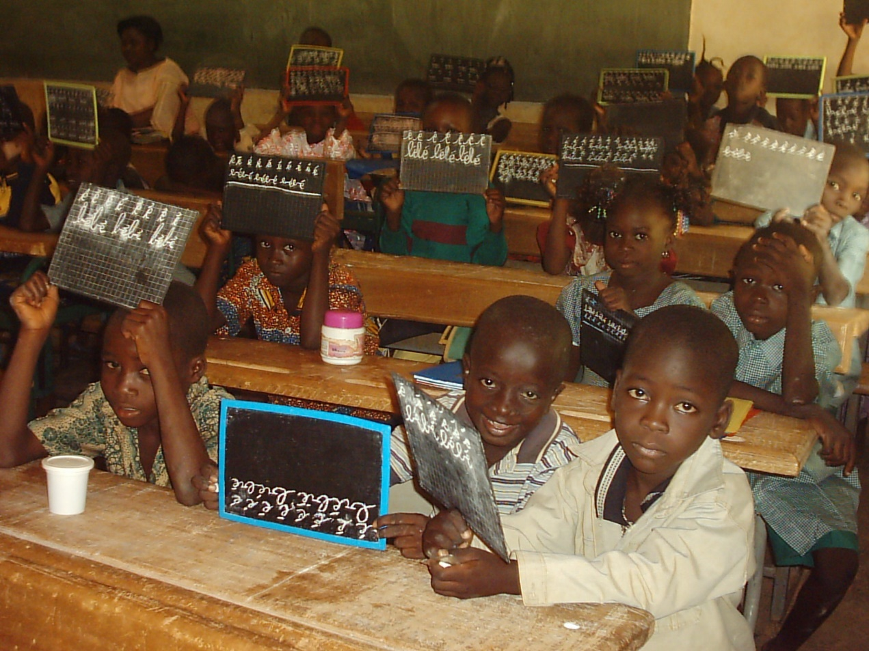
Burkina Faso, S. Imerovic

Photo 6
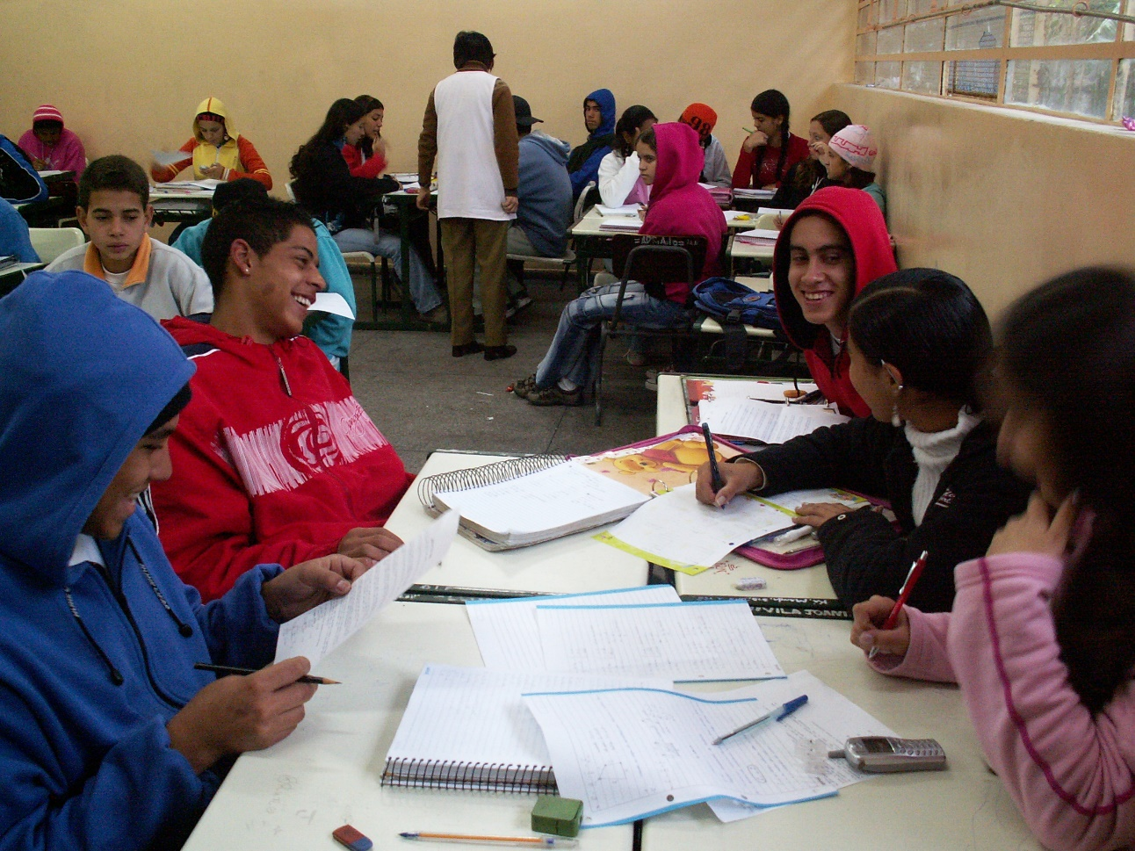
Brazil, W. Ferreira

Resource 7.6: Responding to the classroom photos
Look at and discuss the photos of classrooms in Resource 7.5. Think about and make some notes on the following questions:

Photo | Good things | Challenges | Which learners may struggle?
1
2
3
4
5
6

Resource 7.7: Recommended changes
- Look again at the same photos (your group should start with the same photo as last time).
- Answer these questions:

- What simple changes could you make in these classrooms to ensure that:
- learners feel more comfortable,
- learners can see or hear better, and
- learners and the teacher can move around more easily?

- What changes might be needed that you could not make by yourself as a teacher?
- Describe the changes.
- Explain who else needs to be involved and why.

Photo number | What simple changes could YOU make? | What changes are needed that you could not make yourself as a teacher?

Resource 7.8: Organising the classroom’s physical environment
Copy and cut out these cards and give a set to each group. (There should be 5 ‘main organising tasks’ cards and 13 ‘supporting action’ cards)

Main organising tasks | Supporting actions
Maximise classroom space | Remove any unnecessary furniture, reducing size of teacher’s desk if necessary.
 | Consider using mats, cushions or rugs (instead of chairs/tables) that can be placed temporarily outside and even used there for certain lessons.
 | Make sure every learner can see the main chalkboard and place several small chalkboards around the room for group work.
Enable movement | Establish entry and exit procedures (e.g., that ensure learners sitting at the back enter first and leave last).
 | Plan movement in advance to ensure minimum disruption (e.g., when moving from sitting in rows for a test, to groups for a science activity).
 | Plan ahead to make sure learners can access resources they need and those with additional needs can access the activities.
Use space outside the classroom | Go around your whole school area and identify good places for outdoor learning.
 | Identify areas where learners can safely work, and where particular projects can take place (e.g., a place for role-play and performance or maths enquiry).
 | Make sure learners are clear about the task before they leave the room, monitor them while they are outside and make sure they all come together at the end to feed back on their work.
Display learners’ work | Be creative and display work on walls and doors or even hanging from ceilings. Display work on part of the chalkboard during a lesson.
 | Use string, clips, tape or even blunt thorns.
Involve the learners | Give learners responsibilities to help manage the classroom space (e.g., creating display boards or monitoring displays).
 | Ask the learners to suggest solutions when a problem occurs.
 | At the beginning of the year ask the learners to suggest ways of improving the physical space.

Answers for the trainer:
- The ‘supporting action’ cards in the right-hand column are arranged next to the ‘organising tasks’ cards they support.

Resource 7.9: Organising the classroom’s psycho-social environment

Copy and cut out these cards and give a set to each small group. (There should be 5 ‘main organising tasks’ cards and 14 ‘supporting action’ cards.)

Main organising tasks | Supporting actions
Learn everyone’s name | Make a seating chart, actively use their names and ask learners to stick to the same seats for at least the start of each lesson for the first few weeks.
 | Play interactive ‘getting to know you’ or name games so everyone can learn each other’s name, and have learners take turns over the first few lessons to introduce themselves to the whole class at the start of each lesson.
 | Use name cards and tags and engage with all learners equally.

Involve the learners in establishing an orderly classroom | Appoint ‘class assistants’ to help with demonstrations, giving out materials, etc.
 | Train all learners in specific roles for group learning – leading, note-taking, timekeeping, reporting, etc.
 | Ask the learner, with your help, to develop classroom rules to agree, sign and display.
Attend to individual learner | Track progress and conduct diagnostic assessments early on so you know which learners need extra help.
 | When you are concerned about performance or change in behaviour, hold an individual conference with the learner in a calm and confidential space.
 | Create learner profiles that include information about a learner’s home life.
Encourage talk | Give each learner the opportunity to talk in class in the first few weeks to encourage them to participate in whole-class discussions.
 | Encourage questions and comments; be receptive and warm and give prompts and time to answer to quieter learners.
 | Acknowledge something is difficult before asking learners to respond to difficult questions, and make them feel it is OK to make mistakes.

Be available | Set aside 10-15 minutes at other times of the day to see learner who want to ask questions or discuss the work in more detail.
 | Engage with extra-curricular activities.

Answers for the trainer:
- The ‘supporting action’ cards in the right-hand column are arranged next to the ‘organising tasks’ cards they support.

Resource 7.10: EENET’s ‘An Inclusive Day’ video, programme 7 on teaching and learning

Go directly to the video on YouTube. It is 13 minutes long:

www.youtube.com/watch?v=KyheWrstoHU

Or visit EENET’s website to find out more about the video and access viewing and download links:

www.eenet.org.uk/the-10-videos-and-manuals/

Resource 7.11: Key extracts from the video transcript

- In each lesson, you can use a variety of different activities. Plan to use activities that involve looking, listening, talking, touching and moving. This variety of activities means you can adapt each lesson to suit different learners’ interests and abilities.

- Make lessons fun. Start by being a happy, smiling teacher. “If teachers have a smiling face and good will to us, we feel good … They play games with us and these energise our minds and we understand more.”

- Learners are more likely to feel included if the subjects they learn seem relevant to their lives. There are lots of ways to bring real life into the classroom. You can use objects that are found at home. You can use objects found in the environment. Project-based learning helps to link lessons with real life. You can also use role-play to bring a lesson to life.

- You can use spaces outside the classroom to make lessons feel more connected to the community or environment. “If they go outside they have the chance to refresh their minds. If they stay in class and the teacher talks all the time, they will be sleepy.”

- Some learners learn better when they work together in groups or in pairs. “Group-work means learners will work together to share their ideas to create something good. The group-work will also allow the learners to accept one another. Because there are learners with disabilities in the group, they can better understand each other. The group-work will also allow the weaker learners to do better. The group-work provides pleasure for the learners, and I, to be honest, find pleasure in watching the learners develop and achieve something.”

- Learners learn a lot from discussing with each other.

- You can use peer learning methods to bring variety into lessons. “One of the biggest resources in a school setting are the other learners…”. Peer learning can be particularly useful in large classes.

- Use text books creatively. You can encourage learners to read together from books and discuss what is in the book. You can pair a learner who reads and understands well with one who need more support.

- Provide individual support to learners who need it. Spend time observing the class to see who may need extra help.

- Giving the learners feedback that is positive and encouraging, even if they have got something wrong, can help them feel included and motivated to learn.

Resource 7.12: Active-learning approaches
Ideas/strategies used | Comments

Resource 7.13: Learning outcomes

Copy and cut out these learning outcome cards and give each small group a different card.

Language  Begin to use prepositions for time, location and means, e.g.,  - at six o’clock  - I live in Livingstone  - at number 23  - with a ruler  - by boat… | Maths  To demonstrate the concept of:  - a whole, (ii) a half, (iii) a quarter, (iv) a third  To order these concepts from smallest to largest and largest to smallest and to understand the terms ‘smallest’ and ‘largest’.

Science/plants  To understand the effects of water, temperature and light on plant growth. | Geography  To describe how the weather affects living conditions in the learners’ locality.
Science/health and growth  To understand that taking exercise and eating the correct types and amounts of food help humans to stay healthy. | History  Aim to understand chronological order, the time periods of history and how time periods are classified.

Resource 7.14: Strategies for active learning
Active learning involves learners being fully engaged and participating in the learning process. In active learning there is greater emphasis on solving problems and developing analytical and critical thinking skills. So active learning strategies involve learners doing things, often together, and thinking about what it is they are doing. Active learning therefore provides greater opportunity for feedback.

Below is a list of types of activities that teachers might use, flexibly, to encourage active learning. These need to be planned in response to learners’ needs, interests, and existing level of knowledge and experience.

- Using toys or artefacts
- Brainstorming
- Using pair and group work
- Giving opportunities for learners to use their first language where it helps understanding (e.g., providing notices and labels in their first language)
- Providing visuals that support vocabulary/language acquisition
- Group discussions and collaborative problem solving
- Using experiments
- Concept-mapping
- Learners taking the lead: choosing, peer-teaching, researching and/or making presentations
- Creating a poster or other piece of work for display
- Using games, quizzes or puzzles
- Using role-play, drama and/or performance
- Using outside spaces

Resource 7.15: Benefits and challenges of group work
Benefits of group work | Challenges of group work
- Increases participation  - Learning from each other  - Promotes talking/listening  - Develops communication and social skills  - Co-operation/teamwork  - Promotes active learning  - Improves attentiveness  - Increases thinking and problem-solving skills  - Greater teacher interaction with learners  - Learner independence  - Motivates and engages  - Develops leadership skills  - Changes the pace of learning  - Deepens understanding  - Greater opportunities for assessment | - It may be difficult to move classroom furniture to accommodate effective group work  - Can be noisy  - Learners may not get on  - Learners may go off task  - Hard for the teacher to monitor everyone  - Takes up a lot of time  - Some learners may leave the work to others  - Learners may always be grouped with the same people  - Some groups finish well before the others

Resource 7.16: Planning the composition of each group
Copy and cut out these cards and give a set to each group

Task | Mixed-ability, targeted or same-ability groups? | Why?
Conducting a science experiment which involves exploration outdoors and a presentation | mixed-ability | So that all learners can learn from each other, and bring diverse skills to meeting the demands of the task
Preparing for a classroom debate on whether the world would be better off without religion | mixed-ability | So that as many different backgrounds, views and experiences can inform their arguments
Supporting learners who were late starting the school term to catch up | targeted | So they have a chance for extra help as they are behind
Revising for external exams by discussing a range of questions about a particular topic | Same-ability | So, they can focus on questions and work at the level that they need to perform
Your own tasks

Answers for the trainer:
- The ‘ability’ and ‘why?’ cards in the right-hand columns are arranged next to the ‘task’ cards they support.

Resource 7.17: Checklist for planning successful group work
Is the task specific and clear?
Is the task suited to group work (involving problem-solving, getting to grips with new concepts, exploration/ research, or comprehension)?
Have you planned how to make up the groups? Are you being sensitive to gender and inclusion issues, making sure everyone participates?
Have you accounted for restrictions on learner movement in a large class?
Will all learners be taking part?
Have you planned for learners in each group to hold particular responsibilities?
If it is possible, have you organised for an older learner or another adult to come in and help?
Are the activities planned and equipment prepared?
is the class trained in how to conduct group work or do you need to set aside time to do this?
Have you planned how groups will feed back on the task, e.g., through a presentation, reporting, etc.?
Are you going to be clear and strict with timing to ensure pace and engagement?
Do you plan to move around the classroom, support learning, and see how learners are interacting?
Do you plan to use this opportunity for observation and assessment of some individual learners?

Resource 7.18: Roles and responsibilities
Copy and cut out these cards and give a set to each group.
Chair | Note-taker | Reporter | Organiser and time keeper
Makes sure task is understood and makes sure everyone has a chance to talk | Writes down key points making sure the reporter can read them. | Tells whole class what group has said or done | Makes sure group has all the equipment it needs and that it keeps to time.
‘What do you think? Is he right to say this material is magnetic?’ | ‘Let me check. How do you spell copper?’ | ‘We thought that four materials were magnetic.’ | ‘Here are the pens.’
‘What do you think is inside a battery?’ | ‘Can I check that this is our list of agreed points?’ | ‘We decided attraction isn’t good test if material is magnetic.’ | ‘I will fetch the extra battery.’
‘You have said quite a lot. Let someone else have a say’ | ‘Should I put that first or last?’ | ‘We found it very difficult to decide because….’ | ‘We’ve only got one minute left.’
Add your own example | Add your own example | Add your own example | Add your own example

Resource 7.19: Classroom rules for group work

Co-operate with each other | Work hard all the time | Always work as a group | Help each other
Talk and listen carefully to each other | Listen to instructions | Share ideas | Discuss things quietly
Try to get on with everyone in the group | Be sensible | Be happy to work with everyone in the group | Try to agree with each other
Have the right equipment | Respect everyone’s opinions | Move around the classroom carefully without disrupting others’ learning | Be prepared to take on any role, and encourage others to do so too
Add your own example | Add your own example | Add your own example | Add your own example

Resource 7.20: Checklist for running successful group work

Do learners know where to go when they move into groups?
Do the learners know what to do? Is the task specific and your instructions clear?
Have you clearly explained the objectives of the group work?
Are you regularly enforcing high expectations of good group work behaviour?
Are you allowing for questions so everyone is clear about the task?
Does the class know what hand signal/command to look/listen for so they know when to stop talking?
Is everyone clear about the timing and being regularly told how much time is left?
Have you prepared an extension task for learners who finish early?
Are there opportunities for groups to provide feedback, or make a presentation of their work?
Are you moving around the classroom to see what progress learners are making and what problems are coming up? Are you giving advice, encouragement, and extra individual help where it is needed?

Resource 7.21: Grouping strategies for different purposes

Name of strategy | What is it? | Why use it?
Think, Pair, Share | Learners think individually about a question/problem, pair up with someone to discuss their thinking, and then share their ideas with their table group, and finally the whole group. | Learners use their previous knowledge and share their ideas with peers. This gives learners a chance to organise their ideas before presenting them to the wider group.
Turn and Talk | The teacher asks the class a question and learners turn to the person next to them to discuss. | Learners are able to share their ideas with others and use their previous knowledge about a topic.
Jigsaw | Like completing a jigsaw, each learner in a ‘jigsaw group’ is responsible for learning a piece of information/a topic. They do this in a temporary ‘expert group’ before returning to their ‘home’ jigsaw group where the team members teach each other what they have learned. This enables them all to understand the whole picture. | It encourages co-operation while developing reading/ comprehension skills. It supports good behaviour by engaging learners and it requires effective teamwork, interdependence and other interpersonal skills.

Fish Bowl | A few learners sit in a ‘fishbowl discussion group’ in the centre and the rest of the class sit around them. The discussion group members answer given questions and share their ideas. They can also answer questions posed by the larger group. The learners rotate in and out of the fishbowl discussion group. | It is suitable for large groups and can involve everybody. It shows learners what a good discussion looks like. It can make an excellent pre-writing activity, allowing learners explore questions or ideas more deeply before undertaking an independent assignment.
Four Corners | Learners show their position on a specific statement (‘strongly agree’, ‘agree’, ‘disagree’, ‘strongly disagree’) by standing in a corner of the room designated to each statement. | This activity requires everyone to take a position. It is a good warm-up activity where learners respond to a statement about a topic they will be studying. Also, it can be a follow-up activity when learners apply what they have learned.
Round Robin | Learners form groups of three or four. They pass around a sheet of paper and each learner writes information on the sheet until time is called or they have reached a certain number of entries about the topic. | This allows learners to share their knowledge in a non-threatening way as well as see what their classmates know.

Gallery Walk | Questions/problems are written in marker pen in the middle of large (A3/A2 sized) pieces of paper. These are each placed at a different table or at a different place on the walls. Learners form as many groups as there are questions, and each group moves from question to question. After writing their response to the first question anywhere on the paper, the group rotates to the next position, adding to what is already there. At the last question, it is the group’s responsibility to summarise what has been written down by each group and report to the class. | This promotes co-operation, listening skills, and team building. It actively involves the learners and helps them learn how to reach agreement, ways of writing down their responses and how to summarise and report to the whole class.
Concentric Circles | Learners stand in two concentric circles facing one another and respond to a question in a paired discussion. When prompted by the teacher, one of the circles moves to the left or right so each learner now faces a new partner, with whom they discuss a new question. | This invites every learner in the class to participate as an active listener and speaker. It mixes up learners so that they have the opportunity to share with a wide range of learners. Because they are speaking with just one other person at a time, shy or withdrawn learners might feel more comfortable sharing their ideas than they would in a group or class discussion.

Resource 7.22: Scaffolding v differentiation
Copy and cut out these cards and give a set to each group.

Scaffolding | Differentiation
Text divided into ‘chunks’ for the class to study one chunk at a time | A ‘simplified’ version of the text under study is provided for some learners
A lesson on how to develop an argument before being asked to write a discursive essay | Being paired with a learner who knows how to use quotes
Illustrating how to perform a maths equation on the chalkboard | Providing an illustration on how to perform a maths equation in large print as a hand-out
To prepare for a history essay question, the class examines a historical source to identify three things they can see and three things they can infer | A hand-out with a list of ten things is provided …and the learner is asked to select things from the list that can be seen or inferred from a given historical source
A vocabulary lesson before the class reads a difficult text | Key words from a difficult text are translated into the first language of some of the learners
At the start of a topic, the teacher asks the learners to share their own experiences or ideas about the content or concept of study so that they bring what they already know to the study | Any learners who missed any previous lessons related to the new topic receive a quick catch-up session before the lesson

Answers for the trainer:
- The cards are arranged under the heading (in bold) that describes what kind of strategy they are, and alongside a strategy for the same learning outcome.

Resource 7.23: Differentiation to include all abilities

Differentiation strategies for high ability levels | - Provide extension or more challenging activities  - Encourage co-operation and peer-learning in mixed-ability groups  - Use high ability learners as peer teachers or mentors  - Provide mini-lessons to groups during the lesson.
Differentiation strategies for medium ability levels | - Pitch the learning at medium ability levels  - Encourage co-operation and peer-learning in mixed-ability groups  - Provide learners with an extension activity if they finish early.
Differentiation strategies for low ability levels | - Think of core learning needed and adapt or simplify leaning materials so that the learning is accessible  - Provide pre-teaching preparation sessions and post-teaching review sessions before/ after class  - Provide several examples  - Provide step-by-step instructions  - Vocabulary support in learner’s first language  - Encourage co-operation and peer-learning in mixed-ability groups  - Use peer teachers or mentors  - Provide mini-lessons to groups during the lesson.

Resource 7.24: Differentiation planning

Subject topic / learning outcome
Active learning strategy from Session 7.3
How will you adjust the activity for learners who are less able?
How will you adjust the activity to make sure learners who are more able are fully engaged?

Resource 7.25: Benefits and challenges of group work

Go directly to the video on YouTube. It is 16 minutes long:

www.youtube.com/watch?v=E27Nn_JT1ls

Or visit EENET’s website to find out more about the video and access viewing and download links:

www.eenet.org.uk/the-10-videos-and-manuals/

Resource 7.26: Video transcript

Preparing lessons
Every learner learns in a different way and at a different speed. Inclusive teachers respond flexibly to the different needs of the learners in their class. You can respond better to each learner’s needs if you have prepared well before each lesson.

What can you do?
Decide what the lesson is going to be about. What is the learning outcome linked to the curriculum?

“A teacher should be well prepared and always think ahead about what he or she is going to teach.”

Work out what activities you will do to help the learners learn what you want them to learn.

“If they just sit down and write, they don’t like to write, they are sleepy. But when we do activities they are happy to learn and they are not sleepy and not bored.”

You will need to decide how to adapt these activities for specific learners in your class. For example, you might need to adapt activities for learners who cannot see, hear, or move very well. You might need to create some simpler activities, or break tasks into smaller steps, for learners who have difficulty understanding or remembering.

Before a lesson starts, you need to organise any books, writing materials, and other objects that you will use. Teaching and learning aids can be things you have collected or made for free, using items that are usually thrown away, like cardboard boxes, or bottle tops.

“It is important to prepare lessons in advance and to make sure the materials needed will be available for the lesson you are going to teach. Preparation takes place well in advance. Preparation often takes place at home so that you can collect the materials you need. It is not always the case that we have the materials we need in school. As we have learners with disabilities in class, we need to make sure we prepare materials for the lessons that they can use and manipulate. As part of your preparation you need to write in your book everything that you are going to do and use the next day.”

You can make teaching and learning aids yourself. You can also get learners involved in making them. For example, older learners could help to make materials for learners in lower classes. Or sighted learners could help to make tactile materials for their friends who cannot see well.

You can improve your lesson planning, and make more creative teaching and learning aids, if you work with other teachers. You can share ideas and experiences, borrow each other’s materials, or even set up a resource table or resource room in your school.

"In our school, there are different activities where we plan for the entire year ahead. During the Primary Classes Month, which is in October this year, we plan the lessons together so that we can help each other, we invite each other into our lessons. It is like a family because first we plan together and then we help one another by providing feedback on how we can improve. It is always done with love, in a kind manner, without any aggressive criticism.”

It can be challenging for teachers to find the time or the space to prepare lessons. Head teachers need to make sure teachers have time allocated in their daily schedule for planning. If possible, they also need to provide a space in the school where teachers can do their preparations.

Resource 7.27: Support for learners with disabilities

Copy and cut out these cards and give the relevant one to each small ‘expert group’.

SEE
Peer support/buddy, visuals, good lighting/reduced glare, wall displays, posters, flash-cards, graphic organisers, enlarged print/magnification, flow-charts, mind-maps, story-boards (oversized), illustrations, organise with colours, Braille, touching/hearing activities, seating placement
HEAR
Peer support/buddy, storytelling, gestures/mime, keeping it visual, repetition/recap, music, rhyming, group work, interviews, presentations, audio-tapes and headphones, videos, signing, reduced background noise, seating placement
MOVEMENT
Note-taking buddy, group work, hand motions, board and card games, follow seated activities with moving around activities/provide breaks, adapted writing tools, fill-in-the-blank/matching exercises, seating placement, extra help with tasks needing fine motor skills

Resource 7.28: Adapting activities for learners with disabilities

Subject topic / learning outcome
Activity
How will you adapt the activity for learners who have difficulty seeing?
How will you adapt the activity for learners who do not hear very well?
How will you adapt the activity for learners who cannot move easily?

Resource 7.29: Interventions to support learning
Name of learner and how they are progressing with the task | Suggested teacher intervention
Thandi
Thandi has not started. She says she doesn’t know how to begin.
Joseph
Joseph has written a whole page in a few minutes and clearly has a story to tell. But it is hard to understand as there is no punctuation.
Trina
Trina is distracted by playing with a bangle on her arm. When asked, she says she can’t think of a main character for her story.
Francis
Francis has finished what looks like a good well-written story by the time you reach him. He is sitting looking bored.
Basia
Basia is busy writing and showing no obvious difficulty.

Resource 7.30: Useful feedback
Feedback that, when used appropriately, improves learning:
- Clear, jargon-free and focused on the task/assignment
- Oral feedback should be bite-sized, no more than three or four key points
- Honest
- Encouraging
- Consistent
- Objective
- Evaluative
- Constructive
- Positive
- Identifies strengths alongside any weaknesses
- Provides realistic and effective guidance on how a learner can improve, with examples
- Detailed feedback begins by saying what the learner has done well, progresses to areas the learner could have done better and ends on a positive note
- Specifically linked to what was requested and each task or assignment assessment criteria
- Prompt and timely
- Ensures confidentiality where appropriate.

Resource 7.31: Dos and don’ts

“That is a good idea, and it might work better if you….”

“I don’t know. It seems silly to me….”

“The rest of the class understand so why don’t you?”

“I have marked where you have missed full stops or commas. Can you try and put in the correct punctuation?”

“I don’t care if you don’t have a ruler, next time I want accurate measurements”

“Come on, activate your prior knowledge and tell me what it means”

“…finally, you were asked to summarise your findings but you didn’t. Thandi can show you hers as an example of how you can do this……”

“…yes, there is a lot of work still to do but I am really pleased with your effort”

“Read this to the class so they can see how lazy you are”

“Last week you struggled with this but now you can….”

Resource 7.32: Feedback role-play cards
Copy and cut out these cards and give a set face-down to each small group.

Learner 1
You are a child. You will be asked to complete a task by the trainer. Only start doing the task when told to. During the task, the two ‘teachers’ in your group will give you their feedback.
Learner 2
You are a child. You will be asked to complete a task by the trainer. Only start doing the task when told to. During the task, the two ‘teachers’ in your group will give you their feedback.
Teacher 1
You are a teacher. You will observe the two ‘learners’ when they do the ‘task’ set by the trainer. During the task, your job is to give constructive feedback. Be informative. Tell the learners what you see and notice. Talk about the work they have done, the effort involved, and (imagining them as learners you have taught over the years) any progress they have made (e.g., ‘I can see you now can….’, ‘last week you could…but now you can….’). Prompt the ‘learner’ to talk about how he/she feels about his/her work, what he/she is enjoying the most and what is most challenging, and whether it is better than before.
Remember! Think about the activity we have just completed about what to say when giving feedback. Focus on two questions when giving your feedback: What do I want the learner to do? What do I want the learner to learn?
Teacher 2
You are a teacher. You will observe the two ‘learners’ when they do the ‘task’ set by the trainer. During the task, your job is to give negative feedback. Focus on what each learner is doing badly. Talk about what you like personally, compare the two ‘learners’ work and boast about how much better other learners you have taught have been. Make judgements about their effort.
Remember! Think about the activity we have just completed about what not to say when giving feedback.

Resource 7.33: Better questions

Better questions can…

- Interest, engage and challenge

- Reinforce previous learning

- Reveal understanding or misconceptions

- Lead learners through a planned sequence which progressively establishes key understandings

- Focus thinking on key concepts and issues

- Extend thinking from the factual/concrete to the analytical/evaluative

- Encourage discussion and debate

- Demand explanation

- Encourage creative thinking and problem-solving

- Give learners confidence to express their opinions

Resource 7.34: Some questioning strategies

1. Provide a range of answers
This involves asking a question and giving a range of possible answers - which include definite yes answers, definite no answers and some ambiguous answers

For example: What does parliament do? a) Make laws. b) Enforce laws. c) Improve our lives. d) Make the poor poorer.

To review learning, the teacher then asks the learners to indicate what they think the answer is. From this the teacher knows whether they have learned or need more teaching.

To reinforce learning and promote thinking the teacher gets the learners to group with others who have the same answer; they go to a corner of the room and plan together how they are going to persuade the learners in the other corners that they are wrong.

2. Turn the question into a true or false statement
This involves turning a question into a provocative statement and asking learners to work with a partner to take different points of view and to make use of what they know to argue the case.

For example: Do you agree or disagree with …?

Closed questions with single correct answers are not as effective as those which need an explanation.

3. Don’t ask the question – give the answer and ask why it is correct or focus on how to work the answer out
This involves giving learners the answer and asking them how they think the answer might have been arrived at, or why they think it is correct. This changes the focus from the answer to discussing the reasons for the answer.

For example: a) Instead of asking what 20÷3 is, ask them to explain why 20÷3 is 6.66. Or b) Instead of asking if camels are best suited to live in hot or cold places, ask why camels are best suited to live in hot places.

4. Ask questions that encourage exploration
Encourage learners to compare and contrast, to think about what is the same and what is different, to categorise and look for exceptions. They can be used as a stimulus for class, group or paired discussion.

For example: Why is Pampas grass a weed and Bougainvillea not? Or: Out of everything we have learned this term, what will be most useful to you as an adult? Why?

Resource 7.35: Example of an observation sheet
Things I will look at | I see or I hear…. | I think…. | Possible action…

Resource 7.36: Interview guidelines

Adapted from: ‘Partners in Planning – Information; participation and empowerment’, by Susan B Rifkin and Pat Pridmore, 2001, Macmillan Education.

The following are guidelines to help you in conducting good interviews:

Preparation
- Make sure your interview has a clear purpose.
- Make a short list of topics or questions to guide your interview (4 or 5 are enough).

Introduction
- Introduce yourself first at the start of an interview.
- State clearly the purpose of your interview.
- Ask the interviewee(s) if they have enough time for the interview at the moment, or if not, ask if the can suggest another convenient time.
- Ask if the interviewee(s) if they want the interview to be confidential.

Conducting the interview
- Begin with some friendly, general conversation to help make the interviewee(s) feel comfortable.
- Make the first questions easy ones for the interviewee(s) to answer – beginning an interview with a very personal, or difficult, question may cause offence and stop the flow of information.
- Try to express only one idea per question to avoid confusion.
- Avoid too many ‘yes’ or ‘no’ closed questions because that can stop the flow of information.
- Be careful about how often you ask ‘why'?’. Although ‘why?’ is an important question, asking this too often or pushing too hard for an answer can make the interviewee(s) feel uncomfortable.
- Be careful about asking ‘leading questions’ - that is questions that try to influence the interviewee(s) answers. An example of a ‘leading question’ is ‘Don’t you think that….?’
- Ask the interviewee(s) to repeat an answer if you didn’t understand it, or weren’t able to record what they said. Also, ask them to explain, or clarify their answers if you didn’t fully understand them.
- Avoid passing judgement, giving advice, or your own opinions.
- Tell the interviewee(s) when you are changing the topic, so they can be prepared.
- Be aware of your body language, because this may tell the interviewee(s) what you are feeling about their answers and may disturb the interview. It can also make the interviewee(s) feel uncomfortable or like you are not really interested in what they are saying if, for example, you look bored, or fidgety, or avoid eye contact.

Closing the interview
- Keep your interviews relatively short (less than an hour if possible).
- Try to summarise the main points that you have learned during the interview to check with the interviewee(s) if you’ve correctly reflected what was said.
- Ask the interviewee(s) if there are any questions they’d like to ask you.
- Thank the interviewee(s) for their time and trouble.

Guidelines for recording an interview
- Use a notebook.
- Record details of what was said.
- Record details of body language and feelings that were expressed.
- Record your observations about how the interview went.
- If it was a group interview, who said what and did the others agree?
- Make any follow up notes as soon as possible after the interview.
- Record your personal impressions.

Notes

EENET may be able to provide free copies of the videos on flash-drive. Please contact info@eenet.org.uk for further information.
http://bit.ly/VisibleLearningHattie2008

