Exploring the Role of a School Inclusive Education Co-ordinator

Module
6

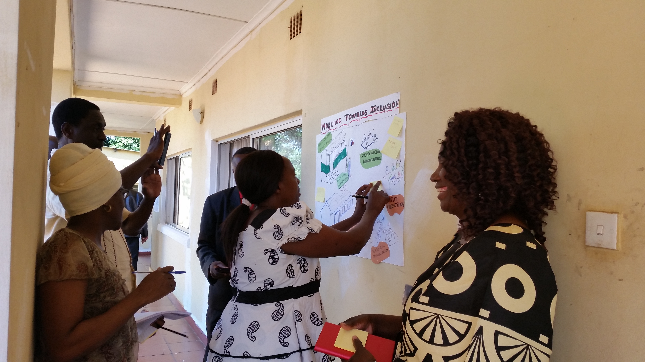

A manual for teacher trainers
Prepared for:
Ministry of General Education, Zambia
The Norwegian Association of Disabled

Developed by:
Enabling Education Network, December 2019

This work is licensed under the Creative Commons Attribution-NonCommercial-ShareAlike 4.0 International License. To view a copy of this license, visit http://creativecommons.org/licenses/by-nc-sa/4.0/

Contents

Introduction 4

Session 6.1: A school Inclusive Education Co-ordinator (IECo) 6
Session 6.2: The characteristics of a school IECo 9
Session 6.3: The role of a school IECo 12
Session 6.4: Whole-school approach to inclusive education. The key role of the school IECo 18
Session 6.5: Establishing or adapting learning support bases to enable effective inclusion support 22

School-based practical tasks 24

Resource 6.1: What is a school inclusive education co-ordinator? 26
Resource 6.2: Statements for discussion 27
Resource 6.3: Characteristics of a school IECo 28
Resource 6.4: Scenarios for role-play 29
Resource 6.5: Faces to demonstrate a school IECo’s attitude 31
Resource 6.6: Activities a school IECo may take part in 32
Resource 6.7: John’s story 34
Resource 6.8: Working towards inclusion 35
Resource 6.9: School IECo role-plays 37
Resource 6.10: Effective use of LSBs 41

Notes 42

Introduction
The overall aim of this module is to explore the role and effectiveness of a school Inclusive Education Co-ordinator (IECo). The module will look at how the school IECo can co-ordinate special educational needs and/or disability (SEND) and inclusive education activities and be a catalyst for change towards a whole-school approach to inclusive education.

The module discusses the school IECo’s role in the network of support that enables the educational needs of all learners to be met. Activities in the module include forming and strengthening the partnerships between schools, learners, parents/guardians/care-takers, communities and other professionals. Part of the school IECo’s role is to initiate and encourage collaboration for inclusion – all activities in this module will give opportunities for discussion and sharing ideas around this topic.

Further information is contained in the module on Including Learners with Additional Needs. This supplementary material can be useful when thinking through some of the practicalities faced by a school IECo and could be used as a reference point throughout this module.

The current module (6) suggests several methods you should use or adapt as a school IECo. However, as an IECo you are free to use other relevant methods not described in this module. The module offers suggestions and examples of the different ways a school IECo can work, whether it is at school, in the district or at regional level. It also gives teachers the opportunity to explore the most effective strategies for a school IECo in the context of their own education environment.

Finally, the module discusses the possibility of establishing and maintaining a Learning Support Base (LSB) for the co-ordination of all inclusive education and SEND training sessions and support activities. The question for discussion will be: ‘What role will the school IECo take in establishing and maintaining effective use of an LSB?’

Duration of training
Trainers should adapt this training to suit the local context and the time available to them for training. Trainers may decide not to use all of the activities, or to shorten some activities if time is limited, or to expand activities if teachers need more support with understanding a particular topic. If all activities are used, without significant adaptation, shortening or lengthening, this module requires approximately 11 hours of training over 2 days, depending on the preferred length of training days, number and length of breaks, and so on.

Session 6.1: A school Inclusive Education Co-ordinator (IECo)
Many teachers and other educators work in isolation and struggle to meet the needs of all the learners they work with. They can be extremely committed to their work but lack support, training opportunities and materials to enable them to be more inclusive teachers. Often, teachers have skills and ideas for good classroom practice but do not get the opportunity to share them with colleagues or the community. Similarly, parents and communities are often not involved in education and may not be aware of the services that are available and the help and the knowledge they can provide. In short, there can often be a lack of collaboration that is necessary if schools and communities are to become more inclusive.

This session is intended to provide a clear understanding of the pivotal role a school IECo plays in inclusive schools, communities and societies. Teachers will understand that a school IECo is not responsible for carrying out all inclusion work. She/he has a co-ordinating role; this means organising and managing, rather than having total responsibility for, the identification, assessment and provision of all good inclusive practice.

Activity 6.1a: What is the role of a school IECo?
Main
10-20 minutes

This activity gives each teacher the opportunity to reflect on and discuss ‘What is the role of a school IECo?’

The trainer asks teachers to work in pairs and discuss their understanding of the meaning of a school IECo. Each pair should write one sentence or a short paragraph to explain what they understand it to mean. Pairs will then share within a small group to discuss their ideas. Finally, groups give feedback to the whole group.

After everyone has had an opportunity to give feedback, the trainer should share the following statement, on a flip chart, board or poster which explains the role of a school IECo:

“The school IECo should perform a co-ordinating role; this means organising and managing, rather than having total responsibility for the identification, assessment and provision of inclusive education. She/he will enhance capacity to ensure the fulfilment of inclusive cultures, policies and practices within schools.”

Resource 6.1
What is a school inclusive education co-ordinator?

The trainer should then give out Resource 6.1. This statement should also be displayed on the wall to be referred to throughout the training.

The trainer should ask teachers if they would like to add anything to the statement.

Note for trainers
Your flip chart/poster for display should be written clearly with good black and white contrast to demonstrate inclusive training. Remember, if you expect teachers to be inclusive you must be an inclusive trainer. It is a good strategy to constantly evaluate your own methods.

Notes

Activity 6.1b: Red or green game (agree or disagree)
Main
15-30 minutes

This activity will stimulate discussion and help to further underpin teachers’ understanding of ‘What is a school IECo?’

The trainer gives each teacher a red card and a green card, similar to those used by a soccer referee. The trainer then reads out a sentence from Resource 6.2 and asks each teacher to hold up one card depending on whether they agree or disagree with the statement.
- Green card is ‘Agree’
- Red card is ‘Disagree’

Resource 6.2
- Statements for discussion

After each statement is read out and decisions have been made, the trainer allows time for teachers to discuss any disagreements. The trainer should also encourage teachers to try to change each other’s views and to listen to each other.

The trainer does not need to use all the statements. She/he can select three or four which they feel are useful for ensuring full understanding of the roles of a school IECo.

This activity is designed to encourage teachers to think about the role of a school IECo in their school and community. It is also very good for giving the trainer an insight into teachers’ views on inclusive education.

To adapt this activity the trainer could ask for a volunteer to read out the statements. Following the activity, the trainer can identify and feedback on the volunteer’s facilitation methods such as:
- Did they speak clearly so everyone could hear?
- Was everyone given the opportunity to speak and be included?
- Did they ensure that teachers listened quietly when someone else was speaking?

Session 6.2: The characteristics of a school IECo
A school IECo is a crucial position in education. It is important to recognise the type of person who would be most effective in this role; it is not necessarily the person in the most senior position or the one with the most qualifications. A school IECo must be committed to giving full opportunities to all learners. She/he should be a good, supportive role model and able to motivate others, while understanding the needs of colleagues and peers as well as learners.

This session will help teachers reflect on not only the skills that will be needed by a school IECo but also the characteristics. What type of person should she/he be?

Activity 6.2a: A school IECO needs to be…
Main
1 – 1.5 hours

The trainer should ask teachers to suggest single words or very short sentences to describe what they think should be the characteristics of a school IECo. Some examples would be:

- Patient,
- Approachable,
- good listening skills,
- committed,
- innovative,
- flexible,
- good time manager,
- friendly and professional,
- positive role model.

The teachers only need to say the word or short sentence. It is not necessary to give any explanation as that will be covered later in the activity.

Each suggestion should be written clearly on the board or flipchart. When teachers have finished and can offer no more suggestions, the trainer should check their ideas with those above, and if there are any suggestions missing, she/he could include them on the flipchart.

The trainer should divide the teachers into groups and give each group two or three words or sentences from their suggestions. No groups should have the same suggestions. The number of groups will depend on the number of words and sentences that are on the flipchart. For example, if there are 18 suggestions, teachers could be divided into 6 groups and given three suggestions each.

The trainer should give the following instructions:

Give an explanation for your word/sentence and explain clearly why a school IECo should have these qualities. Describe a brief scenario to clarify your explanation.

The trainer could give one example, such as:

Able to motivate others: Teachers are often short of time or unwilling to give up their free time for additional training or to make resources. A school IECo should be able to overcome this challenge by motivating the teachers.

Each group will then present their feedback, always allowing a few minutes at the end for questions and additional ideas. Teachers are then given Resource 6.3, and compare their ideas with those in the resource.

Resource 6.3
- Characteristics of a school IECo

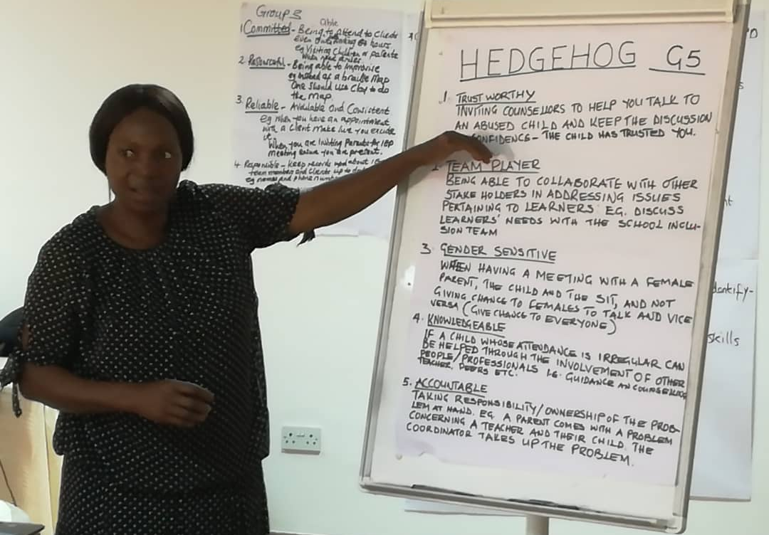
Teacher in Zambia presenting some characteristics of a school IECo

[Image description: A woman is standing on the left-hand side and pointing to a flipchart. The flipchart contains a lot of text, with following subheadings: trustworthy; team player; gender sensitive; knowledgeable; accountable.]

Activity 6.2b: Role-play – good and bad practice
Main
1.5 – 2 hours

This is a fun activity giving teachers a chance to display the characteristics of a good school IECo. The group work will encourage discussion and sharing of ideas. As with other activities, it also demonstrates the use of simple teaching aids made from waste materials.

The trainer should divide teachers into groups – the number in each group will depend on the number of teachers, but the trainer should try to have five (5) or six (6) in each group. Each group will be given one scenario from Resource 6.4. They have 15 minutes to discuss and practise their role-play. After 15 minutes, each group presents its role-play, which should be no longer than 5 minutes.

Resource 6.4
- Scenarios for role-play

At the end of each role-play, the teachers should reflect and decide if the school IECo has the correct characteristics to be effective in her/his role. Opinions will be displayed by use of the face cards in Resource 6.5. The trainer should prepare these cards before the session. Teachers can hold up which face they think is appropriate in response to the school IECo in the role-play.

Resource 6.5
- Faces to demonstrate a school IECo’s attitude

- This school IECo has the right attitude and is the right person.

- This school IECo is the wrong person or would benefit from further training and advice.

Each group should allow ten (10) minutes at the end of its role-play for discussion and questions.

At the end of this last activity, and if there is enough time, hold a plenary session around the topic of how the school IECo could have changed her/his actions or manner in order to be more effective.

Session 6.3: The role of a school IECo
The school IECo is the key person who ensures that all learners have opportunities to learn and achieve to their full ability. She/he is the main link between learners, families, communities, schools and other professionals who will form the network of support for inclusive schools and communities.

The aim of this session is to create an understanding of inclusive education and the pivotal role of the school IECo. Following this session, teachers will understand how schools, communities and the wider society can be brought together to take responsibility and ownership of inclusive education activities and be proud of the changes in their schools. Teachers will understand that a good school IECo plays a key role in this process.

Activity 6.3a: How a school IECo works at community, school and ministry/policy level
Main
30-45 minutes

This activity encourages teachers to think about ways in which a school IECo can be effective and influential at all levels.

The trainer divides teachers into three groups. If possible, each group should be a mixture of school-based professionals, the school inclusion team (SIT), community members and staff from government ministry offices, NGOs, etc.

The trainer should write three headings on the board/flip chart:
- School,
- Community, and
- Ministry of General Education / at policy level.

Each of the three groups is given one of the headings and asked to brainstorm and prepare a presentation on how the school IECo could work with this entity.

For example: Group 1 is the community. This group’s presentation must show specific actions for how the school IECo could work with the community and the benefits of school-community partnership.

It is important to inform teachers that there are no right or wrong answers to this activity. What will often work well in one school or one community may not necessarily work in others. They must think about the twin-track approach to learning when answering the question. The activity will also help them to think about their own work environment.

Allow time for a plenary discussion at the end of each of the three presentations. Use Resource 6.6 to check all suggestions and add anything that is missing, together with your own ideas. Write each addition clearly on the board/flip chart.

Resource 6.6
- Activities a school IECo may take part in

Finally give out Resource 6.6 to the teachers to read.

Notes

Activity 6.3b: Co-ordinating, planning and implementing inclusion
Main
1.5 – 2 hours

This activity will help teachers understand collaboration for successful inclusion. By using the case studies teachers will be encouraged to think about how a school IECo can bring people together to share information and skills, access services and plan for inclusion. Teachers will begin to reflect on their own community and work environment and think about who can help them understand and implement inclusion.

The trainer should read John’s story to the teachers (Resource 6.7).

Resource 6.7
- John’s story

Teachers should work again in five mixed groups if possible so that each group contains people from school, SIT, community, government ministries and/or NGOs. Each group is given a case study or picture from Resource 6.8 and asked to discuss the learner or circumstances.

Resource 6.8
- Working towards inclusion

The groups should then make a plan or a list of ‘actions for inclusion’: actions the group thinks the school IECo should take to ensure the learner is included or the situation/school becomes more inclusive.

The trainer should write the words ‘Collaboration’ and ‘Co-ordination’ on the board as a reminder to the groups that the school IECo is not responsible for all the work – she/he will identify and co-ordinate others who will collaborate.

Each group should then present their school IECo’s plan for inclusion during a carousel / gallery walk session. The groups display their flipchart presentations on the walls of the training room. One member from each group remains with their own presentation. Other teachers move around the room to look more closely at each plan – discussing ideas and adding their own comments and suggestions to each presentation. At the end of this session all teachers should have reviewed each plan and had sufficient time to ask relevant questions. During this activity the trainer should move around the groups observing, listening and highlighting any particularly innovative and useful suggestions.

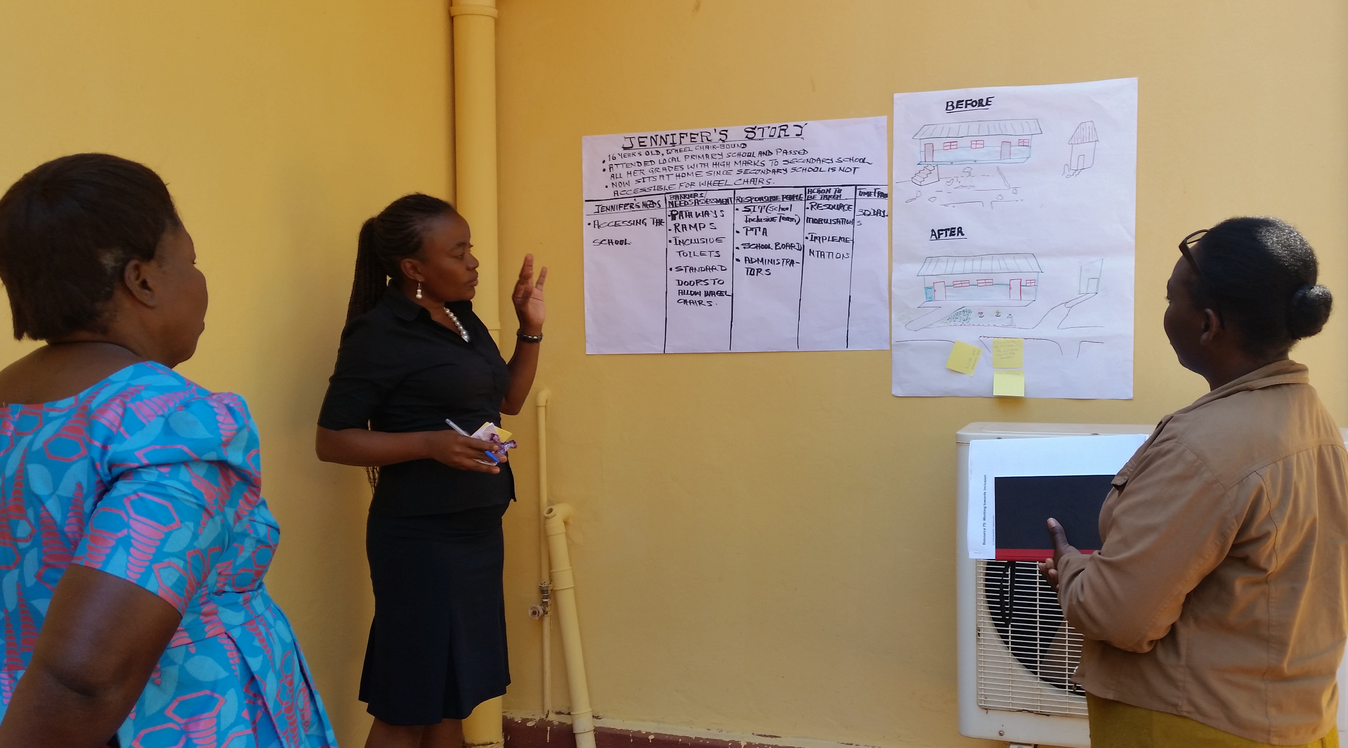

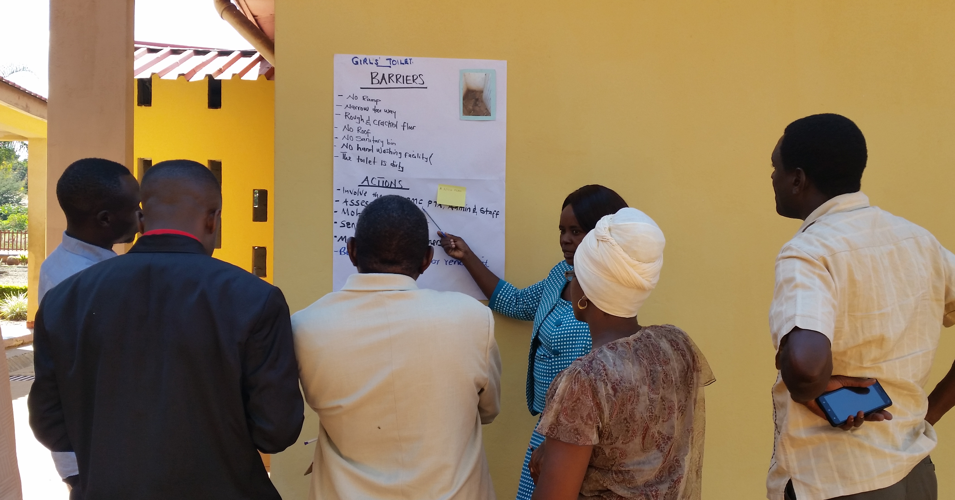
Groups in Zambia presenting their plans based on case stories and photos

[Image description: Top image – a woman stands next to a poster on the wall labelled ‘Jennifer’s story’. Two other women are watching/listening.
Bottom image – a woman stands next to and points at a poster on the wall labelled ‘girls’ toilet’, with subheadings for barriers and actions. 4 men and a woman are watching/listening.]

As this is the main activity in this session it is important to be flexible and allow sufficient time for discussion and questions. This activity looks at possible stakeholders and how they would be involved, therefore teachers will need sufficient time for reflecting on ‘who’ and ‘what’ (i.e. who will be involved and what actions will they take).

Another example of this would be:

The school IECo, as the key person, has been informed that a learner cannot access the lesson because of low vision problems. She/he would then contact the learner’s parents/guardians/care-givers in addition to contacting local health services about an eye assessment (or advising the learner’s carers to do this). The school IECo would also ensure the learner’s teacher has support for classroom strategies to better include the learner (see the module on Including Learners with Additional Needs (p.21) for suggested strategies).

The trainer must highlight the fact that the school IECo does not, and cannot, do everything. She/he co-ordinates with others to ensure the learner is included.

Notes

Activity 6.3c: Additional plenary session
Extra
30 minutes

If additional time is available the trainer should write the heading ‘Collaboration’ on the board. She/he should ask teachers to think about their own school and community and discuss people and strategies for more inclusion. The trainer could begin the discussion by giving an example such as:

‘One of the parents in my village is very good at woodwork and makes teaching aids for Maths – he comes into the school to demonstrate them before the teachers use them’.

Other ideas to guide the discussion could be:
- links between the school IECo and any community groups,
- support from parents and older siblings,
- peer support for children,
- peer support and teamwork amongst teachers,
- sensitisation through the media, and
- the school IECo’s role in any of the above.

The above points are suggestions and all will not necessarily be discussed – they are guidance points to assist the trainer in keeping the discussion on track. Teachers will have their own ideas and suggestions for collaboration in their schools and their communities.

Notes

Session 6.4: Whole-school approach to inclusive education. The key role of the school IECo
In order for schools to be more inclusive, educators have to reflect on what is presently happening. Good things will be happening in every school. Some inclusion methods will already be very effective and may not need changing. Other strategies may not be so inclusive or not happening and this is where the whole school has to work as a team and begin to make changes. The school IECo will act in a position of adviser, monitor and evaluator, and remind stakeholders about using the twin-track approach in their whole-school approach to learning.

At the end of this session teachers will be able to consider ideas for activities that help to make the whole school more inclusive. They will understand that although the school IECo can advise and support the school as it makes changes – making sure the changes taking place are everyone’s responsibility – she/he does not undertake all the inclusion work on her/his own.

Activity 6.4a: Inclusive activities at school
Main
1 – 1.5 hours

Teachers will identify the good practice that is already happening in their school as well as areas where improvement is necessary. The role of the school IECo is crucial in planning and supporting the implementation of the changes.

The trainer should ask teachers to reflect on how inclusive their school is. Working in pairs the teachers first make a list of activities and strategies that are good inclusive practice. They can then share these ideas with others in their group. The groups should then give feedback on their thoughts to the whole group, and these should be recorded on a flip chart or board.

The trainer should check that activities and strategies in the following areas are included in the whole-group list:
- teaching methods,
- physical environment,
- displays in and around the school,
- links with parents and communities,
- peer support and friendliness of all children,
- school management,
- sensitisation of all school staff, both teaching and non-teaching,
- in-service training (INSET) for teachers, and
- twin-track approach.

If any are not included, the trainer should raise the points and add them to the list.

The teachers should now examine the list created by the whole group. In their groups they should decide whether their schools are inclusive with regard to some or all of the above points. Their thoughts can be fed back to the whole group.

The trainer should then ask teachers to think about how a school IECo could instigate changes for more inclusion – again reflecting on the list they created. For 5-10 minutes the teachers discuss this in pairs. Each group will then select 2 topics from the list and prepare feedback for ‘What would a school IECo do to help the school be more inclusive in these areas?’

For example:
What action could a school IECo take to ensure the school management is more aware of inclusion?
Or
What would a school IECo do to ensure that the teaching methods used are inclusive?

Teachers should be asked to give their answers using a method of their choice, e.g., verbal, written, diagrams, or even pictures illustrating the school IECo’s actions. Remember to use the module on Including Learners with Additional Needs as a resource for hints and tips if needed.

After 10-15 minutes each group should present their ideas. Time should be allowed for questions and suggestions.

Finally, each presentation should be displayed on the walls to give teachers opportunities to add suggestions at a later stage.

Activity 6.4b: A school IECo’s activities in a school and in the community
Main
60 minutes or more

The aim of this activity is to help teachers understand the role of the school IECo in both school and community activities.

The trainer should explain that sometimes it can be the school IECo who will suggest new ideas and innovative methods for effective inclusion, but often the ideas come from the schools and from the surrounding communities.

The trainer should write the following activities on the board or flip chart, explaining that these are school/community activities that are focused on making a more inclusive school:
- an ‘open day’ for inclusion – community and school,
- mentoring and peer support programmes – team-work among teachers,
- accessibility of the surrounding environment – community and school,
- focus group discussion with community-based rehabilitation (CBR) volunteers – looking at ways to support identification and intervention for inclusion,
- planning for transition – team-work among stakeholders, and
- using locally available skills and resources – school and community.

Teachers should be given a few minutes to think about these activities and decide if they would like to add any other innovative ideas for inclusion to the list. The trainer then asks each group to select an activity to prepare as a short drama piece.

Groups will be asked to select one member who will play the role of the school IECo. Each school IECo will then read their activity instructions to the rest of the group (see Resource 6.9).

Resource 6.9
- School IECo role-plays

The groups have 10-15 minutes to prepare and present their role-play. The trainer should move around the groups during this time and give advice and help where necessary. Each role-play should be no more than 5 minutes long.

The trainer should remind teachers about some inclusive strategies to bear in mind during their presentations, e.g.: speaking clearly, making sure everyone can see properly, and listening carefully when someone else is speaking. Any written part of the presentations should be clear with good contrast (black on white).

Each group needs to introduce and deliver their role-play to the whole group, and time should be allowed for comments and questions at the end of each role-play.

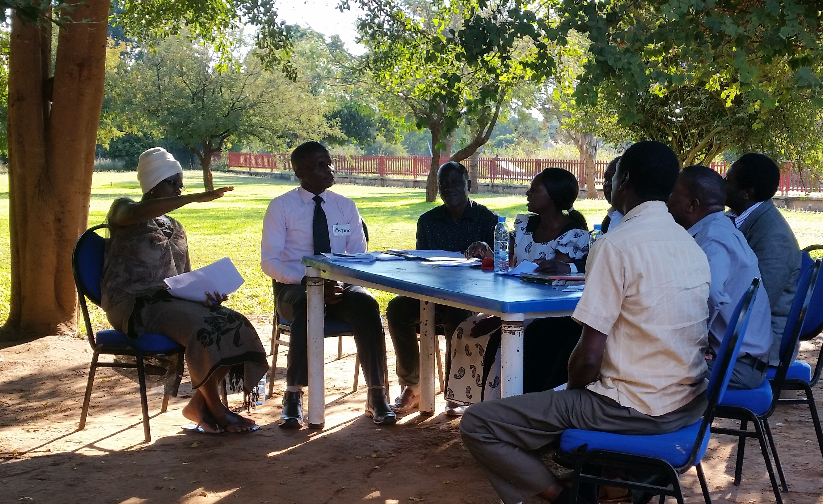
Group role-play in Zambia

[Image description: 8 people are sitting around a table outside under a tree, 2 women and 6 men. One of the women is a little further away from the table than the others and she has her arm half raised, maybe gesticulating and talking. Most of the others are looking towards her.]

Session 6.5: Establishing or adapting learning support bases to enable effective support for inclusion
The change from special education to inclusion does not happen overnight. It is a slow process, whether in countries that are more or less developed. Some children will always need and benefit from specialist help and support in order to participate and achieve to their highest ability. In-service training for teachers should be ongoing, both in developing specialist skills for some teachers and acquiring inclusive strategies for all teachers.

In this session teachers will be discussing the use of special educational needs (SEN) units, special classes, etc., in mainstream schools, and the transition of these into something that is more inclusion support focused: learning support bases (LSB). An LSB is a calm, quiet environment that IECos, teachers and support staff can use for planning and preparations, assessments, meetings, and individual support.

Teachers will discuss and share ideas on how the SEN units can be adapted and used effectively as LSBs; and discuss the role of the school IECo in the transition and subsequent activities in the LSBs.

The additional information contained in the module on Including Learners with Additional Needs may provide useful reference material here.

Activity 6.5a: Creating an LSB in school
Main
60 minutes or more

By the end of this session teachers will have explored the possibilities of adapting SEN units to become more inclusive as LSBs. Teachers will have shared ideas on how the LSBs should be used to support inclusion.

The trainer presents the introduction to this session (see above) and then gives teachers Resource 6.10. She/he explains that the suggestions in this handout are based on models from other countries and may need to be adapted to suit the Zambia context. This resource is merely a list of suggestions designed to be a starting point for discussion.
Resource 6.10
Effective use of LSBs

The trainer should point out that some of the suggestions on the list are probably already happening in units in Zambia, for example:
- training in special skills, and
- development of classroom resources.

Teachers are then divided into groups. The trainer should allow 30 minutes for group discussions around this topic as well as around the role of the school IECo in connection with LSBs. Groups should make brief notes, highlighting their key points for the transition of SEN units into inclusive LSBs.

During the group discussions, ensure that everyone has an opportunity to contribute. Move around the groups to observe and listen. Remind each group to also think about the role of the school IECo in each process.

At the end of the group discussions, a spokesperson from each group will present the key points discussed, giving brief details. The trainer will write all main points on the board/flipchart. If possible, groups should explain the role of the school IECo in all of their suggestions.

The outcome of this activity should be a clear diagram or list reflecting on ideas for the transition and the effective use of the LSBs.

Notes

School-based practical tasks
The trainer should prepare teachers for the following practical school-based tasks that they will need to complete before returning for the next training.

Tasks
- Identify your potential school IECo for each school.
- Identify your possible LSB for each school.
- Support the school IECo to:
- facilitate an awareness-raising meeting in the community about the continuing inclusive education work;
- ensure that all teachers working as school IECos understand their role in the school;
- induct new teachers about inclusive education and inclusion in the school;
- plan and run a meeting for the SIT and the community about the role of the school IECo.

Teachers should carry out these tasks alongside the SIT. They should ensure that they document the processes and progress of these tasks and reflect on what goes well/less well. Teachers should identify ways to improve activities that did not go well. These notes and reflections will be shared during the next training.

Notes

Module
6
Resources

Resource 6.1: What is a school inclusive education co-ordinator?
The school inclusive education co-ordinator (IECo) should work in a co-ordinating role. This means organising and managing, rather than having total responsibility for the identification, assessment and provision of inclusive education.

She/he will enhance capacity to ensure the fulfilment of inclusive cultures, policies and practice within schools.

Resource 6.2: Statements for discussion
- A school IECo must have specialist skills such as Braille and Sign Language.
- A school IECo will be able to carry out specialist assessments for vision and hearing.
- A school IECo should be in the unit or education office 8 hours each day to ensure that parents, teachers, etc., know where to find them if they need advice.
- A teacher who has at least 20 years’ experience of teaching and the highest qualifications should have the role of a school IECo.
- A school IECo should involve children and parents/guardians/care-givers on specific matters whenever possible.
- It is possible for a school IECo to be involved in planning extra-curricular activities such as sport and drama.
- The school IECo should attend meetings of the school inclusion team (SIT) whenever possible.

Resource 6.3: Characteristics of a school IECo
- Patient – has time to listen to suggestions, problems, etc. Waits and gives someone the opportunity to speak.
- Approachable – has a manner that is not scary. Parents/guardians/care-givers, teachers, etc., should feel they can come with questions, problems and ask for advice.
- Good listening skills – listens to the ideas of others. Does not talk all the time to parents, children, etc., but takes time to listen and understand.
- Committed – has good work ethics and a belief that all learners have different abilities and can all achieve. Believes in doing the job to the best of their ability.
- Innovative – is able to think of new and flexible ways of doing things.
- Flexible – is able to change plans even at the last moment; and is able to think of ways to solve problems even in challenging circumstances.
- Good time management – does not waste time on unnecessary tasks. Plans the day to use time effectively.
- Friendly and professional – has a manner that is friendly to be able to build good working relationships.
- Positive role model – demonstrates behaviour that shows a good example to others, both in and out of the working environment. Teachers will observe how they behave towards learners, parents/guardians/care-givers and colleagues and follow their example.
- Understands the twin-track approach to learning – is able to explain that we must focus on both system-level change and also specific learning needs of individual learners. We need to improve inclusion from two points – by promoting systemic change and by giving specific support to individual learners’ learning needs.

Resource 6.4: Scenarios for role-play

- A school IECo is invited to attend a village meeting to discuss a large number of out-of-school children. The meeting has been organised and is chaired by the village headman who does not know what to do about these children. Attendees at the meeting include the village women’s group, the head teacher from the local school, some parents, village elders and community members. The school IECo arrives late, does not pay attention and talks on her cell phone during the meeting. He does not take notes. He does not speak to anyone nor ask to meet the children.

- The school IECo observes a lesson to assess for inclusive teaching methods. She arrives before the lesson starts and asks the teacher to explain the lesson plan. She then sits quietly at the back during the lesson, making notes. After the lesson she speaks quietly (one-to-one) with the teacher, pointing out the good things in the lesson before identifying where the teachers need to make changes to be more inclusive.

- A grandparent arrives at the unit (now the LSB). She is distressed and crying because her two ‘naughty’ grandsons keep running away from school and getting into trouble. The school IECo is impatient and does not have time to speak to her. The IECo is unfriendly and her manner of speaking is sharp. She does not refer the grandmother to anyone else who would have time to give her help and advice.

- The school IECo is invited to a school improvement meeting where teachers raise concerns that their class sizes are very big and they do not have time to be ‘inclusive teachers’. The school IECo patiently listens to their concerns and arranges another time to come into school to observe lessons and give advice to the teachers. He assures them that following his observations they will all sit down together and find solutions to their challenges – it may mean additional training on inclusive classroom strategies.

- The school IECo, together with the head teacher, visits the home of the parents of a child who has an intellectual disability. The girl is 9 years old and has never been to school. The parents are over-protective and do not want her to be bullied. They also think she does not need to go to school or be educated because ‘she won’t be able to do anything anyway’. The head teacher and the school IECo explain why the girl should attend school and do their best to make the parents feel easier about sending her. The school IECo patiently explains how the school will do its very best to make sure the girl is not bullied and is included.

- A school IECo is invited to talk at the District Education Management meeting. Her role is to raise awareness on the current situation in local schools and give details of other Ministry Departments, NGOs, etc., who are part of the network working for more inclusive schools. The school inspectors do not fully understand inclusive education and continuously ask questions about learners with disabilities and special schools. The school IECo does not give a clear explanation or suggest that she visits some of the schools with the inspectors. She does not seem to have a plan, which would help sensitise the inspectors and other colleagues.

Resource 6.5: Faces to demonstrate a school IECo’s attitude

Resource 6.6: Activities a school IECo may take part in

At school
- Build capacity and sensitise school management, teachers and other school staff;
- Ensure school planning is more inclusive;
- Assess physical environment for accessibility;
- Advice on making specific resources;
- Training on inclusive classroom strategies;
- Enhance partnership between school and community;
- Observe and assess individual children;
- Organise focus group discussions for both teachers and children;
- Suggest activities for whole school approach to inclusion.

In the community
- Raise awareness at community level;
- Build partnerships between school and community;
- Visit homes of specific children when necessary;
- Attend local meetings;
- Make referrals for services available locally – for example, medical assessments at the hospital;
- Identify local skills and materials that could be used in schools – for teaching aids, etc.;
- Train local volunteers to identify out-of-school children;
- Arrange specialist training for parents and carers when required.

With the Ministry of General Education / at policy level
- Attend local council meetings to raise awareness and ask about available funding;
- Raise awareness in the media – local radio and newspapers;
- Attend planning meetings to ensure that all plans are inclusive;
- Involve local NGOs and community-based organisations in any inclusive education training at the learning support base or other suitable location.

Resource 6.7: John’s story
John is 12 years old and lives with his grandmother who is old and has a disability. His parents have passed away. He is often absent from school or late arriving. He works hard when in school even though he sometimes looks very tired. He never completes his homework and his teacher thinks he will fall behind if he continues this way. He often looks dirty and uncared for.

A possible support plan for John
The school IECo will:
- attend a school meeting to discuss John’s situation;
- identify the person in school who will visit the community and John’s home to gather information. The school should endeavour to find out the reason for John’s poor circumstances;
- make time to talk to John and his grandmother to ask about his school and home life;
- initiate a community support plan to help John care for his grandmother and himself;
- initiate a school support plan (with peer support) to help John catch up with his work;
- ensure all school staff members are sensitive to the situation;
- monitor the on-going home situation during subsequent visits.

Resource 6.8: Working towards inclusion

1. Inaccessible classrooms
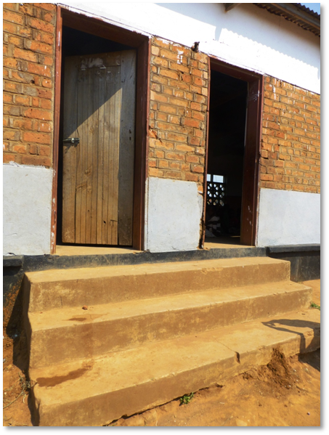

2. Girls’ toilet

3. Mr. Musonda’s science lessons
Mr. Musonda teaches science at primary level. He has three learners identified as having special needs in his class but he does not teach them. They sit in the classroom and he mostly ignores them. When asked about this he said he does not have the proper skills and resources to teach them. The learners are:
- Joshua – blind in one eye and with 50% sight in the remaining eye;
- Mary – extremely quiet and shy. She sits alone and does not answer questions;
- Chipo – speech and communication difficulties. She can make sounds but her speech is very unclear.

4. Jennifer’s story
Jennifer is 16 years old. She has a physical disability and uses a wheelchair. Jennifer has always attended the local primary school with her friends and passed all her grades with high marks. She has now been stopped from moving on to the senior level because the secondary school is not accessible for wheelchairs. She now sits at home all day doing nothing.

5. A school in Mozambique
An external consultant from the Ministry of Education evaluated the school, which was located in a rural area. The consultant was informed that it was an inclusive school because ‘it has lots of children with disabilities’. One of the findings from the evaluation was that the school and classrooms were not decorated with any learning materials at all. Walls in the classrooms and corridors were bare concrete with no visual materials on display. The school has several deaf children sitting in the lessons. When the consultant asked why there were no learning materials or learners’ work on the walls, the answer was that the teachers do not have their own classrooms but move from room to room each lesson.

6. Community concerns about bullying
Parents and community members have reported to the school that a number of learners are being attacked and bullied as they walk to school. The culprits are a group of older boys who have dropped out. They are attacking, bullying and stealing food from other learners who are on their way to school. Some of these learners are now too afraid to go and instead either stay at home or just hang around the streets all day. The community leader and several parents have come to the school to ask for help to sort out this problem.

Resource 6.9: School IECo role-plays

An ‘open day’ for inclusion – community and school
This ‘open day’ is arranged to invite parents/guardians/care-givers and community members into school. It should be a day of sharing information, fun activities, and exhibiting learners’ work and achievements. It is planned to be a day for building partnerships between school and community and raising awareness on inclusion. Your role-play should be about the planning meeting where perhaps the head teacher or a SIT member will chair the meeting with the school IECo as an adviser.

Mentoring and peer support programmes – team-work among teachers
A programme of mentoring and peer support among teachers in any particular school means that teaching methods will become more varied and effective, and teachers will become more inclusive as they observe and support each other and share ideas and skills.

Your role-play will be a feedback session between the teachers and the school IECo. It should make clear what exactly is happening in the school as part of mentoring and peer support school staff. It should answer the following questions:
- How are teachers helping each other and sharing skills?
- How are teachers sharing resources?
- Why is mentoring and peer support important for the professional development of teachers and the effective inclusion of more children?
- What activities form part of the programme?
- What training and support is given to new teachers arriving at the school?
- Who benefits from implementing the programme?
- How could each member of staff be involved?

Accessibility of the surrounding environment – community and school
Teachers should be encouraged to assess the surrounding community environment and think about how accessible it is. For example, would a learner who has difficulty moving around or who uses a wheelchair be as able to travel to school? Would a learner be able to move around the community safely and independently? Teachers and community members, e.g., the SIT, should be asked to walk around the community and reflect on areas where learners pass and travel through on their way to and from school. They could even take photos of any barriers and suggest ways for adaptations. This could lead to raising awareness in the community as it could also be discussed during the school ‘open day’.

Your role-play should demonstrate the school IECo’s actions to initiate a community environmental assessment.

Focus group discussion with CBR volunteers – looking at ways to support identification and intervention for inclusion
Community-based volunteers are often the most active, knowledgeable and approachable people in the area. Because they generally know the community and the families, they can be active in strengthening links between school and families.

Your role-play should be a focus group discussion facilitated by the school IECo and attended by CBR volunteers. Suggestions to guide the discussion are as follows:
- Are the volunteers aware of children who are not in school?
- What do they think are the reasons for these children to be out of school?
- What actions would they take when identifying children out of school?
- What help and advice would they need from the school IECo?
- How could they advise and help the families to enable them to send their children to school?
- Who would they talk to in the community?
- Who would they talk to in the school?

The above is a list of suggestions to guide the discussion. Your group may have additional ideas. Your role-play should demonstrate clearly the role of the school IECo in facilitating the discussion and listening to the volunteers. Each community will be different and each group of CBR volunteers will have different ideas on how they can be active in supporting inclusion for more children in their community.

Planning for transition
The transition from one school to another is an important time for any learner and is often the time when learners drop out of school. This is particularly relevant to learners with disabilities and/or SEN or learners with other individual needs. Planning for the transition is of paramount importance.

Your role-play should be about a planning meeting for the transition of a teenage boy who has difficulty walking. He can walk slowly using crutches but his condition often makes him tired so he sometimes uses a wheelchair.

The school IECo should chair the meeting. Attending the meeting should be the boy, his parents, friends, and head teachers from the two schools. You must decide who else is important and therefore part of the meeting.

Suggestions to guide your role-play are as follows:
- date of meeting (when should the process of planning begin?);
- distance and road conditions from home to the new school;
- physical environment of the new school;
- peer support;
- actions that should take place prior to the move to the new school;
- activities that should take place after he has started in the new school;
- training needed in the new school – and for whom.

The above is a list of suggestions to guide your role-play. Your group may have additional ideas. You should demonstrate clearly the role of the school IECo in facilitating a smooth transition.

Using locally available skills and resources
Many schools, particularly those in rural areas, often have very few resources and limited funds for buying new materials. It can also be a challenge to maintain and adapt school facilities and buildings due to budget restraints. Many of the challenges can be overcome by involving the community and identifying skills and resources (including human resources) that are available.

Your role-play should be a village meeting in which the school IECo investigates assistance that may be available.
Suggestions to guide your role-play are as follows:
- classroom equipment needed for maths and science – who can make this?
- women who can teach sewing;
- classroom support for children with individual needs;
- beginning a school garden;
- clearing the school grounds for easy mobility;
- starting a reading group in the community;
- repairing the ramps to the classrooms;
- helpers for sports activities.

The above is a list of suggestions to guide your role-play. You do not have to follow all of these but can instead use other ideas from your group. Please demonstrate clearly the role of the school IECo in this whole process.

Resource 6.10: Effective use of LSBs
School IECos, teachers and support staff can use LSBs to:
- produce and adapt resources, e.g., large print and tactile diagrams, specific math’s equipment, picture/word cards, etc.;
- assess learners’ individual needs;
- plan lesson support, create target sheets and IEPs, etc.;
- conduct one-to-one support lessons (to underpin classroom learning);
- deliver teacher training for inclusive strategies;
- organise meetings with parents/guardians/care-givers.

Notes

