Identifying Out-of-School Children

Module
3

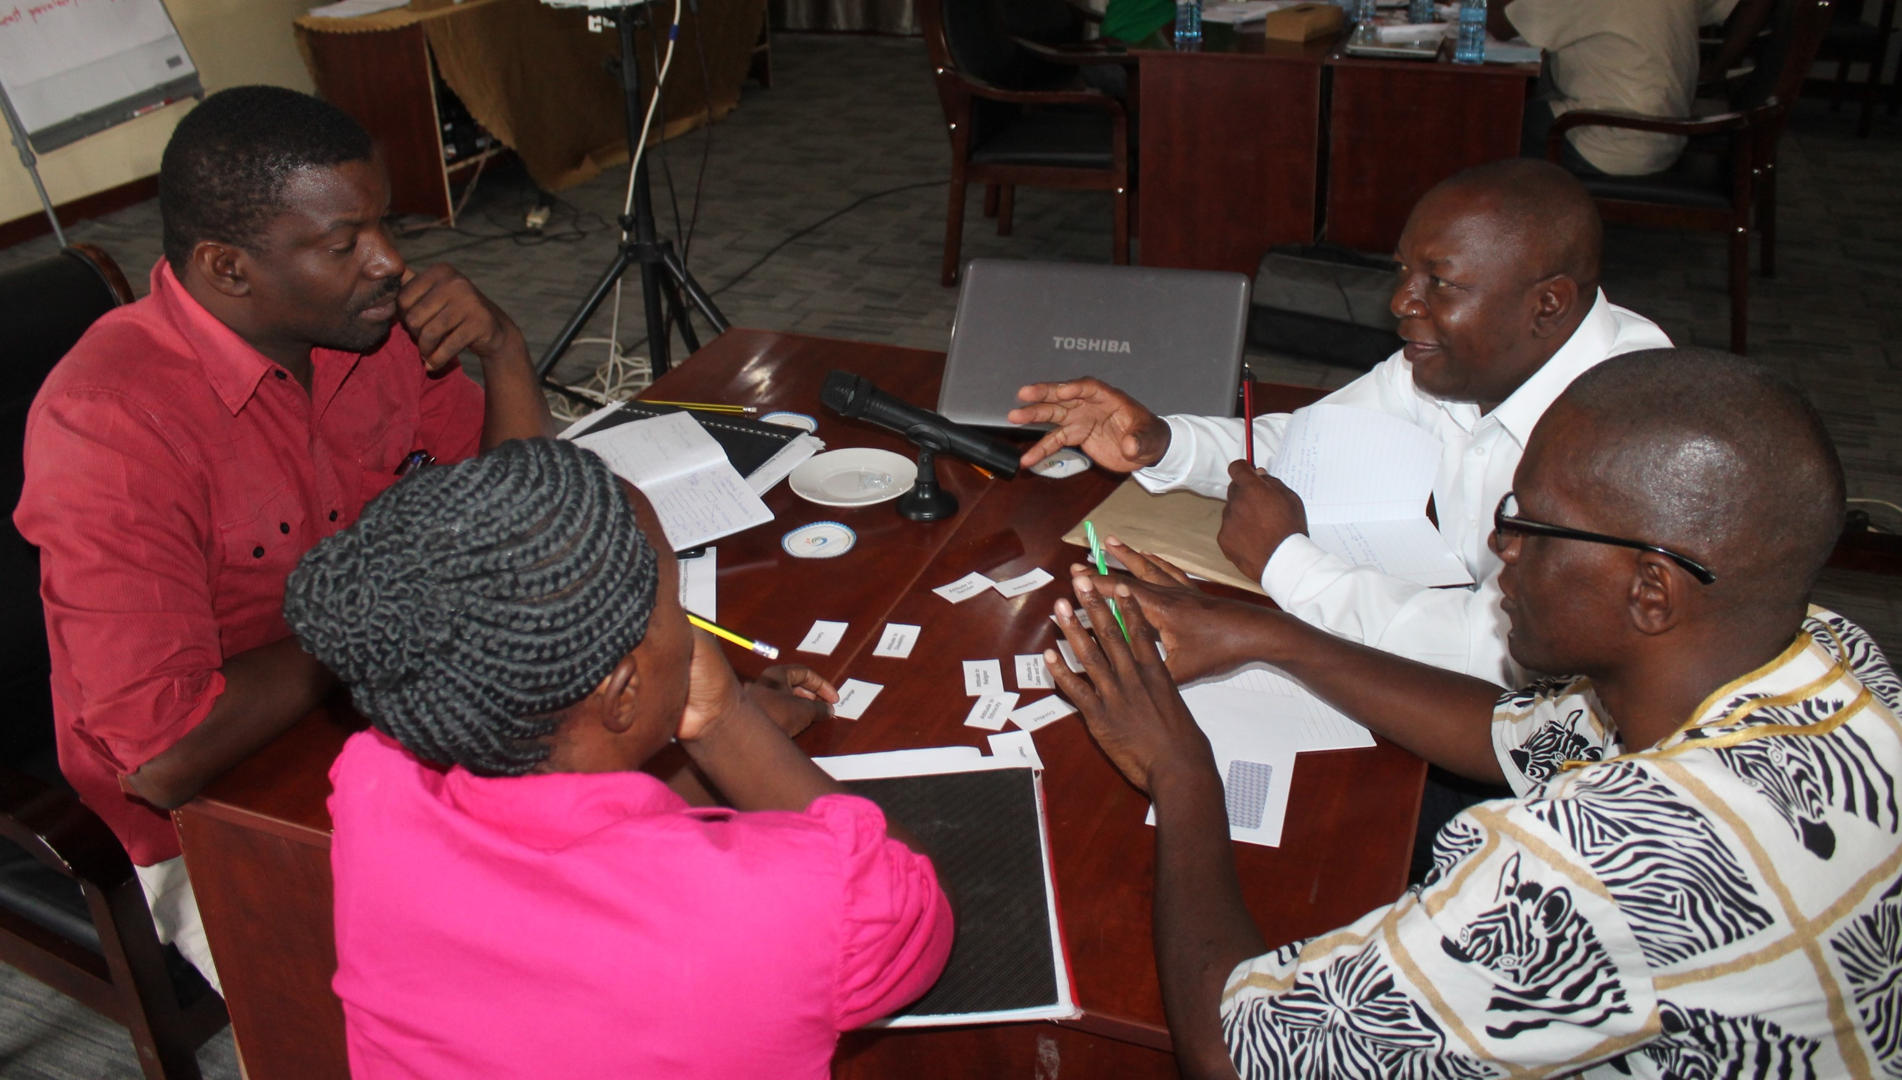

A manual for teacher trainers
Prepared for:
Ministry of General Education, Zambia
The Norwegian Association for Persons with Developmental Disabilities
The Norwegian Association of Disabled
Developed by:
Enabling Education Network, December 2019

This work is licensed under the Creative Commons Attribution-NonCommercial-ShareAlike 4.0 International License. To view a copy of this license, visit http://creativecommons.org/licenses/by-nc-sa/4.0/

Contents

Introduction 4

Session 3.1: An introduction to out-of-school children 5
Session 3.2: A rights-based approach to the problem of out-of-school children: International and national policy frameworks and legislation 13
Session 3.3: Out-of-school children in Zambia: The scope of the problem 17
Session 3.4: Out-of-school children in Zambia: Strategies and solutions for identifying out-of-school children 22

Action research tasks 31

Resource 3.1: Defining the issue: Who are out-of-school children and why are they out of school? 33
Resource 3.2: Outline of barriers to children’s schooling 44
Resource 3.3: Policy frameworks and legislation 45
Resource 3.4: Matching barriers to rights 48
Resource 3.5: Diamond 9 cards – Barriers to children being in school 54
Resource 3.6: Case studies of out-of-school children 55
Resource 3.7: Example of an observation sheet 58
Resource 3.8: Interview guidelines 59

References 61

Notes 62

Introduction
The overall aim of this module is to give teachers, other relevant education staff (e.g., teacher trainers, District Education Board (DEB) officers, and Education Officers (ODL)) and other stakeholders – a broad overview of the issue of out-of-school children in both local and global terms. It explores the barriers and issues around why some children are out of school, and the chain of causes and effects which result in them being absent from school. This module helps teachers to identify, reflect on and discuss barriers to children’s education and understand the problem of out-of-school children within a broader framework of human rights. Note that the module on Including Learners with Additional Needs contains information on some specific ways in which learners with additional needs are excluded from education. Refer to this module where relevant and remind teachers that it provides useful reference material.

There is not one way of locating out-of-school children, identifying barriers to their education and finally ‘solving the problem’. This is because each child’s reason(s) for being out of school vary. Thus, each school and its surrounding community needs to be flexible and respond differently and so develop solutions to suit their own local contexts.

Teachers will have varied degrees of practical experience in relation to working with a diverse range of children. Some will feel confident about discussing the topic; others may understand the theory, but in reality, many still feel nervous or reluctant to work with out-of-school children.

Duration of training
Trainers should adapt this training to suit the local context and the time available to them for training. Trainers may decide not to use all of the activities, or to shorten some activities if time is limited, or to expand activities if teachers need more support with understanding a particular topic.

If all activities are used, without significant adaptation, shortening or lengthening, this module requires approximately 8-10 hours of training, probably carried out over 2 days, depending on the preferred length of training days, number and length of breaks, and so on.

Session 3.1: An introduction to out-of-school children
Many children do not attend school throughout the world. They are known as out-of-school children. Many things prevent them from attending such as distance from school, poverty or conflict and disaster.

This session is intended to provide a broad overview of out-of-school children as both a global and local issue. It will address the barriers to children’s schooling in general descriptive terms, as well as through more specific case studies.

Activity 3.1a: Barriers to children’s schooling
Main
35-40 minutes

This activity will help teachers to reflect on and discuss the barriers to children’s schooling. It should give a sense of teachers’ current understanding of these issues.

The trainer asks teachers to work in small groups of 3-5 people. Each group should assign at least one note-taker to record the discussion. In their groups, teachers should discuss and record as many possible barriers to children being in school as possible. For each barrier, or reason that a child is out of school, they should think of a corresponding practical example. For instance, if poverty or disability or special educational needs (SEN) are stated as barriers, the teachers should think of a specific example of each of these.

After 15 minutes, the trainer asks each group for feedback and records their answers on a flipchart/board. Once a particular barrier has been mentioned, subsequent groups should be asked to mention different barriers (i.e., not to repeat something that has already been discussed). Each group should also give their practical examples to illuminate their answers.

There are many reasons why a child does not attend school. These include:
- attitudes towards age,
- economic and social class,
- attitudes towards disability and SEN, gender, ethnicity, religion and culture,
- conflict and disasters,
- health,
- language,
- migration and
- poverty.

Notes

Activity 3.1b: The ‘but why’ game – critical thinking
Main
10-15 minutes

This activity will engage teachers in thinking deeply about the chain of causes and effects which result in children being out of school.

The trainer says the following to teachers:

“This is the story about an eight-year-old girl named Rebecca. Rebecca lives in an isolated rural area. Rebecca’s village has no school and she has never attended school. Why is Rebecca out of school?”

The trainer then facilitates a discussion which encourages teachers to think about the issues around why Rebecca is out of school. For example:

Teacher’s answer: “Because there is no school in her village.”

Trainer’s response: “But why is there no school in her village.”

Teacher’s answer: “Maybe because the village is poor”

Trainer’s response: “But why is the village poor?”

Teacher’s answer: “Because they are in a remote mountain area.”

Trainer’s response: “But why is the remote mountain area poor?”

The trainer continues this line of questioning, to draw teachers into a deeper analysis of the underlying social, environmental and political causes for Rebecca being out of school. Ideas should be recorded on a flipchart/board.

The aim is to facilitate teachers to come up with as many possible causes for Rebecca being out of school as possible. This should help prepare teachers for looking beyond the surface reasons for children being out of school, to the deeper, more complex and interlinked causes.

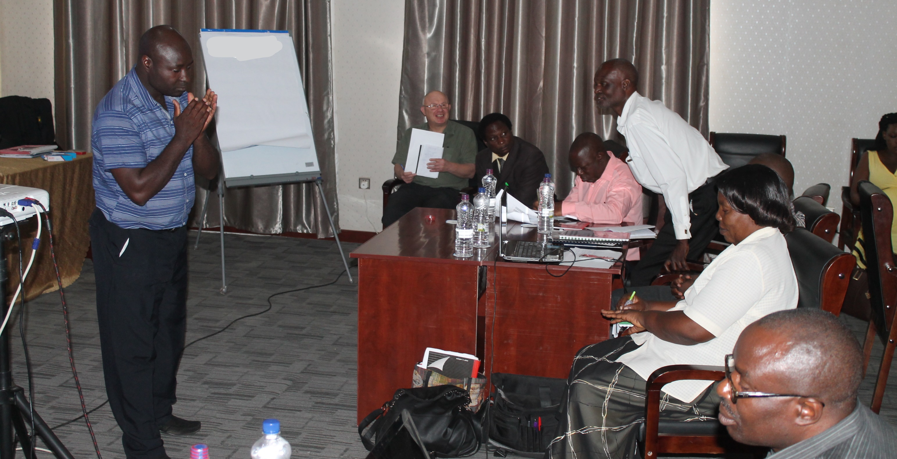
Teachers in Zambia playing the ‘but why’ game

[Image description: A man stands on the left of the photo, facing a group of seated people (7 are visible). He has his hands in front of him, as if clapping them together. The others are looking at him and some are smiling.]

The trainer can then explain to teachers:

“The ‘but why?’ game is an activity that helps us to analyse complex problems with multiple causes. Identifying root causes to problems and understanding how they are interlinked can help us prepare to find solutions. This is a form of critical thinking. This game is a useful preparation for us as we look more closely at the different barriers to children being in school. You could also use this game with your learners in your teaching. You could ask them to look at the problem of out-of-school children, but other problems and issues will work as well.”

The trainer should end the activity by asking for feedback from teachers about the game and recording comments on a flipchart/board.

Extension activity
Extra
20 minutes

Activity 3.1b can be extended if there is time. The teachers are given five (5) minutes to each create their own ‘but why?’ story, using Rebecca’s story as an example.

Teachers are divided into pairs and asked to take turns playing the game with one another’s ‘But Why?’ story. Teachers should also reflect on the process as they play the game and consider how the questions are asked and answered and how far they can extend the chain of questions/responses. This should take ten (10) minutes.

Finally, a 5-minute plenary feedback session can be facilitated.

Notes

Activity 3.1c: Defining out-of-school children – barriers and causes
Main
20-30 minutes

The trainer should ensure that she/he is familiar with the contents of Resource 3.1 before facilitating this session. Resource 3.1 can also be given to teachers to read in their own time, after the training.

Defining the issue: Who are out-of-school children and why are they out of school?
Resource 3.1

Teachers should be given a copy of Resource 3.2, showing some categories of barriers that keep children out of school. The trainer may also want to write out the framework of the three broad categories in advance on flipchart paper, making sure that enough space is left to write examples under each category.

Resource 3.2
Outline of barriers to children’s schooling

The trainer asks the groups to refer to the barriers that were listed during Activity 3.1a, and discuss for five (5) minutes which barriers fit within which categories. The trainer should then facilitate a plenary discussion, ensuring that each category of barriers is covered during the discussion, drawing on examples from real-life practice. These can be based on the teachers’ experiences, the trainer’s experiences and the ideas in Resource 3.2.

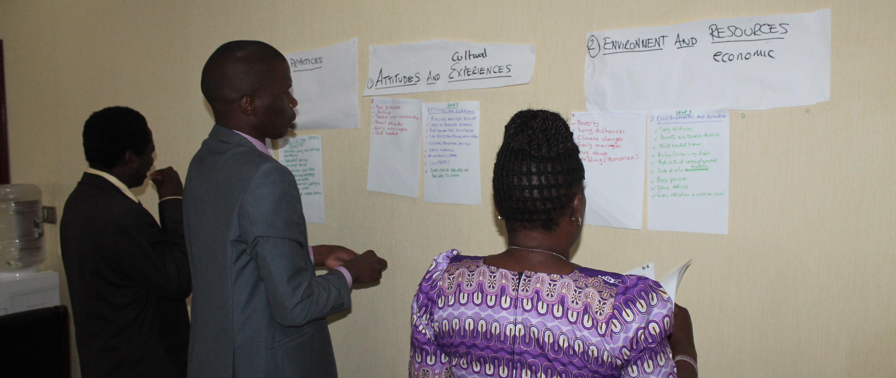
Teachers in Zambia reviewing the categories of barriers

[Image description: Piece of paper are stuck on the wall. Some are labelled with categories (e.g. environment, attitudes). Below these are sheets of paper containing lists. Two men and a woman are looking at the lists on the wall.]

The trainer may also wish to give a presentation based on details provided in Resource 3.2, depending on how much of the content is covered during the discussions.

It may be important for the trainer to highlight that this activity looks at the issue of out-of-school children from a global perspective, to help teachers learn about the wide range of factors preventing children from going to school around the world. There will be a closer look at the issue as it relates to Zambia later in the training. Understanding the global context can be very helpful when we are trying to understand our own context better.

Notes

Extension activity
Extra
20-30 minutes

This activity can help teachers to reflect on the large amount of information presented and discussed in the previous activities, by developing their own definition for out-of-school children.

Teachers should work in small groups. Each group should have a plain piece of paper. At the top they write:

“Out-of-school children are: …”

Each person in the group has to complete this sentence. However, they must not see what each other is writing. The first person should write a line, then make a small fold in the paper so that the next person cannot see what they have written. The second person writes their line, and folds the paper, and so on. When everyone has written something, the group unfolds the paper and reads all the statements. From these statements they create one united statement.

These can be fed back in plenary to form a whole-group definition of out-of-school children and displayed for future reference.

The trainer should ensure that the teachers are clear that out -of-school children:
- have never been to school, or
- have dropped out, or
- sometimes go to school and sometimes are absent.

Notes

Session 3.2: A rights-based approach to the problem of out-of-school children: International and national policy frameworks and legislation
The previous activities (3.1a and 3.1b) helped teachers to understand and reflect on the barriers that keep children out of school. These barriers need to be overcome. To do this, it is helpful to understand the problem of out-of-school children within a broader framework of human rights.

Many barriers keep children out of school, yet education is a right for all children. Education is recognised as crucial to human development. Most of the world’s countries legally guarantee the right to primary education and there is a variety of international policy frameworks and legislation commitments which mandate for this globally. Therefore, it is essential to be aware of international, regional, national and local policy frameworks and legislation which address children’s rights to education.

A child’s right to education has been established by a succession of global declarations such as UN Conventions, from the Universal Declaration of Human Rights (1948) to the Convention on the Rights of the Child (1989). Other initiatives such as the Education for All (EFA) movement, the UN Millennium Development Goals (MDGs) and the Sustainable Development Goals (SDGs) give support to this principle.

In the Zambian context, there are local, national, and regional policy frameworks and legislation which support international guarantees for children’s rights to primary education. At national level, the Educational Reform document (1977), ‘Educating Our Future’ policy (1996) and the Education Act No. 23 of 2011 all address the rights of Zambian children to education.

Understanding primary education as a right, not a luxury, means that working to solve the problem of out-of-school children is a necessity and a responsibility, not an option.

Activity 3.2a: A reminder about policy frameworks and legislation
Main
15-20 minutes

The trainer should ask teachers if they are aware of any international, regional, national, or local policy frameworks or legislation which address children’s rights to education. Their responses are written on a flip chart/board. This should take approximately five (5) minutes.

Next, teachers are given Resource 3.3 which they should read quietly to themselves. This should take 5-10 minutes.

Resource 3.3
Policy frameworks and legislation

When teachers have finished reading, the trainer should ask in plenary if they have any questions or issues they want to discuss (5 minutes).

Notes

Activity 3.2b: Matching barriers to rights
Main
30-45 minutes

This activity will engage teachers in making links between children’s rights to education and the barriers that prevent them from participating in education. It will further consolidate an understanding of the barriers to children being in school as well as the internationally agreed upon rights which address these barriers.

The activity uses a child-friendly version of the UN Convention on the Rights of the Child and asks teachers to determine which articles in the convention deal with education, and to match the various barriers to children being in school with the articles that address them. Using a child-friendly version of the convention makes the activity more accessible. It also models an approach to discussing child rights and education that teachers could use in their own teaching.

The trainer should give teachers Resource 3.4. Teachers should work in small groups and read this child-friendly version of the UN Convention on the Rights of the Child.

Resource 3.4
Matching barriers to rights

Teachers should then identify the articles that relate to education – some articles in the convention are directly focused on education, others relate to education more indirectly, and some not at all.

Finally, groups should try to match barriers they identified in Session 3.1, which keep children out of school, with the articles in the Convention which address them. They should use the space beneath each article in Resource 3.4 to write their answers. They may use Resources 3.1 and 3.2 if they wish and be reminded that some matches between barriers and rights may seem obvious, while others might be more subtle and open to interpretation.

The trainer should move between the groups looking for and making note of interesting points of discussion, debate or disagreement. These notes can be used later in the plenary session. After about 20 minutes, the trainer can facilitate a plenary feedback session, asking each group to share a different example of barriers matched with rights from their group work. The trainer should write their feedback on a flipchart/board. She/he should get the teachers to reflect on the process of doing the activity. To aid this the trainer can mention interesting points of discussion or disagreement they witnessed during the group work.

Notes

Session 3.3: Out-of-school children in Zambia: The scope of the problem
There are many reasons why Zambian children do not go to school, attend irregularly or drop out after attending for a while.

Having looked at the global context of children who are out of school, this session helps teachers to think more specifically about out-of-school children in Zambia. This session also makes the transition from identifying the barriers and issues related to the problem out-of-school children, to thinking about solutions.

Activity 3.3a: Diamond 9 – Why are children out of school in Zambia?
Main
45-60 minutes

This activity is intended to help teachers think about the nature and prevalence of barriers to schooling faced by children in Zambia.

The trainer asks teachers to work in small groups. Each group is given a set of ‘diamond 9’ cards, cut from Resource 3.5. These should be cut out in advance, and preferably put into envelopes.
Resource 3.5
Diamond 9 cards – Barriers to children being in school

Each group must choose nine of the cards and arrange them on a table in a diamond shape showing the order of most and least prevalent and challenging barriers to children being in school in Zambia. The most prevalent or challenging barrier goes at the top and the least prevalent or challenging at the bottom. Teachers must agree to the order of the cards as a group. This should take 15 minutes.

The trainer should draw the diamond 9 pattern (below) on a flipchart/board to give teachers an indication of how to arrange their cards.

A diamond 9 pattern

Most prevalent/challenging

Least prevalent/challenging

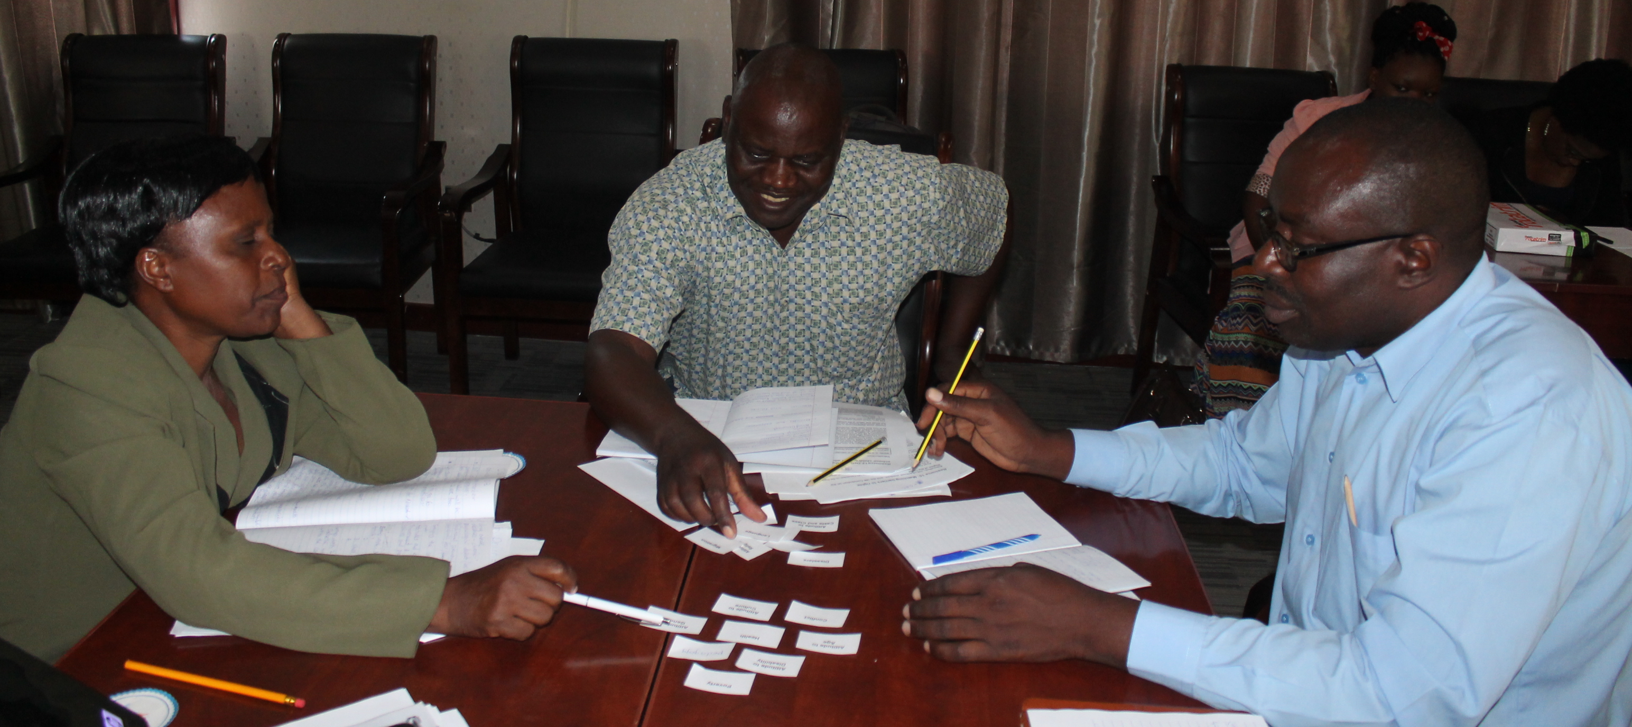
Teachers in Zambia discussing their diamond 9 cards

[Image description: A woman and two men are sitting around a table. On the table are some small pieces of paper with writing on, which have been arranged into a diamond pattern. The woman is pointing at a card and the participants appear to be discussing.]
Resource 3.5 has more than nine cards, so teachers will need to make choices about which cards to include. The barriers printed on the diamond 9 cards match those in Resources 3.1 and 3.2. There are also several blank cards on each worksheet. The trainer must make sure the groups receive these blank cards. If they want, the groups can write different barriers onto the blank cards and use them in their diamond 9. They can also create additional cards if needed. This should take 20-25 minutes.

When the groups have finished ordering their cards, all teachers move from table to table and each small group discusses how and why they ordered their cards as they did. This should take 20-25 minutes.

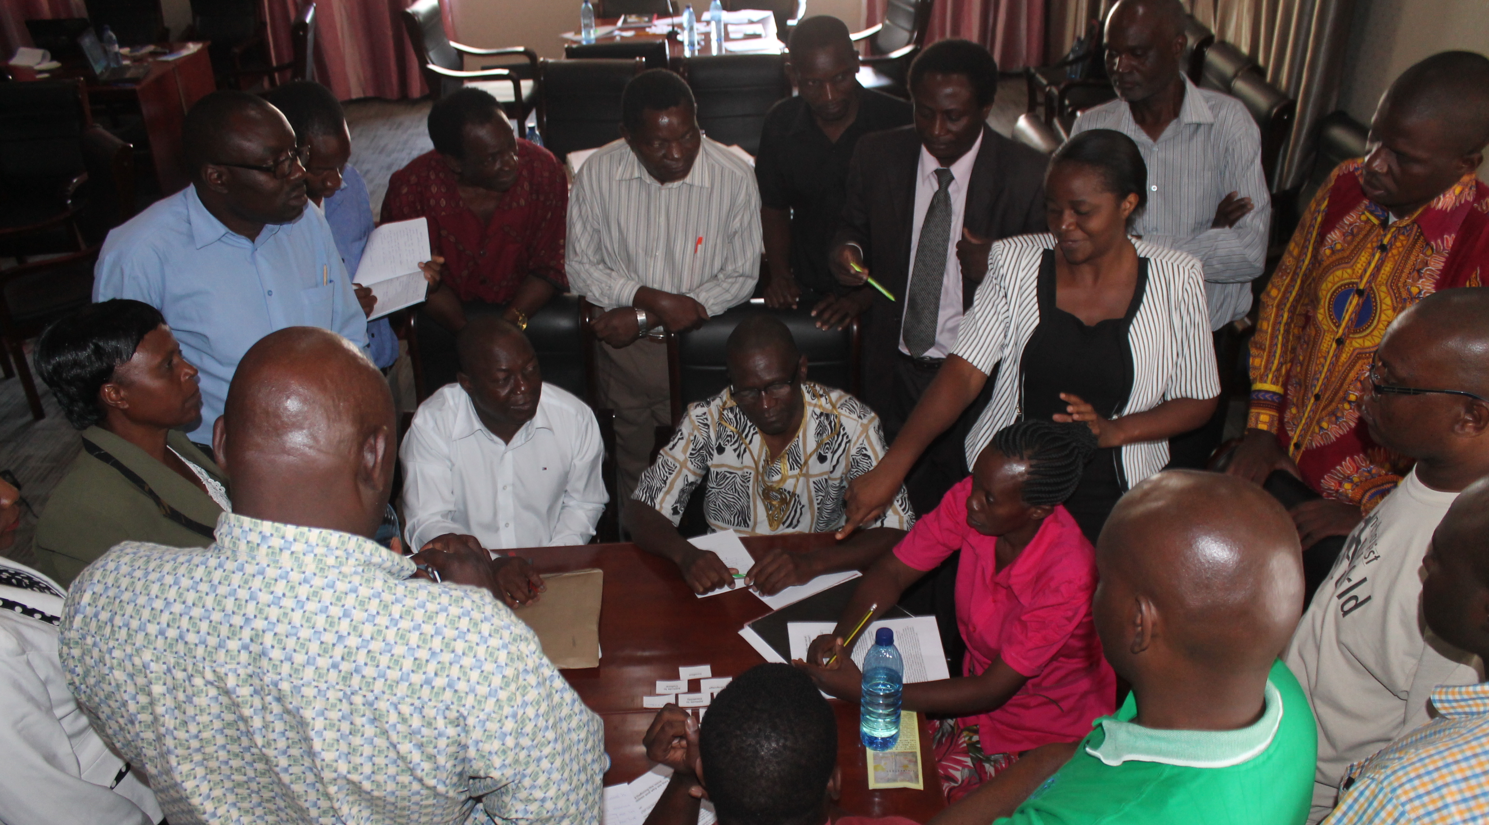
Teachers discuss each group’s diamond 9 arrangement

[Image description: 18 people, women and men, are gathered around a table; some seated, some standing. On the table are some small cards with writing on arranged in a diamond pattern. A woman is pointing at the cards and everyone else is looking at the cards.]

The trainer should travel with all the teachers as they move from group to group, to provoke teachers to ask questions and to help discussions run smoothly.

It is useful to find some way of recording the groups’ diamond 9s and the discussion (e.g., take a photo of the diamond 9 and write aspects of the groups’ discussions on a flipchart/board).

Activity 3.3b: Investigating case studies (i)
Main
35-40 minutes

Teachers work in small groups and read the case studies of out-of-school children in a Zambian context in Resource 3.6.

Note: the trainer may wish to choose which case studies to use and to change the names of the people in the case studies, to suit their local context.
Resource 3.6

Case studies of out-of-school children

In their groups teachers should identify:
- Why the child is out of school (e.g., if the child has dropped out of school, attends occasionally or has never attended school).
- What barriers are there to that child’s schooling, including any relevant details about the child’s family, location, ethnicity, prior experience of education, etc.
- How can these barriers be solved? What are possible solutions?

The discussion should take about 15 minutes.

In plenary, one group should choose a case study and give their feedback, which is captured on flipchart paper. The other groups can add to their thinking. This activity is then repeated with a different group choosing a different case study, until all the case studies have been discussed.

Notes

Activity 3.3c: Investigating case studies (ii)
Main
35-40 minutes

Teachers are now asked to share any examples of out-of-school children in Zambia that they have experience or knowledge of. Their answers should be recorded on a flip chart/board and used to stimulate discussion about the issue of out-of-school children in Zambia. The discussion should take about 15 minutes.

As a next step, teachers need to work in groups to develop a short case study describing a child who is out of school in Zambia. They will have about 20 minutes to do this.

The case study should ideally be based on actual situations of out-of-school children that the teachers are familiar with.

Each case study should describe:
- why the child is out of school, and whether the child has dropped out of school or never attended school, and
- what barriers there are to that child’s schooling, including any relevant details about the child’s family, location, ethnicity, prior experience of education, etc.

If the child has dropped out of school, then relevant details about the child’s former school, classmates, teachers, etc., should also be included in the case study.

As the groups are working on their case studies, the trainer should move around the room observing and making notes about particular case studies that would be interesting to discuss in plenary.

The new case studies should then be shared with the whole group.

Session 3.4: Out-of-school children in Zambia: Strategies and solutions for identifying out-of-school children
Locating and identifying out-of-school children can be challenging, but school and the Ministry of General Education personnel, e.g., DEB officers, can use school data as a starting point and they can share this information with district-level social workers. Reasons for their absence can then be discovered and strategies put in place to provide solutions to these issues to ensure that all children access education provision.

Having looked at the global context of children who are out of school, this session helps teachers to think more specifically about out-of-school children in Zambia. This session also makes the transition from identifying the barriers and issues related to the problem of out-of-school children, to thinking about solutions. Teachers will be asked to consider how to locate and identify out-of-school children and get them into schools; meaningfully and sustainably.

Activity 3.4a: Locating and identifying out-of-school children
Main
30-45 minutes

In order to address the problem of out-of-school children, first it is essential to locate and identify them. This activity is intended to get teachers to consider the challenges of locating and identifying out-of-school children and to strategise about how this can best be accomplished in Zambia.

The trainer asks teachers to brainstorm ideas for how to locate and identify out-of-school children. Ask them to consider:
- Where are these children located? Drawing a community map on flipchart paper is helpful.
- Why are they out of school?
- Who knows them, and knows they are out of school?
- Who is best placed to locate and identify them?
- Which local authorities should help in this procedure, such as social workers, the police (Child Protection Unit), Community Welfare Assistant Committees (CWAC), the Ministry of Community Development and Social Services, Ministry of Gender etc.?

The trainer records responses on a flip chart/board. This should take 10-15 minutes.

Next the trainer asks teachers to work in groups and focus on the case studies created in Activity 3.3c. Their task is to come up with specific strategies that could be used for locating and identifying the out-of-school child in their case study. This should take 10-15 minutes.

In plenary, the trainer asks teachers for examples of their strategies for locating and identifying out-of-school children. Responses should be recorded and the trainer should try to elicit as broad a range of strategies as possible (10-15 minutes).

Notes

Activity 3.4b: Preparing for action research
Main
60+ minutes

This activity aims to help teachers develop action research in their schools and communities, so they can find out more about inclusion and exclusion in the school. It can be daunting to start an action research cycle if you have never done it before, so a ‘supervised’ action research activity can be useful, before trying it ‘for real’ in their schools and communities.

This session outlines a practice action research activity that can be done anywhere (in the community, in the school, etc). The main aim is to help teachers become familiar with the methodology – which they can then use in any action research situation. The trainer must explain clearly, however, that action research ‘for real’ will involve more than simply replicating this one activity.

The trainer needs to choose a location (e.g., the pilot schools) where teachers can try out some of their action research techniques, and where the relevant authorities have given permission.

The trainer should explain to teachers about the location and ask them to brainstorm the kind of barriers to inclusion that they think they might find there, using the three broad categories of barriers discussed previously (see Resource 3.2).

Teachers should then be divided into small groups. Each group will use a different technique during the action research practice session – the main methods for a short activity will be observations, interviews, focus groups and mapping. The trainer should use the notes below to explain and demonstrate these methods to teachers, after first asking teachers to share what they already know about these techniques.

Observations
Explain:
“When observing a situation, it is important to record what we see as objectively as possible. We need to pay attention to what happens, interactions between people, body language, what is said, and also the silences. You should record what you see or hear on an observation sheet. Use two of the columns – one for recording what you saw or heard, and a separate column for recording your personal feelings, understandings and opinions about what you observed. This is important so that when we (or others) look at our notes later, we can clearly distinguish between what we saw/heard, and what we thought about this. This is because two people may see the same incident happening yet interpret it totally differently. Remember observers often need to be as unobtrusive as possible. For instance, if you are observing a classroom, you should not ask the children or teachers questions or interfere with the running of the lesson.”
Resource 3.7

Example of an observation sheet

Interviews – asking questions
Explain:
“Interviewing is about asking questions and about listening. The kinds of questions we ask, how we ask them, and how we listen and respond to the answers are important issues to consider as part of the interviewing process. There are two basic types of questions:
- Closed questions – these elicit short, fixed answers. ‘Yes and no’ are examples of responses from closed questions because there can only be two possible responses: yes or no.
- Open questions – elicit longer answers which are not fixed or limited to predetermined categories. ‘Why?’ questions are open questions because they require explanatory answers.

Another example of a closed question is, ‘What was your favourite subject in school?’ This is a closed question because it is only intended to elicit a short, one or two-word answer, without further explanation. However, this closed question could become an open question by changing it to: ‘What was your favourite subject in school and why was it your favourite?’.”

The trainer should ask teachers to work in pairs to write some examples of open and closed questions that they could ask in an interview about inclusive education. They should then feedback in plenary, so the trainer can check if they have understood open and closed questioning.

The following ‘stages of an interview process’ can then be written on a flip chart (with space left between each stage):

Preparation –

Introduction –

Conducting the interview –

Closing the interview –

Guidelines for recording an interview –

The trainer explains that the interview process can be broken down into these stages, and asks teachers to list some of the issues they need to consider for each stage.
Resource 3.8

Interview guidelines

The ‘interview guidelines’ Resource 3.8 should be given to all teachers. After they have read it they should give more suggestions for filling out the ‘stages of the interview process’ flip chart, and the trainer should add or clarify as necessary.

The trainer may decide to demonstrate some of the ‘wrong ways’ to conduct an interview (e.g. pretend to interview a teacher, but act extremely bored and disinterested), and then invite teachers to explain what the interviewer did wrong and what he/she should have done instead.

Focus groups
Explain:
“Focus groups are discussion groups. They may involve one particular stakeholder group, for example parents/guardians/care-givers, or they may include a range of stakeholders who are asked to focus on a particular topic. At times it may be necessary or preferable to have discussions with one group separately (e.g., a discussion with children when their teachers and parents/guardians/care-givers are not present). At other times it can be helpful to bring different stakeholders together in one group to discuss the particular issue you are focusing on.

You will need to prepare for a focus group in a similar way to preparing for an interview. You will not necessarily ask lots of questions in a focus group, but you will need to prepare guiding questions to help you get the discussions started, and to ensure that you stay ‘on topic’.”

The trainer should highlight that focus group teachers are not always used to speaking openly, which can make it difficult to get a discussion started. In their groups, teachers should think of methods they could use to stimulate a lively discussion, even if their focus group teachers are shy or not used to expressing their views. The previous workshop activities may offer inspiration. The trainer then facilitates plenary feedback and makes notes on a flip chart/board.

Mapping
Explain:
“A map is a way of making sense of (and sharing) your school or community’s environment. It helps you to show what is important to you, the community resources, and the community strengths and weaknesses. This includes the natural and built environment, but also your social and cultural environments. In an action research activity, you can use a map to highlight barriers (and solutions) in a particular location or community. When you do action research ‘for real’, you would want to do a mapping activity with all stakeholders so that you can find out where the barriers and solutions are according to different groups in the community – because they all experience and interact with different parts of the community.”

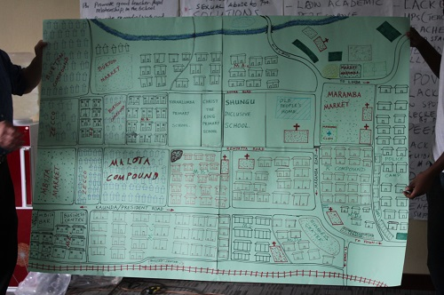
An example of a map created in Livingstone, Zambia

[Image description: The map shows the layout of straight and curved streets. There are lots of small squares illustrating where houses, shops and schools can be found.]

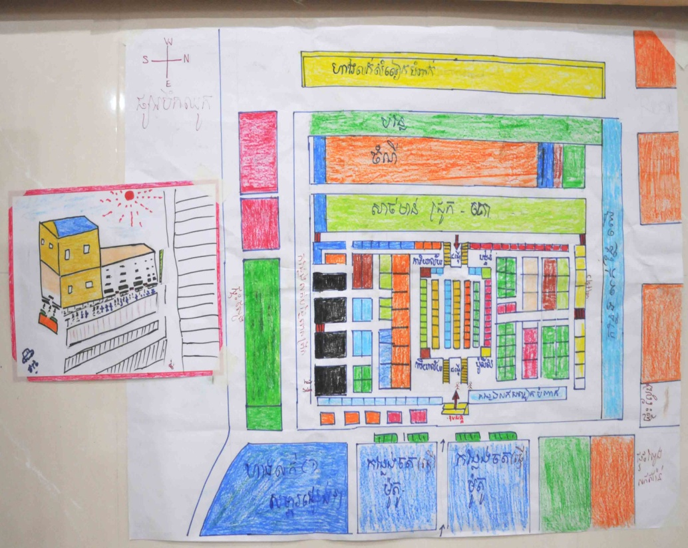
An example of a map created in Cambodia

[Image description: The map has many different sized and coloured squares and rectangles showing the layout of a marketplace.]

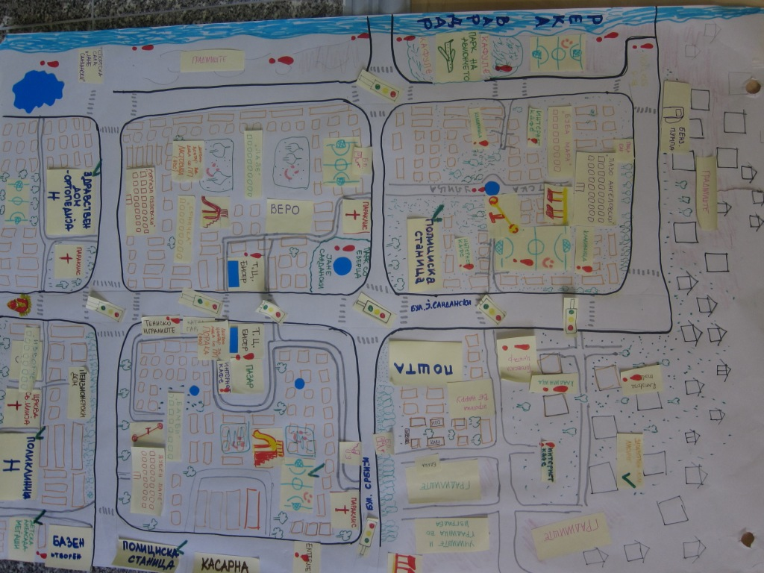
An example of a map created in Macedonia

[Image description: The map shows the layout of streets in a grid pattern. There are lots of small squares illustrating where houses, shops and schools can be found. There are labels showing where there are barriers to inclusion.]

Notes

Activity 3.4c: Feedback on the action research practice session
Main
One of the benefits of using action research is that different people can be involved as researchers, using techniques that best suit them and the stakeholders they want to find out information from. During the practice session, teachers may not have had time to try more than one of the techniques each. A detailed feedback session can therefore help them to share what they learned when using the different techniques.

Back in the training room, the trainer should create new groups. Each new group will contain one teacher who did observation, one who did mapping, and so on. Each new group should create a presentation (visual and verbal) which pulls together all of the information which was gathered using the various techniques.

After the allocated time the trainer should facilitate one of the fun feedback/sharing methods already suggested in previous sessions (carousel, press conference, etc). The trainer can also ask teachers to reflect on the techniques they used during the action research practice session – the pros and cons, what went well, what was not so successful and what they would do to improve the way they use the technique in future.

Notes

Action research tasks
- Ensure the school inclusion team understands it has to make a detailed survey of out-of-school children and they will report to you when you visit them.
- Ensure the school inclusion team understands that out-of-school children:
- have never been to school, or
- have dropped out, or
- sometimes come to school and sometimes are absent

Things to find out:
- Who are these out-of-school children?
- Where are they when they are out-of-school and what are they doing?
- Where do they live?
- Why are they out of school?
- What solutions does the community have to make sure all these children attend school?

- Create a map of the local area.

Resources

Module
3

Resource 3.1: Defining the issue: Who are out-of-school children and why are they out of school?

Introduction
Global: “There are today 264 million children and youth not going to school…”
Zambia: “There are as of 249 586 children and youth not going to school…”¹¹

Out-of-school children is a very broad term, usually referring to children who do not attend formal schooling. However, there have been different and sometimes conflicting approaches to how out-of-school children are defined and measured. For example, prior to 2005, large inter-governmental organisations such as UNICEF and UNESCO used to measure out-of-school children solely on the basis of participation in primary schooling, which meant that primary-aged children attending levels of formal schooling other than primary (i.e., pre-primary or secondary) were statistically considered to be out of school. Although more sophisticated approaches to defining and measuring out-of-school children have since been developed, like all statistics, it is important to remember that measurements of out-of-school children should not just be taken at face value. They need to be considered more deeply as to how they have been constructed and what, exactly, they are trying to measure.

Despite some disagreements in how to classify and measure out-of-school children, it is still worthwhile looking at general definitions and patterns to better understand the scope and nature of the problem and how to solve it.

The term out-of-school children includes children who have never attended school as well as those who have dropped out of school. UNESCO identifies three out-of-school types:

- late entry
- early drop-out
- never attending.

Although this issue may seem straightforward on the surface, it becomes more complicated when we consider the variety of barriers that keep children out of school. There are different possible ways of categorising barriers and their underlying causes. Inevitably, no matter how they are constructed, some of these categories will overlap, or be deeply interlinked with one another and none of them should be considered as mutually exclusive. An example of this would be, if a child is out of school because his family is migrating from one area to another, the process of migration may be considered a barrier, but the underlying reasons for the family’s migration may be poverty, or perhaps conflict in their home region, or both.

“Multiple disparities often intersect with each other, resulting in complex and mutually reinforcing patterns of disadvantage that erect barriers to schooling and erode educational opportunities.”

As in other areas of inclusive education, it is important to remember that whatever the reason(s) a child is out of school, it is always the system that is the problem, never the child. So, if a child is out of school because she has a disability and the local school is not able to support her to attend, then the problem is with the school and system of education rather than with the child herself. Similarly, if we consider, for example, that a child’s first language or mother tongue may be a barrier to that child being in school (in areas where the language of instruction in school is different than the child’s mother tongue), the problem is not with the child’s mother tongue, but with the education system not being flexible enough to accommodate children from language groups other than the dominant language of instruction in schools.

Broad categories of barriers to children’s schooling
There are several broad, cross-cutting categories of barriers to children’s schooling within which more specific barriers can be located. To discuss these broader issues, they have been grouped here into the following three categories:
- environment and resources;
- attitudes and experiences;
- policies and practices.

It is likely that you have already encountered the concept of barriers to inclusion during other trainings about inclusive education. Barriers to inclusion are barriers which affect children’s presence in school, their participation in the learning process, and their achievement.

As a quick reminder, these barriers are:
- Environmental barriers: e.g. school buildings, school surroundings and toilets which are not accessible;
- Resource barriers: e.g. a shortage of teachers, large class sizes;
- Attitude barriers: e.g. fear, embarrassment, shame, pity, low expectations;
- Policy barriers: e.g. inflexible school timetables; lack of mother-tongue teaching;
- Practice barriers: e.g. a lack of interactive and co-operative teaching.

In this training module we are looking specifically at the barriers that cause children to be out of school – though in reality many of them are the same as the barriers to inclusion.

Environment and resources
The word environment here can be used to refer to both built and natural environments. This might concern a specific region, country, city, or village, or a designation such as urban, or rural.

Where a child lives can be an important determining factor in whether or not she/he is in school. For example, there are generally greater concentrations of schools and easier access to schooling in urban areas than rural areas. Consequently, statistically, there are more out-of-school children in rural than urban areas. Further, in remote rural areas where the distances between communities can be great and travel made difficult by the terrain (such as high mountains which are difficult to cross), lack of infrastructure (such as roads and bridges) and even climate (such as long winters with heavy snows), it can be difficult or impossible for some children to access the few schools that are available. Such environmental barriers inevitably contribute to children being out of school in those areas.

Although there can be great differences in numbers of children out of school between different regions in the same country, the literature suggests that generally, in countries where overall national rates of school attendance are high, school attendance rates tend to be high across all regions of the country (Wils, et al, 2006). The big differences in school attendance rates between regions tend to show up in countries where overall attendance rates are relatively low (ibid).

Resources – including economic/material, human, and cultural resources – can affect whether or not children are in school. The economic resources of families and communities can determine whether or not families can afford to send their children to school or whether a community even has a school for its children to attend. Economically poor families may depend on their children’s labour to survive and therefore prioritise work over schooling. Schools in economically poor areas may struggle to have enough material resources, in terms of teaching and learning materials, classrooms and other facilities, to support all of the area’s school-aged children.

A human resource issue impacting children’s access to schooling would be a lack of teachers, or lack of trained teachers. Families without the cultural resources, such as literacy and numeracy, that come from experience of formal education, may struggle to support their children’s learning and this may also be a factor in children not attending, or dropping out of schooling (this also links with attitudes and experiences).

Attitudes and experiences
The attitudes of individuals, families, communities and societies can be a major factor keeping children out of school. For example, some families and communities believe that children with disabilities should not be in school. In other communities, families might feel that girls should stay at home and not attend school.

Another example of how attitudes can lead to children being out of schooling, is children who are bullied by other children (or teachers) in school because they are from minority ethnic, religious or linguistic groups. Children who are bullied in this way may drop out of school to avoid further abuse. Such attitudes reflect the biases of those who hold them, not the actual capacity of children to attend and benefit from schooling. Nevertheless, negative attitudes can be very effective in keeping children out of school.

Connected to their attitudes, are people’s own experiences of education. Parents/guardians/care-givers who have not had access to schooling themselves may see little value in sending their children to school. Research shows that in particular, mothers’ experience of education is an important factor in determining whether or not their children are in schooling. UNESCO’s (2005) study found that, globally, primary school-aged children whose mothers had no education were more than twice as likely to be out of school than children from mothers with some education.

It is often ignorance and fear which lead to and perpetuate biases and negative attitudes. In a related way, ignorance and fear also impact on educational policies and practices.

Policies and practices
National, local, and even school-based policies can contribute to the problem of out-of-school children. For example, if a country does not have a policy of free schooling, many children may be excluded because they and their parents/guardians/care-givers are unable to afford to pay school fees.

An example from the school level would be a school policy that enforces an early start to the school day and at the same time is inflexible about children arriving late to school. Such a policy could result in the exclusion of children who are late to school because they have to walk long distances to and from school.

Education practices, particularly teaching and learning practices, have huge impacts on children’s experience of schooling. Some children choose not to go to school because they feel bored, disengaged or otherwise out of place in schooling. They may feel the teaching is not meeting their needs or has little value or relevance to their lives. In particular, rigid, rote-learning styles of teaching may cause children to disengage in the classroom and drop out of schooling. Or, as another example, children may not attend school for fear of corporal punishment. All of these issues relate to practices, and often poor teaching practices are a result of the poor training of teachers.

Specific barriers to children’s schooling
Within the broader barriers to children’s schooling are a set of more specific barriers. Again, it is important to emphasise that both the general and specific issues affecting children’s attendance at school are often interconnected, and this becomes clearer when we try to trace chains of causality.

Rather than there being a simple, singular reason for a particular child being out of school, there is usually a chain of causes and effects. For example, a shortage of teachers with proper training may lead to a school having one, poorly trained teacher responsible for classes with large numbers of children. This in turn results in those children receiving a poor-quality education; which further results in some children dropping out of school because they are disengaged with the teaching and learning, and/or their parents/guardians/care-givers feel it is no longer worthwhile sending them to school. It may also be that the school is a long distance from some children’s homes and therefore difficult for them to access, and this also impacts on their school attendance.

In the above example, we might say that poor teaching is the reason the children have dropped out of school. However, such a statement does not address the reasons behind the poor-quality teaching (such as a lack of teachers, a lack of training in how to manage large class sizes and child-centred teaching methods), or other contributing factors (such as the parents’/guardians’/care-givers’ attitudes towards and experiences of formal schooling).

Now let’s look at some of the more specific barriers to children’s schooling. These include:
- age;
- socio-economic class;
- conflict and disasters;
- disability;
- ethnicity, religion and culture;
- gender;
- health;
- language;
- migration;
- poverty.

Age
Age can be an important factor in children being out of school, particularly with regards to children dropping out of school. There is evidence that when children start school late (i.e., later than their peers), or repeat grades, it is more likely they will drop out of school before completion. Also, in some contexts there is a lot of pressure on children to be working at young ages, which keeps them out of schooling.

Socio-economic classes
In some contexts, issues of socio-economic class determine whether or not children have access to schooling. Generally, children born into lower socio-economic families are less likely to be in school, or stay in school for the full duration, than children in higher classes.

Conflict and disasters
Conflicts (such as civil wars) and disasters (such as flooding and earthquakes) can be the main factor, or a contributing factor in keeping children out of school. In areas experiencing conflicts and/or disasters, schools may be damaged, destroyed, or non-existent. Travel to and from school may be unsafe or impossible due ongoing fighting, landmines, and damage to infrastructure such as school buildings, bridges, roadways, etc. Even when schools are open, they may not be safe spaces for children. In contexts of conflict, for example, schools may be targets of violence. Additionally, in some countries children may risk being forced to fight as child soldiers.

“Although there are no exact figures, hundreds of thousands of children under the age of 18 serve in government forces or armed rebel groups. Some are as young as eight years old. Since 2001, the participation of child soldiers has been reported in 21 on-going or recent armed conflicts in almost every region of the world.

In some countries, former child soldiers have access to rehabilitation programs to help them locate their families, get back into school, receive vocational training, and re-enter civilian life. However, many children have no access to such programs. They may have no way to support themselves and are at risk of re-recruitment.”

Disability
Children with disabilities are often excluded from schooling. This may be for a range of reasons, including:
- Societal attitudes and beliefs – in some places it may be believed that children with disabilities cannot, or should not, be in school;
- Access – schools may be physically inaccessible to some children with disabilities;
- Lack of resources and capacity – some schools lack (or believe they lack) the material resources and capacity, in terms of numbers of staff and training, to properly include children with disabilities.

Children with emotional and behavioural problems are often excluded from schooling because they are disruptive and considered dangerous to themselves, other children and school staff. This is often a resource and training issue, and with proper staff training and support schools can meaningfully include children with emotional and behavioural problems. See the module on Including Learners with Additional Needs (pp.15-18) for hints and tips on including learners with emotional and behavioural difficulties.

Ethnicity, religion and culture
Children may be excluded from schooling because of their ethnicity. This is often an issue for minority ethnic groups. Other factors, such as ethnic conflict may exacerbate the problem and work to keep particular ethnic groups out of school. Even if not explicitly excluded from schooling, some children may drop out of school if they face prejudice and bullying due to their ethnicity.

Children may also be out of school because of their religion. This may be because children are excluded from attending school or drop out due to religious persecution. Or, for example, some parents/guardians/care-givers may keep their children out of school because the available schooling does not cater to their family’s religious needs and beliefs.

There may be similar issues in relation to cultural beliefs and practices. Often, issues of ethnicity, religion and culture (and language) are intertwined.

Gender
Although, overall, gender imbalances for children out of school have been reduced considerably since the 1990s, there is still a disproportionate number of girls out of school globally. The impact of gender on schooling differs regionally. Some regions have a much greater proportion of out-of-school girls, and other regions having a more equal balance of girls and boys in and out of school, or even a slightly higher percentage of boys out of school, especially in industrialised countries.

However, negative attitudes and related harmful cultural practices continue to disproportionably impact girls and their access to schooling. For example, child marriage, in which girls as young as eight or nine in some countries are forced into marriages, amongst other negative impacts on girls’ lives, greatly reduces the likelihood of them attending or staying in school.

Health
Poor health, due to malnourishment and disease, keeps many children out of school. Additionally, there are often stigmas and prejudices attached to certain diseases, in particular HIV and AIDS, which contribute to excluding children from schooling.

As with many of the specific barriers to children attending school, health, is often interconnected with, if not a direct result of other barriers, such as poverty, and disasters and conflicts.

Language
Language, and in particular, the language of instruction in schools, can be a barrier to children being in schooling. If the language of instruction in school is different from the language spoken in a child’s home (the ‘mother tongue’), that child may struggle to learn and ultimately drop out of school. This disproportionably affects children from minority language groups. Again, issues of language are often interlinked with ethnicity, religion and culture.

Migration
The movement of people from one area to another, whether due to economic reasons, to escape disasters and conflicts, for cultural reasons, or combinations of these factors, inevitably has impacts on children’s schooling.

For example, children who are forced to migrate because of disasters and conflicts in their home countries often end up in internationally supported refugee camps in other countries where access to schooling may be limited. The situation is worse for children who are internally displaced persons (IDPs) within their own countries, as they are less likely to access internationally supported and monitored refugee camps. They therefore have even less, if any, access to formal schooling in comparison to children in ‘official’ refugee camps.

Even children who migrate for non-crisis reasons – such as moving so the family can find work – may find themselves out of school. They may face language or cultural barriers, their parents/guardians/care-givers may not be able to afford education-related costs, or the very fact of being in a strange place may make it difficult for their parents/guardians/care-givers to understand and access the services that are available.

Poverty
Poverty is one of the most serious and pervasive barriers to children attending school. The economic conditions for individual families, local communities, local regions, nations and even larger geographical regions can greatly affect whether children are in or out of school. In economically poor areas, there are generally fewer schools with fewer resources and fewer teachers with less training than in more highly economically resourced areas. These issues contribute to children being out of school. Some families cannot afford to send their children to school. Children may be forced to work instead of attending school. Even when children experiencing economic poverty do attend school, they are much more likely to drop out before completion than children from economically wealthier families.

Like other barriers, poverty is complex, and more than just a factor of geography. Even in relatively wealthy areas where there is generally a good provision of schooling, there may be pockets of poverty and deprivation resulting in some children being out of school.

Worldwide, supposedly ‘free’ schools often have hidden costs, such as uniforms and textbooks. In some schools, children may not be taught properly, or may be failed on purpose if they or their parents/guardians/care-givers cannot afford to pay bribes to teachers.

Resource 3.2: Outline of barriers to children’s schooling

Broad categories of barriers to children’s schooling
- Environment and Resources

- Attitudes and Experiences

- Policies and Practices

Specific barriers to children’s schooling
- Attitudes to age

- Attitudes to class

- Conflict and disasters

- Attitudes to disability

- Attitudes to ethnicity, religion and culture

- Attitudes to gender

- Health

- Language

- Migration

- Poverty

Resource 3.3: Policy frameworks and legislation

International policy and legislation
The following text box outlines some of the major international policy frameworks and legislation addressing the right to education.

International recognition of the right to education

“This right has been established by a succession of UN Conventions, from the Universal Declaration of Human Rights (1948) to the Convention on the Rights of the Child (1989), which acquired the status of international law in 1990. According to Article 28 of the Convention, governments have the responsibility of making primary education compulsory and available free to all.

Education is also recognised as crucial to human development. Indeed, the Education for All (EFA) movement and the Millennium Development Goals (MDG) have led to greater attention paid to educational participation and completion. Universal primary education is Goal 2 of both EFA (Jomtien, 1990; reaffirmed in Dakar, 2000) and the MDGs, adopted by UN Member States in 2000 (UNESCO, 2000; UN, 2003).”

Out of all of the international policy frameworks and legislation, the UN Convention on the Rights of the Child is one of the most comprehensive in regards to basic standards for children’s right to education, as well as other rights. The UN Convention on the Rights of the Child is made up of 54 articles addressing children’s rights. Article 28 of the Convention deals most specifically with the right to education, but many of the other articles also touch on issues which impact on education (such as children’s rights to health and well-being).

UN Convention on the Rights of the Child – Article 28

1. States Parties recognize the right of the child to education, and with a view to achieving this right progressively and on the basis of equal opportunity, they shall, in particular:

(a) Make primary education compulsory and available free to all;

(b) Encourage the development of different forms of secondary education, including general and vocational education, make them available and accessible to every child, and take appropriate measures such as the introduction of free education and offering financial assistance in case of need;

(c) Make higher education accessible to all on the basis of capacity by every appropriate means;

(d) Make educational and vocational information and guidance available and accessible to all children;

(e) Take measures to encourage regular attendance at schools and the reduction of drop-out rates.

2. States Parties shall take all appropriate measures to ensure that school discipline is administered in a manner consistent with the child's human dignity and in conformity with the present Convention.

3. States Parties shall promote and encourage international cooperation in matters relating to education, in particular with a view to contributing to the elimination of ignorance and illiteracy throughout the world and facilitating access to scientific and technical knowledge and modern teaching methods. In this regard, particular account shall be taken of the needs of developing countries.

Policy frameworks and legislation in Zambia
Zambia recognises a variety of international, regional, national and local policy frameworks and legislation which reinforce children’s rights to education. National policy frameworks and legislation include the following:

Educational Reform document (1977)
This policy document emphasises the principle of positive discrimination in favour of learners with disabilities and/or special educational needs (SEN) in the provision of education. It also sets the categories of disability and SEN as Mentally Handicapped, Deaf and Hard of Hearing, Blind, Partially Sighted, Physical Handicapped and Multiple Handicapped.

‘Educating Our Future’ policy (1996)
This national policy on education upholds the principle that the child has the right to quality educational opportunities and mainstreaming.

Education Act No. 23 of 2011
The Act has provided for learners with disabilities and/or SEN in a number of educational areas including materials and accessibility.

Persons with Disabilities Act No. 6 of 2012
Part 5 division 1 upholds the right to inclusive education based on equal opportunities for persons with disabilities. It upholds the provision of reasonable accommodation to meet the learning needs of persons with disabilities, and it also provides for protection from all forms of discrimination on the basis of disability.

Resource 3.4: Matching barriers to rights

Education, out-of-school children, and the UN Convention on the Rights of the Child
- Read the child-friendly version of the articles of the UN Convention on the Rights of the Child (below).
- Find the articles that relate to education (some do this directly and others do it indirectly or not at all).
- Discuss in your groups which barriers keeping children out of school are addressed by the articles in the UN Convention. (Refer to previous discussions and resources for a reminder about possible barriers.)
- Where possible, try to match barriers and the examples you identified earlier to rights. Write them in the space under the appropriate rights.

Article 1
Everyone under 18 has these rights.

Article 2
All children have these rights, no matter who they are, where they live, what their parents do, what language they speak, what their religion is, whether they are a boy or girl, what their culture is, whether they have a disability, whether they are rich or poor. No child should be treated unfairly on any basis.

Article 3
All adults should do what is best for you. When adults make decisions, they should think about how their decisions will affect children.

Article 4
The government has a responsibility to make sure your rights are protected. They must help your family to protect your rights and create an environment where you can grow and reach your potential.

Article 5
Your family has the responsibility to help you learn to exercise your rights, and to ensure that your rights are protected.

Article 6
You have the right to be alive.

Article 7
You have the right to a name, and this should be officially recognized by the government. You have the right to a nationality (to belong to a country).

Article 8
You have the right to an identity – an official record of who you are. No one should take this away from you.

Article 9
You have the right to live with your parent(s), unless it is bad for you. You have the right to live with a family who cares for you.

Article 10
If you live in a different country than your parents do, you have the right to be together in the same place.

Article 11
You have the right to be protected from kidnapping.

Article 12
You have the right to give your opinion, and for adults to listen and take it seriously.

Article 13
You have the right to find out things and share what you think with others, by talking, drawing, writing or in any other way unless it harms or offends other people.

Article 14
You have the right to choose your own religion and beliefs. Your parents should help you decide what is right and wrong, and what is best for you.

Article 15
You have the right to choose your own friends and join or set up groups, as long as it isn’t harmful to others.

Article 16
You have the right to privacy.

Article 17
You have the right to get information that is important to your wellbeing, from radio, newspaper, books, computers and other sources. Adults should make sure that the information you are getting is not harmful, and help you find and understand the information you need.

Article 18
You have the right to be raised by your parent(s) if possible.

Article 19
You have the right to be protected from being hurt and mistreated, in body or mind.

Article 20
You have the right to special care and help if you cannot live with your parents.

Article 21
You have the right to care and protection if you are adopted or in foster care.

Article 22
You have the right to special protection and help if you are a refugee (if you have been forced to leave your home and live in another country), as well as all the rights in this Convention.

Article 23
You have the right to special education and care if you have a disability, as well as all the rights in this Convention, so that you can live a full life.

Article 24
You have the right to the best health care possible, safe water to drink, nutritious food, a clean and safe environment, and information to help you stay well.

Article 25
If you live in care or in other situations away from home, you have the right to have these living arrangements looked at regularly to see if they are the most appropriate.

Article 26
You have the right to help from the government if you are poor or in need.

Article 27
You have the right to food, clothing, a safe place to live and to have your basic needs met. You should not be disadvantaged so that you can't do many of the things other kids can do.

Article 28
You have the right to a good quality education. You should be encouraged to go to school to the highest level you can.

Article 29
Your education should help you use and develop your talents and abilities. It should also help you learn to live peacefully, protect the environment and respect other people.

Article 30
You have the right to practice your own culture, language and religion - or any you choose. Minority and indigenous groups need special protection of this right.

Article 31
You have the right to play and rest.

Article 32
You have the right to protection from work that harms you, and is bad for your health and education. If you work, you have the right to be safe and paid fairly.

Article 33
You have the right to protection from harmful drugs and from the drug trade.

Article 34
You have the right to be free from sexual abuse.

Article 35
No one is allowed to kidnap or sell you.

Article 36
You have the right to protection from any kind of exploitation (being taken advantage of).

Article 37
No one is allowed to punish you in a cruel or harmful way.

Article 38
You have the right to protection and freedom from war. Children under 15 cannot be forced to go into the army or take part in war.

Article 39
You have the right to help if you’ve been hurt, neglected or badly treated.

Article 40
You have the right to legal help and fair treatment in the justice system that respects your rights.

Article 41
If the laws of your country provide better protection of your rights than the articles in this Convention, those laws should apply.

Article 42
You have the right to know your rights! Adults should know about these rights and help you learn about them, too.

Articles 43 to 54
These articles explain how governments and international organizations like UNICEF will work to ensure children are protected with their rights.

Adapted from UNICEF’s ‘UN Convention on the Rights of the Child in Child-friendly Language’ www.unicef.org/rightsite/files/uncrcchilldfriendlylanguage.pdf

Resource 3.5: Diamond 9 cards – Barriers to children being in school
The cards should be cut up before giving them to teachers.

Attitude to  age | Attitude to  Class | Conflict
Attitude to  disability | Attitude to  Ethnicity | Attitude to  gender
Health | Language | Migration
Poverty | Attitude to  Religion | Attitude to  culture
Disasters | blank cards for teachers to write their own ideas for barriers

Resource 3.6: Case studies of out-of-school children

1. Sarah uses a wheelchair. She wants to attend her local school with friends from home. The school has no wheelchair access, so her cousin who was unemployed accompanied her to school to lift her up the stairs and move her through the doorways. Her cousin now has a job and he can no longer accompany her. The school says Sarah cannot attend school without a helper. Sarah has been at home ever since.

2. Charles has severe behaviour and emotional problems. When he did attend school, he could only sit still in class for 15 minutes and was almost always in trouble by the end of the session. This caused him to throw major tantrums, which got him into even more trouble and often his teachers ended up excluding him from the classroom. Eventually Charles stopped coming to school. Now he does not go to school anymore, but spends his days in the local town where he has been spending time with older boys and getting into trouble with shopkeepers and police.

3. Nyambe is 16 years old. She lives with her family of nine children in two small thatched huts near the River Zambezi. None of the family has been to school. Her mother walks 6 kms every day to the Kazungula border to collect leftover food from the restaurants to feed the family in the evening. At times Nyambe is sent to Kazungula border to do ‘piecework’ in bars and restaurants at the lorry park. Her father stopped her brothers from going to school to help him burn charcoal and water the garden. When he was spoken to, he answered that the “school is not profitable”.

4. Edward has got a visual impairment and some learning difficulties. His parents are ashamed of him. They live a long way from the school so he helps with the family business of selling vegetables in a local market and has never been to school.
5. Some girls have stopped coming to primary school, because they keep getting sick. It turns out that when they were in school they never used the school toilets. The school toilets were always very dirty, and also the girls were scared of getting bullied in the toilets. When the girls complained to the head teacher, she started making sure the toilets were cleaned, but she also stared locking them and keeping the key so students would need to ask for the key whenever they needed to use the toilet. Sometimes students can’t find the head teacher when they need the toilet.

6. Hantomulya is a sixth grader who dropped out of school because he cannot manage to pay ‘a coin’ (1 Kwacha) to older boys who have completed their 9th grade. They appear at the school gate every day, bullying him for money. He starts to pretend that he is sick and stays at home to avoid confrontation with them. His parents ask him why he has given up on his desire to go to school and can’t find any reason for his sickness. Finally, they consult a local healer who confirms Hamtomulya’s ‘sickness’ and tells them that he will die if he continues to go to school. Therefore, he drops out.

7. Esther is illiterate and dropped out of school at age 9 and was forced to get married when she was 14. Esther’s family is very poor and married her off to bring the family some money and security. Esther still lives with her family.

8. Mary is a 14-year-old girl in grade 7. She stopped attending school during the examination period. When the school authority visited her family, after she had written her first two papers, she refused to go back to school and her parents did not say anything to help change her mind. Later, when she talked to friends, she said that school is not beneficial and she had opted to get married and her parents married her off to an older young man.

9. Cecil is 10 years old. He was very happy to start school a few years ago, but his joy was short-lived. His teacher never had patience to work with him. He is hyperactive and his teacher thinks that he is ill-behaved, disruptive and spoiled. He was also always in conflict with his parents. His parents had tried to look for solutions, without success. They felt increasingly powerless, frustrated and angry, and sometimes vented their anger and frustration on him – they would insult him, punish him or stop talking to him. His friends in the playground and the neighbourhood mock him and won’t play with him; they say he always ‘ruins’ their games.
One can almost see the question “but why?” on his face. Cecil no longer goes to school.

10. Lweendo was orphaned and went to stay with the grandmother. She kept on repeating her grade, and never progressed out of her grade. Finally, her grandmother kept her out of school until she was older and then she was married off.

11. Samwangala is a ten-year-old boy. He belongs to the Lunda tribe. Their culture demands that he undergoes male circumcision; this traditional ceremony means he has to go and live with other boys of his age, secluded in the bush, for six months. His parents agree to take him to the ‘village’ where he stays for six months in order to undergo traditional practices. Therefore, Samwangala does not go to school and he is worried that his friends will laugh at him. He fails the end of year exam, because of his long absence from school.

12. Mutinta was made to stay with her aunt when her parents died in a road accident. When Mutinta asked her aunt about school she was told “you have to work for the food you eat” hence she became a maid in her aunt’s house.

Resource 3.7: Example of an observation sheet

Things I will look at | I see or I hear… | I think… | Possible action…

Resource 3.8: Interview guidelines

Following are some guidelines to help you in conducting good interviews:

Preparation
- Make sure your interview has a clear purpose.
- Make a short list of topics or questions to guide your interview (4 or 5 are enough).

Introduction
- Introduce yourself first at the start of an interview.
- State clearly the purpose of your interview.
- Ask the interviewee(s) if they have enough time for the interview at the moment, or if not, ask if they can suggest another convenient time.
- Ask the interviewee(s) if they want the interview to be confidential.

Conducting the interview
- Begin with some friendly, general conversation to help make the interviewee(s) feel comfortable.
- Make the first questions easy ones for the interviewee(s) to answer – beginning an interview with a very personal or difficult question may cause offence and stop the flow of information.
- Try to express only one idea per question to avoid confusion.
- Avoid too many ‘yes’ or ‘no’ closed questions because that can stop the flow of information.
- Be careful about how often you ask ‘why?’. Although ‘why’ is an important question, asking this too often or pushing too hard for an answer can make the interviewee(s) feel uncomfortable.
- Be careful about asking ‘leading questions’ - that is questions that try to influence the interviewee(s) answers. An example of a ‘leading question’ is ‘Don’t you think that…?’
- Ask the interviewee(s) to repeat an answer if you did not understand it or were not able to record what they said. Also, ask them to explain or clarify their answers if you did not fully understand them.
- Avoid passing judgement, giving advice, or conveying your own opinions.
- Tell the interviewee(s) when you are changing the topic, so they can be prepared.
- Be aware of your body language, because this may tell the interviewee(s) what you are feeling about their answers and may disturb the interview. It can also make the interviewee(s) feel uncomfortable or like you are not really interested in what they are saying if, for example, you look bored, or fidgety, or avoid eye contact.

Closing the interview
- Keep your interviews relatively short (less than an hour if possible).
- Try to summarise the main points that you have learned during the interview to check with the interviewee(s) if you have correctly reflected what was said.
- Ask the interviewee(s) if there are any questions they would like to ask you.
- Thank the interviewee(s) for their time and trouble.

Guidelines for recording an interview
- Use a notebook.
- Record details of what was said.
- Record details of body language and feelings that were expressed.
- Record your observations about how the interview went.
- If it was a group interview, who said what and did the others agree?
- Make any follow-up notes as soon as possible after the interview.
- Record your personal impressions.

Adapted from: S.B. Rifkin and P. Pridmore, (2001) ‘Partners in Planning – Information; participation and empowerment’, Macmillan Education.

References

Human Rights Watch, 2008
http://www.hrw.org/news/2008/12/03/facts-about-child-soldiers

Johnstone, C. (2010) ‘Inclusive Education as Part of a Child-Friendly Schools Framework: Results and Recommendations from a Study in Macedonia’. UNICEF.

MoGE. (2016). Educational Statistical Bulletin, Lusaka.

Spavoski, O., Ballazhi, S. and, Friedman, E. (2010) ‘Mapping Policies and Practices for the Preparation of Teachers For Inclusive Education in Contexts of Social and Cultural Diversity - Country Report - Former Yugoslav Republic of Macedonia.’ European Training Foundation - A Report prepared by SCIENTER and Centre for Education Policy

UNESCO Institute for Statistics (2005) ‘Children Out of School: Measuring Exclusion from Primary Education’. Montreal: UNESCO Institute of Statistics.
www.uis.unesco.org/Library/Documents/oosc05-en.pdf

UNESCO, Education For All - Global Monitoring Report 2010: p – 1
http://unesdoc.unesco.org/images/0018/001866/186606E.pdf

UNICEF, ‘UN Convention on the Rights of the Child in Child friendly Language’
www.unicef.org/rightsite/files/uncrcchilldfriendlylanguage.pdf

UNICEF and UNESCO Institute for Statistics, 2011
www.unicef.org/education/files/OOSCI_flyer_FINAL.pdf

United Nations High Commissioner for Human Rights, 2005
www2.ohchr.org/english/law/crc.htm

Werner, D. (cited in), Linney, B. (1995) Pictures, People and Power. London and Oxford: Macmillan.

Wils, A., Zhao, Y., and Hartwell, A. (2006) ‘Looking Below the Surface: Reaching the Out-of-School Children’. Collaborative Working Paper CWP-02-01. Education Policy and Data Center.

Notes

UNESCO (2017) Accountability in Education. Meeting our Commitments. Global Education Monitoring Report, 2017/18, p.i. http://unesdoc.unesco.org/images/0025/002593/259338e.pdf
UNESCO (2005). Children Out of School: Measuring Exclusion from Primary Education, UNESCO Institute for Statistics, Montreal. http://uis.unesco.org/sites/default/files/documents/children-out-of-school-measuring-exclusion-from-primary-education-en_0.pdf MoGE (2016). Educational Statistical Bulletin. Lusaka.
Ibid, p.27
UNICEF (2012) ‘All Children in School by 2015. Global Initiative on Out-of-School Children.’ UNICEF and the UNESCO Institute for Statistics (2011), p.2. https://files.eric.ed.gov/fulltext/ED566875.pdf
UNESCO, 2005
Wils, A., Zhao, Y., and Hartwell, A. (2006) ‘Looking Below the Surface: Reaching the Out-of-School Children’. Collaborative Working Paper CWP-02-01. Education Policy and Data Center.
UNESCO, 2005
UNESCO, 2005
Human Rights Watch, 2008. www.hrw.org/news/2008/12/03/facts-about-child-soldiers
UNESCO, 2005
UNESCO (2005). Children Out of School: Measuring Exclusion from Primary Education, UNESCO Institute for Statistics, Montreal. http://uis.unesco.org/sites/default/files/documents/children-out-of-school-measuring-exclusion-from-primary-education-en_0.pdf
www.unicef.org.uk/wp-content/uploads/2010/05/UNCRC_united_nations_convention_on_the_rights_of_the_child.pdf

