Module
111
Making Teaching and Learning Aids from Locally Available Resources

A manual for teacher trainers
Prepared for:
Ministry of General Education, Zambia
The Norwegian Association of Disabled
Developed by:
Enabling Education Network, December 2019

This work is licensed under the Creative Commons Attribution-NonCommercial-ShareAlike 4.0 International License. To view a copy of this license, visit http://creativecommons.org/licenses/by-nc-sa/4.0/
Contents

Introduction 4

Session 11.1: Identifying teaching and learning aids 6
Session 11.2: Creating teaching and learning aids 11

Resource 11.1: Case studies for group-work 23
Resource 11.2: Learning outcomes and learners’ profiles (case studies) 25
Resource 11.3: Easily adaptable teaching and learning aids – examples 27

Notes 32

Introduction

The aim of this module is to help trainers of trainers to develop teaching and learning aids from locally available resources. We realise that teachers need to be creative, innovative and resourceful in the absence of expected teaching and learning aids. This is called improvisation.

When identifying barriers to inclusive education, teachers and other educators often refer to a lack of resources. They say they cannot be more inclusive and meet the needs of individual learners because they do not have enough classroom resources. Often the barrier is a lack of flexible thinking and flexible teaching methods. As with other modules, this module encourages teachers and trainers to identify problems and work together to find solutions. When using this module they will investigate reasons for using effective teaching and learning aids, how to develop and make them in context with their own school and lessons, and how to adapt them to meet the needs of individual learners.

All teaching and learning aids used in the training activities are made from waste materials and cost nothing. Teachers will be able to see that it is possible to have learner-centred lessons, using appropriate and interactive teaching and learning aids to enhance their lessons, even in challenging environments where schools have limited resources.

Teachers often experience a chronic lack of resources in their schools, often compounded by having to teach large class sizes. This often compels them to resort to using lecture methods where teaching aids may not always be used. The use of lecture methods means that learners remain largely passive. The training sessions provided in this module help teachers to promote active learning in large, under-resourced, mixed-ability classes; enabling all learners to participate and improve their learning.

Planning the delivery of the sessions in this module should be done with close reference to the other training modules in this series, including ‘An Introduction to Inclusive Education’ (Module 1), ‘Promoting Active Learning in the Classroom’ (Module 7) and ‘Developing Learner Participation’ (Module 8). Material from the module on Including Learners with Additional Needs relating to specific impairments may be useful when thinking about developing different resources.

As with the other modules, the training outlined here focuses on using participatory methods and active learning techniques. It follows this basic principle:

We must use inclusive training methods if we are to successfully train others how to teach inclusively.

Preparation for the training
Prior to the training/workshop, the trainer should ask teachers to collect any waste materials and locally available resources they think will be useful for the practical activities, which will be shared at the training. For example:

- bottle tops;
- milk or food cartons / boxes;
- old newspapers or magazines;
- advertisement leaflets from your local shops;
- drinking straws;
- sandpaper;
- old pieces of string;
- tubes from toilet rolls;
- any old clean food containers like yoghurt pots;
- pasta (uncooked);
- rice (uncooked);
- small sticks and stones from outside;
- leaves of different shapes and sizes;
- old calendars, posters or leaflets from their place of work.

These are just some ideas. Teachers will have many more if they are given enough time to collect items before the training.

Duration of training
Trainers should adapt this training to suit the local context and the time available to them for training. Trainers may decide not to use all of the activities, or to shorten some activities if time is limited, or to expand activities if teachers need more support with understanding a particular topic. If all activities are used, without significant adaptation, shortening or lengthening, this module requires approximately 10 hours of training. This could be split over 2 days, depending on the preferred length of training days, number and length of breaks, and so on.

Session 11.1: Identifying teaching and learning aids

It is important for teachers to acknowledge what they are already using as teaching and learning aids, i.e., what is already effective in the classroom but also think about other resources they can develop using locally available materials.

Activity 11.1a: ‘Mingle-Mingle’
Main
45 minutes

This fun activity is designed as an ice-breaker and opens the training by encouraging teachers to think about how and what they are already using as teaching and learning aids; what is already effective and what can be improved.

The trainer should prepare the following table on a flipchart and display it on the wall before the activity – or draw it clearly on the board.

Lesson outcome(s) | Teaching and learning aid used | Made from

Teachers will be moving around for this activity so the trainer should make sure there is enough empty space at the back of the training room or use the outside space.

The trainer will give the following instructions:

‘We will sing, ‘Mingle-Mingle’ and clap our hands as we move around. When you hear me say a number you should stop moving around (mingling) and hug/move yourself into a group of that number. For example, if I say, ‘Mingle 5’, you should be hugging/standing with 4 other people so your group total is 5’.

The trainer will need to give a demonstration of the grouping at this point.

‘This will continue and each time you hear me say, ‘Mingle’ and then a number you must hug/move yourself into a group making that specific number’.

This part of the ice-breaker finishes when the trainer says, ‘Mingle 2’, this puts teachers into pairs for the second part of the activity.

The trainer should then hand out sticky notes (post-it notes) to each pair and ask them to discuss teaching or training aids they have used in the past or are currently using, what they are made from and what the lesson outcome is/was. Answers should be written onto the post-it notes and placed under the appropriate heading in the table – teachers should make sure their post-it notes are displayed in a straight line.

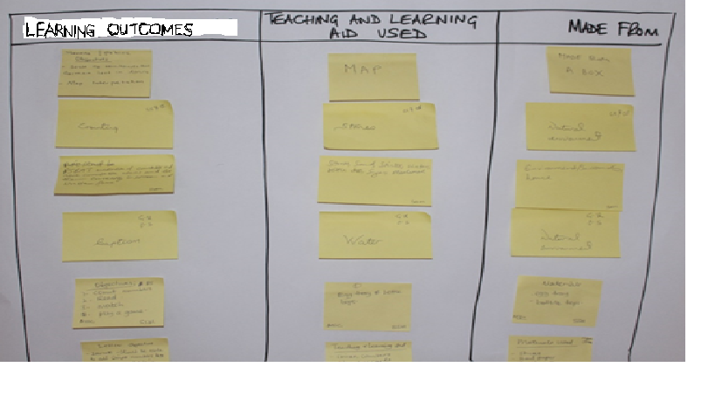
Teaching and learning aids used by teachers

When all pairs have added their answers to the table, the trainer, or a volunteer, can, if they wish, read them out to all teachers.

This table should be left on display – each idea will be discussed again in Activity 11 1c. The examples may also be used as a point of reference during discussions throughout the training.

Activity 11.1b: A good teaching and learning aid should be...
Main
45 minutes

The purpose of this activity is to help teachers understand the qualities of a good, appropriate teaching and learning aid. The trainer should give the following introduction:

‘Good teachers should develop ways in which they work more as a team that share ideas and classroom materials. Not only will their lessons be more effective, but also their roles as teachers more interesting and their skill-set broader. In order to develop teaching and learning aids that will be long lasting as well as effective in teaching any given concept they were designed for; we are going to think in more detail about the qualities that are needed in a good teaching and learning aid’.

The trainer should ask teachers to make suggestions of the qualities of a good teaching and learning aid. If they need a prompt, the trainer can start the list by writing and explaining one of the points below. For example, the trainer could say:

‘made of strong materials and therefore durable. This is because a good teaching and learning aid should be shared by others and used again and again in different lessons’.

Write the suggestions as a list on the board/flipchart – after each suggestion ask for a more in-depth explanation.
By the end of the session you should have a list similar to this:
- Something that will help a learner to find the solution to a problem.
- Can be easily adapted to meet the needs of individual learners – for example, can be made into larger print for someone who does not see very well.
- Be interactive – something the learners can touch, investigate and manipulate.
- Be clear to see and shows relevant information.
- Made of strong materials that will be durable.
- Diagrams that show only relevant information. Should not be cluttered with unnecessary information or visuals.
- Fun to use (e.g., tactile dominos and number tiles).
- Clearly demonstrate the concept they were designed for. For example, if the lesson is about sizes from small to big, the teaching and learning aid should have several different sized objects (e.g., seeds/leaves/stones) that can be arranged in sequence of size from small too big.

The trainer should stimulate discussion by raising questions and asking for examples. Teachers may want to talk about teaching and learning aids that have worked well in their lessons. Encourage the quieter teachers to be involved in this discussion by asking them for examples of teaching and learning aids they have used, or will use, in their lessons. They may want to refer to examples and ideas they posted on the chart in Activity 11.1a.

Activity 11.1c: Teaching and learning aids we know and use – a review
Main
30 minutes

The trainer should ask teachers to work again in the same pairs as in Activity 11.1a and carry out a review of the teaching and learning aid they posted on the chart in that activity. They can remove their sticky notes (post-it notes) from the chart and place them in the middle of a piece of A4 paper.

By using the list generated in Activity 11.1b, ‘A good teaching and learning aid should be....’, pairs should be able to review their teaching and learning aids and decide if they meet all the criteria in the list – in other words, are they good teaching and learning aids?

The trainer should ask the pairs to use two different coloured pens/pencils (one for ‘yes’ and one for ‘no’). He/she should ask the pairs to decide whether or not their teaching and learning aid meets each point on the list from Activity 11.1b. For example, if learners are not able to touch, hold and manipulate the teaching and learning aid displayed on the wall, then it is not interactive. The pair should write in their ‘No’ colour why their teaching and learning aid is not an effective resource and write in their ‘Yes’ colour why it is effective.

At the end of this activity, pairs will have a clear review of the teaching and learning aid they have been using – the negative parts of the review can be turned into opportunities for adapting and improving the teaching and learning aid. Each pairs’ poster should be displayed on the wall and teachers should be asked to add suggestions – using post-it notes – for improvement at any time during the training.

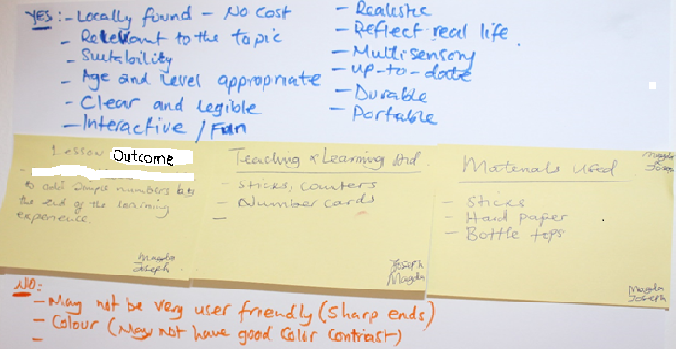
One pair’s teaching and learning aid reviewed

Session 11.2: Creating teaching and learning aids

Where resources and finances are scarce, it is important that teachers are able to easily create appropriate teaching and learning aids, which do not cost any money, from waste or locally available materials. They must be durable, ensuring that teachers can use them again and again over a number of years, with different classes and year groups and in different subject areas.

Activity 11.2a: Demonstrations and role-play – teaching and learning aids made from things we usually throw away
Main
45 minutes

The trainer should demonstrate a number (a minimum of 6) of teaching and learning aids. The trainer should prepare their resources prior to the training and be able to demonstrate how they will be used – she/he should also be able to clearly explain the learning objectives of the activities in which the learning and teaching aids are used. The teaching and learning aids to be demonstrated should cover a range of grade levels and subjects. They should be made from waste or locally available materials and do not cost money.

Discussion, questions and evaluations
Following the demonstrations, teachers will have the opportunity to evaluate each teaching and learning aid. They should identify the good points of each one as well as suggesting areas for improvement. The trainer should ask for a volunteer who can lead this session and write the key points on the board/flipchart.

The two examples below are found, together with other examples, in Resource 11.3. Trainers should cut them out – stick them onto strong card – and use them as training aids for demonstrations.

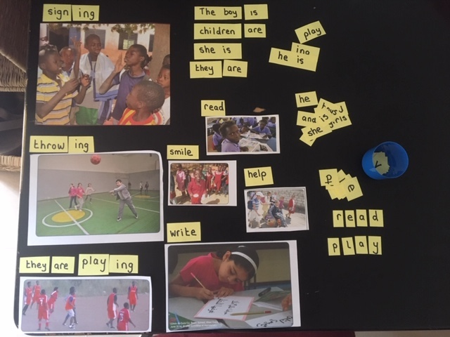
A teaching and learning aid for a language lesson, made from waste materials and old magazines. Used for comprehension with pictures, building words, building sentences, building action words (+ing). Easily adapted for all abilities, allowing learners to investigate and problem solve.

Using old card, magazines and clothes pegs. Some learners may be able to identify objects, some may be able to build the words and then write them. Others may be able to write complete sentences about what they see in the picture.

Activity 11.2b: Adapting teaching and learning aids to include learners who have intellectual and/or developmental impairments
Main

60 minutes

Resource 11.1
Case studies for group-work (also in Module 10)

The trainer should divide the teachers into 4 groups and explain in the introduction that teachers will remain in these groups for the following activities. Each group will be given the case study of a learner who has an intellectual and/or developmental impairment. Teachers will already be familiar with the case studies as they are included in Module 10.

The aim of this activity is for the groups to read their case study and then consider each teaching and learning aid demonstrated by the trainer in Activity 11.2b. They must then answer the following questions:
- Is this teaching and learning aid accessible for the learner in our case study?
- If not, why?
- How can it be adapted to be used by the learner in our case study?

During this activity the trainer should move around to guide and support each group. He/she should ensure each group member understands the task and the details of the learner in their case study. Groups should look at each teaching and learning aid individually and make notes or a chart/diagram that answers the above questions for each teaching and learning aid.

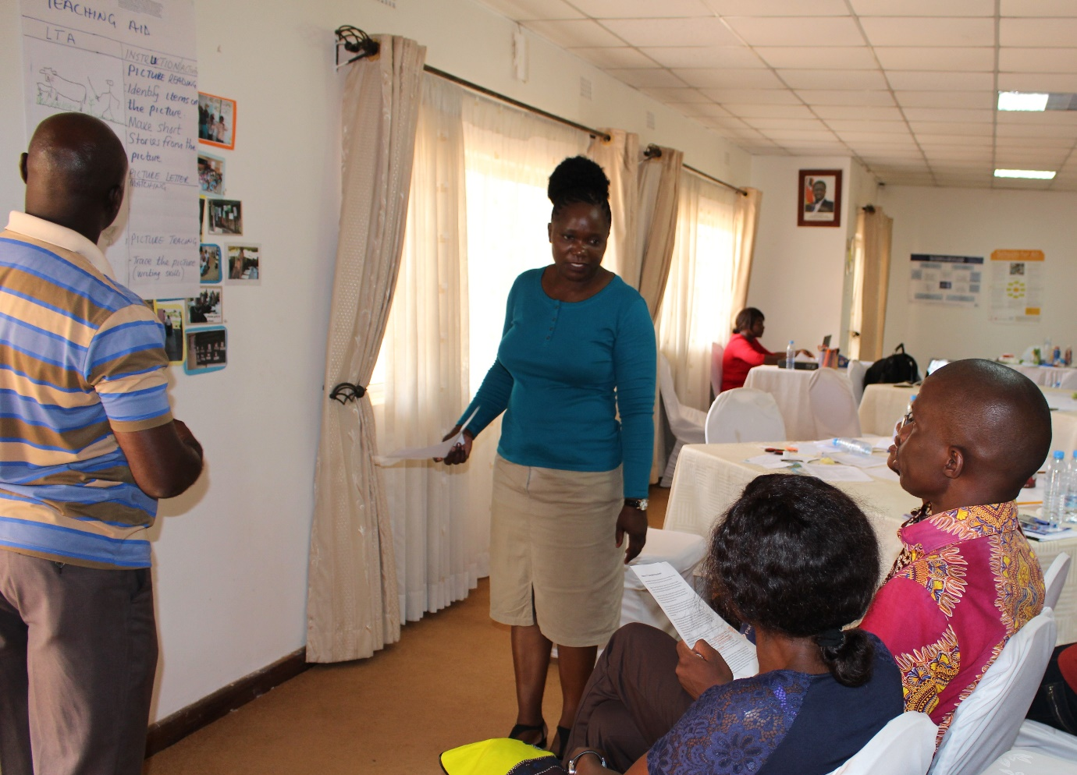
Teachers reviewing a group’s findings during a galley walk

Each group’s findings should be displayed together with the case study of their learner – teachers will be expected to review each display and add their own ideas for adaptations during a gallery walk. Alternatively, the teachers can review the displays at the end of the training day or during breaks.

Activity 11.2c: Developing and making appropriate teaching and learning aids
Main
120 minutes

Learning outcomes and learners’ profiles (case studies)
Resource 11.2

The trainer should introduce the activity by reminding teachers that inclusive education is about meeting the needs of all learners. Teaching and learning aids can be used by all learners to enhance their learning experience and may need adapting to meet the needs of individual learners. This activity is to develop teaching and learning aids that can be used by all learners and are also adapted for learners with specific needs.

The trainer should present the 4 case studies from Resources 11.2 or ask for a volunteer to read out each lesson’s outcomes and details of the learners to consider. The teachers should remain in 4 groups. One case study should be given to each group.

Each case study contains a basic lesson plan with clear learning outcomes and the details of individual learners who may need special consideration for inclusion. The lessons cover a range of topics such as agriculture, life-skills, languages, mathematics and science. Teachers should be encouraged to suggest and write their own lesson plan if they prefer, however, these must be reviewed by the trainer prior to beginning the activity. This is to ensure the Learning outcomes are clear and realistic and that there is still a diverse range of lesson topics. The individual needs of the learners include visual impairment, behaviour difficulties, lack of concentration, hearing impairment, low self-esteem and shyness, learning difficulties, communication problems and physical impairments.

Each group must design and make a teaching and learning aid that fulfils all the criteria from the list in Activity 11.1b, using waste materials and locally available resources collected and brought to the workshop by the teachers. The teaching and learning aid must help meet the Learning outcomes, be used by all learners in the class and adapted to enable inclusion for the learners in their case studies.

Example:
Lesson plan for Grade 2 – English
Topic: Animals in Zambia

The group must develop a teaching and learning aid that helps learners identify and name 8 animals that can be found in Zambia. The aid must help learners spell and pronounce the animals’ names as well as form sentences that include the names. When making the teaching and learning aid the group should consider whether it is necessary to adapt the aid to help Velaphi, Christine, Mary and Sarah to achieve the Learning outcomes. They must then also make and demonstrate the adapted teaching and learning aid.

Presenting
After 1 hour the trainer should ask each group to present their teaching and learning aid, explaining clearly how it meets the criteria from Activity 11.1b, how it enhances the lesson and how it is adapted and used by the individual learners in their case study. Groups can decide the format of their presentation and may choose to use drama and role-play to show how the teaching and learning aid is used in the lesson.

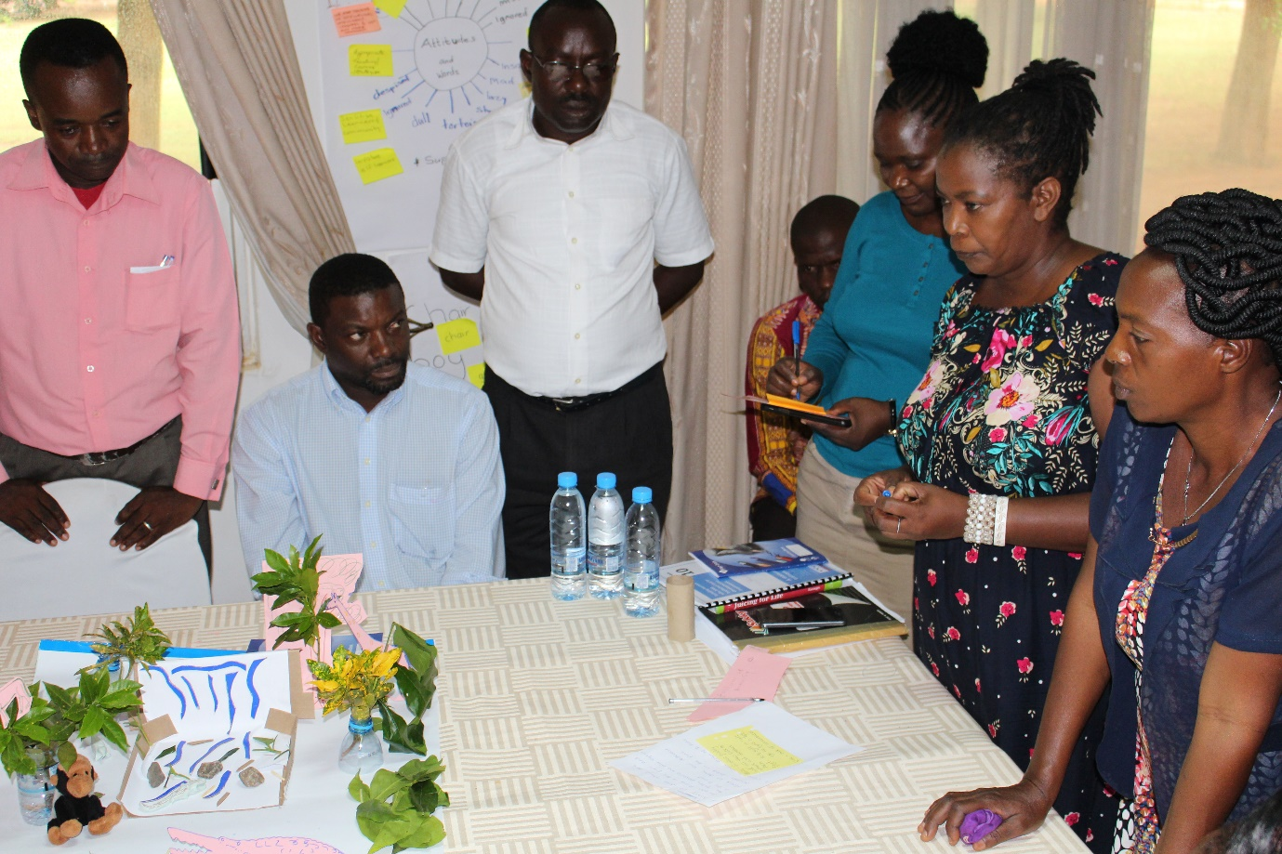
Teachers discussing a teaching and learning aid make out of locally available materials.

Evaluating
Following each presentation, the trainer should ask teachers to evaluate the teaching and learning aid that has been demonstrated. The trainer should allow adequate time for this and not adhere too rigidly to the 2 hours allocated for this whole activity. The evaluations and suggestions for improvement are the most important aspect of this activity – sharing ideas will enable teachers to return to their schools/education settings with new knowledge for making and using the best teaching and learning aids possible in their environment.

After all teachers have had an opportunity to comment, question and evaluate, the trainer should add anything that has been omitted. For example, if the teaching and learning aid is made using thin paper instead of thick, strong card, it is the responsibility of the trainer to point this out if it has not already been said. He/she can say,

‘Teaching and learning aids should be durable and strong, they should be made to be used by many teachers and to last for a long time. Therefore, thick card would be better and should have been used for this resource’.

If the teaching and learning aid has not been effectively adapted for a learner who has difficulty seeing, the trainer can point this out and demonstrate clearly how it should have been adapted. These are just some examples; it is important that the trainer refers to the list of criteria from Activity 11.1b and also the details of the individual learners in each case study when summarising at the end of each evaluation.

Activity 11.2d: Helping learners achieve more
Main
60 minutes

The trainer should introduce this activity as an extension of Activity 11.2c. She/he should say that because learners learn in different ways and at different paces, there are always learners in the class who will complete the work quickly and may find it easier than others. A good teacher should always plan additional, more complex activities for these learners as well as being able to adapt the teaching and learning aids to meet their needs.

In this activity groups will move to the table on their right and adopt the teaching and learning aid that has been developed by the table’s previous group. The task is to adapt and further develop the teaching and learning aid so it can be used effectively by those in the class the teacher considers to be the higher achievers (20 minutes).

The trainer could give an example by saying that while some learners can use letters and build words, others may be able to write sentences and even paragraphs using more complicated vocabulary. Resource 11.3 illustrate some examples.

Examples of easily adapted teaching and learning aids
Resource 11.3

Presenting and evaluating
As with Activity 11.2c, groups will be expected to present their adapted teaching and learning aid and teachers will discuss and evaluate. Teachers are expected to evaluate each teaching and learning aid in a constructive manner – not merely criticising but identifying good points and making suggestions for improvement if necessary. Finally, the trainer can also comment if something important has been omitted.

Activity 11.2e Consultancy circles – building a supply of teaching and learning aids
Main
60 minutes

The trainer should introduce this activity by saying:

‘The purpose of this activity is to encourage teachers to reflect on their own school/education setting and the teamwork of their colleagues. It gives teachers the opportunity to investigate ways of building a sustainable supply of teaching and learning aids that will enhance the school education as a whole’.

Teachers will work in their groups beginning with each person individually thinking about the challenge they are facing with the lack of sustainable teaching and learning aids for all lessons – thinking of reasons behind the answers to the following questions:
- Why aren’t teachers sharing their ideas and resources?
- Why are most teaching and learning aids used once and then not properly stored and are sometimes eventually discarded?

One of the group members should share the challenge they are facing with their group.

The trainer should instruct the groups to now act as a consultancy group. Each group member should give feedback on the challenge; suggest solutions and share their own experiences of dealing with a similar situation, and how to turn the challenge into an opportunity. Once they have finished discussing the first challenge, another person can share their challenge. This continues until all group members have shared their challenge and others have given solutions.

Groups should then list their ideas for making changes within their school/education setting to ensure that teaching and learning aids are developed, used, shared and stored in a way that will ensure sustainability. The outcome should be presented on flipchart paper as a visual information chart, list or brainstorm diagram, identifying challenges and finding a number of solutions. Each member of the group should contribute their ideas. The bullet points on each chart will form the basis of a plan for establishing what is really a Resource Base for teaching and learning aids, similar to a library for books, where teachers can borrow and return, and add to the supply of teaching and learning aids.
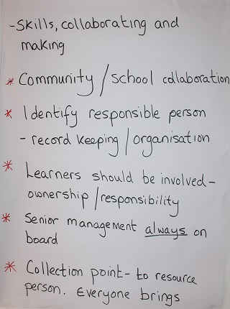
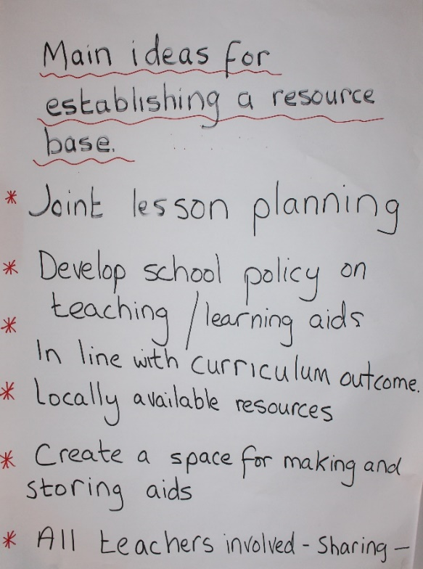
A list of Principal Trainers’ reasons for the creation of a Resource Base.

Activity 11.2f: School projects – Using locally available resources
Extra
60 minutes

(i) Setting up a multi-sensory ‘Discovery Table’ (40 minutes)

The trainer should introduce this activity and say that it is about a whole school approach to using locally available resources that enhances education and encourages learners to investigate and problem solve.

‘This gives learners opportunities to investigate a varying number and type of objects, using them to develop all their senses and find out about new things’.

The objects could be collected by both teachers and learners and changed or added to regularly.

The discovery table could also be used as the basis for many different lessons and topics. For example, if the class is learning about size and texture, learners could be asked to bring in a variety of objects from outside such as leaves and stones. These could be put onto the table for learners to investigate and manipulate, and more fully understand the concepts being taught. If a current topic is ‘Health and Nutrition’, teachers and learners could be asked to bring in small amounts of what they think is nutritious food. This is an excellent method to remind teachers to use the local things around them as teaching and learning aids.

The table can be set up as a classroom resource or implemented as a whole-school project in a common area. Objects can be labelled several languages if the language of instruction is different to local mother tongues. The ‘Discovery Table’ could be more interactive by placing the object labels at the end of the table to allow learners to select the correct labels for each object.

The trainer should ask groups to come up with answers to the following questions:
- What would be the steps in creating a ‘Discovery Table’?
- Who would be involved in this?
- How could this lead to changes for inclusion in our school?

Note for trainers:
Introduce this topic at the end of the previous day’s work. Ask teachers to agree on a subject and to bring an item in to display on the ‘Discovery Table’. The table can then be on display during this activity – giving a good clear example.

(ii) New ideas for school projects – using locally available resources (20 minutes)

For the second part of this activity the trainer should ask teachers to work in pairs to discuss and suggest ideas for other school projects that would demonstrate the use of locally available resources that are accessible to all learners.

Pairs must suggest an idea that is realistic, achievable, inclusive and costs nothing. Each idea should be clearly written onto post-it notes which will be displayed on the wall for teachers to look at and discuss at the end of the day.
Module
11
Resources

Resource 11.1: Case studies for group-work

Note for trainers:
Photocopy these case studies and stick them separately onto strong card. Use them as training aids. You can also write your own case studies. Refer to the module on Including Learners with Additional Needs to help you think through potential case studies.

Busiku is 12 years old and was born with Cerebral Palsy. He has delays in speech development, has difficulty speaking, has learning difficulties and has problems with fine motor skills, such as buttoning clothes, tying shoelaces or picking up small objects.

In addition, Busiku has difficulty sitting up straight without support (the local community-based rehabilitation (CBR) officer has now made him a special chair) and difficulty controlling the muscles in his hands which means he cannot grip small objects like a pen. He does not speak clearly but makes noises.

Busiku has a very supportive and loving family who communicate with him very well. His mother is a teacher. He has been in the ‘Special Class’ for the past 3 years but has made very little progress as the teacher did not know how to teach him. In line with the new education policy the Special Class will now close and Busiku will be included in mainstream classes.

Steven has learning and developmental impairments. He is 11 years old and has just moved to live with a foster family. He has just started to go to school for the first time having previously attended a residential institution for boys who have intellectual impairments. He cannot read or write. He is very quiet and shy with limited social skills. He appears to be very unhappy at school – some days he does not stay but goes home during the morning break. Steven loves animals and walks to school with his two dogs that wait outside the school gates for him. His other interest is basketball although he only ever plays alone.

Beauty is 9 years old and has just moved to a new area and new school – she previously attended a mainstream Primary School in another part of the country for one year. She was born with Foetal Alcohol Syndrome.

Beauty is slow to process information and does not understand long, more complex instructions. She is often hyperactive and finds it difficult to concentrate for even a short amount of time. She cannot read or write but can recognise individual letters and smaller single-digit numbers. She understands a picture if it is in her own context, for example, showing something in a school, a village or a farm. She can explain the picture content and answer simple questions verbally. Physically, Beauty looks ‘different’ to other learners in her class – she is very short for her age with a smaller than usual head and very small wide-set eyes. Since her mother passed away Beauty lives with her aunt and five other children.

Natasha was found by an education inspector while visiting a village school. She was living in the corral with the goats and has never been to school. She appears to have complex needs, rocking from side to side and making unclear sounds. She has a beautiful smile and can understand and look happy in response to kind words. Her grandmother provides food for her and is her only relative – she did not know that Natasha should go to school. The inspector and the local school inclusive education co-ordinator (working with the school inclusion team) will arrange for Natasha to attend the small village school where there are 39 other learners.

Resource 11.2: Learning outcomes and learners’ profiles (case studies)
Note for trainers:
Photocopy these lesson plans and stick them individually onto strong card with the lesson plan on one side and the learner’s details on the reverse. These will be your training aids. You can add to the resource by writing your own case studies in context with your work and the schools in your area.

(i) Lesson Plan

Grade 1: English
Topic: Letters and sounds – p + a e i o u
Objectives: Learners must be able to:
- Recognise, pronounce, and write the letter ‘P’.
- Identify objects that begin with ‘P’.
- Recognise, pronounce, and write pa, pe, pi, po, pu.

Learners with additional needs
- Diana – deaf but has some speech (not very clear).
- Catherine and Peter – severe learning disabilities.
- Kenneth – physical disability with missing fingers (has difficulty holding a pencil).

(ii) Lesson Plan
Grade 7: Agriculture
Topic: Planning a school garden
Objectives: Learners must be able to:
- Identify factors to consider when choosing the site for the school garden.
- Mark the perimeter of the chosen area for the garden.
- Draw out the plan for the garden.
- Identify tools and materials needed and describe their uses.

Learners with additional needs
- James – deaf and does not speak at all.
- Anna – learning difficulties with literacy level of Grade 2.
- Beauty – difficulty walking and uses crutches.
(iii) Lesson Plan
Grade 3: Science
Topic: Measuring liquids
Objectives: Learners must be able to:
- Understand the difference between millilitre and litre.
- Know how many millilitres make ¼ litre, ½ litre and 1 litre.
- Measure the above quantities.

Learners with additional needs
- Patrick – challenging behaviour, lack of concentration, can be disruptive and noisy.
- Ruth – visually impaired (total).
- Monica – visually impaired with very little sight in one eye only.

(iv) Lesson Plan
Grade 6: Mathematics
Topic: Calculating surface area
Objective: Learners must be able to:
- calculate how much glass would be needed if all the windows in the classroom needed replacing.

Learners with additional needs
- Sebastian – physically impaired and in a wheelchair.
- Simon – intellectually impaired (slow to process information).
- Fortune – hearing impaired (50% hearing in one ear only).

Resource 11.3: Easily adaptable teaching and learning aids – examples
Note for trainers:
Make your own sets to demonstrate in your training together with your own ideas for teaching and learning aids.

(i)
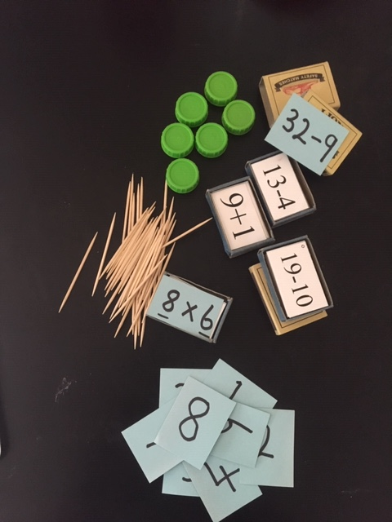
Matchbox Mathematics sets are easily made, stored and adapted. They can be used for all levels of Mathematics and are made from empty match boxes, old card, bottle tops and toothpicks for counters.

(ii)
An adapted exercise book for learners who do not see very well. Teachers can use a black marker pen to change the page to wider-spaced, easier to see lines. The space between the lines would depend on the findings from an individual learner’s functional assessment.

(iii)
Examples of images to use in the classroom – easy to draw or photocopy and display on the wall. The images tell learners to listen, look, speak, work individually, in pairs, in groups, to be quiet, to read or to write. Inclusive teaching and learning aids for good classroom management – for all learners and specifically for learners who do not hear well.

(iv)

A teaching and learning aid for a language lesson – made from waste materials and old magazines. Used for comprehension with pictures, building words, building sentences, building action words (+ing). Easily adapted for all abilities, allowing learners to investigate and problem solve.

(v)

Using old card, magazines and clothes pegs. Some learners may be able to identify objects, some may be able to build the words and then write them. Others may be able to write complete sentences about what they see in the picture.

Notes

