Module
101
Including Learners who have Intellectual and/or Developmental Impairments
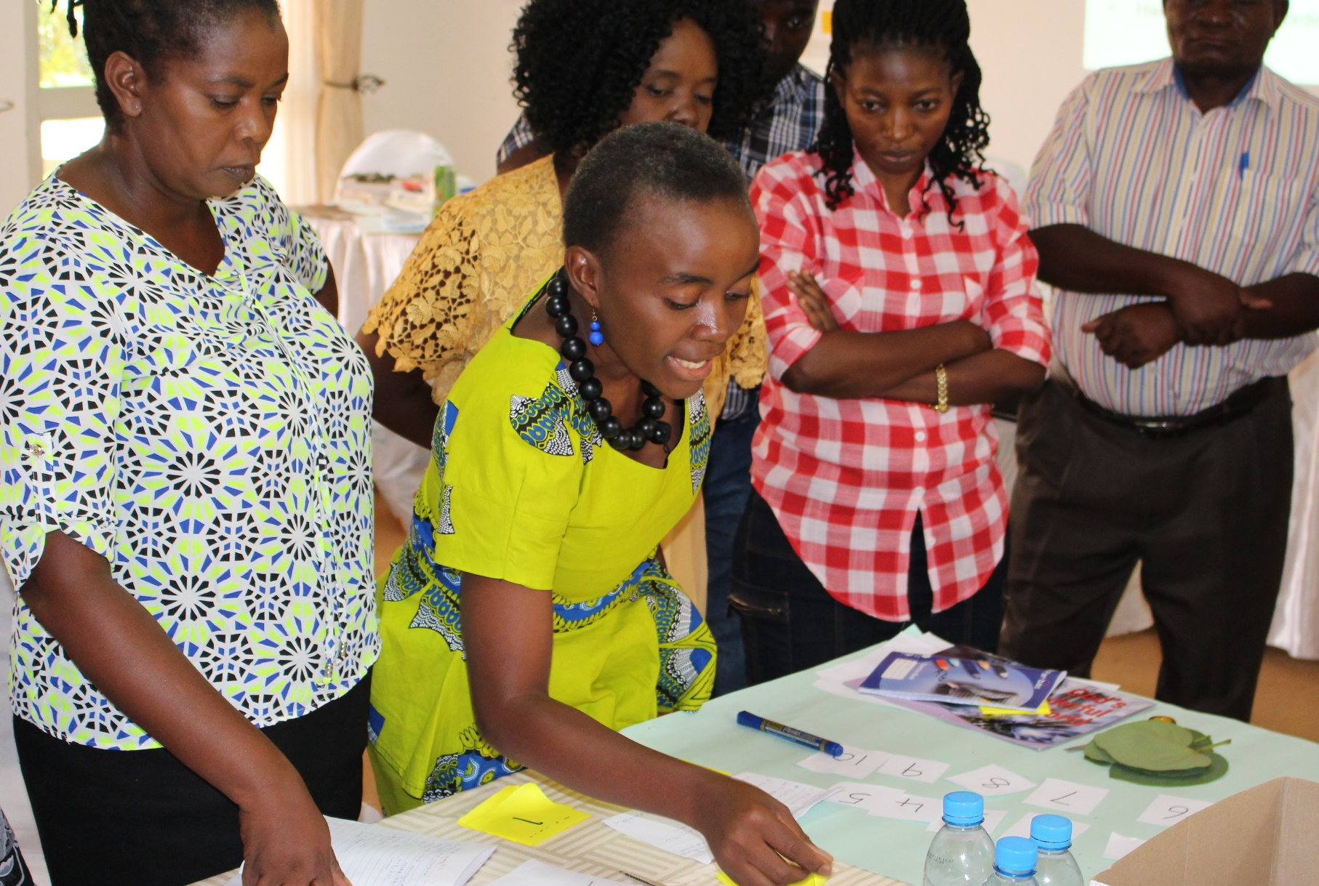

A manual for teacher trainers
Prepared for:
Ministry of General Education, Zambia
The Norwegian Association of Disabled
Developed by:
Enabling Education Network, December 2019

A module for teacher trainers
Prepared for:
Ministry of General Education, Zambia
The Norwegian Association for Persons with Developmental Disabilities
The Norwegian Association of Disabled
Developed by:
Enabling Education Network, December 2019

This work is licensed under the Creative Commons Attribution-NonCommercial-ShareAlike 4.0 International License. To view a copy of this license, visit http://creativecommons.org/licenses/by-nc-sa/4.0/
Contents

Introduction 4

Session 10.1: Our commitment to inclusion 6
Session 10.2: Initial basic assessment 12

Resource 10.1 Example – words and attitudes diagram 21
Resource 10.2: Glory’s story and practical strategies 22
Resource 10.3: Case studies for group work 24
Resource 10.4: Additional reading - common misconceptions on dyslexia 26

Notes 29

Introduction

Learners who have intellectual and/or developmental impairments often have difficulty in certain areas of their life, especially independent living, language development, learning, mobility and self-help.

Many learners who have intellectual and/or developmental impairments need extra support in organizing their day-to-day routines in order to be as independent as possible at school and travelling to and from school. It can often take them longer to process information and learn and to develop new skills. Some learners may have low self-esteem and some may trust others too easily, and are therefore at risk of abuse from adults or other learners in school or on the way to or from school.

However, all learners can learn and make progress, no matter what their impairment. Each learner is an individual with different abilities. The level of support needed depends on each learner’s individual needs. It is important for teachers to focus on a learner’s abilities before thinking about how to help. Most learners with intellectual and/or developmental impairments, given the right support and education, can go on to lead productive, independent lives. For education, perhaps the most challenging issue is that it is difficult to predict what learners with intellectual and/or developmental impairments might achieve.

The aim of this module is to both introduce and explore effective methods of including learners with intellectual and/or developmental impairments. The module will offer practical ideas for meeting learners’ needs in the classroom and give teachers opportunities to problem-solve for difficulties they have experienced as educators. As with the other modules, the activities here highlight the importance of listening to, and involving, the learners themselves, parents/guardians/care-givers, friends, community members and other professionals. As for all learners, the support and friendship of their peer group is extremely important for the holistic development of learners with intellectual and/or developmental impairments.

Further information is contained in the module on Including Learners with Additional Needs. This includes advice and guidance on identifying additional needs, how additional needs can exclude learners, and practical tips and ideas for teachers on supporting learners with additional needs in the school and classroom environment.

This module is designed to equip teachers with skills to enable the process of identification and support:

Observation Reflection Enquiry Action Response

Planning the delivery of the sessions in this module should be done with close reference to all the other training modules in this series.

As with the other modules, the training outlined here focuses on using participatory methods and active learning techniques. It follows this basic principle:

We must use inclusive training methods if we are to successfully
train others how to teach inclusively.

Duration of training
Trainers should adapt this training to suit the local context and the time available to them for training. Trainers may decide not to use all of the activities, or to shorten some activities if time is limited, or to expand activities if teachers need more support with understanding a particular topic. If all activities are used, without significant adaptation, shortening or lengthening, this module requires approximately 6-7 hours of training. This could be split over 1 or 2 days, depending on the preferred length of training days, number and length of breaks, and so on.

Session 10.1: Our commitment to inclusion

This is an introduction to strategies that help in the inclusion of learners with intellectual and/or developmental impairments. Teachers are not expected to be Educational Psychologists or medical experts who can administer formalised assessments for learners. Instead, a good teacher will be able to recognise when there is a challenge or difficulty and take action as the first step of intervention. They must also know when to ask for help from their school inclusive education co-ordinator, and together with them when to refer a learner to appropriate specialists.

Activity 10.1a: Raising awareness and changing attitudes
Main
60 minutes

The trainer should use this activity to encourage teachers to explore attitudes and existing ideas about learners with intellectual and/or developmental impairments. Teachers will be asked to work together and recap how learners, teachers, parents/guardians/care-givers and other community members treat others and how schools can play an important role in raising awareness and changing attitudes. It is important when introducing this activity to point out that sometimes the attitudes of other people, although negative, can be well meaning. For example, parents/guardians/care-givers may not want to send their children to school because they are over-protective and want to shelter them from forms of abuse such as bullying. Teachers who do not want the learners in their class because they lack the skills and confidence to include them and teach them.

Initial discussion (15 minutes)

In pairs, the trainer should ask teachers to discuss what they know about attitudes towards learners with intellectual and/or developmental impairments. What do they know about the attitudes of other learners, of teachers or other staff members in schools, of parents/guardians/care-givers, and in the community. Pairs should make notes of their key points and be encouraged to write down things they have heard people say. The trainer should give one example by saying that parents/ guardians/care-givers often do not want to send their learners to school because, ‘the other learners call him stupid and bully him’.

During this time, the trainer should walk around the room listening to the discussions and making suggestions when help is needed.

After 10 minutes the trainer should ask the pairs to share their thoughts with others in their small groups.

Resource 10.1
Example of the attitudes and words diagram

Brainstorm diagram (15 minutes)

Finally, the trainer should ask to write the key points on flipchart paper, as a ‘brainstorm diagram’ (see Resource 10.1 for an example) using their discussion notes (also called ‘mind-maps’). These can then be displayed on the walls and teachers can look at other groups’ posters and add additional thoughts to them using sticky notes (post-it notes). The trainer can also add any important points when all groups have contributed. She/he can also comment on inclusive training and teaching methods demonstrated during the feedback session; for example, clear board writing with good contrast (black/white), giving everyone opportunities to contribute, and listening when others are speaking.

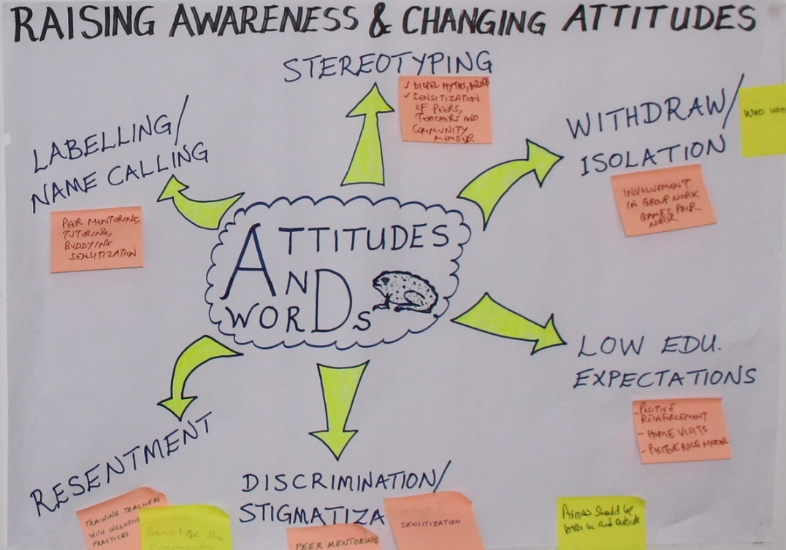
Attitudes and words poster

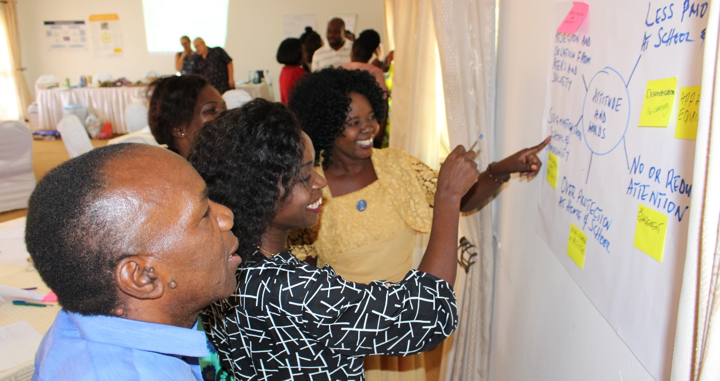
Discussing an ‘attitudes and words’ mind-map during a ‘gallery walk’.

Plenary (15 minutes)

During the plenary session the trainer should give teachers a final opportunity to discuss and share ideas on how to overcome the challenges and change the attitudes identified in the brainstorm diagram. This part of the activity should again cover three aspects: the attitudes of other learners/teachers/support staff in schools, of parents/guardians/care-givers, and in the community. It is important for the trainer to guide the discussion and keep it on-track so it does not use more than 15 minutes but gives everyone an opportunity to contribute. Key points should again be written on the board/flipchart.

Teachers should complete this activity with the knowledge that schools and the school inclusion teams (SITs) can be a part of changing attitudes about inclusion, recognising that all learners are different, and helping them achieve to the best of their ability is everyone’s responsibility.
Schools can lead by example.

Note for trainers:
To adapt and give more focus to this activity it could be divided into the following three points – each pair could discuss and make notes on one point and highlight what they have seen and what they have heard:
- Attitudes, actions and words of other learners.
- Attitudes, actions and words of parents/guardians/care-givers and in the community.
- Attitudes, actions and words of teachers and education managers.

For an alternate activity, the trainer can ask for a volunteer to lead a feedback session and write the key points from all the groups on the board/flipchart. This will create one whole group mind-map or brainstorm diagram which can be displayed on the wall for all teachers to then look at during break-time.

Activity 10.1b: Identifying learners with intellectual and/or developmental impairments
Main
45 minutes

How can a teacher determine that a learner may be intellectually and/or developmentally impaired?

- Visible signs of conditions such as Down Syndrome and Foetal Alcohol Syndrome.
- Significant difficulty with physical coordination.
- Speech and communication problems.
- Significant difficulties with problem-solving or reasoning tasks that their peers can do.
- Slow to process information and answer questions.

Just because a learner may have visible signs of a physical impairment it does not mean that they also have an intellectual impairment. For example, you cannot say that a learner who is hard of hearing has an intellectual impairment.

If a teacher reported that half the learners in her class had an intellectual and/or developmental impairment then it would not be those 50% who need assessing, but rather the teacher who needed additional support and training to be able to meet the needs of all her learners.

The trainer should begin this activity by reading out the short introduction above and emphasising the word ‘may’, which is written in bold. She/he should then ask teachers why they think this word is emphasised so strongly. Teachers should be able to answer that, because a particular learner looks different, or appears to be struggling in class, it cannot be taken for granted that he or she has an intellectual and/or developmental impairment. The teacher is correct in identifying that there may be a problem but then must go further and investigate. At this point the trainer should write the word ‘investigate’ on the board/flipchart as a visual reminder.

Who to talk to?
Teachers will be divided into two groups – the groups should be as diverse as possible so that each group has teachers from schools, colleges, district education offices, parents/guardians/care-givers, communities, other stakeholders, etc (this depends on the diversity of trainees in the workshop). Each of the groups should discuss who the school inclusive education co-ordinator would consult to gather information on a particular learner they have concerns about (they should agree on the story of one learner, but not use the learner’s real name).

The trainer should refer the teachers to the roles of the SIT and the school inclusive education co-ordinator in this work. Each group should select a note-taker and presenter and during feedback.

They should give reasons why they would communicate with that particular person or group of people. For example:
- Talk to other teachers (colleagues) – Is the learner also having difficulties in other lessons? Do the other teachers have good strategies to share?
- Talk to parents/guardians/care-givers – How is the learner at home? What sort of things does he do around the house, compound, etc. Do the parents/guardians/care-givers use any particular strategies at home to help the learner manage his/her everyday activities?

Examples of who the school inclusive education co-ordinator should expect to meet:
- the learner and his or her friends;
- family members: parents/guardians/care-givers, siblings;
- school management, SITs, teachers, other school staff;
- community members;
- any community-based rehabilitation (CBR) volunteers or other community-based organisation (CBO) working in the learner’s area or village;
- the ‘adviser’ at the local learning support base (LSB): Are they already aware of the learner?

Teachers will have many more suggestions, and these will vary from community to community and school to school. The trainer will write a list of all suggested stakeholders on the board/flipchart.

This activity will be reassuring for teachers who can sometimes feel that inclusion for learners with intellectual and/or developmental impairments is impossible for them to manage. As with all modules it is important in this one to stress that inclusive education is everyone’s responsibility and is only possible through commitment and collaboration. The trainer should continuously remind teachers of others who can help.

Session 10.2: Initial basic functional assessment

Teachers should also be aware of some practical activities that can help them in their classrooms. At the end of this training the teachers should be more confident in their inclusion of learners with intellectual and/or developmental impairments and have a clearer idea of their role and that of others around them.

Activity 10.2a: Ideas for basic functional assessment
Main
80 minutes

Teachers will work in groups to explore ways of carrying out basic functional assessments using resources made from everyday objects or waste materials. Each group will be asked to select two activities from the following basic assessment criteria:
- counting and number recognition;
- letter and word recognition;
- colours;
- shapes;
- speech and vocabulary;
- writing skills (holding a pencil, pen, etc);
- different concepts such as size, weight and distance;
- hand and eye co-ordination.

Before teachers begin, the trainer should demonstrate using appropriate resources as tools for basic functional assessments. For example:

The trainer will place a selection of fruit and vegetables on the table and explain how they can be used in various ways. He/she will give examples of questions and basic functional assessment activities.

- Letter recognition – Which ones begin with ‘C’?
- Speech and vocabulary – Can you say the name of each vegetable?
- Which one is the biggest?
- Can you put them in a line starting with the smallest and ending with the biggest?
- Find all the red items.
- Count six sticks.

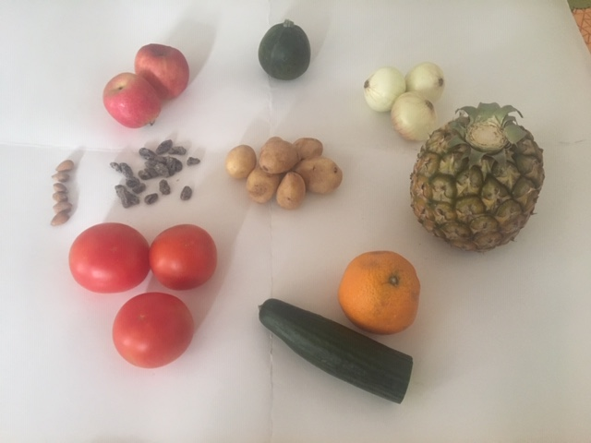
Examples of food items that can be used for basic assessments

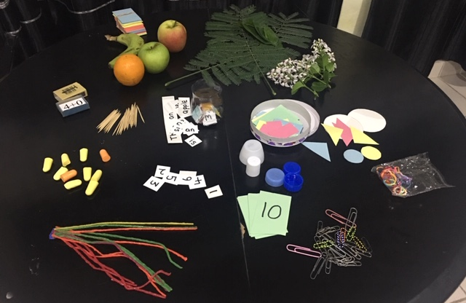
Everyday items that can be used as basic assessment tools

The trainer and teachers will be able to add to this list.

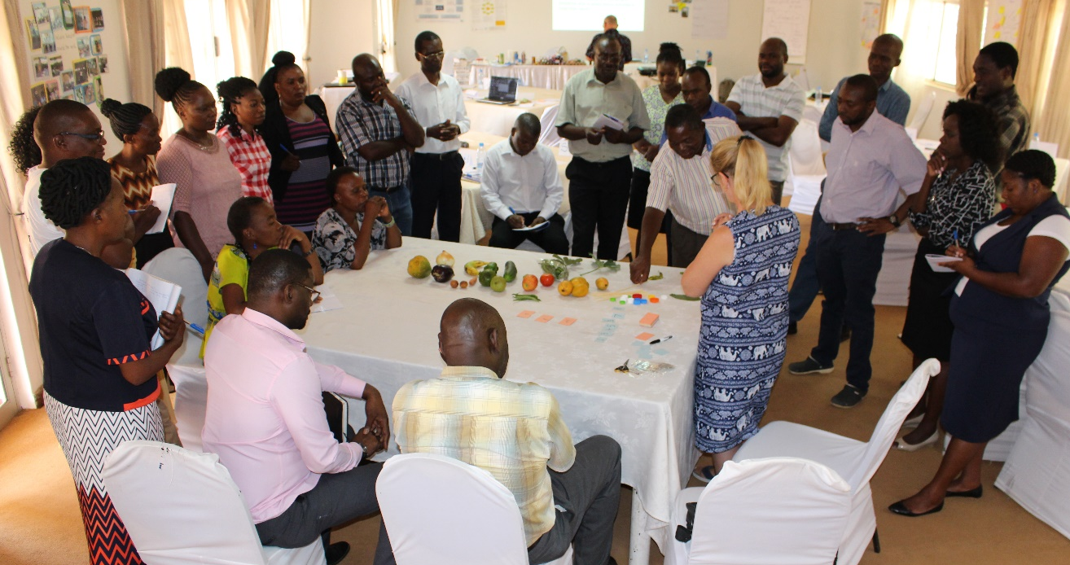
Demonstrating ways to use locally available objects

Following the demonstration teachers will understand that everyday items such as fruit, vegetables, sticks, leaves, and stones can be used as basic functional assessment tools. By carrying out small tests using these tools, a teacher will discover more about the ability of a learner and should be able to adapt lesson activities to meet their needs.

Teachers will be given 30 minutes to collect their resources and develop three basic functional assessment activities. Groups will then demonstrate and explain clearly what the basic functional assessment is for.

Note for trainers:
Demonstrate clearly what you expect the teachers to do. Allow time at the end of your demonstration for them to ask questions. Emphasise that basic assessment tools do not need to be formal but like all teaching aids they can be made from everyday materials and even things we sometimes throw away. Remind the teachers that one of the most effective basic assessment tools they can use is their own patience, observation and communication with others.

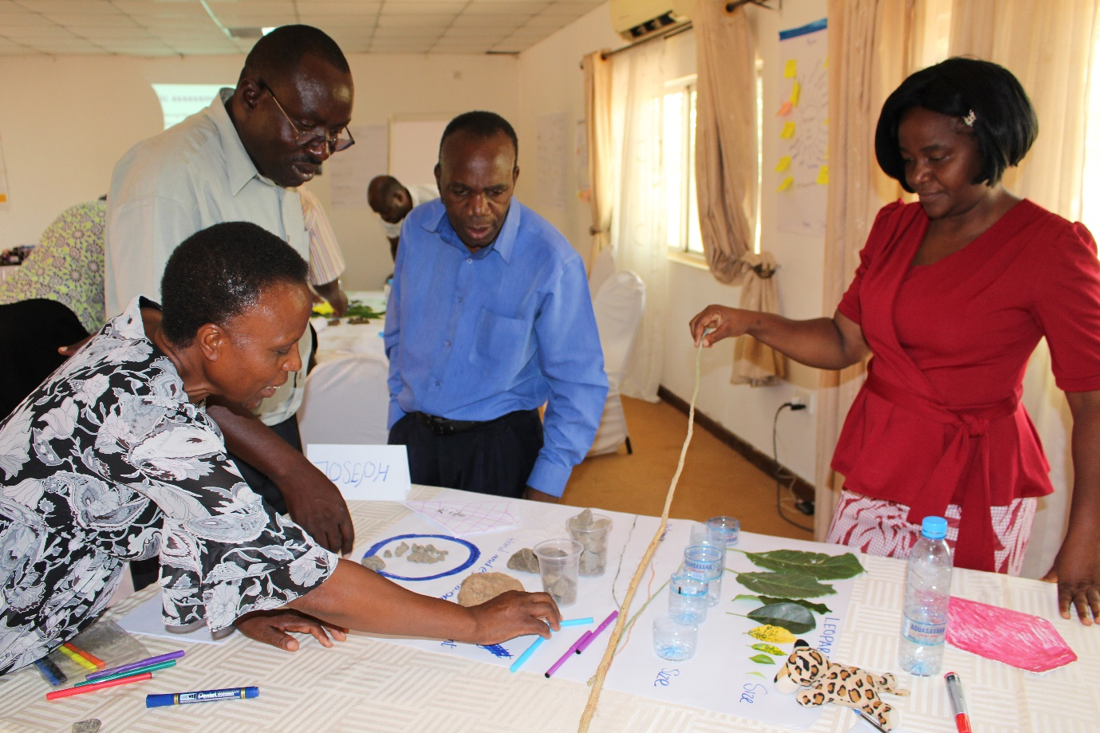
Creating a basic assessment activity with locally available objects

Activity 10 2b: Exploring support from the school inclusive education co-ordinator and the learning support base
Main
30 minutes

Using the following questions, the trainers should guide a discussion on how the school inclusive education co-ordinator and the learning support base can support the inclusion of learners with intellectual and/or developmental impairments:

- In what ways would collaboration between the school inclusive education co-ordinator, parents/guardians/care-givers and teachers be important for the inclusion of learners who have intellectual and/or developmental impairments?
- How could a learning support base be utilised effectively to support the inclusion of these learners?

The trainer should flipchart the main discussion points.

Activity 10.2c: After the basic functional assessment – practical classroom strategies
Main
120 minutes

Resource 10.2
Glory’s story and practical strategies

Resource 10.3
Case studies for group work

The use of case studies, stories of individual learners or situations, as training tools, can often be the most effective way of enhancing understanding of inclusive education. This activity will demonstrate the practical activities implemented by the school to ensure that Glory, who has an intellectual impairment, is fully included and supported to be able to achieve to the best of her ability.

The trainer will read Glory’s story and explain the practical strategies that were implemented to ensure that Glory was included in all aspects of school life. The trainer will point out that planning and implementation was a team effort on behalf of the teachers, school inclusive education co-ordinator and the school management.

Before beginning the group-work with individual case studies teachers should be given the opportunity to ask questions about the strategies used to make sure Glory was fully included.

Group work with case studies
The time allocated for this group work indicates the importance of this, and the previous basic functional assessment activity. Teachers will work together in their groups to jointly decide on practical classroom strategies to support the learner in their case study. The actions should be specific, with groups able to demonstrate clearly how the strategy will help their learner progress. The teachers should present their strategies using the same chart format as Glory’s story.

Whilst the groups are working the trainer should move around to answer questions and give guidance and advice.

After 45 minutes the trainer should ask each group to display their charts on the wall.

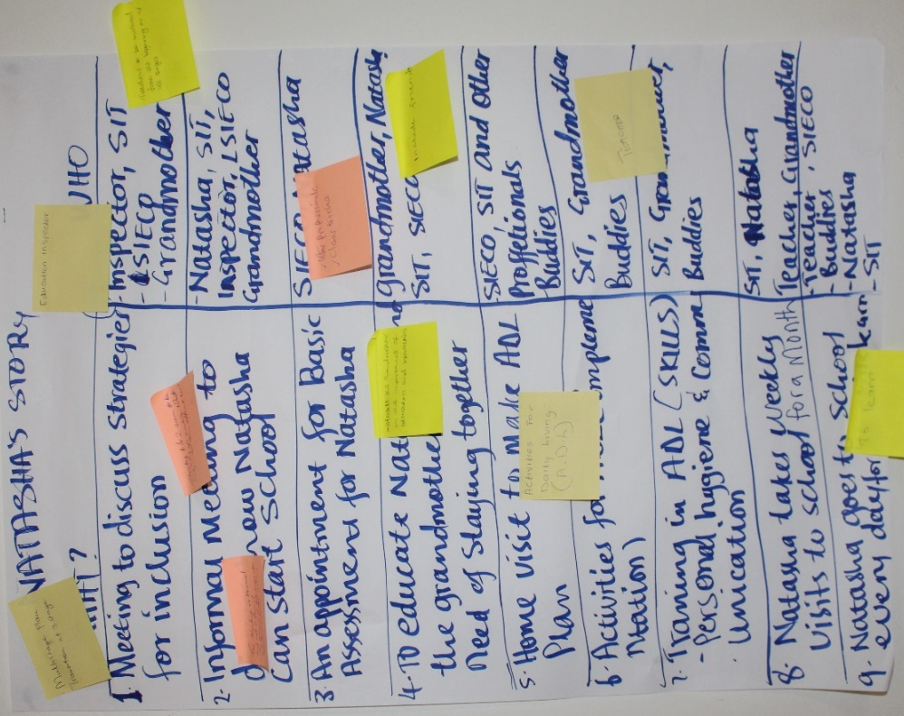
An example of strategies for one case study

Gallery walk
Groups will display their charts on the wall and then engage in a ‘gallery walk’. Teachers will walk around and review / discuss the strategies on each chart in relation to the case study. This is an opportunity for one member of each group to clearly explain their strategies for inclusion. All teachers will use post-it notes to submit additional ideas and comments. It is important for the trainer to allow sufficient time for this part of the activity – each teacher should clearly understand the case studies and have sufficient time to add their own strategy ideas. The trainer should walk around each presentation, listening to the input and ensuring everyone is focused on the task and all suggested strategies are practical and realistic.

Presenting practical strategies during the gallery walk.

Summary and outcome
In the final part of this activity the trainer should bring everyone together to discuss the strategies suggested. Led by the trainer and reviewing each case study individually, teachers should jointly decide if each strategy suggested would be appropriate, realistic and effective. The outcome should be final bullet-pointed lists of practical classroom strategies, linked to each case study, that will help each learner achieve in the classroom. Teachers should be aware of small changes they can make to lesson activities and classroom management to enable better inclusion for learners with intellectual and/or developmental impairments.

Activity 10.2d: Final questions and points of clarification
Main
15 minutes

Use a plenary session as an opportunity for teachers to ask any final questions and clarify any points raised during the training.
Module
10
Resources

Resource 10.1 Example – words and attitudes diagram

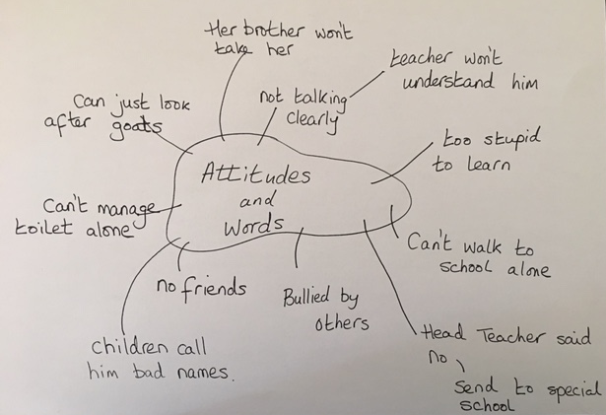
Mind-map diagram

Resource 10.2: Glory’s story and practical strategies

Glory is 7 years old and has Down’s Syndrome. She can say a few words, but her speech is not clear, and she mainly uses gestures to communicate – she has even learned some basic sign language from her uncle who is deaf. The other learners love playing with her because she has a great sense of humour and is always happy – she has lots of friends who manage to communicate with her through both words and gestures. She finds it difficult to sit still in class and does not concentrate on the class work – her teacher thinks she is disruptive and would prefer it if her parents kept her at home. She thinks Glory interferes with the other learners’ education. Because Glory cannot speak well, the teacher never bothers to ask her any questions or check to see if she understands the lesson.

Practical strategies to include Glory

What? | Who?
Meeting to discuss strategies for inclusion | Teacher, SIT, school inclusive education co-ordinator, parents/guardians/care-givers, uncle
Informal friendly meeting to discuss how best to support Glory in class | Glory and a small group of her friends
Basic assessments for Glory | School inclusive education co-ordinator, teacher, uncle
Raising awareness | For all staff and learners
Classroom support assistant (to help all learners) | Glory’s uncle, other family or community member or CBR volunteer
Classroom rules displayed and explained to all learners – check that Glory understands about discipline and behaviour in class | Teacher and uncle/other family or community member/CBR volunteer
Group work in lessons – Glory to sit with supportive but well-behaved friends | Teacher to plan and monitor – help from school inclusive education co-ordinator when necessary
Extra inclusive education training for teachers and parents/care-givers | school inclusive education co-ordinator– specialist teachers at LSB
Differentiate lessons to give Glory level appropriate activities (in-line with basic assessment results) | Teacher and training and monitoring from school inclusive education co-ordinator
10 minutes one-to-one informal chat – daily | Teacher and Glory
Set, monitor and review short-term achievable targets for Glory. | Glory, teacher, school inclusive education co-ordinator, parents/guardians/care-givers, SIT
Immediate praise for progress, e.g., ‘Well done Glory – you were quiet and sat still this lesson’. | Teacher

Resource 10.3: Case studies for group work

Busiku is 12 years old and was born with Cerebral Palsy. He has delays in speech development, has difficulty speaking, has learning difficulties and has problems with fine motor skills, such as buttoning clothes, tying shoelaces or picking up small objects.

In addition, Busiku has difficulty sitting up straight without support (the local community-based rehabilitation (CBR) officer has now made him a special chair) and difficulty controlling the muscles in his hands which means he cannot grip small objects like a pen. He does not speak clearly but makes noises.

Busiku has a very supportive and loving family who communicate with him very well. His mother is a teacher. He has been in the ‘Special Class’ for the past 3 years but has made very little progress as the teacher did not know how to teach him. In line with the new education policy the Special Class will now close and Busiku will be included in mainstream classes.

Steven has learning and developmental impairments. He is 11 years old and has just moved to live with a foster family. He has just started to go to school for the first time having previously attended a residential institution for boys who have intellectual impairments. He cannot read or write. He is very quiet and shy with limited social skills. He appears to be very unhappy at school – some days he does not stay but goes home during the morning break. Steven loves animals and walks to school with his two dogs that wait outside the school gates for him. His other interest is basketball although he only ever plays alone.

Beauty is 9 years old and has just moved to a new area and new school – she previously attended a mainstream Primary School in another part of the country for one year. She was born with Foetal Alcohol Syndrome.

Beauty is slow to process information and does not understand long, more complex instructions. She is often hyperactive and finds it difficult to concentrate for even a short amount of time. She cannot read or write but can recognise individual letters and smaller single-digit numbers. She understands a picture if it is in her own context, for example, showing something in a school, a village or a farm. She can explain the picture content and answer simple questions verbally. Physically, Beauty looks ‘different’ to other learners in her class – she is very short for her age with a smaller than usual head and very small wide-set eyes. Since her mother passed away Beauty lives with her aunt and five other children.

Natasha was found by an education inspector while visiting a village school. She was living in the corral with the goats and has never been to school. She appears to have complex needs, rocking from side to side and making unclear sounds. She has a beautiful smile and can understand and look happy in response to kind words. Her grandmother provides food for her and is her only relative – she did not know that Natasha should go to school. The inspector and the local school inclusive education co-ordinator (working with the school inclusion team) will arrange for Natasha to attend the small village school where there are 39 other learners.

Resource 10.4: Additional reading - common misconceptions on dyslexia

Taken from: www.understood.org/en/learning-attention-issues/child-learning-disabilities/dyslexia/understanding-dyslexia

Dyslexia signs and symptoms - learners who have dyslexia

Dyslexia is a specific learning disability. Learners with dyslexia have trouble reading accurately and fluently but this does not mean they are intellectually impaired. They may also have trouble with reading comprehension, spelling and writing. It is the most common learning issue.

Learners with dyslexia may have trouble answering questions about something they’ve read. But when it’s read to them, they may have no difficulty at all. This is an effective assessment tool for teachers to remember – some learners cannot easily access and give information through writing. Assessments and evaluations can be carried out verbally or visually with diagrams and questions.

Dyslexia can create difficulty with other skills such as:
- spelling;
- reading comprehension;
- writing;
- mathematics.

Dyslexia impacts people in varying degrees, so symptoms may differ from one learner to another. Generally, symptoms show up as problems with accuracy and fluency in reading and spelling. However, in some learners, dyslexia can impact writing, maths and language.

A key sign of dyslexia in learners is trouble de-coding words. This is the ability to match letters to sounds and then use that skill to read words accurately and fluently. One reason learners can have difficulty decoding is that they often struggle with a more basic language skill called phonemic awareness. This is the ability to recognize individual sounds in words. Problems with this skill can show up as early as preschool.

In some learners, dyslexia is not identified until later on, when they have trouble with more complex skills. These may include grammar, reading comprehension, reading fluency, sentence structure and more in-depth writing.

One potential sign of dyslexia is when learners avoid reading both aloud and silently. They may even get anxious or frustrated when reading. This can happen even after they have mastered the basics of reading.

Signs of dyslexia can be different at different ages. Here are some examples:

Pre-school
- Has trouble recognizing whether two words rhyme;
- Struggles with taking away the beginning sound from a word;
- Struggles with learning new words;
- Has trouble recognizing letters and matching them to sounds.

Primary School
- Has trouble taking away the middle sound from a word or blending several sounds to make a word;
- Often cannot recognise common sight words;
- Quickly forgets how to spell many of the words she studies;
- Has difficulty with word problems in maths

Upper Primary Middle School
- Makes many spelling errors;
- Frequently has to re-read sentences and passages;
- Reads at a lower academic level than how she speaks.

Secondary School
- Often skips over small words when reading aloud;
- Does not read at the expected grade level;
- Strongly prefers multiple-choice questions to fill-in-the-blank or short answer.

Dyslexia does not just affect learning. It can also impact everyday skills and activities such as social interaction, memory and dealing with stress.

Activity for independent research
Identify at least one well known person (international) who has dyslexia. Make a list – you will be surprised!

Notes

