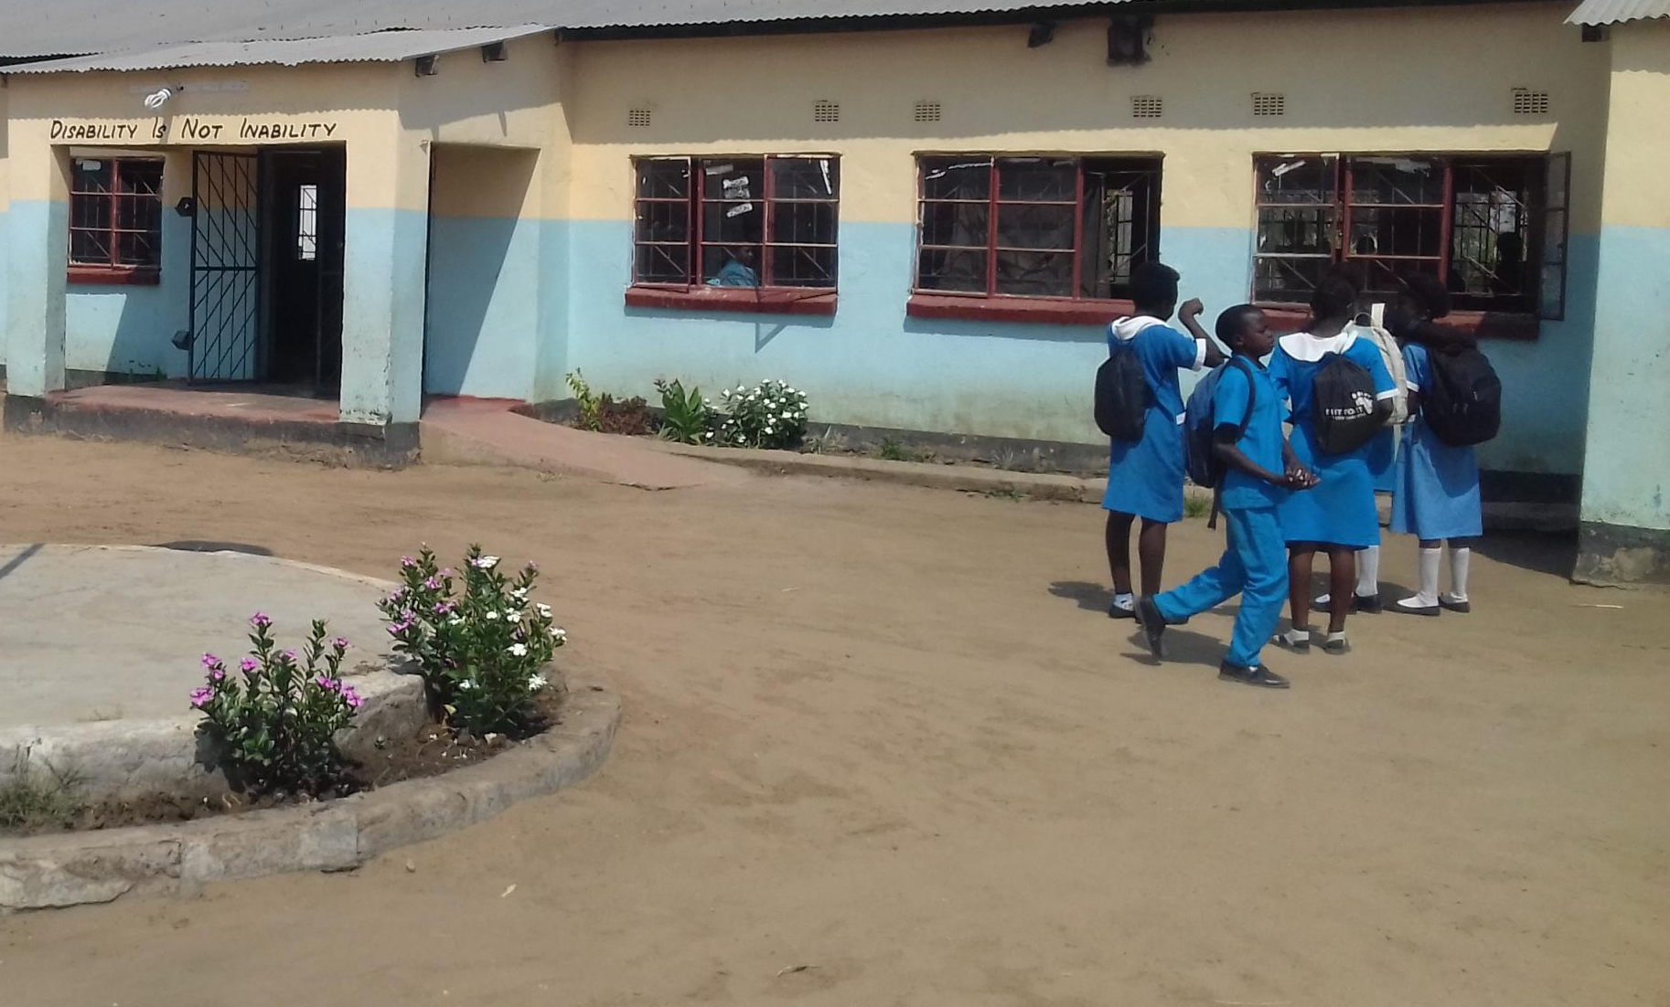
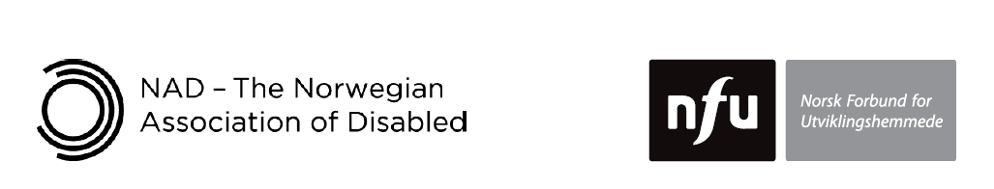

A manual for teacher trainers
Prepared for:
Ministry of General Education, Zambia
The Norwegian Association for Persons with Developmental Disabilities
The Norwegian Association of Disabled
Developed by:
Enabling Education Network, December 2019

Introductory booklet

Inclusive Education

This work is licensed under the Creative Commons Attribution-NonCommercial-ShareAlike 4.0 International License. To view a copy of this license, visit http://creativecommons.org/licenses/by-nc-sa/4.0/

Contents

Acknowledgements and sources iv
Useful information v
Acronyms vi
Preface viii

A. Contents of the manual x
B. Purpose of the manual xvii
C. Methodology xviii
D. Communication skills xx
E. What is inclusive education? xxi
F. The Zambian context xxii
G. Target audience for this training xxiv

Acknowledgements and sources
The materials in this introduction and accompanying set of training modules are based on materials developed, tried and tested by Enabling Education Network (EENET) team members in various locations across Africa, Asia and Europe over a period of at least ten years. These include:
- Training-of-trainers workshop developed for Diakonia, Palestine, July 2011,
- ‘Inclusive Education: Manual for teacher trainers’, prepared for the Handicap International Federation (HIF), Cambodia, 2011,
- Training-of-trainers programme developed for the United Nations Children’s Fund (UNICEF), Macedonia, 2012–13,
- Training-of-trainers programme developed for UNICEF, Libya, 2012–2013,
- ‘An Introduction to Inclusive Education: Manual for teacher trainers’, created for HIF, Liberia, 2012–13,
- ‘The Foundations of Teaching: Training for educators in core teaching competencies’, prepared for Save the Children, 2017,
- ‘Inclusive Education: Introductory training for teachers’, developed and tested for Leonard Cheshire, Tanzania and Uganda, 2017–2018, and
- Training-of-trainers programme developed and piloted for the Norwegian Association for Persons with Developmental Disabilities (NFU) and the Norwegian Association of Disabled (NAD), Zanzibar and Zambia, 2016 – 2019.

The following organisations have played a key role in the development of the training modules: EENET, the Ministry of General Education (MoGE), NAD, NFU, various teacher training colleges (TTCs) in Southern Province, and the University of Zambia (UNZA)

A large number of individuals have been involved in the process of developing and testing the training modules. We are unable to list everyone here, but express deep gratitude for their energy and commitment to supporting the development of inclusive education in Zambia.

Useful information
Resources such as handouts, forms, activity cards and worksheets mentioned in the training sessions can be found at the back of each module.

Throughout the modules, photographs and diagrams have been annotated to assist readers with visual impairment.

The term ‘learner’ is used throughout the training modules to denote children, pupils, students, teenagers, young people and adults. Similarly, the term ‘school’ is often used for brevity but in many instances can be interpreted to cover formal schools at all levels, colleges, higher education institutions, and other settings that provide an education.

Acronyms
7NDP Seventh National Development Plan
CBID Community-Based Inclusive Development
CBM Christian Blind Mission
CBR Community-Based Rehabilitation
CDC Curriculum Development Centre
CWAC Community Welfare Assistant Committee
DEB District Education Board
DESO District Education Standards Officer
DRCC District Resource Centre Coordinator
DPO Disabled People’s Organisation
ECD Early Childhood Development
ECE Early Childhood Education
EENET Enabling Education Network
EU European Union
HIF Handicap International Federation
INSET In-Service-Training
ILO International Labour Organization
JICA Japan International Cooperation Agency
MoGE Ministry of General Education
MoHE Ministry of Higher Education
NAD Norwegian Association of Disabled
NFU Norwegian Association for Persons with Developmental Disabilities
NGO Non-Governmental Organisation
NORAD Norwegian Agency for Development
SEN Special Educational Needs
SIC School In-Service-Training Coordinator
SNDP Sixth National Development Plan
ToT Training-of-Trainers
TTC Teacher Training College
UNESCO United Nations Educational, Scientific and Cultural Organisation
UNICEF United Nations Children’s Fund
UNCRPD United Nations Convention on the Rights of Persons with Disabilities
UNZA University of Zambia
ZAMISE Zambia Institute of Special Education
ZAPD Zambia Agency for Persons with Disability
ZAEPD Zambia Association on Employment for Persons with Disabilities
ZIC Zonal In-Service-Training Coordinator

Preface
Norwegian Association of Disabled (NAD) and its partners in Zambia and Zanzibar worked with Enabling Education Network (EENET) to develop and test an approach to teacher training on inclusive education for use in low and middle-income contexts. The result is a high quality teacher training course in inclusive education.

This training package is designed to develop trainers who are already embedded within an education system as teachers, teacher trainers and leaders for inclusion.

The modules used should be closely aligned with pre-service and teacher training curriculum reform, directly contributing to the systemic change needed to ensure all learners can access, participate in and progress through education. The costs of this programme can be kept low by selecting principal trainers from those who are already employed in jobs that support, train and/or manage teachers.

The training approach used to deliver these modules should avoid cascade training which does not routinely provide teachers with high-quality learning opportunities that ensure genuine and sustained changes in their attitudes and practices within schools. Cascade approaches are rapid, often consisting of short, one-off courses, and can reach a lot of trainees, but the trainees often learn only superficial theory and have little chance to observe, discuss or try out inclusive practices in a real-world situation. Materials are often developed by external experts and are not locally ‘owned.’ Such trainings succeed in raising teachers’ awareness but fall short of changing their practice.

Summary of key characteristics of the training approach
The approach is designed to:
- Focus on building a cadre of experienced, skilled and confident principal trainers who have the capacity both to roll out the training to teachers and trainee teachers and to make ongoing improvements to the training. This training takes place incrementally over a period of at least two years.
- Create contextually relevant training materials that are co-developed and therefore co-owned by key education stakeholders, including trainers.
- Promote the use of a teacher training approach that prioritises practice over theory, promotes learning-by-doing, and builds teachers’ capacity to be innovative and critically reflective problem-solvers.
- Take an accumulative approach to learning, starting with basic inclusive education foundations and then moving on to more complex and specific topics. This helps teachers to gradually build their confidence with learning.
- Take an approach to teacher capacity building that recognises the vital importance of collaboration and therefore embeds mechanisms to ensure teachers are not tackling inclusion challenges on their own.
- Ensure that in-service teacher training is closely linked to and/or influences sustained change in pre-service training, by enlisting trainers who are employed by teacher training institutions and by maintaining links with those institutions to share materials and information.

Timescale
Ideally, plan for a course that will roll out all the modules sequentially over two years. This requires principal trainers to learn about and help to adapt four to six modules per year and attend two or three trainings each year.

If this is not realistic for your context, identify either a longer timeframe or a compromise on how many modules are rolled out.

A. Contents of the manual
The training manual consists of this introductory booklet plus eleven (11) modules and a supplementary resource on ‘Including Learners with Additional Needs’. Further modules may be added in future.

The modules are arranged so that teachers are first introduced to the theories and concepts of inclusive education. As they become more confident with inclusive approaches and methodologies they are introduced to more complex content and activities. Trainers are advised to follow the steps laid out in the manual to ensure that there is a thorough understanding of inclusion. The supplementary resource contains information on supporting learners with additional needs and guidance around specific impairments.

The table below provides a brief description of all modules in the inclusive education training course. It also describes the topic areas that are covered in each module. Please note that conducting action research on the topics covered is a component that runs through all of the modules.

Module | Brief description | Key topics covered
Module 1: Introduction to inclusive education | Introduces the concepts and theories of inclusive education and the theoretical basis for its implementation; and introduces active participatory learning methods which teachers will experience throughout the training. | Inclusive education definition and discussion  Policy frameworks and legislation  Learning styles  Active learning  Barriers to inclusive education including discrimination, teacher attitudes and systemic hurdles.  Action research and appreciative enquiry.
Module 2: School Inclusion Teams | Provides information for teachers and other relevant stakeholders, such as school support staff, District Education Board officers, community members and other stakeholders who want to plan, develop and manage a school inclusion team in their school. | Building school inclusion teams  Guidance on selecting members  Awareness of power dynamics
Module 3: Identifying Out-of-School Children | Provides a broad overview of the issue of out-of-school children in both local and global terms; and explores why some children are out of school, and the chain of causes and effects which result in them being absent from school. | Rights based approaches to out of school children  Policy frameworks and legislation  Out of school children in Zambia  Strategies and solutions
Module 4: Screening and Identification of Learning Needs | Promotes a move away from the ‘special needs’ / medical model approach to identifying learners’ learning needs, and encourages an approach which focuses on identifying barriers impacting learning and development (‘social’ model approach). | Inclusive approaches to education in practice  Inclusive principles for identification, screening and assessment  Learning styles  Barriers to education  Impact of impairments on learning  Understanding wider contexts affecting the learner  Organising support for the learner and for schools
Module 5: Creating Individual Education Plans | Supports understanding of what an individual education plan (IEP) is, its characteristics, and the reasons why schools develop and use IEPs; and looks at some of the benefits of IEPs and which learners can benefit from having one. | Individual Education Plans: definition  What is included in an IEP  How to develop an IEP  Collaborating on IEPs  Running successful IEP meetings  Monitoring, reviewing and revising IEPs
Module 6: Exploring the Role of a School Inclusive Education Co-ordinator | Explores the role and effectiveness of a school Inclusive Education Co-ordinator (IECo), looking at how the school IECo can co-ordinate special educational needs and/or disability and inclusive education activities, and how they can network and be a catalyst for change towards a whole-school approach to inclusive education for all. | School Inclusive Education Coordinator definition  Characteristics of a SIECo  Whole school approaches  Establishing and adapting learning bases for effective inclusion support
Module 7: Promoting Active Learning in the Classroom | Provides ideas for inclusive teaching strategies for active learning that are effective in diverse settings, including under-resourced schools with large class sizes. These strategies support differentiation and highlight the effectiveness of mixed-ability groupings in promoting achievement. | Committing to inclusive education  Active learning  Developing learning objectives  Group work  Differentiation in teaching and learning  Organising classrooms – physical and psychosocial environments  Asking questions  Feeding back  Assessing learning
Module 8: Developing Learner Participation | Enables teachers to further develop learner participation in their school through peer support, peer mentoring, peer tutoring, and involving learners in making decisions that affect them. | Commitment to learner participation  Developing peer support  Developing independent learning and critical thinking  Supportive environments and safe spaces  Barriers to participation
Module 9: Including Learners in Transition | Provides ideas to promote the achievement of learners who are in transition. Education transition refers to learners who are leaving, arriving or newly arrived in an education setting, or moving mid-year. Transition can be from home to early learning centre, from there to primary and then secondary and tertiary education, from education to employment, and so on. | Understanding transition between education levels  Managing inclusive transitions  Planning guidance  Teacher checklists  Observations  School self-evaluation
Module 10: Including Learners who have Intellectual and/or Developmental Impairments | Introduces and explores effective methods of including learners with intellectual and/or developmental impairments. Offers practical ideas for meeting learners’ needs in the classroom and gives teachers opportunities to problem-solve for difficulties they have experienced as educators. This module is designed to equip teachers with skills to enable the process of identification and support. | Basic assessment for intellectual and/or developmental impairments  Discrimination and challenges  Exploring support from the school inclusive education co-ordinator and the learning support base  Practical classroom strategies
Module 11: Making Teaching and Learning Aids from Locally Available Resources | Provides advice for trainers of trainers to develop teaching and learning aids from locally available resources. | Identifying teaching and learning aids  Creating teaching and learning aids
Module 12: Including learners with additional needs | Offers basic information about different additional needs, how to identify additional needs, how additional needs can exclude learners and practical tips and ideas for teachers on supporting learners with additional needs in the school and classroom environment. | Identifying impairments  Understanding barriers faced by individuals with specific impairments.  Practical approaches, hints and tips for teachers on:  - Cognitive or learning impairments  - Speech and communication difficulties  - Behavioural, emotional and social difficulties  - Visual impairments  - Hearing impairments  - Physical impairments  - Health problems  - Multiple impairments  - Gifted and talented learners

B. Purpose of the manual
This manual has been developed and tested in an inclusive education training-of-trainers (ToT) programme with Principal Trainers. The Principal Trainers then use the manual to guide their work of training teachers in schools.

Each module within the manual provides Principal Trainers with:
- the content and methodology they need to learn and practise during ToT and then use during training workshops with teachers and trainee teachers,
- guidance for how to replicate and adapt workshop activities in their own training work with teachers and trainee teachers, and
- ideas for how to continue working on some of the topics raised in the workshops, and how to expand on other activities after the workshops.

C. Methodology
The training outlined in the manual focuses on using participatory methods and active learning techniques. It follows this basic principle:

We must use inclusive training methods if we are to successfully train others how to teach inclusively.

Teacher development is most effective when the training activities reflect the inclusive practice expected from teachers in the classroom. During the training sessions provided in this manual, therefore, teachers are always given direct experience of interactive learning, through group-work, pair-work, buddying, and other activities that respond to different learning styles.

The ideal room set-up is to have teachers working in small groups around tables, for instance 4-6 teachers per table. The tables should be large enough to accommodate flipchart paper and for the groups to work comfortably together. The tables should be positioned so that everyone can easily move their chairs to see the front of the room or wall where PowerPoints are being projected, whenever necessary. There should be plenty of space between tables to ensure accessibility and ease of movement for trainer and trainees.

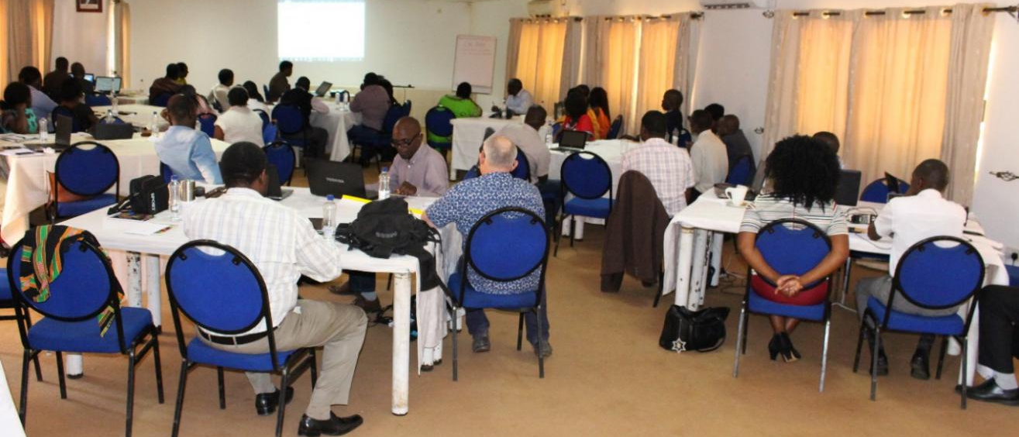
A good example of a workshop room set up for group work

[Image description: A large room with square tables, spread out so each table fits 5-6 chairs around it. Many chairs are occupied by male and female teachers. Wide spaces between the tables make the room feel spacious.]
Professional development provides the biggest impact for teachers when it:
- is concrete and classroom-based,
- brings in expertise from outside the school,
- involves teachers in choosing areas to develop and activities to undertake,
- enables teachers to work collaboratively with peers,
- provides opportunities for mentoring and coaching,
- is sustained over time, and
- is supported by effective school leadership.

Within each module there are activities labelled as ‘Main’ activities and others labelled as ‘Extra’ activities
Main
The ‘Main’ training activities are designed to help trainers respond inclusively to the varied learning styles of the teachers. These activities should be used flexibly, in response to teachers’ needs, interests, and existing level of knowledge and experience. The order and timing of activities provided is only a guide, not a rigid prescription. Some activities will need more or less time than suggested, depending on the size of the group, their levels of understanding and/or interest in investigating particular issues more deeply, whether you are using language/sign language interpretation, and so on.
Extra
‘Extra’ activities can be delivered if there is sufficient time and/or if the trainer feels that her/his teachers would benefit from doing them.

Trainers are encouraged to be reflective practitioners. They need to look at how they facilitated an activity or explained a particular topic, and think critically about its success and how they could improve it in a future workshop. Workshop evaluation activities should be used to elicit teachers’ views about the content and methodology of training. Trainers can use reflective diaries to document and reflect on their own training/facilitation work.

D. Communication skills
Whether we are training in a workshop, or teaching in a classroom, it is important to ensure that we communicate as effectively and accessibly as possible with everyone. Here are some important communication guidelines for trainers to follow and encourage teachers to follow:
- Speak and/or sign clearly and at a pace at which everyone can understand.
- We may pronounce or sign words differently depending where we come from, so be aware of this.
- When communicating in a group with someone who has a visual impairment, make yourself known by saying your name to get yourself noticed.
- When communicating in a group with someone who has a hearing impairment, make yourself known by raising your hand.
- Reintroduce yourself to people in case they have forgotten your name.
- Ask for clarification if you do not understand something.
- When working in small groups, ask colleagues to explain if you do not understand something.
- Try to use different communication methods, e.g., gestures, drawings, etc.
- When writing on a flip chart, use large, clear letters in a bold dark colour such as blue or black.
- When working in groups, some people are quiet while others have strong personalities. Make sure each group has a facilitator, a recorder and someone who will report back to the main group.

E. What is inclusive education?
Inclusive education is a process of increasing the presence, participation and achievement of all learners in educational settings: Early Childhood Education (ECE), primary schools, secondary schools and tertiary institutions.

Education for all learners means for all girls and boys, teenagers and young adults regardless of gender identity, from majority and minority ethnic groups, refugee and asylum-seeking learners, displaced learners, learners with and without disabilities, learners with health problems, and those who are street-connected and working as well as those who are orphaned, among others. It involves restructuring the cultures, policies and practices in schools so that they respond to the diversity of all learners in their community.

Inclusive education is built on the understanding that educational exclusion happens because of fundamental problems in the education system or school – it does not place the ‘blame’ for exclusion on a learner’s personal characteristics or abilities. Therefore, through an inclusive education approach we seek to bring about changes to the school, education system and neighbouring society – the system – so that schools and other education settings can effectively welcome and educate any learner, including those with disabilities and/or special educational needs (SEN). Inclusive education does not focus primarily on changing aspects of the learner (physically or intellectually). This does not prevent us from carrying out interventions that might prove beneficial to a learner’s physical and intellectual well-being. It simply does not make these interventions the primary or only solution we strive for.

Inclusive education acknowledges that all children, young people and adults can learn, and that they learn at different speeds. It encourages flexible teaching, which supports differentiated learning, using different methods to suit various learning styles. It draws on a range of methods for supporting learners with disabilities and/or SEN or other marginalised learners, depending on local context, e.g., peer support, parental/care-giver involvement, disabled adult volunteers, additional in-service training for mainstream teachers, etc.

Above all, inclusive education is an aspirational process; it is something we always keep working towards, because we can always keep improving. It is not a quick-fix – the development of inclusive education takes time and requires everyone involved to commit themselves to permanent, ongoing action.

F. The Zambian context
Missionaries in Zambia led the way in providing education opportunities for persons with disabilities. Lazarus Banda, a man with blindness, was educated at Magwero by missionaries in 1902. The Dutch Reformed Church opened the first school in Magwero in 1905 for children with visual impairments.

In 1948, the Northern Rhodesian Government recognised the need to integrate persons with disabilities after the Universal Declaration of Human Rights was passed. Until 1960, missionaries and other philanthropists established residential institutions for learners with disabilities, and technical education was emphasised. In 1971, Republican President Dr Kenneth David Kaunda passed a decree that education for persons with disability was a government responsibility. After this decree:
- Lusaka College for the Teachers of the Handicapped, now ZAMISE, was opened to train teachers to work with learners with disabilities.
- The first Special Education Unit for the Visually Impaired was opened at Munali.
- An Education Officer for Special Education was appointed based at the Ministry of Education headquarters.
- The Policy on Education, the Education Reform Document of 1977, included education for persons with disabilities. It used derogatory terms such as physically handicapped and mentally retarded.
- The Curriculum Development Centre (CDC) established the Special Education Unit.
- Some people with disabilities were appointed to decision-making positions, such as Lazarus Tembo who was blind and appointed Minister of State.

Integration was practiced to help more children learn in schools closer to their homes. Learners with disabilities considered mild to moderate were integrated into local schools, while those with severe and multiple disabilities attended segregated institutions – but many received no education at all. Like many other countries, Zambia has over the years established special schools and units countrywide where children with disabilities are taught by trained special education teachers.

By the 1990s there was global concern that learners with disabilities were not getting quality education and were segregated, which led to the development of inclusive education. The World Conference on Special Needs Education held in Salamanca Spain in 1994 was a pivotal moment as it called for international endorsement of inclusive education.

Zambia piloted inclusive education in Kalulushi District of the Copperbelt Province in 1997 and it was expanded to all districts. However, the MoGE has not evaluated the successes and challenges of inclusive education practices. To fill gaps, organisations like NAD, NFU, Save the Children, UNICEF, Plan International, Sightsavers International and Cheshire Homes Society of Zambia have been implementing inclusive education in selected parts of the country. These organisations do not have a common package for inclusive education training. In the next few years, the MoGE, in partnership with NAD, NFU and other stakeholders, hopes to achieve more in making curriculum changes that promote inclusive education in Zambia. This is one reason why an inclusive education training package has been developed to be used when training teachers and other stakeholders in inclusive practices.

G. Target audience for this training
Initially trained participants will be trainers who play a role in delivering teacher training, for example:
- District Education Board (DEB) staff, such as District Education Standards Officers (DESOs) and District Resource Centre Coordinators (DRCCs),
- schools, e.g., head teachers, Guidance and Counselling teachers, School in-service training (INSET) Coordinators (SICs) and Zonal INSET Coordinators (ZICs),
- TTCs and university lecturers,
- the inspectorate, and
- other stakeholders who are working towards becoming more inclusive, such as social workers, health personnel, DPO members, and other MoGE and Ministry of Higher Education (MOHE) staff members.

These teachers will have a variety of practical experiences in education in relation to teaching, training and working with a diverse range of learners. Some will feel confident about training teachers to be inclusive educators. Others will understand the theory but, in reality, still feel nervous or reluctant to work inclusively or train others to include and teach all learners, especially those learners with disabilities and/or SEN. It is always best, therefore, to start each training session from ‘where the teachers already are’. It is strongly advised that trainers begin each module with a short recap of content and activities from the previous modules.

The training modules in this manual will subsequently be used by the Principal Trainers when they are training teachers during INSET and trainee teachers during pre-service training.

EENET is a global information-sharing network. Since 1997, it has been dedicated to supporting education stakeholders and practitioners to document and share their experiences and ideas relating to the inclusion, and to think and act critically about how they implement inclusive, quality education for marginalised groups.
Ministry of General Education (MoGE), Ministry of Higher Education (MoHE) and University of Zambia (UNZA)
Ministry of Education and Vocational Training (MoEVT), State University of Zanzibar (SUZA) and Zanzibar Association of Persons with Developmental Disabilities (ZAPDD)
For brevity in this document we use the term ‘school’ to include all educational settings at all levels (e.g. pre-school/early education settings, tertiary institutions, non-formal education settings, and so on).
To date the ToT programme has been funded by the Norwegian Association for Persons with Developmental Disabilities (NFU) and the Norwegian Association of Disabled (NAD), supported by the Ministry of General Education (MoGE) and the Ministry of Higher Education (MoHE), and designed and facilitated by EENET.
From Walter, C. and Briggs, J. (2012). ‘What professional development makes the most difference to teachers? Oxford University Department of Education.
Kalabula, D.M. (1991) Integrating Visually Impaired Children into Zambian Secondary Schools. Unpublished Ph.D Thesis, the University of Birmingham

