Campaigning for inclusion: taking the Global Campaign for Education to the streets of Nigeria

Funke Bolaji
State Specialist, Access & Equity, ESSPIN Kwara

In Nigeria, civil society has been taking up the call of the Global Campaign for Education on inclusive education. In Kwara state, this year’s GCE Global Action Week provided a focus for bringing inclusive education for children with disabilities to the attention of the public and government. Kwara’s Civil Society Action Coalition on Education for All (CSACEFA) organised a series of events with support from the DFID-funded ESSPIN programme.

Action Week featured a visit to the State House of Assembly; sensitisation on inclusive education at places of worship across the state; and a street rally across Ilorin (the state capital). The events pulled together staff from the Ministry of Education and Human Capital Development, the State Universal Basic Education Board, ESSPIN, CSACEFA, schools, communities and the media.

The week was rounded off with a stakeholders’ forum, with over 200 participants. The forum clarified that inclusive education caters not only for children with disabilities, but for all marginalized children. Other children often excluded from education in Kwara included pregnant girls and young mothers, orphaned and vulnerable children, children affected by diseases, and children from various ethnic and religious backgrounds.

Stakeholders came up with seven strategies to address the profound challenges faced by people with disabilities in realizing their right to education. The strategies were:
1: Create appropriate legislative frameworks, and set out ambitious national/State plans for inclusion
2: Provide the capacity, resources and leadership to implement ambitious national/State plans on inclusion
3: Improve data on disability and education, and build accountability for action
4: Make schools and classrooms accessible and relevant for all
5: Ensure enough appropriately trained teachers for all
6: Challenge attitudes which reinforce and sustain discrimination
7: Create an enabling environment to support inclusive education, including cross-sectoral policies and strategies that reduce exclusion.

During the House of Assembly visit, CSACEFA’s Coordinator, Hajia Labaika, introduced the House to the theme for the campaign, ‘Equal Rights, Equal Opportunities’. She updated the House on current policy and work in communities to develop inclusive schools. She implored the House to support improved policy legislation and funding to bring inclusive education into the mainstream education system.

The campaign created real momentum towards inclusive education in Kwara. The Chairman of the House Committee on Education, Mrs. Nimota Ibrahim, said, “The House will ensure issues of inclusive education become a continuous agenda in the state education system and not an issue brought only on occasions.” Mrs Ibrahim also pledged to mobilise more support from the House for children, especially those living with disabilities.

At the end of the week, the state education Ministry and Universal Basic Education Board issued a joint communiqué with CSACEFA, stating that children with disabilities and all other children have equal rights to education.

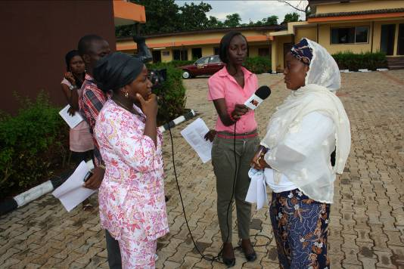
CSACEFA Kwara Co-ordinator Hajia Labaika using the media to advocate for inclusive education. Photo: CSACEFA

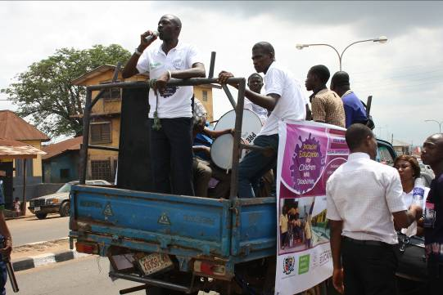
Inclusive Education is the responsibility of all: road rally through the streets of Ilorin.
Photo: CSACEFA

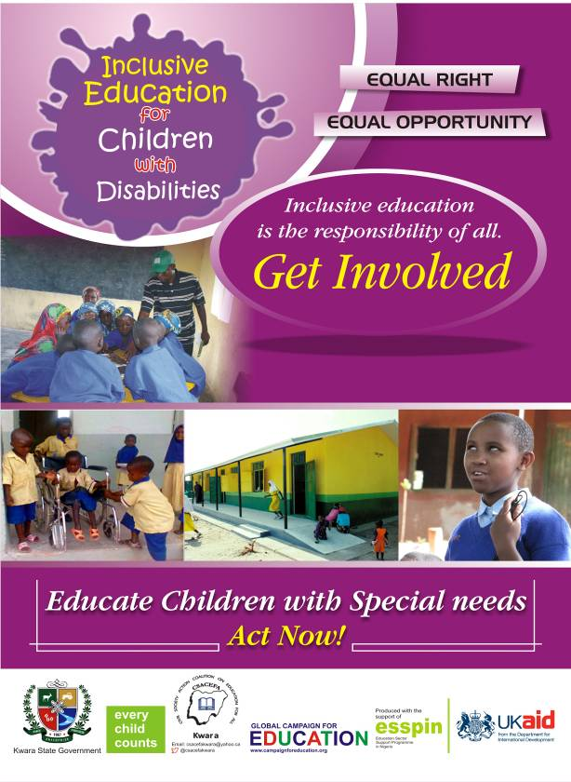
The campaign poster.

