Call for Articles
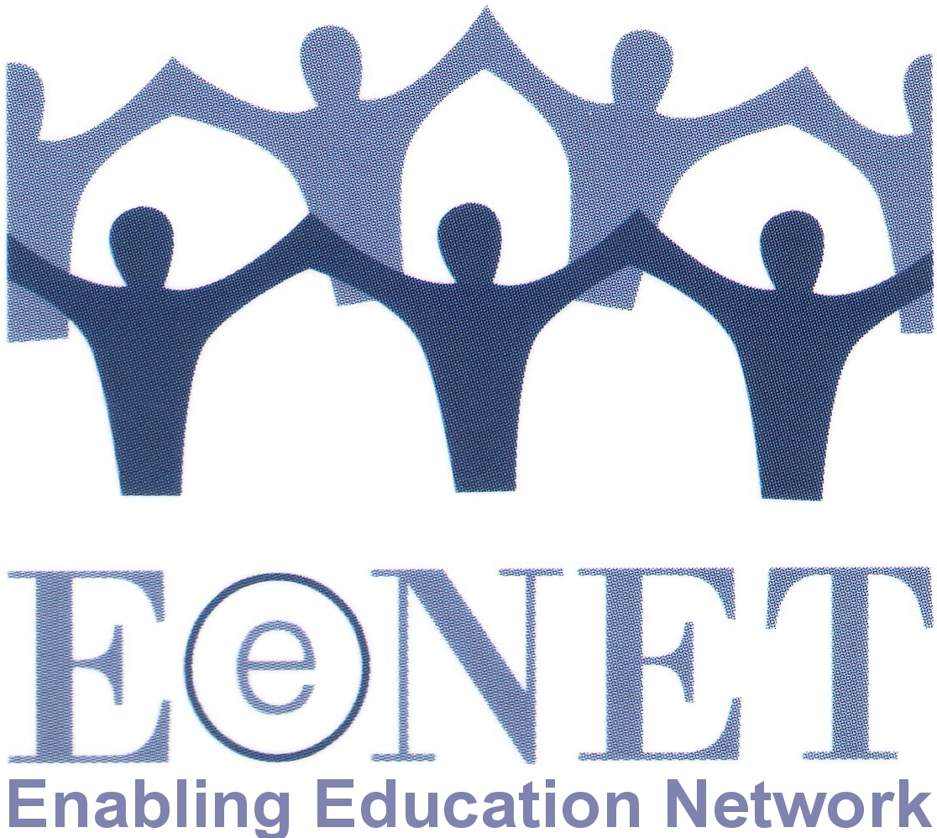
Enabling Education Review
Issue 11, 2022

The COVID-19 pandemic turned education upside down during much of 2020 and 2021. Schools have reopened in most places, but our education systems will never be the same again. We all experienced not just disruption and challenges but innovations and achievements that can shape the future of education for the better.

The theme for the 2022 edition of Enabling Education Review will be:

“Inclusion in the new normal”

The deadline for submitting first drafts of articles is 30 June 2022. Details of suggested topics and how to submit articles are provided below.
Contact info@eenet.org.uk with any questions.

1. Why have we chosen this topic?

Globally we continue to see the impact of COVID-19 and other recent crises on education systems, educators and learners. The effects include:
- shortages of teachers and lost expertise;
- larger class sizes;
- millions of learners who need to catch up and millions of others who did not return to school;
- millions of students and teachers with extra well-being needs;
- learners with increased or different behaviour issues;
- recurring closures and illness-related absences.

In our 2021 edition we looked at the challenge of inclusive home learning during the pandemic. Now we want to share your experiences of transitions back into school, what the situation is like in the ‘new normal’, and what we have learned that could help us rebuild education systems better and more inclusively.

2. What could you write about?

There are many aspects of inclusion in the new normal that you could write about, including but not limited to:

- What has been done to support learners transitioning back into schools?
- How have approaches to teaching and learning changed because of the pandemic?
- As a teacher, what did you do to reach and support all your learners when schools reopened? What challenges and opportunities have you experienced? Who has helped you?
- How have adaptations to the new normal been financed and managed, and by whom?
- As a parent/caregiver/learner, how have you advocated at the local or national level for approaches to education to be more inclusive after schools re-opened?
- For learners who were already learning at home before the pandemic, how has their home learning been affected (positively or negatively) by the changes resulting from the COVID-19 pandemic?
- How has the pandemic affected the mental and physical well-being of learners, parents, families, and teachers? What has been done to support them?
- What lessons have we learned that we could use to improve the design and inclusivity of education systems long term?

Enabling Education Review helps people share and learn from each other’s experiences. Therefore we welcome articles that offer practical insights to help others looking for ideas that they can adapt and try. We like articles that provide a little background to the context, project or programme and then explain the activities that happened (what, where, when, with or by whom, and why). We also like to read about the results, if possible.

3. How can you submit an article?

Please email your article to info@eenet.org.uk or send a hard copy to the address at the end of this document.

Authors can write in English or their preferred language.

Length – 550 words (for a single-page article) or 1,100 words (for a double-page article). We may edit longer articles down to a single page, depending on the quantity and quality of articles received.

Style

Write an article: please keep the article easy to read and non-academic. We encourage the use of sub-headings, bullet lists, simple diagrams, etc. Have a look at previous editions of the publication if you are not sure what style to use: www.eenet.org.uk/enabling-education-review/

Write a poem: we encourage you to be creative with your submissions, so if you prefer to write a poem rather than an article, that’s great.

Present a drawing: if you feel that the story you wish to tell is better told visually, please feel free to submit a picture rather than an article. Please give your drawing a title. You could also write and submit a shorter piece of writing that explains the drawing.
Editing – we are happy to help edit the article, so don’t worry if you are not an experienced writer. We can work with you to improve the structure and content of your article, make it shorter/longer, etc.

Working in audio – if you would like to send us a voice recording of your article or be interviewed as the basis for an article, please contact Su Corcoran at info@eenet.org.uk to discuss options.

Photos – it is great if you can add photos, drawings or diagrams to your article. When selecting photos, please look for the following:
- Active images – e.g., children learning in groups, children playing, teachers/ parents working with learners, and so on;
- Images that are not too dark, blurred, or pixelated.

Please send us high-resolution images by email (these should be at least 1MB in size), or post us an original print/drawing. For every image you want to add to your article, you will probably need to remove about 75-100 words of text – but we can help with this editing.

Permission
Please ensure that the people in any photos have given their permission for the photos to be published, or that parents/guardians have given permission for photos of children or vulnerable adults to be used.

Please fill in and send us the permission form (below) attached to your photo(s).

Deadline – the first deadline for draft submissions is 30 June 2022. We will then review all articles and work with the authors to edit them.

Selection – please note that we might not publish all of the articles we receive. In addition to ensuring that we publish articles that are easy to read and of practical use to a range of education stakeholders, we will also ensure that the final selection includes:
- articles from a variety of countries/regions;
- articles about a range of different issues;
- articles by authors from different backgrounds.

Articles not selected for publication in EER may instead be published on EENET’s website (www.eenet.org.uk).

Queries – if you have any questions, please email info@eenet.org.uk.

Postal address – if you want to send an article in hard copy or as an audio recording (e.g., on CD or flashdrive), please send it to:

EENET
PO Box 422
Hyde
Cheshire, SK14 9DT, UK
Permission form – Enabling Education Review

Please fill in a form for each photo you want us to publish. Please also fill in a form if you name people in a case story and have chosen not to change their names.

Name of person submitting the article to EENET:

Title, file name or description of photo:

Name of person in photo / story (delete as applicable):

Parent / guardian’s name (if person in photo/story is under 16):

I understand that my / my child’s photo / story may be published in EENET’s Enabling Education Review, in printed copy and online.

I also understand my / my child’s photo / story may be shared through other media, such as social media.

I understand that once the photo / story is published and shared online, it will not be possible to remove it in future.

I give my permission for my / my child’s photo / story to be used in these ways.

Signature:

Date:

Contact details (e.g. tel no, email, address):

