Amalya’s Story: A young disability advocate

Non-official translation. Original article in Armenian: 16 August 2019 published via Mediamax at https://mediamax.am/am/news/special-report/34557/

She is Amalya Harutyunyan. Her mission is to change people.

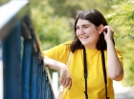

Amalya Harutyunyan is studying psychology at the Yerevan State University in Armenia. She wants to work as a psychologist in schools to bring about change in the way pupils are included and supported in class.

As well as studying, she works with the NGO ‘Bridge of Hope’ which advocates for the equal rights of people with disabilities. She organises camps and trainings in Vayots Dzor province for children with disabilities promoting active citizenship and addressing stigma and discrimination.

Here she explains her experience growing up with a visual impairment and how this led to her becoming an advocate for people with disabilities.

I do not want to remember my school years.

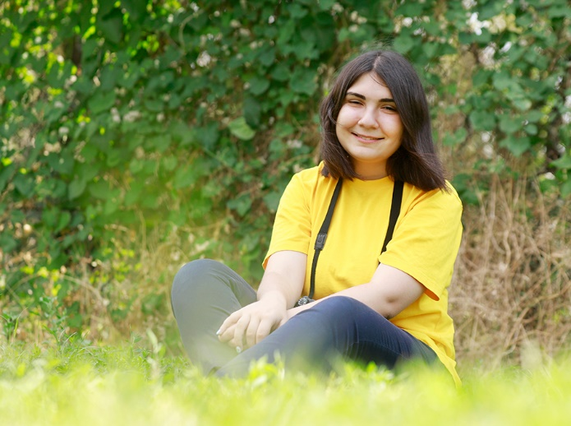
Poor vision did not prevent Amalya attending a mainstream school, but the challenges she faced within her classes led to difficulties throughout all her schooling. The start of every school year, September 1st, brought with it fresh optimism that Amalya had the strength to change something that year. But every year, after a few days attending her local mainstream school, she would realise yet again, that the lack of inclusion within the school would prevent her from reaching her potential. For the girl with poor vision the start of a new academic year was a new challenge instead of being an opportunity for meeting new friends.

“In kindergarten people told me that I would hinder the ‘normal’ children and that I was not a “normal” child and therefore, they could not work with me. After applying to two or three kindergartens and being rejected, we decided not to apply anymore and so I did not attend kindergarten at all.

“I lived in Nor Nork, in the 9th district yet I went to a school called N189 in the 8th district because the two schools nearest my house would not accept me. With the help of some acquaintances I started studying in N189 school, where inclusive education was being introduced for the first time.

I do not like to recall my school years. I don’t have any childhood friends and I faced many difficulties at school. My desk was the nearest one to the blackboard. This helped me to see what was written but instead of bringing everyone’s desk to line up with mine so we could all study together, there was a huge gap between my desk and my classmates’ desks. I often sat on my own because the children next to me complained that the blackboard was too near or that I leant over the table too much which made it uncomfortable for them. I was allocated a teaching assistant who sat next to me and read what was on the board, yet this just created more issues. It would have been better if the class teacher read out everything she wrote on the board to the whole class – that way I could write it down and I would not be isolated from my classmates.

I remember in the 6th grade that the last lesson on a Thursday afternoon was Armenian history and prior to that was physical education (PE). During the history class I used to cry because of events that happened during PE. I got teased a lot and my glasses would fall off and break. I was not allowed to do heavy exercises, but I would have gladly completed the easy ones alongside my peers. Instead, during these classes I was separated from the group and made to play on my own or do homework.

Alternatively, the opposite happened - I was given more support than was needed. For example, sometimes I was intentionally graded higher than my performance, which made me angry. I wanted to be like the others. It seemed hard for people to distinguish the difference between equality and positive discrimination.

Despite difficulties I performed well until the 8th grade. I know I have complained a lot about the school, but it is worth mentioning that inclusive education had only just been introduced at the time to the school and so consequently it is normal that there were some problems. It was good that I was admitted in the first place and not rejected like in other schools.”

The expression “you cannot” empowered me.

The same problems Amalya faced with accessibility and inclusion in her school are present in her university as well. She is still fighting stereotypes and unsuitable environments as she completes her degree.

“The expression ‘you cannot’ has empowered me. When I applied to university, my parents doubted whether I would be able to get high enough scores. But I did it! For my English exam I got 20/20 scores. My parents became advocates when, by some miracle, I was chosen to participate in camps organised by ‘Bridge of Hope’, where I now volunteer. Two students were selected from my school and even though I was technically too young for the programme, one of them was me.

At 11 years old I was already speaking about equal rights. At the age of 12 and 13 I was writing articles about the Human Rights Convention and involving my mother in workshops.

At ‘Bridge of Hope’ I attended journalism classes. When it was time to choose a profession, I hesitated between journalism and psychology. I chose psychology because I had seen psychologists working in schools. I didn’t want to be like them. I wanted to spread the idea of equality and I think when you want to change something in people you must be able to understand them thoroughly.

“I also took up photography. I was curious about what the world looks like through my eyes, with eyes that are different from others. Therefore, some photos might show ‘difference’. This was also a good way to express myself.”

We need like-minded teachers.

Amalya has noticed that people find it an exceptional achievement when a person with disabilities studies or works. But if appropriate support was in place from the beginning then everyone could get an education, have a social life and would not be isolated from their environment.

“Inclusive education is very important to me. Avoiding limitations and isolation is crucial. During my whole life I have been trying to achieve equal rights for all.

In Armenia, when you say a person has a disability, people just think of wheelchairs. When talking about accessible transport I also point out the need audio announcements and people are always surprised that this is a part of adaptation. When speaking about inclusive education we need to remember the adaptation of textbooks – from fonts to content. We lack teachers for whom inclusive education is an ideology not simply a governmental programme. The physical presence of a child in the class does not equal inclusive education.

We need to work with parents as well. Sometimes parents would not let their children play with me. People do not understand that avoiding interaction is discrimination. The same treatment can be seen in schools today. Children might not offend their peers with disabilities, but they do not communicate with them either.”

My mission is to change the world.

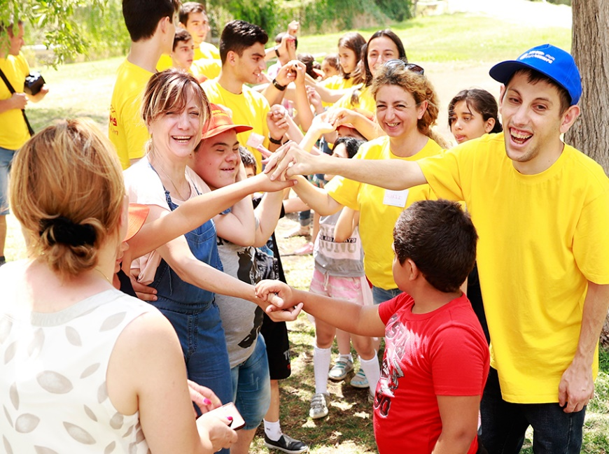

During the summer, Amalya organises camps together with the volunteers of ‘Bridge of Hope’. The camps are for children with disabilities who will attend the mainstream school. Amalya wants to help children become members of their communities and see their life from another angle. She believes that advocating for the rights of people with disabilities and spreading the idea of equality is her mission.

“It does not matter what problems you face. If you want to have a role in this life and to have a mission, you must be able to feel the world, not just observe. I like to love, and in fact, this helped me to react positively to all obstacles I have faced.

My mission is to bring a change. At one point my family wanted to move to Germany, but I wanted to stay in Armenia. Even changing the values of ten people brings us closer to the idea of equality.

I see my future in the civil society sector, and I would like to continue advocating for the rights of people with disabilities. Being aware of rule of law determines our relationship with people with disabilities. We must reach the level where rights prevail over pity, stereotypes or other social norms, and we must exercise a rights-based approach.

We organise two-day trainings against discrimination and to advocate for an active civil society in four marzes (provinces). The programme encourages people with disabilities but also increases the awareness of youth without disabilities. I did not want the programme to be only for people with disabilities. If we are trying to get rid of special schools, we must organise programmes which are not just targeted to people with disabilities.

In Vayk, young adults without disabilities initially stated that special schools are a better option for children with disabilities, rather than inclusive education. However, by the end of the training the same students’ feedback highlighted they felt like we had given them arms so that they could shoot in the face of injustice. If in each marz at least ten people start thinking about this, I will be happy.”

Article author: Lusine Gharibyan
Photos from Marianna Petrosyan and from Amalia Harutyunyan’s personal archive.

