Exploring Inclusive Education:
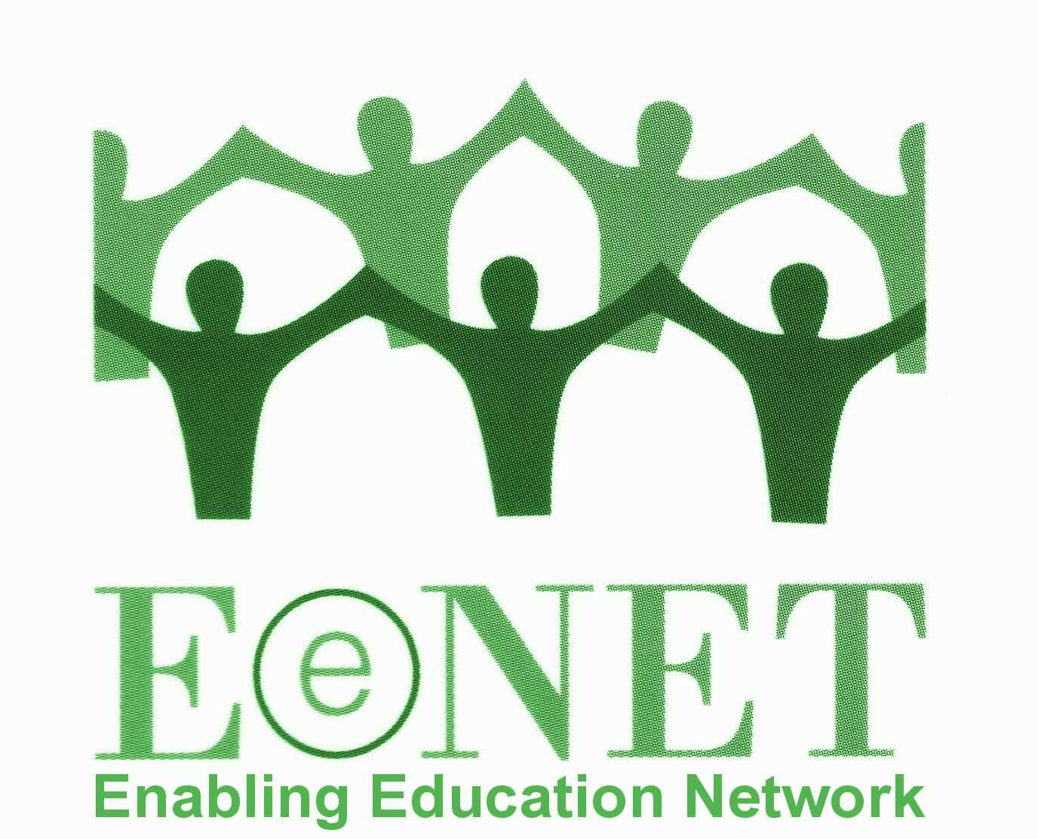
An EENET workshop

The workshop: 5-days facilitated by trainers from EENET’s consultancy company, EENET CIC
When: 12–16 September 2011 (arrival on 11 September) OR
19–23 September 2011 (arrival on 18 September)
Where: Bandung, Indonesia

1. About EENET

EENET is an inclusive education information-sharing network, open to everyone worldwide. We support a wide range of people to access information on inclusion in education. We also encourage critical thinking, innovation and conversations on issues around inclusion, equity and rights in education. For more information about EENET visit our website: www.eenet.org.uk.

In recent years we have received a growing number of requests to run workshops on the theme of inclusive education for education practitioners, policy-makers and funders. The Indonesia workshops are part of a series of events to support the learning needs expressed by our network members and supporters.

2. About the workshop

In Indonesia, EENET will be running the same workshop twice, with identical content, to accommodate the large number of potential participants who have expressed an interest. The first workshop will be on 12–16 September 2011 (arrival on 11 September) and the second workshop will be on 19–23 September 2011 (arrival on 18 September). The schedule for both events will be the same. Please choose the week that best suits you.

Aims
- to provide education practitioners with a ‘quick tour’ of inclusive education
- to explore specific aspects of inclusive education in more detail
- to enable participants to reflect on and share their own ideas and experiences.

Content
Participants will be sent short questionnaires prior to the workshop. The responses to these questionnaires will help us to adapt sections of the workshop to suit participants’ needs.
The workshop content will include:
- An in-depth look at the concept of inclusive education and how we can make it happen in reality.
  - Identifying barriers to inclusion and exploring solutions, building on what already exists.
  - Using action research as a tool for inclusive education implementation.
  - School visit and debrief sessions.

Methods
The workshop will use participatory learning methods – there will be no formal lectures. The facilitators will use games and activities to create a fun learning environment. Methods will include:
- working in groups, pairs and as individuals
- using images, videos, diagrams and photographs
- developing and sharing case studies based on participants’ experiences
- school visit (to be confirmed)
- optional one-to-one support/advice surgeries with the facilitators
- ‘market place’ sessions where participants can network and share their ideas.

The workshop will enable participants to deepen their understanding of inclusive education, meet and share ideas with others working in similar situations, and learn new techniques which they can use in their own work.

Language
This workshop will be run in English. We are unable to provide language translation on this occasion. We aim to offer future workshops in other languages.

Facilitators
The workshop facilitators are all EENET CIC consultants with a wide range of experiences in inclusive education from Africa, Asia, Europe and the Middle East, covering issues including disability, refugees and emergencies, gender and child marriage, advocacy and policy development, participatory training, action research, and evaluation, etc.

There will also be guest facilitators and presenters during the workshop.

Participants
This workshop is open to anyone. However, we anticipate that it will be of most benefit and interest to:
- Field-level and management-level staff from national and international NGOs working on education and seeking to develop or improve their inclusive education focus.
- Teacher trainers wishing to develop or improve pre-service and in-service training around inclusive teaching practices.
- Experienced teachers, who already specialise in working with students with disabilities or with learning and behavioural difficulties, and who want to find out more about inclusive education so they can encourage and support their colleagues to be more inclusive.

There will be a limited number of places.
Please book early to avoid disappointment!

3. Logistics

Venue
- Isola Resort Hotel, Bandung (full details will be sent when you register for the workshop).
- Transport to/from Bandung town or Jakarta airport and the hotel will be provided.

Schedule
A detailed schedule will be sent to registered participants. Participants will be asked to book either the Week 1 workshop or the Week 2 workshop.

Week 1 workshop: 12–16 September 2011

Participants are requested to arrive during the day on Sunday 11 September 2011 and to book their departure after 5pm on Friday 16 September.

Overview of the week
Sunday 11 September | Arrival at venue  Informal introductory gathering in the evening
Monday 12 September | Workshop Day 1: inclusive education concepts
Tuesday 13 September | Workshop Day 2: barriers to inclusive education, solutions, building on what already happens, school visit briefing
Wednesday 14 September | Workshop Day 3: school visit and debrief
Thursday 15 September | Workshop Day 4: continued reflection on school visit, practical application of action research, and experience exchanges
Friday 16 September | Workshop Day 5: continued experience exchanges and personal action plans, plus workshop evaluation  Departure from venue after 5pm

Week 2 workshop: 19-23 September 2011

Participants are requested to arrive during the day on Sunday 18 September 2011 and to book their departure after 5pm on Friday 23 September.

Overview of the week
Sunday 18 September | Arrival at venue  Informal introductory gathering in the evening
Monday 19 September | Workshop Day 1: inclusive education concepts
Tuesday 20 September | Workshop Day 2: barriers to inclusive education, solutions, building on what already happens, school visit briefing
Wednesday 21 September | Workshop Day 3: school visit and debrief
Thursday 22 September | Workshop Day 4: continued reflection on school visit, practical application of action research, and experience exchanges
Friday 23 September | Workshop Day 5: continued experience exchanges and personal action plans, plus workshop evaluation  Departure from venue after 5pm

4. Price

The workshop costs £495 (GB pounds) per person.

This includes:
- Full-board accommodation in single occupancy, en-suite rooms for the nights of 11, 12, 13, 14, 15 September (Week 1) or 18, 19, 20, 21, 22 September (Week 2)
- Workshop tuition fees, and one-to-one advice from the trainers for 12, 13, 14, 15, 16 September (Week 1) or 19, 20, 21, 22, 23 September (Week 2)
- Workshop and reading materials
- Transfer to/from Bandung town/Jakarta airport and hotel (if required).

If you choose to attend Week 1, and choose to arrive before Sunday 11 September, or to depart on or after Friday 16 September, you will need to pay for the additional nights’ accommodation at £45 per night.

If you choose to attend Week 2, and choose to arrive before Sunday 18 September, or to depart on or after Friday 23 September, you will need to pay for the additional nights’ accommodation at £45 per night.

All other costs must be covered directly by participants. For instance, you will need to arrange and pay for your own travel/flights to Bandung/Jakarta, your visa (if required), travel insurance and inoculations, etc.

5. Optional extras

To enable participants to enjoy and explore Bandung, we will work with the hotel to offer some short evening leisure activities. Full details of the options available, and costs, will be sent to registered participants. Please note that these short leisure activities are not included in the workshop price.

6. Specific needs

We will endeavour to meet participants’ needs in relation to physical and communication access, and dietary requirements. Please notify us of any specific needs or requests when you book. If you will attend the workshop with a personal assistant, they will also need to pay for accommodation and meals, but not the workshop fee. Accommodation in a twin room will be available if required. Please notify us of accommodation needs for your personal assistant when you book.

7. How to book

If you would like to book a place, please send an email with the subject line “Indonesia IE Workshop Week 1” or “Indonesia IE Workshop Week 2” to ingridlewis@eenet.org.uk, or call/SMS +44 (0)7929 326 564. You will be sent an application form to fill in. The form will also provide payment details.

You will be asked to pay a deposit of £50 to secure your place on the workshop. This must be paid when you book. We will ask you to pay the balance of £445 before
1st August 2011. You may pay in one instalment if you wish, but please read carefully the terms and conditions below with regard to refunds.

8. Terms and conditions

- Deposits cannot be refunded if you choose to cancel your place on the workshop.
- If you choose to cancel after you have paid the full amount (£495), a refund (minus £50 deposit) will be available only if we are able to find a new participant to take your place.
- Your place on the workshop will not be confirmed until we have received your application form and deposit.
- The full fee must be paid by 1st August 2011 or you may lose your place on the workshop and forfeit your deposit.
- When paying by international bank transfer, you must ensure that EENET receives the full amount of the deposit (£50) and balance (£445) – i.e. you must ensure that you pay the bank charges or that you transfer a sufficient amount to cover bank charges.
- Please note that all details provided in this information sheet are subject to change.

9. Other questions

If you have any other questions about the workshop, the venue, payment, etc, please contact:

Ingrid Lewis (EENET CIC Director)

Email: ingridlewis@eenet.org.uk

Tel/SMS: +44 (0)7929 326 564

Information sheet prepared 13 April 2011

The organisers reserve the right to cancel one of the workshops or merge them if there is insufficient enrolment for both weeks, but any such decision will be made only after full discussion with the enrolled participants.

