Call for Articles for
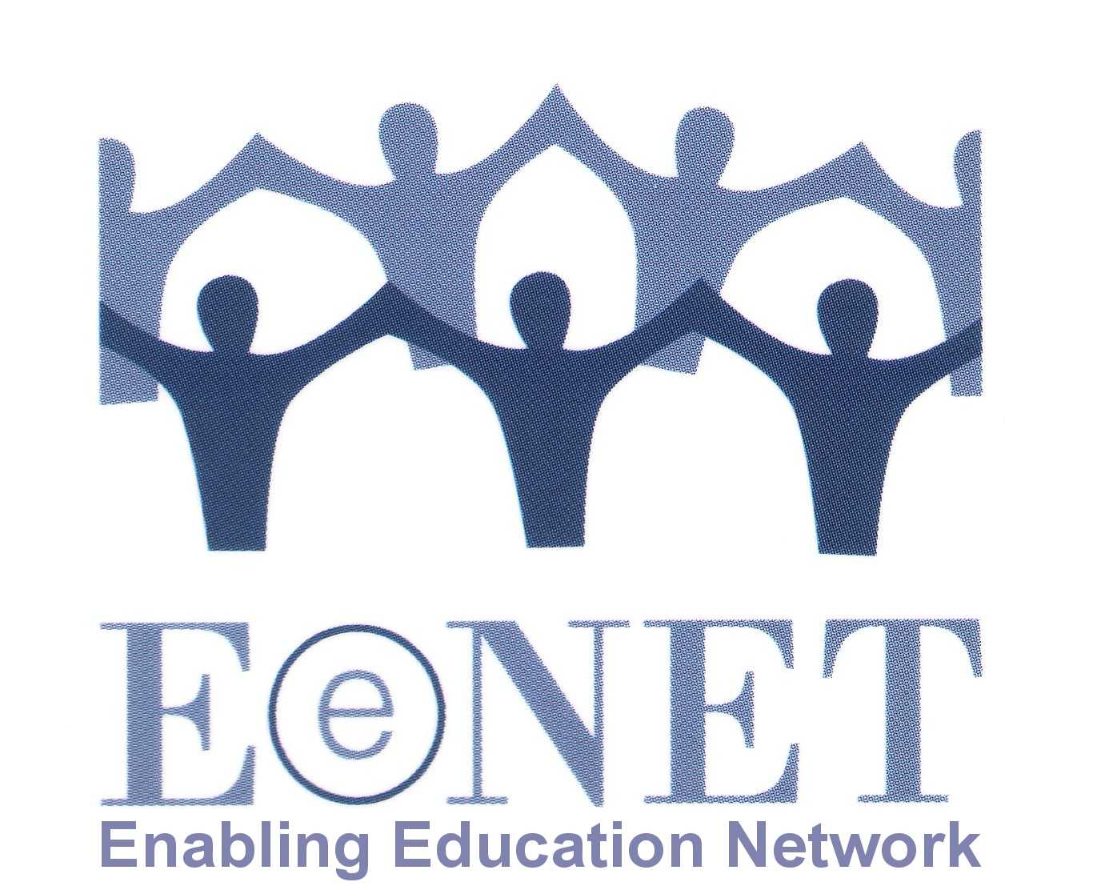
“Enabling Education Review” 2013

The theme for the 2013 newsletter from EENET and EENET Asia will be:

“Inclusive education and disability”

1. Why have we chosen this topic?

EENET has always been very keen to stress that inclusive education is not just about disability and including learners with disabilities in regular schools. We still firmly believe this – inclusive education is a process of making whole-school and whole-system changes so that every child, from any group in society, is able to attend, participate and achieve in education.

However, when taking a broad approach to inclusion it is still vital to think about the specific needs that learners with disabilities may face – needs that we may not be able to meet through general school improvements and good practice in education alone, and needs that may not be common to other groups of learners. We have therefore chosen to focus the 2013 newsletter on the complex debate about making education more inclusive across the board for all learners, whilst also meeting specific disability-related needs within an inclusive setting.

Recent research for UNICEF has highlighted that, while many countries and NGOs support inclusive education as a concept for all learners, in reality, teachers remain confused, uncertain or resistant to the inclusion of learners with disabilities. Often this is because teacher training has taken only a broad approach to inclusion and has not provided teachers with the specific guidance and confidence they feel they need for working with learners with disabilities. Likewise, ministries of education, provincial and local level education authorities in many countries struggle with how to develop and implement policy that ensures learners with disabilities are meaningfully included in education.

This newsletter theme has been designed to tie in with the 2014 Global Campaign for Education which will focus on disability. Find out more about the GCE here (although information about the 2014 campaign is not available yet) www.campaignforeducation.org.

EENET and EENET Asia published their first joint newsletter in December 2012. The two networks will work together again on the 2013 newsletter. The 2013 edition is also being published in collaboration with IDDC – the International Disability and Development Consortium – and will complement other IDDC activities around inclusive education and disability (see for instance the recent leaflet on teachers and inclusion: www.eenet.org.uk/resources/docs/IDDC_Every_Child_Needs_a_Teacher_leaflet.pdf

2. What could you write about?

- Your experiences of developing ‘twin-track’ inclusive education programmes (i.e. inclusive education programmes that support quality, inclusive education and system changes that help all learners, while at the same time making specific efforts to address the disability-related needs of certain learners).
- Your experiences of developing education policies that manage to promote inclusive education broadly, without side-lining specific disability issues.
- Your experiences of developing/delivering training that helps teachers to embrace general inclusive education principles and also gives them the skills/confidence to provide effective support to learners with disabilities.
- Your experiences of improving school infrastructure, facilities and equipment so that all children, including those with disabilities, are able to participate in learning.
- ICF-CY (the International Classification of Functioning, Disability and Health, with a focus on children and young people) is increasingly being promoted as a tool for use within inclusive education. We would really welcome your thoughts on this, and are looking for varied opinions (i.e. whether you think it is a useful tool for inclusive education, whether you want to critique its use in education) and perspectives (e.g. how useful is it for people at different levels in the education system).

If you do not want to write about disability issues, don’t worry, we will still have a section in the newsletter for articles on other inclusion-related topics.

3. How do you submit an article?

Please email your article to ingridlewis@eenet.org.uk or send a hard copy to the address at the end of this document.

Length – either 600 words (for a single page article) or 1,200 words (for a double-page article). We may edit longer articles down to a single page, depending on the quantity and quality of articles received.

Style – please keep the article easy-to-read and non-academic. We encourage the use of sub-headings, bullet lists, etc. Have a look at previous newsletters if you are not sure what style to use: www.eenet.org.uk/resources/eenet_newsletter/index.php

Editing – we are very happy to help with editing the article, so don’t worry if you are not an experienced writer, we can work with you to improve your article, make it shorter/longer, etc.

Photos – it is great if you can add photos, drawings or diagrams to your article. Please send us high resolution images by email, or post us an original print/drawing. For every image you want to add to your article, you will probably need to remove about 75-100 words of text – but we can help with this editing. Please ensure that every person shown in a photo has given their permission for the photo to be published.

Deadlines – the deadline for draft submissions of articles is 12 August 2013.
But we welcome submissions as soon as possible so we can spread the editing workload. We will then review all articles and work with the authors to edit them. This process will happen during August and September. We then aim to finalise articles and design the newsletter in October, so that it can be printed in October/November 2013.

Selection – please note that we might not publish all of the articles we receive. In addition to ensuring that we publish articles that are easy to read and of practical use to a range of education stakeholders, we will also ensure that the final selection includes:
- articles from a variety of countries/regions
- articles about a range of different issues
- articles by authors from different backgrounds (e.g. teachers, NGOs, parents, academics, etc).

Articles that are not selected for publication in the newsletter may instead be published on EENET’s website (www.eenet.org.uk).

Queries – if you have any questions, please email ingridlewis@eenet.org.uk.

Postal address – if you want to send an article in hard copy or as an audio recording (e.g. on CD), please send to:

EENET CIC
37 Market Street
Hollingworth
Cheshire, SK14 8LS
UK

17 May 2013

